Mental Health, Disabilities and Addiction Committee Staff
Sara Sucher, Legislative Counsel
John LaRosa, Legislative Counsel
Cristy Dwyer, Senior Legislative Policy Analyst
Rose Martinez, Assistant Deputy Director of Data
Danielle Heifetz, Finance Analyst

Hospitals Committee Staff
Rie Ogasawara, Legislative Counsel
Mahnoor Butt, Legislative Policy Analyst
Melissa Nuñez, Senior Data Scientist
James Wu, Data Scientist
Reese Hirota, Data Scientist
Veda Yagnik, Finance Analyst

Fire and Emergency Management Committee Staff
Josh Kingsley, Senior Legislative Counsel
William Hongach, Senior Legislative Policy Analyst
Erik Brown, Data Scientist
Rachel Avram, Data Scientist
Tanveer Singh, Finance Analyst

Public Safety Committee Staff
Josh Kingsley, Senior Legislative Counsel
Chad Benjamin, Legislative Policy Analyst
Erik Brown, Data Scientist
Rachel Avram, Data Scientist
Owen Kotowski, Finance Analyst



THE COUNCIL OF THE CITY OF NEW YORK

BRIEFING PAPER OF THE LEGISLATIVE DIVISION
Andrea Vazquez, Director
Smita Deshmukh, Deputy Director, Human Services
Rachel Cordero, Deputy Director, Governmental Affairs

COMMITTEE ON MENTAL HEALTH, DISABILITIES AND ADDICTION
Hon. Linda Lee, Chair

COMMITTEE ON FIRE AND EMERGENCY MANAGEMENT
Hon. Joann Ariola, Chair

COMMITTEE ON HOSPITALS
Hon. Mercedes Narcisse, Chair

COMMITTEE ON PUBLIC SAFETY
Hon. Yusef Salaam, Chair

September 23, 2024

Oversight – Behavioral Health Emergency Assistance Response Division (B-HEARD) and Responses to Mental Health Crises
Legislation:
Int. No. 532-2024 By Council Members Brannan, Yeger, Gennaro, Abreu, Holden, Menin, Schulman, Salamanca Jr., Narcisse, Hanks, Ariola, Paladino and Vernikov
Title: A Local Law to amend the administrative code of the city of New York, in relation to reimbursing small nonpublic schools for the cost of security guard services

Int. No. 1019-2024 By Council Members Brannan and Schulman
Title: A Local Law to amend the administrative code of the city of New York, in relation to the reporting and publication of mental health emergency response data

- INTRODUCTION
On September 23, 2024, the Committee on Mental Health, Disabilities and Addiction, chaired by Council Member Linda Lee, the Committee on Fire and Emergency Management, chaired by Council Member Joann Ariola, the Committee on Hospitals, chaired by Council Member Mercedes Narcisse, and the Committee on Public Safety, chaired by Council Member Yusef Salaam, will hold a joint oversight hearing titled “Behavioral Health Emergency Response Division (B-HEARD) and Responses to Mental Health Crises.” The Committees will also consider Introduction Number 532-2024 (Int. No. 532), sponsored by Council Member Justin Brannan, in relation to reimbursing small nonpublic schools for the cost of security guard services. The Committees will also consider Introduction 1019-2024 (Int. No. 1019), sponsored by Council Member Brannan, in relation to the reporting and publication of mental health emergency response data. Witnesses invited to testify include representatives from the Mayor’s Office of Community Mental Health (OCMH), the New York City Fire Department’s Emergency Medical Services (FDNY/EMS), the New York City Health + Hospitals Corporation (H+H), the New York City Police Department (NYPD), as well as advocacy groups, community-based organizations, and other interested stakeholders.
- BACKGROUND
Nationwide, police officers have traditionally been the default responders to individuals experiencing mental health crises. The National Alliance on Mental Illness defines a “mental health crisis” as “any situation in which a person’s behavior puts them at risk of hurting themselves or others and/or prevents them from being able to care for themselves or function effectively in the community.” When an individual experiences a mental health crisis, their loved ones or bystanders typically have no option other than to call 9-1-1. The 9-1-1 dispatcher must then make a decision on whether to send police, EMS, or both. According to the Vera Institute of Justice, mental and behavioral health issues make up a substantial percentage of 9-1-1 calls for which police are the first responders. But even when police officers have been trained on de-escalation, the mere presence of an armed, uniformed officer with a police vehicle can exacerbate the individual in crisis’s feelings of distress and escalate their mental health situation. This system is worsened by the stigma surrounding mental illness, barriers to accessing proper treatment, lack of housing and access to social services, lack of culturally competent care, as well as the overall mental health impact of racism. As a result, individuals experiencing mental health crises are often arrested, subject to uses of force, and in tragic cases, severely injured or killed. According to the Center for Policing Equity, nearly 37 percent of individuals in state and federal prisons and 44 percent of individuals in local jails nationwide have a diagnosed mental illness, and since 2015, 21 percent of individuals killed by the police in the United States (U.S.) had a known mental illness.
Some localities have begun to shift away from dispatching police officers in situations involving a mental health crisis and have begun relying on alternative responses to mental health-related calls. Several states have implemented community-based response models, such as CAHOOTS in Oregon and STAR in Colorado. According to the CEP, evidence from these programs shows that crisis response services with minimal or no police involvement can effectively divert individuals experiencing mental health crises away from arrest and hospitalization, can decrease the repeated use of crisis services, as well as improve the health of individuals in need of emergency mental health care.
- New York City’s 9-1-1 System and Emergency Dispatch Procedures
In New York City, the NYPD and FDNY answer approximately 9 million 9-1-1 calls annually. All emergency calls to 9-1-1 are connected to an NYPD call taker. Based on the nature of the emergency, the NYPD call taker transmits information to dispatchers in the NYPD, FDNY and EMS. In a medical emergency, the police call taker conferences and transfers a call to an FDNY Emergency Medical Dispatcher (EMD) who is also an Emergency Medical Technician (EMT) and certified in emergency medical dispatch procedures. EMD call takers provide pre-arrival instructions to callers over the phone.
The NYPD 9-1-1 operation unit consists of 1,435 Police Communications Technicians (PCTs), Supervising Police Communication Technicians (SPCTs), and Principal Police Communication Technicians (PPCTs). Staffing of FDNY Dispatch Operations has 370 EMTs and 53 Lieutenants and Captains assigned to Emergency Medical Dispatch. Dispatch operations take place at both the Public Safety Answering Center located in downtown Brooklyn (“PSAC I”), and an additional location in the Bronx that opened in 2016 (“PSAC II”). PSAC II handles the majority of city-wide dispatch.
  - Behavioral Health Emergency Response Division (B-HEARD)
In June 2021, New York City implemented a pilot program in East Harlem and parts of Central and North Harlem (police precincts 25, 28, and 32) in which both mental and physical health professionals respond to 9-1-1 mental health crisis calls, referred to as the Behavioral Health Emergency Response Division, or B-HEARD. The number of precincts in which B-HEARD operates has expanded to 31 out of 77 total police precincts in New York City. B-HEARD teams operate 7 days a week, 16 hours a day, and include 2 EMTs and paramedics from FDNY/EMS, as well as a mental health professional, such as a licensed social worker, from H+H. The goal of the program is to route 9-1-1 mental health crisis calls to B-HEARD teams when appropriate to help increase connections to community-based care, reduce unnecessary voluntary transports to hospitals, and reduce the unnecessary use of police resources and police involvement.
To initiate a B-HEARD response, NYPD 9-1-1 call takers analyze incoming calls to determine whether the situation is appropriate for a B-HEARD team, and if so, operators will then route the caller to speak with an EMT to triage and assign calls to B-HEARD based on call location, dispatch criteria, and availability of B-HEARD teams. When a B-HEARD team is dispatched, the team—identified by FDNY EMS uniforms and H+H identification—arrives in an FDNY-branded vehicle that contains the same Basic Life Support equipment as an ambulance. Once on the scene, the team works with the individual in need of assistance, and if appropriate, other involved parties. Teams perform de-escalation if necessary and conduct physical and mental health assessments, as well as on-site assistance such as connecting the individual to their existing medical or mental health provider, crisis counseling, or, with their consent, connecting them to follow-up services. If the individual requires emergency medical services, the B-HEARD team provides emergency medical care and can call EMS for an ambulance transport.
According to OCMH, the mayoral office tasked with programmatic oversight of B-HEARD, in Fiscal Year 23 (January to March 2023), 45 percent (3,888) of the 8,688 total mental health calls placed to 9-1-1 in the B-HEARD pilot area were deemed eligible for a B-HEARD response, and B-HEARD responded to 56 percent (2,191) of such calls. In Fiscal Year 23 (April to June 2023), 45 percent (5,365) of the 12,004 total mental health 9-1-1 calls in the pilot area were eligible for B-HEARD response, and B-HEARD responded to 54 percent (2,904) of such calls.
The most recently available data brief from OCMH on B-HEARD also states that from January 1, 2023, to June 30, 2023, 36 percent of individuals that B-HEARD responded to were served onsite, meaning that de-escalation, counseling, or referrals to community-based care occurred at the location of the individual, and 6 percent of individuals were transported to a community-based healthcare or social service location (such as Support and Connection Centers). The majority of individuals (58 percent) were transported to a hospital for additional care based on a comprehensive mental health assessment provided onsite.
B-HEARD teams respond to all mental health emergency calls without law enforcement, but there are exceptions in cases in which there is an increased risk for harm, including situations on subway tracks or involving weapons, a crime in progress, or other circumstances requiring law enforcement assistance. Once a B-HEARD team arrives at a location, they can request backup from the NYPD if they deem it unsafe for the B-HEARD team to intervene, and likewise, NYPD officers and EMS field units can request a B-HEARD team in situations in which B-HEARD was not originally dispatched.
Regarding the areas in which B-HEARD operates, as mentioned, in June 2021, B-HEARD launched in precincts 25, 28, and 32, which covers East Harlem and parts of Central and North Harlem. In November 2021, B-HEARD expanded to precincts 26 and 30, which cover calls from East Harlem to the Hudson River. In March 2022, B-HEARD teams began responding to calls in the 33 and 34 precincts in Manhattan and the 42 and 44 precincts in the Bronx. In June 2022, B-HEARD expanded to the 40 and 41 precincts in the South Bronx. In October 2022, B-HEARD expanded to the remainder of the South Bronx and to East New York and Brownsville, which included the 46, 48, 73, and 75 precincts. B-HEARD then expanded into parts of Queens and to additional neighborhoods in Brooklyn, which includes the 63, 69, 67, 71, 104, 112, 108, 114, 110, and 115 precincts. In October 2023, B-HEARD expanded to cover the entire borough of the Bronx, including precincts 50, 52, 47, 49, 43, and 45. According to OCMH, these areas were identified based on the volume of 9-1-1 mental health calls coming from these communities, as these radio zones have among the highest volume of 9-1-1 calls in New York City, as well as the availability of community-based mental health resources, such as Comprehensive Psychiatric Emergency Programs (CPEPs), outpatient clinics and other behavioral health providers.
B-HEARD's nature as a collaborative effort between multiple agencies has resulted in challenges in determining the program’s exact budget. In the Fiscal 2025 Adopted Budget, the Adams Administration allocated $35.1 million combined to H+H and FDNY/EMS for B-HEARD. Currently, H+H’s Fiscal 2025 Adopted Budget for B-HEARD totals $12.5 million, which represents a reduction of $5.8 million compared to the Fiscal 2024 Adopted Budget amount of $18.3 million. The 2023 November Plan also included a baselined Program to Eliminate the Gap (PEG) for H+H that reduced funding by $700,000 starting in Fiscal 2024. In the Fiscal 2025 Preliminary Plan, the program saw additional PEG totaling $6.6 million in Fiscal 2024 and $5 million baseline starting in Fiscal 2025. The PEGs halted the expansion of B-HEARD and introduced a hiring freeze. As of August 2024, H+H’s headcount includes 42 social worker positions dedicated to the B-HEARD program. FDNY’s Fiscal 2025 Adopted Budget for B-HEARD totals $22.6 million, which represents a reduction of $4.1 million compared to the Fiscal 2024 Adopted Budget amount of $26.7 million. The November 2023 Plan included a PEG savings of $2.0 million that reduced the B-HEARD budget by 20 civilian positions in Fiscal 2024. The current budgeted headcount as of the Fiscal 2025 Adopted Budget within EMS is 42 full-time positions for the B-HEARD program.
  - Mobile Crisis Teams, Intensive Mobile Treatment, Assertive Community Treatment, Shelter Partnered Assertive Community Treatment, and Forensic Assertive Community Treatment
In addition to B-HEARD, which focuses on “emergency responses” to mental health calls placed to 9-1-1, New York City provides additional services for individuals experiencing a mental health crisis. 988 (formally NYC WELL), is a free, confidential hotline that individuals can call to receive immediate mental health support from a counselor and receive referrals to mental health and substance use services. 988 is also the referral system for Mobile Crisis Team (MCT) services in New York City. MCTs are small teams that provide on-site help to individuals experiencing a mental health crisis in order to de-escalate and connect such individuals to appropriate support services. Most teams include mental health professionals and paraprofessionals, such as a masters-level clinicians and peer support staff. Individuals experiencing a crisis, as well as family members, friends, and acquaintances, can request help from a MCT by calling or texting 988. 988 counselors then assess the situation and, if they deem the individual eligible for MCT services, will send a referral to the most appropriate MCT, depending on the individual’s age and location. The MCT team typically responds within several hours, and operates between 8 a.m. and 8 p.m., 7 days per week, 365 days per year. According to the New York City Department of Health and Mental Hygiene (DOHMH), every borough has 1 MCT that serves children and adults younger than age 21 in that borough, while 19 MCTs serve adults age 21 and older across the 5 boroughs.
In addition to MCTs, DOHMH’s Single Point of Access (SPOA) program is the platform used to help mental health providers connect individuals with mental illness to services such as Intensive Mobile Treatment (IMT), Assertive Community Treatment (ACT), Shelter Partnered Assertive Community Treatment (SPACT), and Forensic Assertive Community Treatment (FACT), which are described below. Inpatient or outpatient mental health providers, homeless services, corrections, and community-based organizations can submit requests for services for individuals on SPOA, in which DOHMH then reviews individual eligibility and makes referrals for either IMT, ACT, SPACT, FACT teams, or any other support services deemed necessary.
DOHMH’s IMT program serves adults who frequently interact with city services, such as mental health services, the criminal justice system, and homeless outreach and shelters, with more flexible treatment options than those traditionally available. IMT teams are comprised of a program director, 3 behavioral health specialists, a psychiatrist, a nurse, an administrative assistant, and 2 peer specialists. Each team serves a maximum of 27 clients. ACT, SPACT, and FACT teams provide similar mental health support services as IMT but with a greater focus on treatment, rehabilitation, and community integration services, and only serve individuals diagnosed with serious mental illness (SMI).
  - First Responders and Mental Health Crises
In New York City, first responders, primarily police officers and EMS workers, respond to approximately 175,000 emergency mental health calls each year. The following is an overview of existing NYPD and FDNY/EMS protocols for responding to mental health calls that are either deemed ineligible for B-HEARD response or occur in areas not covered by B-HEARD.
    - NYPD Operational Guidance for Responding to Mental Health Calls
The NYPD’s Patrol Guide (“Patrol Guide” or “P.G.”) provides detailed operational procedures for police officers responding to emergency calls or for engaging with individuals while on patrol. The Patrol Guide sections relevant to police response for individuals experiencing a mental health crisis include, but are not limited to, Patrol Guide Procedure No. 216-06 (“P.G. 216-06”), entitled “Mental Health Removal Orders;” and Patrol Guide Procedure No. 221-13 (“P.G. 221-13”), entitled “Mentally Ill or Emotionally Disturbed Persons,” which establishes procedures for police responses to mental health calls. While P.G. 216-06 largely details administrative procedures required for mental health removals, P.G. 221-13 provides operational guidance relevant to police interactions with individuals experiencing a mental health crises.
According to P.G. 221-13, an emotionally disturbed person (EDP), which is the term utilized in the P.G., is a “person who appears to be mentally ill or temporarily deranged and are conducting [themselves] in a manner which a police officer reasonably believes is likely to result in serious injury to [themselves] or others.” Framed as procedures to “safeguard a mentally ill or emotionally disturbed person who does not voluntarily seek medical assistance,” upon arriving at the scene, police officers must assess the situation regarding the threat of immediate serious physical injury to the EDP, others present, or to the police officers. According to protocol, if an immediate threat is determined, the responding police officer may take reasonable measures to prevent the threatening behavior, including using deadly force as a last resort. In all other circumstances, where the EDP presents no immediate threat, the responding police officer must “[a]ttempt to slow the pace of the incident and establish dialogue with the EDP . . . [w]hen there is time to de-escalate, all time necessary to ensure the safety of all individuals concerned will be used…[and] [a]void any action which might agitate or provoke the EDP, if possible.”
Ultimately, the arriving officer must attempt to isolate and contain the individual, while maintaining a “zone of safety” until arrival of a patrol supervisor and Emergency Service Unit (ESU) personnel. P.G. 221-13 advises that the zone of safety be a minimum distance of 20 feet, so that the distance is greater than the effective range of a weapon other than a firearm.” Upon arrival of a patrol supervisor, and once the EDP is isolated but refuses to leave voluntarily, the supervisor must establish firearms control by directing members of service to not use their firearms or any other deadly physical force, unless their lives or the life of another is in imminent danger. Deployment of protective devices, such as shields and non-lethal devices, and other efforts can be used to assist in the containment and control of an EDP. Patrol supervisors are further directed to request the response of a hostage negotiation team and coordinator; or request assistance of interpreters, family or friends of the EDP, or local clergymen, as necessary.
Once an EDP is restrained, police officers are directed to remove property that is dangerous to life or will aid escape, and then have the individual removed to a hospital in an ambulance. P.G. 221-13 prohibits transporting an EDP to a police facility, and a police officer is required to ride in the transporting ambulance with an EDP. Restraining equipment, including handcuffs, may be used during hospital transport if an individual is deemed violent, resists, or upon the direction of a physician examiner. When an EDP arrives at the hospital, police officers are directed to safeguard the EDP until they can be examined by a psychiatrist, and inform the physician on use of non-lethal restraining devices and circumstances that brought the EDP into police custody.
In 2020, P.G. 221-13 was updated to include an emphasis on firearm control and crossfire awareness, along with other newly introduced procedures. For example, before arriving on the scene of a mental health call, police officers are instructed to request an EDP location history from dispatch, to determine if there has been prior incidents involving ESU response at the location. The updates also included directive to use police officers who have received Crisis Intervention Team (CIT) training, as contact police officers, where available.
    - NYPD Crisis Intervention Team (CIT) Training
Introduced in 2015, the NYPD’s CIT training program, seeks to instruct police officers on how to effectively communicate with individuals experiencing a mental health crisis in hopes of reducing the risk of injury to police officers and civilians, as well as divert individuals in crisis away from the criminal justice system and into mental health treatment when appropriate. Concepts addressed in CIT training include how to affect behavioral change through active listening, developing empathy and rapport, and influencing the individual in distress to de-escalate crises. CIT training is a 36-hour course, delivered to police officers over 4-days by Police Academy instructors and licensed mental health clinicians from partner entities with hands-on experience interacting with individuals in crisis. Police officers receive professional training on mental health disorders including relevant symptoms, prevalence, and available treatment options, as represented within the Diagnostic and Statistical Manual of Mental Disorders. For each condition, police officers receive instruction on unique engagement considerations and communication strategies, such that CIT trained police officers should be better equipped to engage with individuals experiencing a mental health crisis.
CIT training also incorporates scenario-based instruction in which trainees undergo simulated crises where the skills and techniques taught by instructors are implemented and evaluated. To successfully navigate the scenario portion of CIT training and achieve a “voluntarily compliant resolution” to the crisis incident, trainees are required to use full crisis communication and de-escalation while displaying tactically sound techniques and professionalism. Following each scenario, trainees debrief to evaluate what could have been done differently to more effectively gain voluntary compliance and ensure improved outcomes.
In 2020, the NYPD suspended CIT training for all police officers, citing the ongoing COVID-19 pandemic. Although the NYPD contends that CIT training is now ongoing, the number of trained police officers has significantly decreased since the program was suspended. As of September 2020, more than 18,000 of 36,000 uniformed police officers had been trained, whereas that total dropped to 13,802 police officers as of November 2022. According to the Mayor’s Management Report, while the number of CIT training hours delivered increased from Fiscal Year 2022 to 2023, the frequency of training remained below pre-pandemic levels. Reported CIT training hours since Fiscal Year 2018 are as follows: 127,680 hours (2018); 99,168 hours (2019); 88,896 hours (2020); 0 hours (2021); 12,192 hours (2022); and 40,960 (2023).
In addition to CIT training, the NYPD provides heightened training to specialized units who may respond to mental health calls. For example, ESU is comprised of police officers with training in crisis communication skills and certification as Emergency Psychological Technicians (EPTs). In the event more enhanced communication skills are required, the Hostage Negotiation Team, a unit consisting of experienced detectives who are trained in negotiation in crisis situations and are also certified as EPTs, may be summoned.
The Fiscal 2025 Executive budget includes about $2 million for NYPD Crisis Intervention Training (CIT) and refresher trainings.
    - FDNY/EMS Operating Guidelines and Procedures for Mental Health Calls
As mentioned, FDNY includes the Bureau of Emergency Medical Services (EMS), which is responsible for delivering pre-hospital emergency medical services citywide, and routinely dispatches ambulances via the emergency 9-1-1 system. FDNY/EMS maintains operational guidelines and procedures for ambulances responding to mental health calls and for treating individuals experiencing mental health crises.
Specifically, EMS Operating Guidelines and Procedures, § 106-08, titled “Mental Health Assignments,” establishes operational procedures and policy guidance for ambulance workers responding to mental health calls and conducting involuntary hospital transports. Operating procedures for mental health calls require that EMS personnel not knowingly approach or remove an individual in crisis who is displaying violence without police assistance, which includes entering the premises or treating the individual. As a general policy, EMS workers are directed to take safety measures when responding to an incident involving an individual threatening harm to themselves or others, including use of protective equipment (eye protection, face mask, or soft body armor), de-escalation techniques, and distancing as needed. If an individual is willing to be transported to the hospital, and if the EMS worker believes the individual can be removed without restraint or help from police, an ambulance can provide transport to a hospital without police. The procedures further instruct EMS workers that an individual may refuse hospital transport and decline medical aid “if the patient has decisional capacity and is not an involuntary removal.” When transporting an individual subject to involuntary removal pursuant to New York State Mental Hygiene Law, or an individual who is restrained or potentially violent, law enforcement must be present in the compartment of the ambulance to facilitate the transport.
Lastly, EMS policy states that: (i) “The Police Department is charged with the responsibility of custody, restraint, and resolution at incidents involving mentally ill patients”; (ii) “EMS members shall not attempt to restrain a violent patient unless they are requested to assist a police officer in doing so”; (iii) EMS personnel “must make every effort to assure an open airway and unrestricted chest member when treating a restrained patient,” and must ensure restrained patients are not transported “in the prone position or in any position that compresses the chest.”
- ISSUES
  - Challenges in Identifying Eligible Calls for B-HEARD Response
According to the most recently released data brief on B-HEARD, OCMH stated that it is generally very difficult for 9-1-1 operators to get a clear and accurate description from callers regarding exactly what is occurring in a situation that may be appropriate for a B-HEARD response. The nature of such emergencies is fluid, dynamic, and quickly evolving, even while the 9-1-1 operator is speaking with the caller. Due to an increase in 9-1-1 call volume and a need for more EMS call-takers, many mental health calls do not receive the additional triage needed to determine eligibility for B-HEARD. However, per OCMH, “[t]he city is working to address these challenges through a number of strategies, including hiring more EMS 9-1-1 call-takers in Fiscal Year 2024.”
According to OCMH, newly implemented protocols now allow B-HEARD teams to respond to a broader range of mental health calls. Historically, mental health calls where EMS call-takers do not have enough information to assess eligibility for B-HEARD receive a response from NYPD or EMS. Now, in addition to being sent on their own to calls triaged as non-violent as a primary responder, B-HEARD teams can be added to calls assigned to NYPD or EMS for a response where eligibility for a B-HEARD response might not be established during the initial call triaging process. In calls where a B-HEARD team with NYPD or EMS are dispatched, once it is determined that the call is appropriate for a B-HEARD response, the team can take over engagement with the individual, while NYPD or EMS departs from the scene. According to OCMH, due to these new protocols, more calls are being identified as B-HEARD eligible and thus teams are responding to a higher percentage of mental health 9-1-1 calls.
  - Challenges in Interpreting the Publicly Available Data to Evaluate B-HEARD
In an effort to understand B-HEARD’s impact on New York City’s mental healthcare infrastructure and on law enforcement response to mental health calls, the New York City Council Data Team (the “Data Team”) investigated the publicly available datasets relevant to the program. The Data Team hoped to trace cases throughout the entire B-HEARD pipeline, beginning with 9-1-1 calls and ending with the potential outcomes such as hospitalization or NYPD involvement. However, as discussed below, drawing meaningful and independent conclusions about the effectiveness of B-HEARD based on the publicly available data has been challenging.
First, the Data team examined the NYPD Calls for Service dataset, publicly available on the New York City Open Data portal, which covers 9-1-1 calls made by the public as well as self-initiated entries by NYPD officers. This dataset showed that in 2023, there were 6,816,062 total calls made to 9-1-1. Of these, 2.57 percent were given an “EDP” code, meaning that the 9-1-1 call involved an EDP. According to the Data Team, this proportion has stayed more-or-less steady since 2018, when the dataset first began.
Below, Figure 1 shows a map of 9-1-1 calls involving EDPs around New York City (5-year average), with the B-HEARD precincts highlighted in black. The areas in dark blue have the highest 5-year average of NYPD Calls for Service for EDPs, while light blue areas have the lowest.

Figure 1: NYPD Calls for Service Involving EDPs (5-year average)
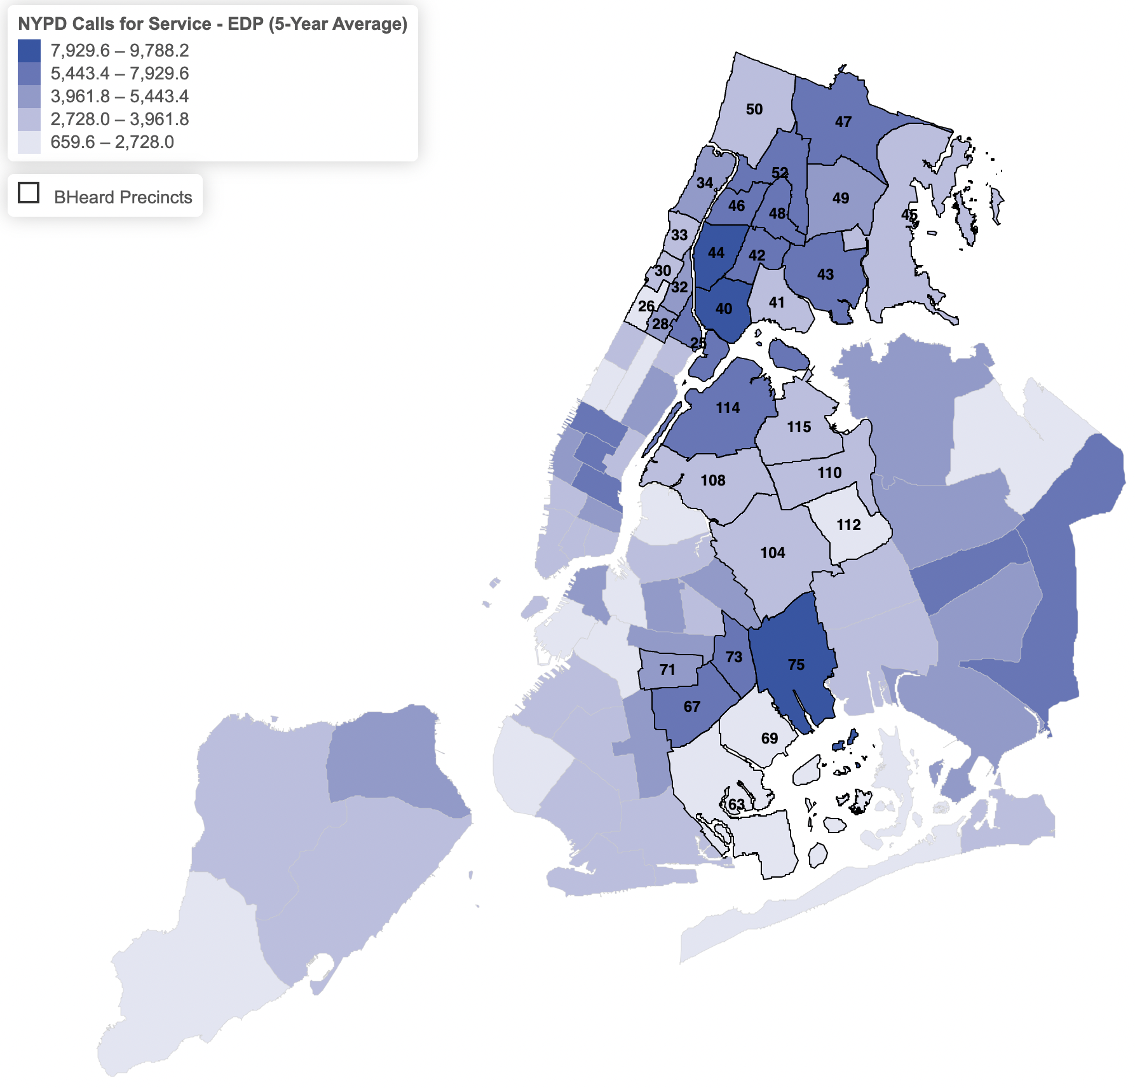

According to the Data Team, in 2023, B-HEARD precincts held 42.28 percent of New York City’s total population and received 48.29 percent of 9-1-1 calls made regarding an EDP. Of the top 10 precincts with the highest number of EDP-related 9-1-1 calls over the past 5 years, 9 out of 10 such precincts were in the B-HEARD pilot area, indicating that B-HEARD precincts tend to have a higher volume of EDP 9-1-1 calls. However, according to the Data Team, there is no B-HEARD indicator column in the NYPD dataset, which makes it impossible for the public to determine which 9-1-1 EDP calls were routed for a B-HEARD response. The dataset also does not provide any information about the outcome of a given 9-1-1 call (such as whether the call was responded to by NYPD or routed to FDNY/EMS, and whether the individual was arrested, transported to a hospital, or another outcome.). Without this information, it was difficult for the Data Team to assess whether B-HEARD played a meaningful role in reducing NYPD involvement in mental health crises since the program was created in 2021.
Similarly, the EMS Incident Dispatch dataset publicly available on the Open Data portal provides data on EDP-related calls in which ambulances were dispatched to the scene. The dataset provides information on the outcome of the FDNY/EMS dispatch, referred to as the “Incident Disposition Code.” As previously mentioned, calls to 9-1-1 are first routed to NYPD dispatch and then routed to FDNY/EMS dispatch, if appropriate. The FDNY/EMS dispatch codes in the dataset include incident outcomes such as “transporting patient,” “condition corrected,” and “patient gone on arrival.” But like the NYPD 9-1-1 dataset, no information is provided on whether or not B-HEARD was involved, which prevented the Data Team from performing an independent analysis of B-HEARD’s impact on individual incident outcomes.
Further, while both the NYPD Calls for Service and EMS Incident Dispatch datasets have codes that classify the types of calls, the codes do not match across datasets. For example, EMS classifies the various call types as “EDP Transport Requested,” “Psychiatric Patient NYC Well,” “Psychiatric Patient Violent/Weapons,” and “Psych Patient Non-Violent.” The NYPD dataset, however, classifies EDP calls as “Ambulance Case: EDP/Inside,” “Ambulance Case: EDP/Outside,” “Ambulance Case: EDP/Transit,” “Ambulance Case: EDP/School,” and “Ambulance Case: EDP/LTD HWY” and provides no information on the outcome of the call. In sum, the datasets are not connected and therefore, it was not possible for the Data Team to link NYPD 9-1-1 calls to the incident disposition codes in the EMS dataset to accurately assess the outcomes of EDP calls involving NYPD or EMS.
Next, the Data Team examined the NYPD Use of Force Incident dataset that is available on the Open Data portal to explore any potential relationship between B-HEARD and use of force by NYPD in responding to mental health crisis calls. About 20 percent of the use of force incidents between 2020 and 2024 list “Person in Crisis” as the basis for the encounter. Of these incidents, physical force by the NYPD was used in 75 percent of “Person in Crisis” incidents and used an electrical weapon or taser in 25 percent of such incidents. Using data on EDP 9-1-1 calls to assess how frequently the NYPD uses force when responding to mental health calls, the Data Team found that force was used in about 1-in-200 mental health responses between 2020 and 2024.
Figure 2 below shows which police precincts have a relatively lower (lighter blue) and higher (darker blue) percentage of EDP calls that involved the use of force, with B-HEARD precincts outlined in black. Based on the available data, the Data Team concluded that B-HEARD precincts do not necessarily overlap with the precincts where the use of force during a response to an EDP call are most common.
Figure 2: Percent of EDP Calls w/ Use of Force Precinct Map
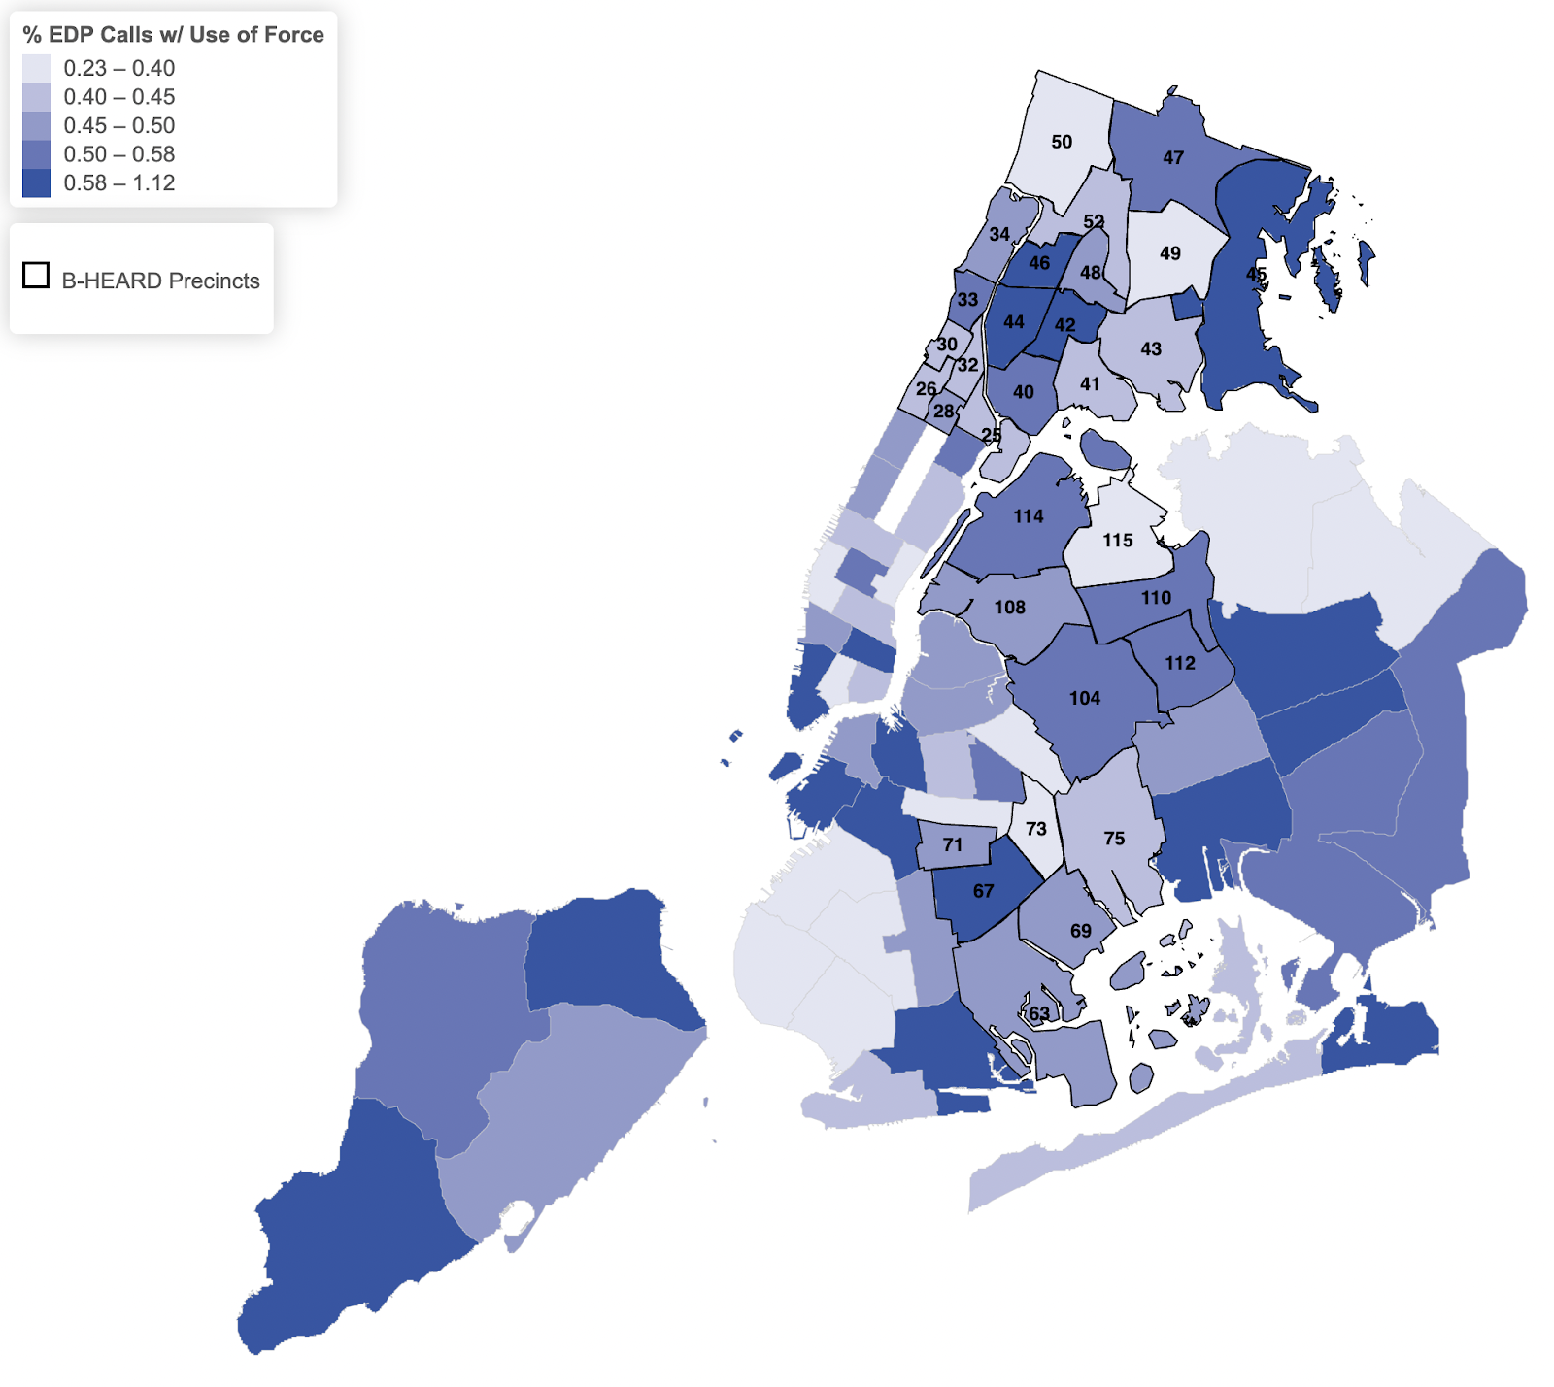

There is no explicit mention of any B-HEARD involvement in the use of force dataset. However, the Data Team indirectly investigated whether B-HEARD has impacted the frequency of use of force by NYPD. Figure 3 below shows the percentage of EDP calls that involved use of force across time for both B-HEARD (in blue) and non-B-HEARD precincts (in red).
Figure 3: Percent of EDP Calls involving Use of Force by precincts with B-HEARD and non-B-HEARD
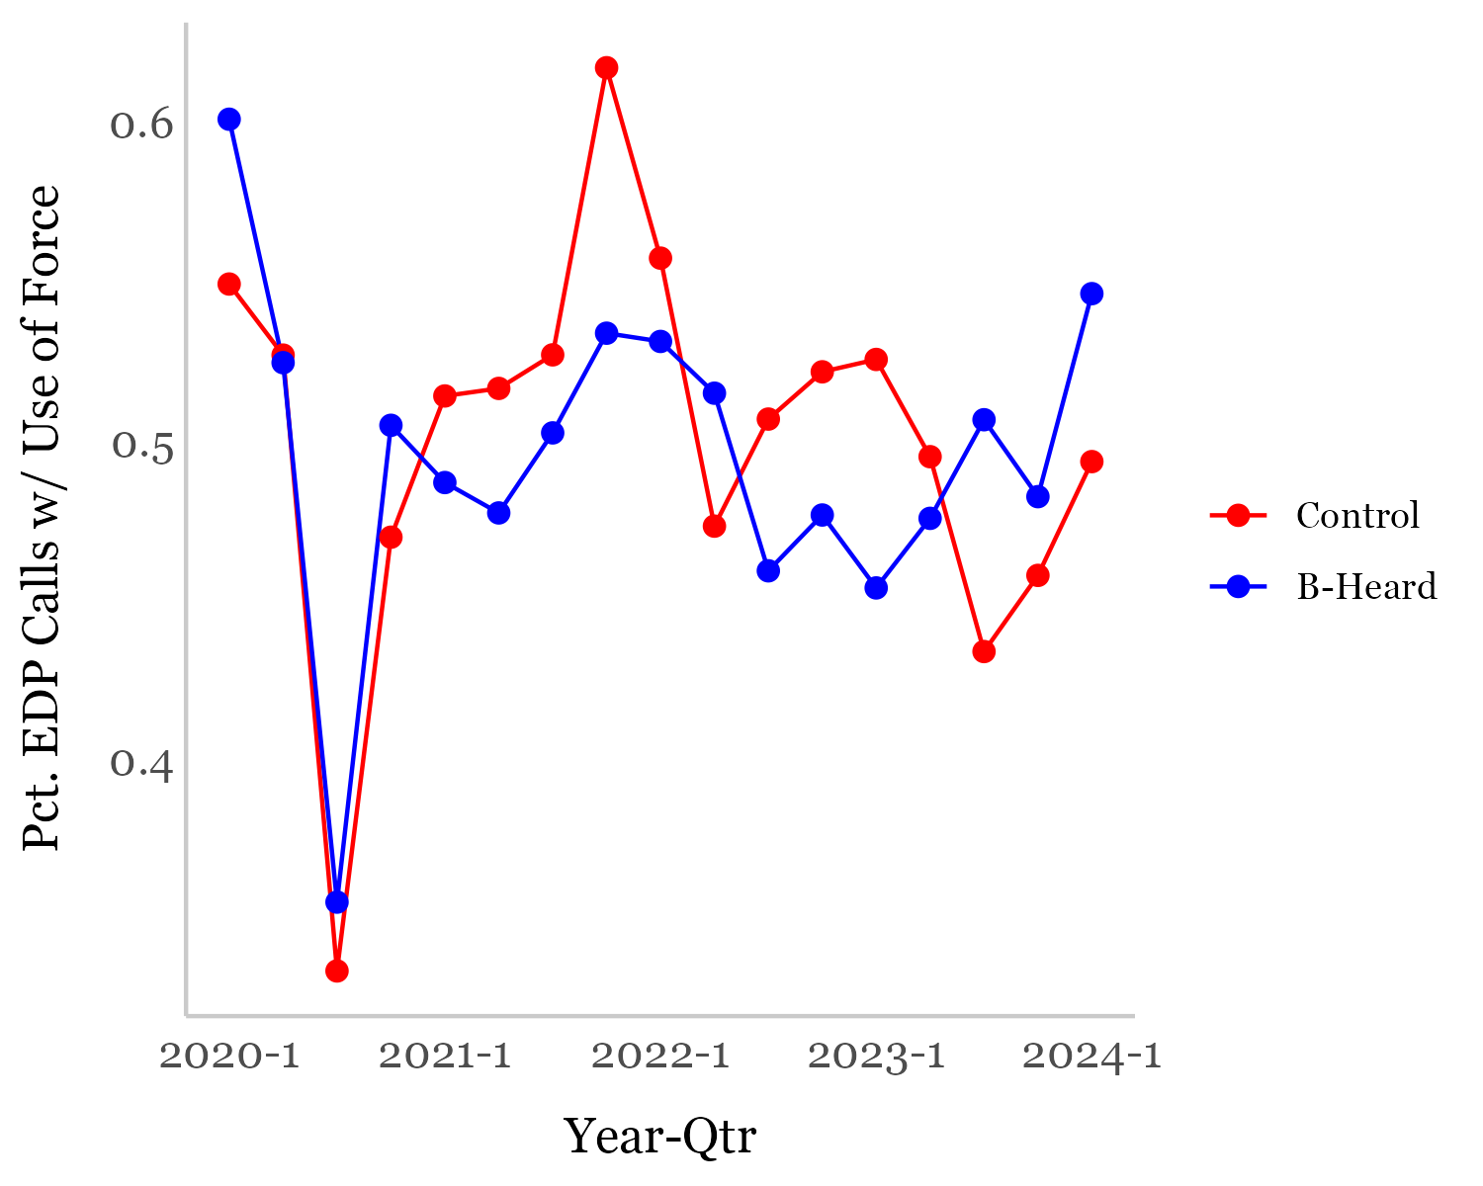

Based on the available data, the Data Team concluded that the percentage of EDP calls in which NYPD used force is similar between precincts that have B-HEARD and those that do not. According to the Data Team, statistical tests indicate that B-HEARD had little to no impact on the frequency of the use of force during EDP responses.

- LEGISLATIVE ANALYSIS
  - Int. No. 532
This bill would amend Administrative Code Section 10-172 which authorizes the reimbursement to some nonpublic schools for expenses relating to hiring unarmed security guards. Enacted as Local Law 2 (“the law”) of 2016, these provisions apply to qualifying nonprofit elementary or secondary schools that are not New York City Public Schools, and provide instruction in accordance to New York State Education Law. Pursuant to the law, New York City provides qualifying schools reimbursement for the costs of security guards who provide services during school hours, school-related after school programs and athletic events. The law further specifies that allowable costs are based on the number of students at each school; such that, schools that enroll 300-499 students are reimbursed the cost of one security guard, schools with at least 500 students for two security guards, and additional security guards to be reimbursed per 500 students at a school. Finally, the total amount of reimbursement authorized by the law is set at $19,800,000 dollars per school year; however, the maximum amount can increase annually to account for growth in the number of eligible schools and changes in prevailing wages.
Int. No. 532 expands school eligibility for the above-mentioned program by allowing for the reimbursement of cost for security guards in nonpublic schools with fewer than 300 students, whereas currently only schools with more than 300 students can qualify for reimbursement. Further, the bill would increase the total annual amount of reimbursements authorized to $39,300,000.

  - Int. No. 1019
This bill would require OCMH, in coordination and consultation with other relevant agencies, to report to the mayor and speaker and online regarding each 9-1-1 call that is identified as involving a mental health emergency, on a quarterly basis. The report would include information about responses to these emergencies and would specify whether B-HEARD responded. Additionally, the bill would require NYPD FDNY to include the unique identifiers generated by their respective computer-aided dispatch systems in their 9-1-1 call data publication on the Open Data Portal. The NYPD and FDNY would also be required to indicate whether a B-HEARD team was dispatched and able to respond in their 9-1-1 call data publication on the Open Data Portal.
- CONCLUSION
At this hearing, the Committees will seek an update on, and an in-depth overview of, the B-HEARD program, including efforts to maintain and improve the program, as well as any plans for its expansion. The Committees are also interested in understanding the roles of each agency in carrying out the program, how data is collected to evaluate the effectiveness of the B-HEARD program, and any other issues that have arisen related to the implementation or evaluation of the program.

Int. No. 532

By Council Members Brannan, Yeger, Gennaro, Abreu, Holden, Menin, Schulman, Salamanca, Narcisse, Hanks, Ariola, Paladino and Vernikov

A Local Law to amend the administrative code of the city of New York, in relation to reimbursing small nonpublic schools for the cost of security guard services

Be it enacted by the Council as follows:

Section 1. Subdivision f of section 10-172 of the administrative code of the city of New York, as added by local law 2 for the year 2016, is amended to read as follows:
f. Except as set forth in subdivision g of this section, the administering agency shall provide reimbursement of the allowable costs for:
1. one security guard at a qualifying nonpublic school that enrolls [from 300] up to 499 students;
2. two security guards at a qualifying nonpublic school that enrolls at least 500 students; and
3. an additional security guard at a qualifying nonpublic school for each additional 500 students enrolled.
For purposes of this subdivision, students with respect to whom the city separately provides assistance that includes funding for security shall not be included in the reimbursement determination, and reimbursement for the services of one security guard during periods of school-related instruction or school-related events may include the costs of different individuals providing security services at different times. Further, the term "student" shall be deemed to refer to the full-time equivalent thereof, based upon a six hour and twenty-minute school day for a student.
§ 2. Subdivision j of section 10-172 of the administrative code of the city of New York, as added by local law 2 for the year 2016, is amended to read as follows:
j. Notwithstanding any provision to the contrary in this local law, the total annual amount of reimbursements authorized by this section shall be a maximum of [$19,800,000] $39,300,000 dollars per school year, which shall be adjusted annually by the administering agency, if such agency anticipates that such maximum will be reached in the subsequent one-year period, to reflect changes in the prevailing wage and supplements, the number of students attending qualifying nonpublic schools, or the number of qualifying nonpublic schools, provided that such reimbursements shall in no event exceed the amounts appropriated for implementation of this section. To the extent the administering agency anticipates that the amount requested for reimbursement will exceed the funds available, the administering agency shall reimburse for allowable costs on an equitable basis until such funds are exhausted.
§ 3. This local law takes effect July 1, 2022.

Int. No. 1019

By Council Members Brannan and Schulman

A Local Law to amend the administrative code of the city of New York, in relation to the reporting and publication of mental health emergency response data

Be it enacted by the Council as follows:

Section 1. Subchapter 9 of chapter 1 of title 3 of the administrative code of the city of New York is amended by adding a new section 3-195 to read as follows:
§ 3-195 Mental health emergency response reporting. a. Definitions. For purposes of this section, the following terms have the following meanings:
B-HEARD. The term “B-HEARD” means the behavioral health emergency assistance response division of the office, or any successor division or program with the same or substantially similar functions.
Involuntary removal. The term “involuntary removal” means any removal of an individual pursuant to subdivision (a) of section 9.41 of the mental hygiene law or subdivision (a) of section 9.58 of the mental hygiene law.
Use of force incident. The term “use of force incident” has the same meaning as set forth in subdivision a of section 14-158.
b. Report. 1. No later than 1 year after the effective date of the local law that added this section and quarterly thereafter, the director of the office, in coordination with the police commissioner, commissioner of information technology and telecommunications, fire commissioner, commissioner of health and mental hygiene, and any other relevant agency head and in consultation with the New York city health and hospitals corporation, shall submit to the mayor and the speaker of the council and post to the office’s website a report regarding each 911 call that is identified as involving a mental health emergency from the previous quarter. Such report shall include a table in which each separate row references a 911 call. Each row shall include, at a minimum, the following information set forth in separate columns:
(a) The time and date of the call;
(b) The location of the call, given as latitude and longitude;
(c) The patrol precinct in which the call was made;
(d) The emergency medical services zone, designated by the fire department, in which the call was made;
(e) Any unique identifier for the call generated by the police department’s computer-aided dispatch system;
(f) Any unique identifier for the call generated by the fire department’s computer-aided dispatch system;
(g) Whether a B-HEARD team was dispatched in response to the call;
(h) If a B-HEARD team was dispatched in response to the call, whether the team was able to respond to the call;
(i) If a B-HEARD team was not dispatched in response to the call, the reason it was not dispatched;
(j) Whether any other responder, including but not limited to the police department, the fire department, and any mobile crisis team operated by the department of health and mental hygiene, was dispatched in response to the call, and if so, which ones;
(k) If multiple responders were dispatched in response to the call, which responder was first dispatched;
(l) If multiple responders were dispatched in response to the call, which responder first arrived on the scene;
(m) Whether the responder that first arrived on the scene requested assistance, and if so, the responder from which assistance was requested;
(n) The amount of time between the initial receipt of the 911 call and the first dispatch of responders;
(o) The amount of time between the first dispatch of responders and first arrival of responders on the scene;
(p) Any services the individual experiencing the mental health emergency accepted from, or to which the individual was referred by, responders, including but not limited to medical treatment on the scene, voluntary transport to a hospital, health counseling on the scene, crisis counseling on the scene, or follow-up services offered by the department of health and mental hygiene or department of homeless services, by community-based healthcare or social service providers, or through a hospital-based program; and
(q) Whether the individual experiencing the mental health emergency was left at the scene, was subjected to involuntary removal, experienced a use of force incident, was issued a summons, or was arrested.
2. The report required under paragraph 1 of this subdivision shall include a data dictionary.
§ 2. Section 14-150 of the administrative code of the city of New York is amended by adding new subdivision g to read as follows:
g. Publication of 911 call data on the open data portal. 1. Definitions. For purposes of this subdivision, the term “B-HEARD” means the behavioral health emergency assistance response division of the office of community mental health.
2. Dispatch system identifier columns. When publishing data to the open data portal regarding a 911 call, the department shall include a column indicating any unique identifier for such call generated by the department’s computer-aided dispatch system and a separate column indicating any unique identifier for such call generated by the fire department’s computer-aided dispatch system. The department shall coordinate with the fire department to obtain any unique identifier for such call generated by the fire department’s computer-aided dispatch system.
3. B-HEARD team response columns. When publishing data to the open data portal regarding a 911 call, the department shall include a column indicating whether a B-HEARD team, or a team from any successor division or program with the same or substantially similar functions, was dispatched in response to such call and a separate column indicating whether any such team was able to respond to such call. The department shall coordinate with any relevant agency to obtain such information.
4. Previously published data. The department shall also include the information specified in paragraphs 2 and 3 of this subdivision with respect to 911 calls for which data is already published on the open data portal, to the extent such information is available to the department.
§ 3. Chapter 1 of title 15 of the administrative code of the city of New York is amended by adding a new section 15-150 to read as follows:
§ 15-150 Publication of 911 call data on the open data portal. a. Definitions. For purposes of this section, the term “B-HEARD” means the behavioral health emergency assistance response division of the office of community mental health.
b. Dispatch system identifier columns. When publishing data to the open data portal regarding a 911 call, the department shall include a column indicating any unique identifier for such call generated by the department’s computer-aided dispatch system and a separate column indicating any unique identifier for such call generated by the police department’s computer-aided dispatch system. The department shall coordinate with the police department to obtain any unique identifier for such call generated by the police department’s computer-aided dispatch system.
c. B-HEARD team response columns. When publishing data to the open data portal regarding a 911 call, the department shall include a column indicating whether a B-HEARD team, or a team from any successor division or program with the same or substantially similar functions, was dispatched in response to the call and a separate column indicating whether any such team was able to respond to such call. The department shall coordinate with any relevant agency to obtain such information.
d. Previously published data. The department shall also include the information specified in subdivisions b and c of this section with respect to 911 calls for which data is already published on the open data portal, to the extent such information is available to the department.
§ 4. This local law takes effect immediately.
REC
LS #149/17030/17150
8/30/2024 3:34 PM

Session 13
LS #734
1/10/24

Session 12
MMB
LS #734
3/15/22; 8:56 a.m.

Identifying a Mental Health Crisis, Aurora Mental Health & Recovery (Jan. 4, 2023), https://www.auroramhr.org/blog/identifying-a-mental-health-crisis.
Charlotte Resing, J.D., et al., Redesigning Public Safety: Mental Health Emergency Response, Center for Policing Equity (updated Dec. 2023), https://policingequity.org/mental-health/69-cpe-whitepaper-mentalhealth/file.
Id.
Nicholas Turner, We Need to Think Beyond Police in Mental Health Crises, Vera Institute (Apr. 6, 2022), https://www.vera.org/news/we-need-to-think-beyond-police-in-mental-health-crises.
Id.
Charlotte Resing, J.D., et al., Redesigning Public Safety: Mental Health Emergency Response, Center for Policing Equity (updated Dec. 2023), https://policingequity.org/mental-health/69-cpe-whitepaper-mentalhealth/file. Systematic inequities put Black individuals more at risk of police violence in mental health crises responses. Because of racial disparities in rates of police contact, Black individuals – including individuals with mental illness – are more likely to interact with police. Nearly 2 out of every 3 Black individuals in need of mental health services does not receive them, and due to inequitable mental health care access and quality, Black individuals may be more likely to experience mental health crises that are handled by police. Such inequities are compounded by the toll of police interactions themselves and the presence of societal racism, both of which have been shown to adversely impact mental health. Id.
Id. On May 26, 2024, 26-year-old Andre Mayfield was fatally shot by NYPD officers in an encounter with police after officers said he came at them with knives. According to Andre’s family, he suffered from depression and mental health issues, and that a social worker should have been there to help de-escalate. Jennifer Bisram, Brooklyn man’s family speaks after deadly NYPD shooting. Here’s what they say should change., CBS News (May 29, 2024), https://www.cbsnews.com/newyork/news/andre-mayfield-fatally-shot-by-police-family-speaks-out. In March 2024, 19-year-old Win Rozario was shot to death by the NYPD after calling 9-1-1 for help while experiencing a mental health crisis. Charles Lane & Bahar Ostadan, Police shoot and kill 19-year-old in Queens who called police for mental help, NYPD says, Gothamist (Mar. 28, 2024), https://gothamist.com/news/police-shoot-person-in-queens-now-in-critical-condition-nypd.
Id.
Charlotte Resing, J.D., et al., Redesigning Public Safety: Mental Health Emergency Response, Center for Policing Equity (updated Dec. 2023), https://policingequity.org/mental-health/69-cpe-whitepaper-mentalhealth/file. Crisis Assistance Helping Out On The Streets (CAHOOTS) is a mental health crisis intervention program in Eugene, Oregon, that has handled lower-risk emergency calls involving mental illness and homelessness since 1989. Staff respond to calls from 988 and 911 and typically respond in pairs; usually one has training as a medic and the other has experience with homeless street outreach or mental health support. Omar Villafranca, An alternative to police: Mental health team responds to emergencies in Oregon, CBS News (Oct. 23, 2019), https://www.cbsnews.com/news/mental-health-team-responds-to-emergencies-oregon-alternative-to-police-2019-10-23. Support Team Assisted Response (STAR) program responds to any person in Denver, Colorado, who needs urgent help related to mental health distress, poverty, homelessness, substance misuse, resource needs, and more. To request support from a STAR team, individuals can either call 9-1-1 or a special number that connects them to an operator. STAR teams include behavioral health clinicians and paramedics, and respond to low-risk calls where there are no significant safety concerns, and is considered a “civilian emergency response that is dispatched by Denver 9-1-1”. Support Team Assisted Response (STAR) Program, City and County of Denver, https://www.denvergov.org/Government/Agencies-Departments-Offices/Agencies-Departments-Offices-Directory/Public-Health-Environment/Community-Behavioral-Health/Behavioral-Health-Strategies/Support-Team-Assisted-Response-STAR-Program.
Charlotte Resing, J.D., et al., Redesigning Public Safety: Mental Health Emergency Response, Center for Policing Equity (updated Dec. 2023), https://policingequity.org/mental-health/69-cpe-whitepaper-mentalhealth/file.
Id.
2018 Annual Report on Implementation of Next Generation 9-1-1in NYC, Department of Information Technology & Telecommunications (Dec. 2018), https://www1.nyc.gov/assets/doitt/downloads/pdf/2018_doitt_ng911_ll78_annual_report.pdf.
City of New York 9-1-1 Call Processing Review (911CPR), Windbourne Consulting, LLC (May 1, 2012).
Personnel with the PPCT title perform multiple functions, including the 9-1-1 call taker and dispatcher positions. Information provided by the New York City Police Department via email. On file with the Committee on Public Safety.
Information provided by the New York City Fire Department via email. On file with the Committee on Fire and Emergency Management.
Information provided to Committee on Public Safety by NYPD.
Transforming NYC’s Response to Mental Health Emergencies, OCMH (2024), https://mentalhealth.cityofnewyork.us/wp-content/uploads/2024/01/BHEARD-Data-Brief-FY23-Q3-Q4_2024.pdf.
B-HEARD: 911 Mental Health Emergency Health-Centered Response Pilot Project, OCMH, https://mentalhealth.cityofnewyork.us/wp-content/uploads/2023/10/B-HEARD-One-Pager-UPDATE-October-2023_Final.pdf; Find Your Precinct and Sector, NYC Police Department, https://www.nyc.gov/site/nypd/bureaus/patrol/find-your-precinct.page.
Id.; B-Heard: 911 Mental Health Emergency Alternate Response Pilot Project Frequently Asked Questions, https://www.nyc.gov/assets/nypd/downloads/pdf/public_information/b-heard-public-faqs-5-27-2021.pdf. Join the B-Heard Team, Health + Hospitals, https://www.nychealthandhospitals.org/bheard-social-workers.
Transforming NYC’s Response to Mental Health Emergencies, OCMH (2024), https://mentalhealth.cityofnewyork.us/wp-content/uploads/2024/01/BHEARD-Data-Brief-FY23-Q3-Q4_2024.pdf.
Behavioral Health Emergency Assistance Response Division (B-HEARD) – New York, NY, CSG Justice Center (June 10, 2022), https://csgjusticecenter.org/publications/expanding-first-response/program-highlights/newyork.
Basic Life Support equipment includes tools such as face masks, Automated External Defibrillators (AEDs), and manual resuscitators.
Reimagining New York City’s mental health emergency response, NYC Mayor’s Office of Community Mental Health, https://mentalhealth.cityofnewyork.us/b-heard.
Id.
Id.
Id.
B-HEARD: Transforming NYC’s Response to Mental Health Emergencies, OCMH, https://mentalhealth.cityofnewyork.us/wp-content/uploads/2024/01/BHEARD-Data-Brief-FY23-Q3-Q4_2024.pdf.
Id.
Id. Support and Connection Centers are centers that offer short-term clinical and non-clinical services to individuals with mental health and substance use needs, and promote community-based and person-centered engagement, stabilization, and connection to services. Support and Connection Centers (formerly Diversion Centers), NYC Mayor’s Office of Community Mental Health (Nov. 10, 2019), https://mentalhealth.cityofnewyork.us/program/support-and-connection-centers.
B-HEARD: Transforming NYC’s Response to Mental Health Emergencies, OCMH, https://mentalhealth.cityofnewyork.us/wp-content/uploads/2024/01/BHEARD-Data-Brief-FY23-Q3-Q4_2024.pdf.
Reimagining New York City’s mental health emergency response, NYC Mayor’s Office of Community Mental Health, https://mentalhealth.cityofnewyork.us/b-heard.
NYC: Behavioral Health Emergency Assistance Response Division (B-HEARD), Transform911: Implementation Case Studies, https://www.transform911.org/resource-hub-old-map/case-studies/nyc.
B-HEARD: Transforming NYC’s Response to Mental Health Crises: First Month of Operations, https://mentalhealth.cityofnewyork.us/wp-content/uploads/2021/07/B-HEARD-First-Month-Data.pdf.
B-HEARD: Transforming NYC’s Response to Mental Health Crises: First Six Months of Operations, https://mentalhealth.cityofnewyork.us/wp-content/uploads/2021/12/FINAL-DATA-BRIEF-B-HEARD-FIRST-SIX-MONTHS-OF-OPERATIONS-12.15.21-1.pdf.
B-HEARD: Transforming NYC’s Response to Mental Health Crises: January – March 2022 (FY 22 Q3) https://mentalhealth.cityofnewyork.us/wp-content/uploads/2022/06/FINAL-DATA-BRIEF-B-HEARD-FY22-Q3.pdf.
B-HEARD: Transforming NYC’s Response to Mental Health Crises: Fiscal 22 (July 1, 2021 – June 30, 2022), https://mentalhealth.cityofnewyork.us/wp-content/uploads/2022/10/FINAL-DATA-BRIEF-B-HEARD-FY22-TOTAL.pdf.
B-HEARD: Transforming NYC’s Response to Mental Health Emergencies: Data for July 1, 2022 – December 31, 2022 (FY23 Q1 & Q2), OCMH https://mentalhealth.cityofnewyork.us/wp-content/uploads/2023/05/2023_05_23-BHEARD-Data-Brief-FY23-Q1Q2-July22-Dec22.pdf.
B-HEARD: Transforming NYC’s Response to Mental Health Emergencies: Data for January 1, 2023 – June 30, 2023 (FY23 Q3 & Q4), OCMH, https://mentalhealth.cityofnewyork.us/wp-content/uploads/2024/01/BHEARD-Data-Brief-FY23-Q3-Q4_2024.pdf.
Re-imagining New York City’s mental health emergency response, OCMH, https://mentalhealth.cityofnewyork.us/b-heard. Thus, as of 2024, B-HEARD operates in the following areas: Harlem (river to river), Washington Heights, Inwood, the entire borough of the Bronx, East New York, Brownsville, East Flatbush, Remsen Village, Marine Park, Canarsie, Crown Heights, Wingate, and Prospect Lefferts Gardens. Id.
Id.
The hotline operates 24 hours a day, 7 days a week, 365 days a year and allows individuals the option to either call, text, or chat with a counselor and is offered in more than 200 language. Helping New Yorkers in Crisis, NYC 988, https://nyc988.cityofnewyork.us/en. Individuals can also use the NYC 988 “Find Services” database to find mental health and substance use services offered throughout NYC. Id.
Crisis Services, NYC 988, https://nyc988.cityofnewyork.us/en/crisis-services.
Mobile Crisis Teams: Frequently Asked Questions, NYC Department of Health and Mental Hygiene, https://www.nyc.gov/assets/doh/downloads/pdf/mh/mct-faq.pdf.
Mobile Crisis Teams: Frequently Asked Questions, NYC Department of Health and Mental Hygiene, https://www.nyc.gov/assets/doh/downloads/pdf/mh/mct-faq.pdf. MCTs rely on a combination of public funding and insurance revenue to operate. Id.
Mobile Crisis Teams, NYC 988, https://nyc988.cityofnewyork.us/en/crisis-services/mobile-crisis-teams.
Mobile Crisis Teams: Frequently Asked Questions, NYC Department of Health and Mental Hygiene, https://www.nyc.gov/assets/doh/downloads/pdf/mh/mct-faq.pdf. According to DOHMH, to be eligible for MCT services, the individual must be located in NYC, experiencing or at risk of a behavioral health crisis (defined as “non-threatening situation in which a person experiences an intense behavioral, emotional, or psychiatric response that may be triggered by a precipitating event), is at potential risk of harming themselves or others, is disoriented or out of touch with reality, functionally compromised, or otherwise agitated; in a crisis that could result in an emergency if untreated, and is unwilling or unable to seek or adhere to behavioral health care on their own or with the aid of a family member, caregiver, or friend. Id.
Id.
Id. Factors may affect response time, including information from referral source about best time to engage the individual in crisis, triaging among multiple requests received at the same time, traffic, and difficulty gaining entrance to the home or other location. Id. MCTs are operated by hospitals with state-licensed Comprehensive Psychiatric Emergency Programs, psychiatric emergency rooms, or by community-based organizations designated by DOHMH. Id.
Id.
Mobile Behavioral Health Treatment and Care Coordination Services, NYC Department of Health and Mental Hygiene, https://www.nyc.gov/assets/doh/downloads/pdf/mh/mobile-behavioral-treatment-care-coordination.pdf.
Id.
Report At A Glance: Department of Health and Mental Hygiene’s Intensive Mobile Treatment Initiative, Office of NYC Comptroller Brad Lander (Feb. 7, 2024), https://comptroller.nyc.gov/wp-content/uploads/2024/02/Audit-at-a-Glance.pdf. DOHMH contracts with providers who employ the IMT teams, who are then responsible for providing continuous and direct support and treatment to individuals within their communities. Id.
Id.
Id.
Jana Colton et al., Reaching the Unreachable: Intensive Mobile Treatment, an Innovative Model of Community Mental Health Engagement and Treatment, Community Mental Health Journal (Sept. 14, 2023), https://www.cucs.org/wp-content/uploads/2024/03/Reaching-the-Unreachable-IMT-Whitepaper.pdf.pdf. “Serious mental illness” is defined as a “mental illness that interferes with a person’s life and ability to function,” such as bipolar disorder, major depressive disorder, and schizophrenia. Living Well with Serious Mental Illness, SAMHSA, https://www.samhsa.gov/serious-mental-illness. One of the key differences between IMT and ACT/SPACT/FACT is the IMT funding structure – IMT teams are fully financed by contracts through DOHMH and not through Medicaid or other insurance reimbursement, which ACT/SPACT/FACT programs rely on. Thus, IMT teams can provide services in a variety of settings that would traditionally be considered "double billing," including hospital stays, rehabs, day treatment programs, and other types of community treatment. Id.
See NYC Open Data, EMS Incident Dispatch Data, https://data.cityofnewyork.us/Public-Safety/EMS-Incident-Dispatch-Data/76xm-jjuj; NYC Open Data, NYPD Calls for Service, https://data.cityofnewyork.us/Public-Safety/NYPD-Calls-for-Service-Historic-/d6zx-ckhd.
NYPD Patrol Guide, § 216-06, Mental Health Removal Orders, https://www.nyc.gov/site/nypd/about/about-nypd/manual.page
NYPD Patrol Guide, § 221-13, Mentally Ill or Emotionally Disturbed Persons, https://www.nyc.gov/site/nypd/about/about-nypd/manual.page.
For this section, “EDP” is used to describe individuals with SMI solely due to its use in the NYPD patrol guide.
Id.
Id.
Id. P.G. 221-13 further notes that damaging property would not necessarily constitute an immediate threat of serious physical injury or death. Id.
Id.
Id.
Id. ESU responds to a wide range of calls for assistance, including people threatening to jump off bridges or buildings, people stuck in elevators, barricaded perpetrators, and hostage situations. ESU supports all department initiatives and provides assistance to every patrol command, as well as Federal and State law enforcement authorities. Special Operations, NYC Police Department, https://www.nyc.gov/site/nypd/bureaus/patrol/citywide-operations.page.
NYPD Patrol Guide, § 221-13, Mentally Ill or Emotionally Disturbed Persons, https://www.nyc.gov/site/nypd/about/about-nypd/manual.page.
Id.
Id.
Id. A Mesh Restraint Device may also be used to gain compliance of an EDP at the discretion of an ESU supervisor. Id.
Id.
Id. Where an ambulance is needed but not available, transportation of the EDP to the hospital in a police vehicle, if able to do so with reasonable restraint at the direction of a supervisor, is permissible. Id.
Id.
Id.
Id.
Id.
Specialized Training Section, NYPD, https://www.nyc.gov/site/nypd/bureaus/administrative/training-specialized.page.
Id.
Id.
Id.
Id.
Id.
Id.
Id.
Gwynne Hogan, NYPD Abruptly Halts Training Program Meant to Help Police De-Escalate Encounters with People in Mental Health Crisis, Gothamist (Sep. 25, 2020), https://gothamist.com/news/nypd-abruptly-halts-training-program-meant-help-police-de-escalate-encounters-people-mental-health-crisis. According to then-Mayor Bill de Blasio, CIT training relied on in-person instruction and the program would resume when it was safe to do so. Id.
Greg Smith, What Happens When Police Show Up for Mental Health Calls, The City (Dec. 12, 2022), https://www.thecity.nyc/2022/12/12/23502195/what-happens-police-respond-mental-health-calls-edp.
2024 Preliminary Mayor’s Management Report, p. 49, https://www.nyc.gov/assets/operations/downloads/pdf/pmmr2024/nypd.pdf.
Lawrence Byrne, Deputy Commissioner, DOI OIG NYPD Response Letter (April 18, 2017), https://www1.nyc.gov/assets/doi/oignypd/response/2017-4-18-NYPD_Response_to_CIT_Report_FINAL.pdf.
Id.
Id.
This includes both municipal ambulances and voluntary hospital-based ambulances under contract with NYC.
City of New York Fire Department, Emergency Medical Services Command Operating Guidelines and Procedures, §106-08, “Mental Health Assignments.” Dated March 14, 2023. On file with staff for the Committee on Fire and Emergency Management.
Id.
Id. § 6.1.1
Id. § 4.2
Id. § 6.1.3
Id. § 6.1.4
Id. § 4.4
Id. § 4.3 (emphasis added).
Transforming NYC’s Response to Mental Health Emergencies, OCMH (2024), https://mentalhealth.cityofnewyork.us/wp-content/uploads/2024/01/BHEARD-Data-Brief-FY23-Q3-Q4_2024.pdf.
Id.
Id.
Id.
Id.
Id.
Id.
Id.
Id.
NYPD Calls for Service, NYC Open Data, https://data.cityofnewyork.us/Public-Safety/NYPD-Calls-for-Service-Year-to-Date-/n2zq-pubd/about_data (updated April 22, 2024).
Using the data briefs on the OCMH website, the Data Team determined which police precincts are covered by B-HEARD, as well as the start date of B-HEARD in each of these precincts. Re-imagining New York City’s mental health emergency response, OCMH, https://mentalhealth.cityofnewyork.us/b-heard.
Data Team was unable to receive further information about what these codes mean, including “Psychiatric Patient NYC Well.”
Ambulance Case: EDP/Inside refers to NYPD calls involving an EDP indoors and an ambulance was dispatched; EDP/Outside, EDP/Transit, and EDP/School are self-explanatory, while EDP/Ltd Hwy refers to cases in which an EDP was on a limited access highway (i.e. anything that is not a regular “street”).
NYPD Use of Force Incidents, NYC Open Data, https://data.cityofnewyork.us/Public-Safety/NYPD-Use-of-Force-Incidents/f4tj-796d/about_data. The Threat, Resistance, or Injury (TRI) Report is the primary means by which the NYPD records use of force incidents. All reportable instances of force – whether used by a member of the NYPD or against the member – are recorded on a TRI Report. Data provided here are a result of the information captured on TRI Reports. Each record corresponds to an incident where a member of service used force. The data can be used to explore the various categories of force incidents and when and in which precinct they occurred. Id.
It is unclear whether “Person in Crisis” refers to an EDP or to any individual experiencing an acute crisis whether it be mental health, substance misuse, or other. For purposes of this section, “Person in Crisis” will be interpreted to include EDPs.
Administrative Code §10-172.

