THE COUNCIL OF THE CITY OF NEW YORK
RESOLUTION NO. 954

Resolution approving with modifications the decision of the City Planning Commission on Application No. N 230379 ZRK, for an amendment of the text of the Zoning Resolution (L.U. No. 278).

By Council Members Salamanca and Riley
WHEREAS, 166 Plaza, LLC filed an application pursuant to Section 201 of the New York City Charter, for an amendment of the text of the Zoning Resolution of the City of New York, modifying APPENDIX F for the purpose of establishing a Mandatory Inclusionary Housing area, which, in conjunction with the related action, would facilitate the development of a new ten-story mixed-use building containing ground-floor commercial space and approximately 97 dwelling units, of which 30 would be income-restricted, located at 166 Kings Highway in the Bensonhurst neighborhood of Brooklyn, Community District 11 (ULURP No. N 230379 ZRK), (the “Application”);
WHEREAS, the City Planning Commission filed with the Council on April 14, 2025, its decision dated March 19, 2025 (the “Decision”) on the Application;
WHEREAS, the Application is related to application C 230378 ZMK (L.U. No. 277), a zoning map amendment to change an R6B/C2-3 zoning district to an R7X/C2-4 zoning district;
WHEREAS, the Decision is subject to review and action by the Council pursuant to Section 197-d of the City Charter;
WHEREAS, upon due notice, the Council held a public hearing on the Decision and Application on April 23, 2025;
WHEREAS, the Council has considered the land use implications and other policy issues relating to the Decision and Application; and
WHEREAS, the Council has considered the relevant environmental issues, including the Negative Declaration issued on November 15, 2024 (CEQR No. 23DCP163K), which includes an (E) designation to avoid the potential for significant adverse impacts related to hazardous materials, air quality, and noise (E-753) (the “Negative Declaration”). The Council has also considered the Technical Memorandum dated [ ], 2025 (“Technical Memorandum”).
RESOLVED:
The Council finds that the action described herein will have no significant impact on the environment as set forth in the (E) Designation (E-753) and Negative Declaration and the Technical Memorandum.
Pursuant to Sections 197-d and 200 of the City Charter and on the basis of the Decision and Application, the environmental determination and consideration described in the report, N 230379 ZRK, incorporated by reference herein, the record before the Council, the Council approves the Decision of the City Planning Commission, with the following modifications.
Matter underlined is new, to be added;
Matter struck out is to be deleted;
Matter double-underlined is new, added by the City Council;
Matter double struck out is old, deleted by the City Council;
Matter within # # is defined in Section 12-10;
* * * indicates where unchanged text appears in the Zoning Resolution.

* * *
APPENDIX F
Mandatory Inclusionary Housing Areas and former Inclusionary Housing Designated Areas
* * *
BROOKLYN
* * *
Brooklyn Community District 11
* * *
Map 3 – [date of adoption]
[EXISTING MAP]
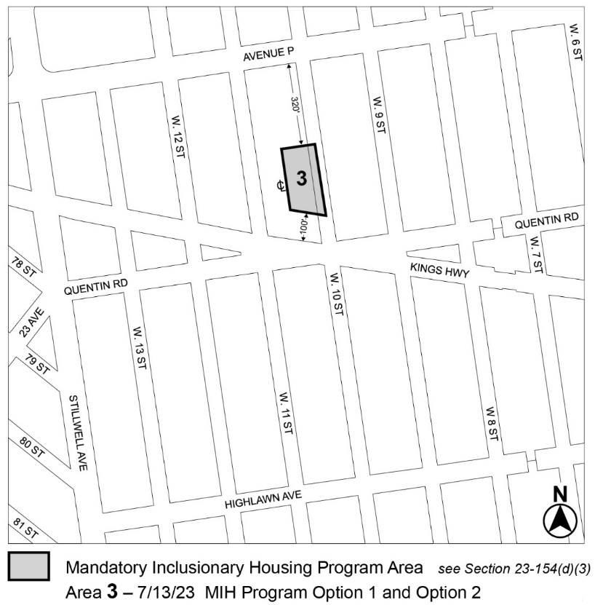

[MAP Approved by CPC]
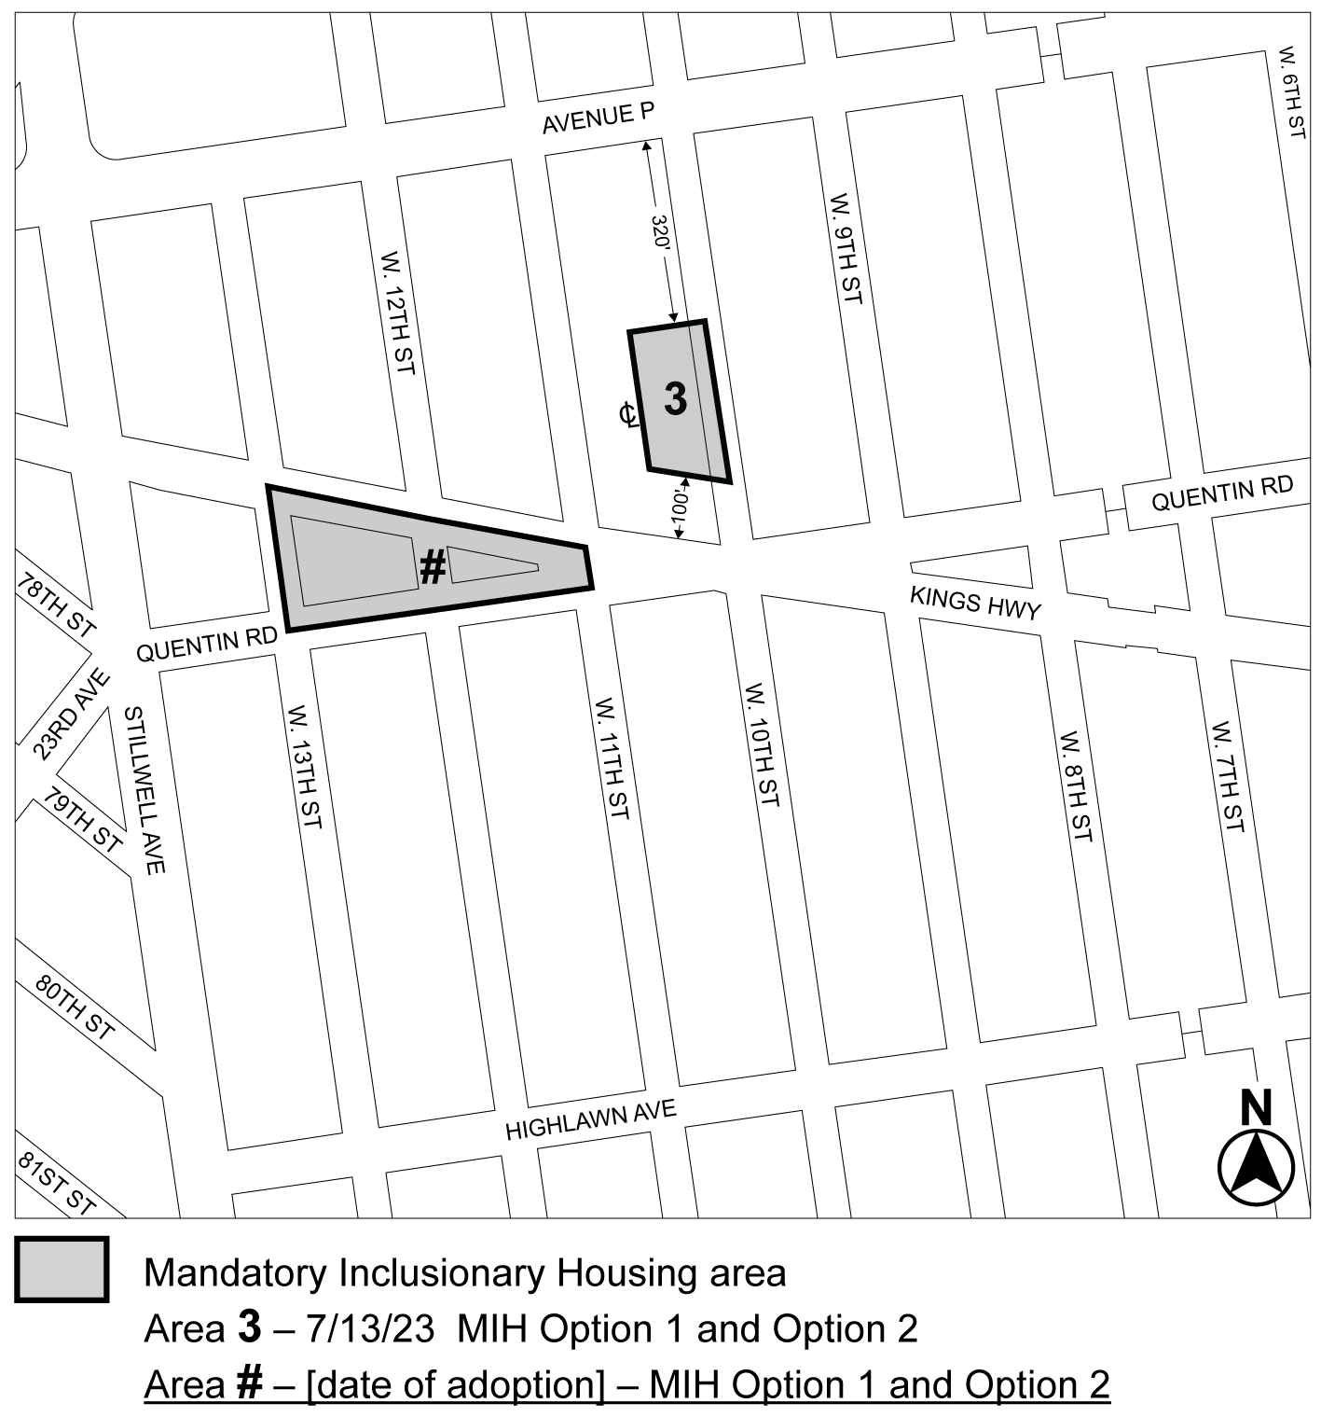
[PROPOSED MAP – Modified by City Council]
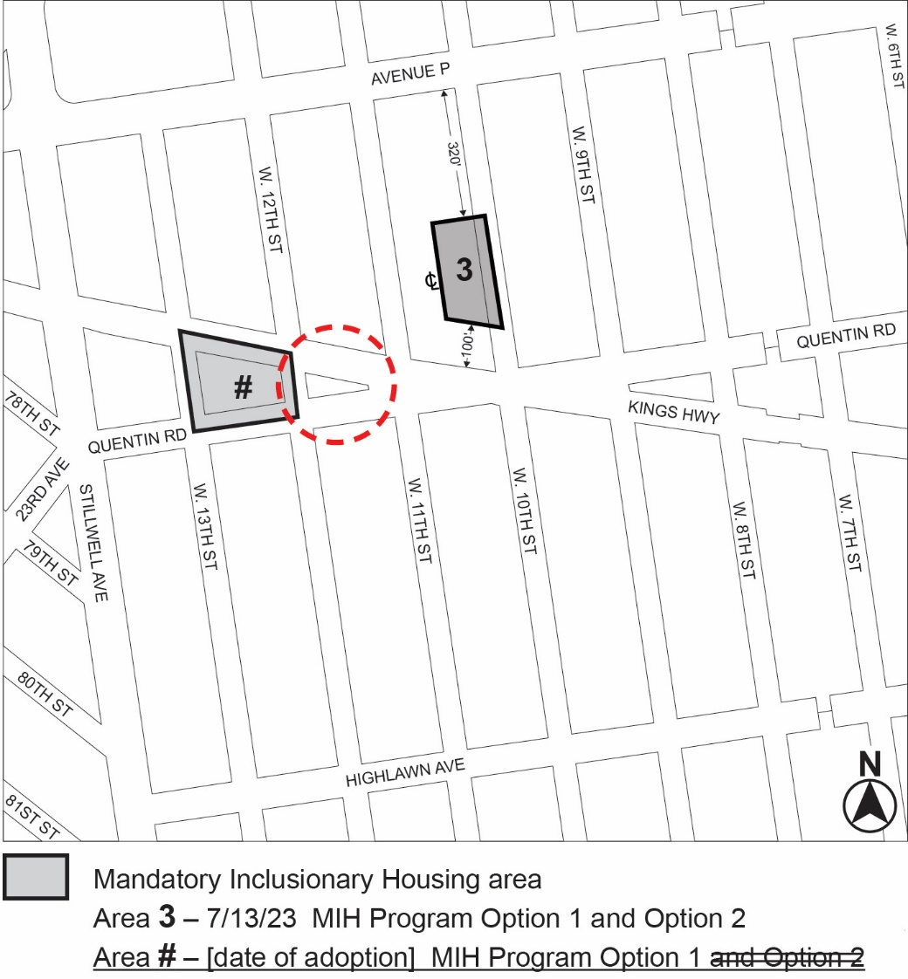

Portion of Community District 11, Brooklyn
* * *
Adopted.

Office of the City Clerk,}
The City of New York, } ss.:

I hereby certify that the foregoing is a true copy of a Resolution passed by The Council of The City of New York on ______, 2025, on file in this office.

.....................................................
City Clerk, Clerk of The Council

