THE COUNCIL OF THE CITY OF NEW YORK
RESOLUTION NO. 590

Resolution approving the decision of the City Planning Commission on Application No. N 230251 ZRQ, for an amendment of the text of the Zoning Resolution (L.U. No. 146).

By Council Members Salamanca, Riley and Mealy

WHEREAS, Astoria Park Warehouse LLC, filed an application pursuant to Section 201 of the New York City Charter, for an amendment of the text of the Zoning Resolution of the City of New York, modifying APPENDIX F for the purpose of establishing a Mandatory Inclusionary Housing area, which in conjunction with the related action would facilitate the development of a two-tower, mixed-use development with 92 dwelling units, approximately 28 of which would be permanently income-restricted, and ground-floor commercial space at 21-01 24th Avenue and 21-16 24th Avenue, in the Ditmars-Steinway neighborhood of Queens, Community District 1 (ULURP No. N 230251 ZRQ) (the “Application”);

WHEREAS, the City Planning Commission filed with the Council on September 6, 2024, its decision dated August 21, 2024 (the "Decision") on the Application;

WHEREAS, the Application is related to application C 230250 ZMQ (L.U. No. 145), a zoning map amendment to change R5B and R5D/C1-3 zoning districts to an R6A/C1-4 zoning district;

WHEREAS, the Decision is subject to review and action by the Council pursuant to Section 197-d of the City Charter;

WHEREAS, upon due notice, the Council held a public hearing on the Decision and Application on September 10, 2024;

WHEREAS, the Council has considered the land use implications and other policy issues relating to the Decision and Application; and

WHEREAS, the Council has considered the relevant environmental issues, including the Negative Declaration issued April 1, 2024 (CEQR No. 24DCP027Q), which includes an (E) designation related to hazardous materials, air quality and noise to avoid the potential for significant adverse impacts (E-762) (the “Negative Declaration”).

RESOLVED:

The Council finds that the action described herein will have no significant impact on the environment as set forth in the (E) Designation (E-762) and Negative Declaration.

Pursuant to Sections 197-d and 200 of the City Charter and on the basis of the Decision and Application, and based on the environmental determination and consideration described in the report, N 230251 ZRQ, incorporated by reference herein, and the record before the Council, the Council approves the Decision of the City Planning Commission, with the following modifications.

Matter underlined is new, to be added;
Matter struck out is to be deleted;
Matter within # # is defined in Section 12-10;
* * * indicates where unchanged text appears in the Zoning Resolution.

* * *

APPENDIX F
Inclusionary Housing Designated Areas and Mandatory Inclusionary Housing Areas

* * *

QUEENS

Queens Community District 1

* * *

Map 1 – [date of adoption]

[EXISTING MAP]
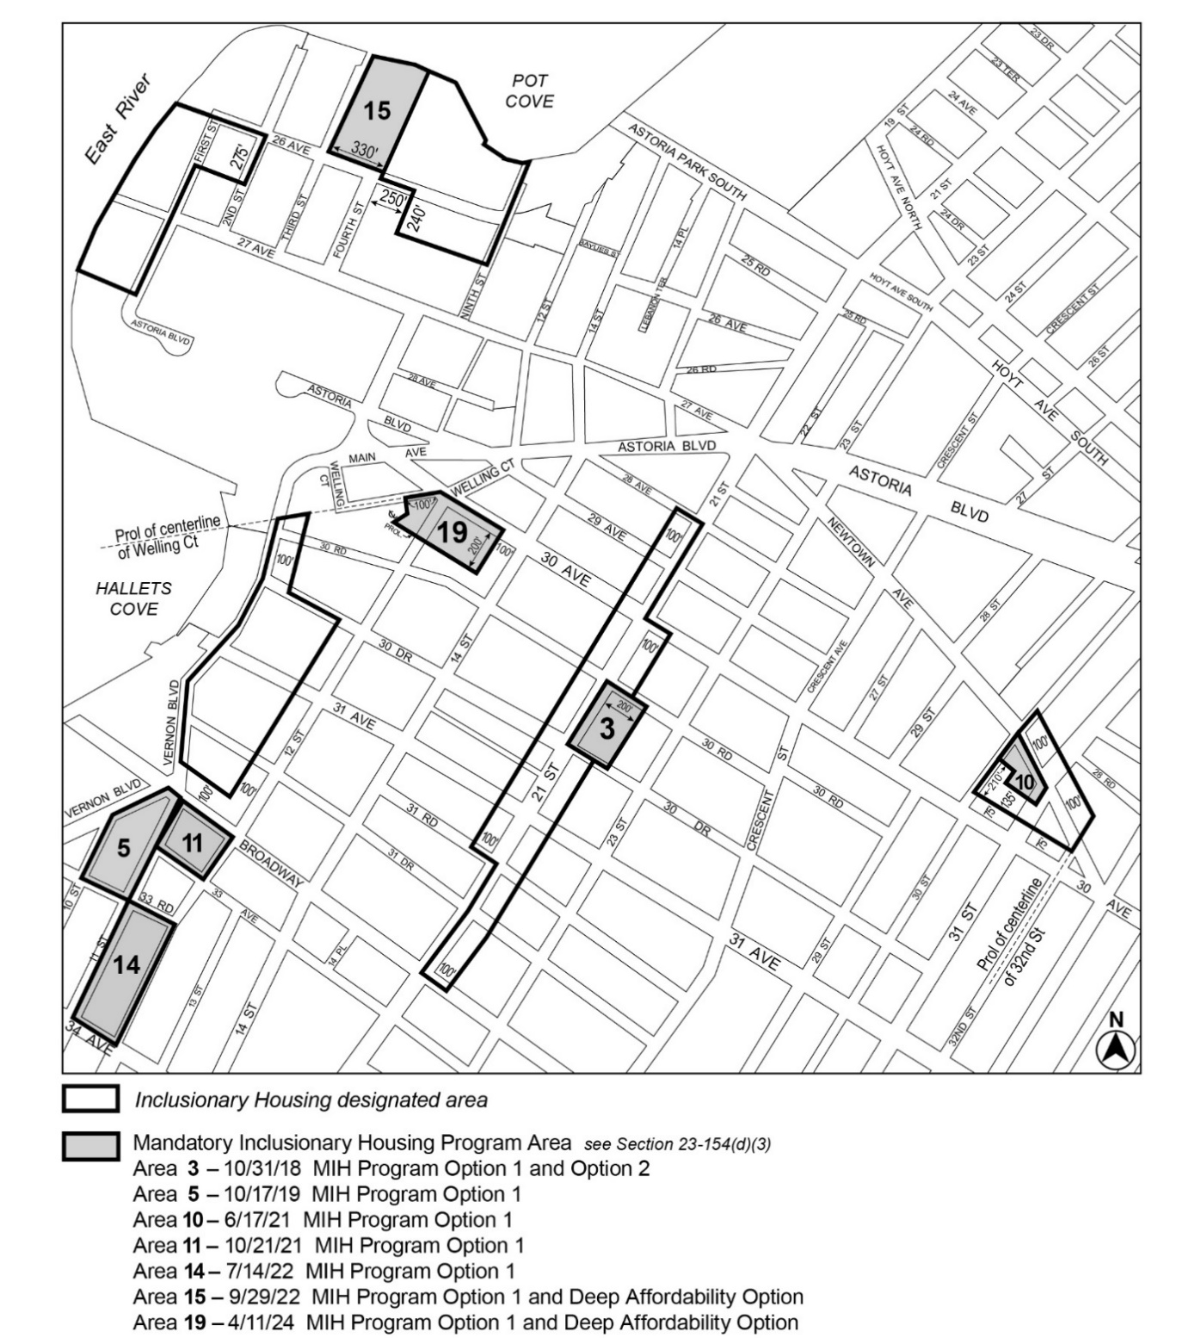

[PROPOSED MAP]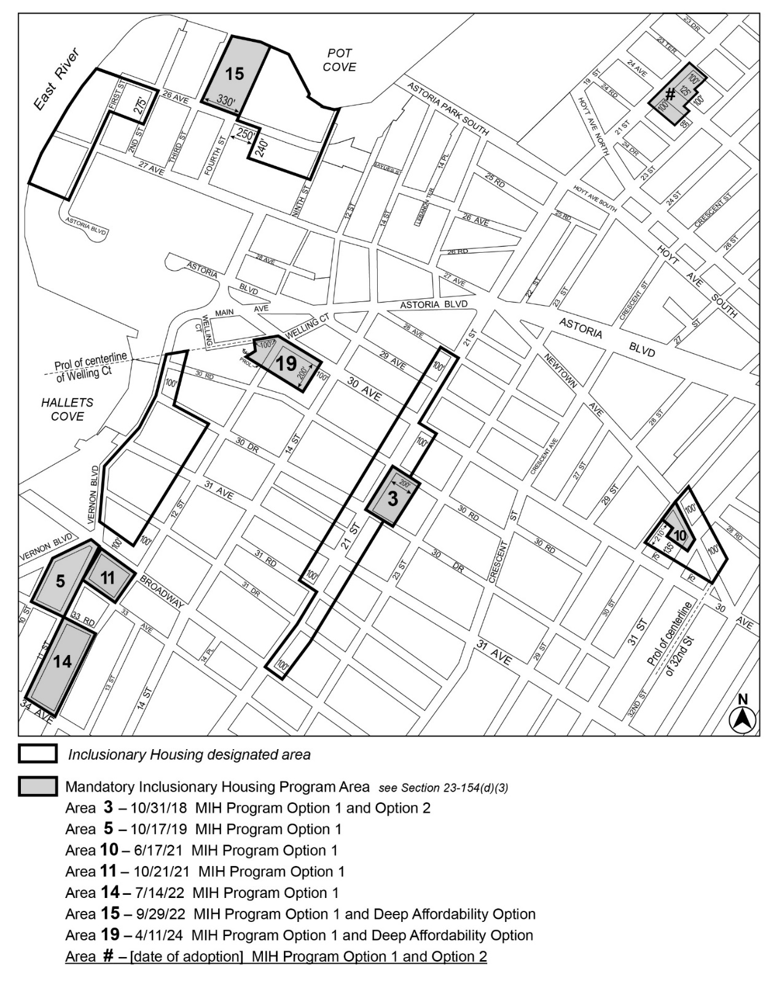

Portion of Community District 1, Queens

* * *

Adopted.

Office of the City Clerk,}
The City of New York, } ss.:

I hereby certify that the foregoing is a true copy of a Resolution passed by The Council of The City of New York on _________, 2024, on file in this office.

.....................................................
City Clerk, Clerk of The Council

