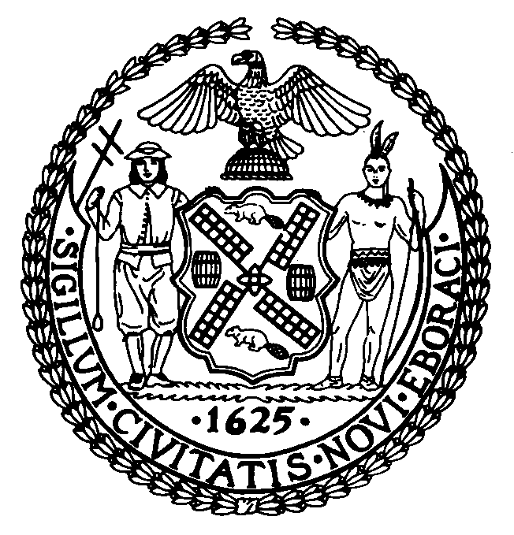

The Council of the City of New York

Finance Division
Preston Niblack, Director
Fiscal Impact Statement

Preconsidered Intro. No:

Committee: Parks and Recreation

Title: In relation to the naming of 41 thoroughfares and public places, Police Officer Deon Taylor Way, Borough of the Bronx, Sgt. Kimel L. Watt Way, Borough of Brooklyn, Run DMC Way, Borough of Queens, Nancy Cataldi Way, Borough of Queens, Frederick T. Haller, Jr. Way, Borough of Queens, Frank J. Verderame Way, Borough of Brooklyn, Sugar Ray Robinson Way, Borough of Manhattan, James Weldon Johnson Plaza, Borough of Manhattan, Robert M. Buonvino Place, Borough of Brooklyn, Dr. Thomas Tam Way, Borough of Manhattan, Professor Juan Bosch Way, Borough of Manhattan, Mr. Joe Marotta Way, Borough of Staten Island, John A. Nappi Flag Way, Borough of Staten Island, Sgt. Kenneth C. Amatrudo Way, Borough of Staten Island, James “Skippy” Prior Way, Borough of Staten Island, Jimmy O’ Hanlon Way, Borough of Staten Island, NYPD Sgt. Ned Thompson Way, Borough of Staten Island, Lisa Moudatsos Way, Borough of Staten Island, Pfc. Ronald Jones Way, Borough of Staten Island, Police Officer Gerard L. Carter Avenue, Borough of Staten Island, Monsignor John T. Servodidio Way, Borough of Staten Island, Arielle Newman Run, Borough of Staten Island, Firefighter Bobby Beddia Way, Borough of Manhattan, Robert “Mr. Lou” Williams Way, Borough of Brooklyn, Thomas L. Guess Place, Borough of the Bronx, Hector Lavoe Boulevard, Borough of the Bronx, Henry McKenzie Place, Borough of the Bronx, Donnette and Sean Sanz Place, Borough of the Bronx, Vincent Jackson Way, Borough of the Bronx, Rev. James B. Staggers Place, Borough of the Bronx, PFC Le Ron A. Wilson, Borough of Queens, Corporal Jonathan Rivadeneira Corner, Borough of Queens, Judge Ralph Sherman Way, Borough of Queens, Major Jeffery Ray Calero Way, Borough of Queens, Alexander Felix Place, Borough of Manhattan and renaming six thoroughfares in the Borough of Queens, 163rd Road, 163rd Drive, 164th Avenue, 164th Road, 164th Drive, 165th Avenue and to amend the official map of the city of New York accordingly and the repeal of section 10 of local law number 25 for the year 2009, sections 36 and 38 of local law number 64 for the year 2008 and local law number 54 for the year 2008.

Sponsor: By (The Speaker) Council Member Quinn and Council Members Arroyo, Barron, Comrie, Crowley, DeBlasio, Dickens, Gentile, Gerson, Jackson, Martinez, Mitchell, Recchia, Jr., Rivera, Sanders, Jr., Sears, Ulrich, and Weprin

Summary of Legislation: This legislation would co-name, through the posting of additional signs, forty-one thoroughfares in the Boroughs of The Bronx, Brooklyn, Manhattan, Staten Island, and Queens. In addition, the legislation would repeal Section 10 of local law number 25 for the year 2009, Sections 36 and 38 of local law number 64 for the year 2008, and Local law number 54 for the year 2008.

New Co-Name | Present Name | Limits
Brooklyn
Sgt. Kimel L. Watt Way | Hemlock Street | Between Blake Avenue and Dumont Avenue
Frank J. Verderame Way | Second Place | Between Court Street and Smith Street
New Co-Name | Present Name | Limits
Robert M. Buonvino Place | None | At the intersection of 83rd Street and 18th Avenue
Robert “Mr. Lou” Williams Way | West 33rd Street | Between Surf Avenue and Mermaid Avenue
Manhattan
Sugar Ray Robinson Way | None | At the intersection of 124th Street and Lennox Avenue
James Weldon Johnson Plaza | None | At the intersection of 135th Street and Adam Clayton Powell Jr. Boulevard
Dr. Thomas Tam Way | None | At the Southeast corner of Canal Street and Cortland Alley
Professor Juan Bosch Way | None | At the intersection of Amsterdam Avenue and 190th Street
Firefighter Bobby Beddia Way | None | At the intersection of Bedford Street and Barrow Street
Alexander Felix Place | None | At the intersection of West 161st Street and Riverside Drive
Queens
Run DMC Way | None | At the intersection of 205th Street and Hollis Avenue
Nancy Cataldi Way | None | At the intersection of 109th Street and 86th Avenue
Frederick T. Haller, Jr. Way | Union Turnpike | Between Woodhaven Boulevard and Myrtle Avenue
PFC Le Ron A. Wilson | 145th Avenue | Between Farmers Boulevard and Arthur Street
Corporal Jonathan Rivadeneira Corner | None | At the northeast corner of 75th Street and 37th Avenue
Judge Ralph Sherman Way | 77th Avenue | Between Springfield Boulevard and Cloverdale Boulevard
Major Jeffery Ray Calero Way | Hollis Court Boulevard | Between Jamaica Avenue and Hillside Avenue
163rd Road | Burlingham Court | Between 104th and Hawtree Basin
163rd Drive | James Court | Between 104th Street and Hawtree Basin
164th Avenue | McKee Avenue | Between 104th Street and Hawtree Basin
164th Road | Calhoun Road | Between 104th Street and Hawtree Basin
164th Drive | Moncriff Drive | Between 104th Street and Hawtree Basin
165th Avenue | Lockwood Court | Between 104th Street and Hawtree Basin
Staten Island
New Co-Name | Present Name | Limits
Mr. Joe Marotta Way | None | A the intersection of Victory Boulevard and St. Marks
John A. Nappi Flag Way | None | At the northeast corner of Forest Avenue and Burnside Avenue
Sgt. Kenneth C. Amatrudo Way | None | At the intersection of Josephine Street and Manor Road
James “Skippy” Prior Way | None | At the intersection of Whitewood Avenue and Hart Avenue
Jimmy O’ Hanlon Way | None | At the intersection of Harvest Avenue and North Burgher Avenue
NYPD Sgt. Ned Thompson Way | St. Austins Place | Between Bard Avenue and Davis Avenue
Lisa Moudatsos Way | None | At the intersection of St. Peter’s Place and Richmond Terrace
Pfc. Ronald Jones Way | None | At the intersection of Grandview Avenue and Richmond Terrace
Police Officer Gerard L. Carter Avenue | None | At the intersection of Pelton Avenue and Henderson Avenue
Monsignor John T. Servodidio Way | None | At the intersection of Tompkins Avenue and St. Mary’s Avenue
Arielle Newman Run | None | At the intersection of Royal Oak Road and Rice Avenue
Bronx
Police Officer Deon Taylor Way | Simpson Street | Between East 163rd Street and Westchester Avenue
Thomas L. Guess Place | Clinton Avenue | Between Oakland Place and East 180th Street
Hector Lavoe Boulevard | East Tremont Avenue | Between Webster Avenue and Boston Road
Henry McKenzie Place | Prospect Avenue | Between East 183rd Street and East 185th Street
Donnette and Sean Sanz Place | None | At the intersection of East 188th Street and Webster Avenue
Vincent Jackson Way | Clinton Avenue | Between East 181st Street and East 182nd Street
Rev. James B. Staggers Place | East 181st Street | Between Vyse Avenue and Bryant Avenue

Effective Date: This local law would take effect immediately upon its enactment into law.

Fiscal Year IN WHICH Full Fiscal Impact Anticipated: Fiscal 2010

Fiscal Impact Statement:
 | Effective FY10 | FY Succeeding  Effective FY11 | Full Fiscal  Impact FY10
Revenues (+) | $0 | $0 | $0
Expenditures (-) | ($13,284) | $0 | ($13,284)
Net | $0 | $0 | $0

Impact on Revenues: There would be no impact on revenues resulting from the enactment of this legislation.

Impact on Expenditures: This legislation would require approximately 41 signs at $74 each and an additional $10,250 for the installation of these signs. The total cost of enacting this legislation would be approximately $13,284.

Source of Funds To Cover Estimated Costs: General Fund

Source of Information: City Council Finance Division

Estimate Prepared By: Jonathan Rosenberg, Deputy Director
Walter Pitts, Legislative Financial Analyst

History: This legislation will be considered by the Committee on Parks and Recreation on June 24, 2009 and introduced and considered by the full Council on June 30, 2009.

