THE COUNCIL OF THE CITY OF NEW YORK
RESOLUTION NO. 619

Resolution approving with modifications the decision of the City Planning Commission on Application No. N 230023 ZRQ, for an amendment of the text of the Zoning Resolution (L.U. No. 139).

By Council Members Salamanca and Riley

WHEREAS, 31 17 19 IZ, LLC, filed an application pursuant to Section 201 of the New York City Charter, for an amendment of the text of the Zoning Resolution of the City of New York, modifying APPENDIX F for the purpose of establishing a Mandatory Inclusionary Housing area, which in conjunction with the related action would facilitate the development of a new eight-story mixed-use building with 35 dwelling units, of which nine would be permanently income-restricted, located at 31-17 12th Street in the Astoria neighborhood of Queens, Community District 1 (ULURP No. N 230023 ZRQ), (the “Application”);

WHEREAS, the City Planning Commission filed with the Council on August 9, 2024, its decision dated July 24, 2024 (the "Decision") on the Application;

WHEREAS the Application is related to application C 230022 ZMQ (L.U. No. 138), a zoning map amendment to change an R5B zoning district to an R6B zoning district;

WHEREAS, the Decision is subject to review and action by the Council pursuant to Section 197-d of the City Charter;

WHEREAS, upon due notice, the Council held a public hearing on the Decision and Application on August 27, 2024;

WHEREAS, the Council has considered the land use implications and other policy issues relating to the Decision and Application; and

WHEREAS, the Council has considered the relevant environmental issues, including the Negative Declaration issued March 4th, 2024 (CEQR No. 22DCP098Q), which includes an (E) designation to avoid the potential for significant adverse impacts related to hazardous materials and air quality (E-757) (the “Negative Declaration”).

RESOLVED:

The Council finds that the action described herein will have no significant impact on the environment as set forth in the (E) Designation (E-757) and Negative Declaration.

Pursuant to Sections 197-d and 200 of the City Charter and on the basis of the Decision and Application, and based on the environmental determination and consideration described in the report, N 230023 ZRQ, incorporated by reference herein, and the record before the Council, the Council approves the Decision of the City Planning Commission, with the following modifications.

Matter underlined is new, to be added;
Matter struck out is to be deleted;
Matter double-underlined is new, added by the City Council;
Matter double struck out is old, deleted by the City Council;
Matter within # # is defined in Section 12-10;
* * * indicates where unchanged text appears in the Zoning Resolution.

* * *

APPENDIX F
Inclusionary Housing Designated Areas and Mandatory Inclusionary Housing Areas

* * *

QUEENS

* * *

Queens Community District 1

* * *

Map 1 – [date of adoption]

[EXISTING MAP]
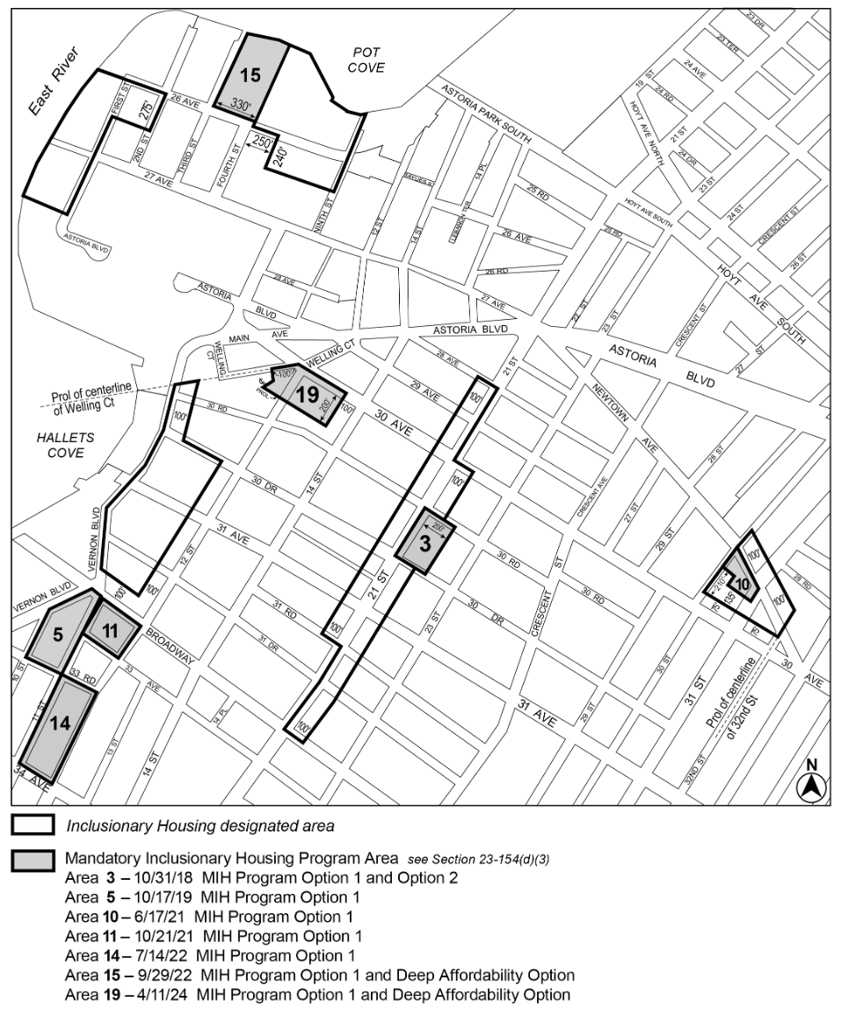

[PROPOSED MAP]
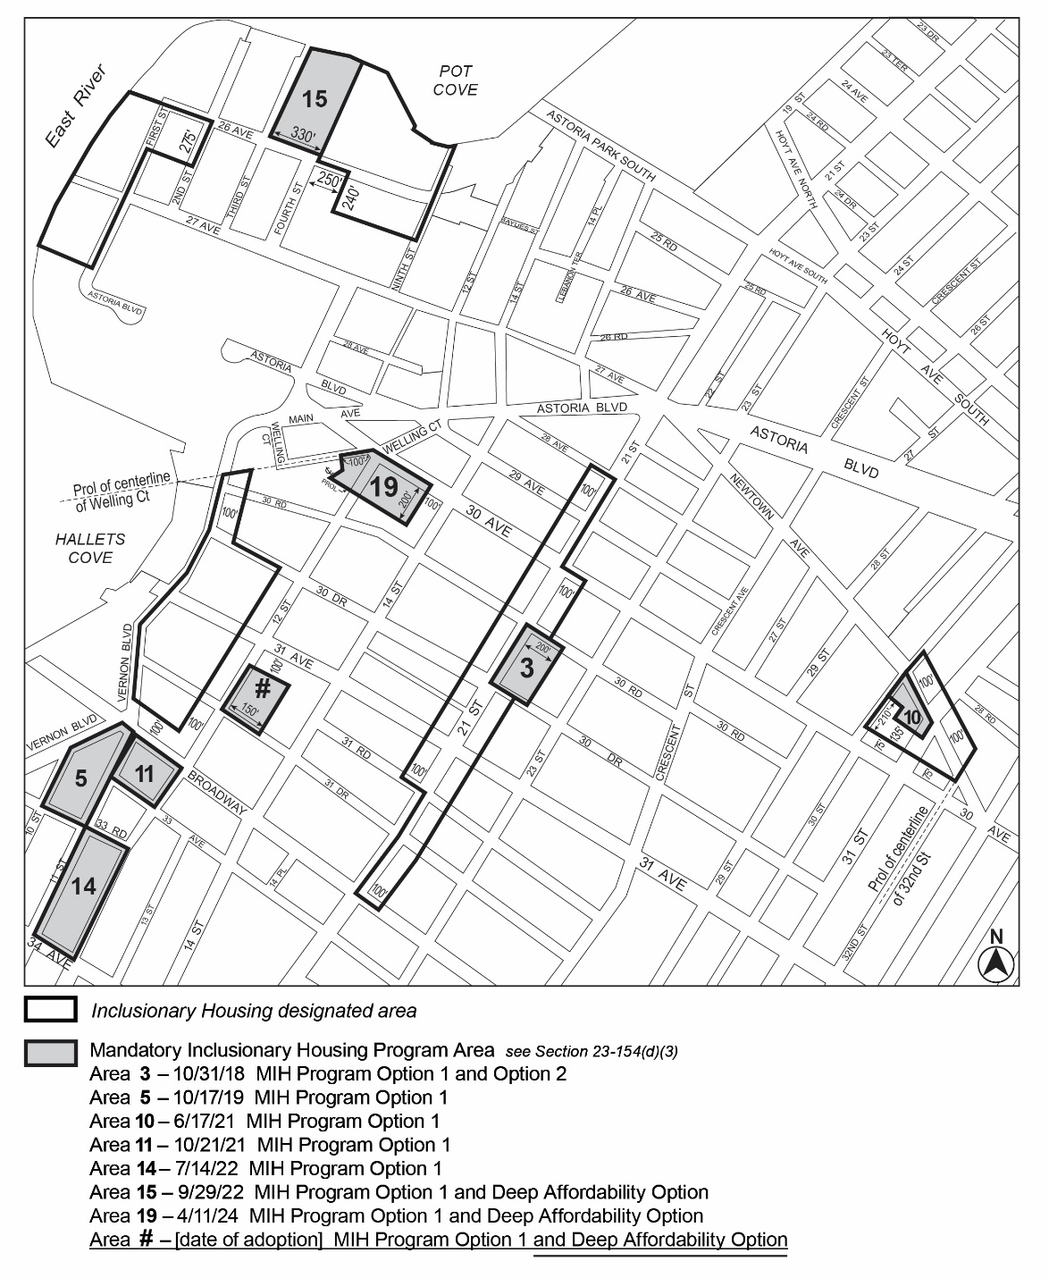
Portion of Community District 1, Queens

* * *

Adopted.

Office of the City Clerk,}
The City of New York, } ss.:

I hereby certify that the foregoing is a true copy of a Resolution passed by The Council of The City of New York on _________, 2024, on file in this office.

.....................................................
City Clerk, Clerk of The Council

