THE COUNCIL OF THE CITY OF NEW YORK
RESOLUTION NO. 571

Resolution approving the decision of the City Planning Commission on Application No. N 180188 ZRK (L.U. No. 216), for an amendment of the Zoning Resolution of the City of New York, modifying Article X, Chapter 1, Section 101-11 (Special Ground Floor Use Regulations within the Special Downtown Brooklyn District) and related sections, Community District 2, Borough of Brooklyn.

By Council Members Salamanca and Moya

WHEREAS, the City Planning Commission filed with the Council on September 7, 2018 its decision dated September 5, 2018 (the "Decision"), pursuant to Section 201 of the New York City Charter, regarding an application submitted by Red Apple Real Estate, for an amendment of the text of the Zoning Resolution of the City of New York, modifying Article X, Chapter 1, Section 101-11 (Special Ground Floor Use Regulations within the Special Downtown Brooklyn District) in order to allow all non-residential uses permitted by the underlying zoning district within the required Special Ground Floor uses for buildings fronting on Myrtle Avenue between Ashland Place and Fleet Place within Community District 2, Brooklyn, (Application No. N 180188 ZRK), Community District 2, Borough of Brooklyn (the "Application");

WHEREAS, the Decision is subject to review and action by the Council pursuant to Section 197-d(b)(1) of the City Charter;

WHEREAS, upon due notice, the Council held a public hearing on the Decision and Application on September 17, 2018;

WHEREAS, the Council has considered the land use implications and other policy issues relating to the Decision and Application; and

WHEREAS, the Council has considered the relevant environmental issues, including an (E) designation related to noise will be assigned to 81 Fleet Place (Block 2061, Lot 110) and 218 Myrtle Avenue (Block 2061, Lot 101) in order to preclude significant adverse impacts (E-482) (CEQR No. 18DCP155K), which supersedes a previously-assigned (E) designation assigned to the affected sites in connection with the Special Downtown Brooklyn District Rezoning (E-124) (CEQR No. 03DME016K), (the “E Designation (E-482)”).

RESOLVED:

The Council finds that the action described herein will have no significant impact on the environment as set forth in the (E) Designation E-482.

Pursuant to Section 200 of the City Charter and on the basis of the Decision and Application, and based on the environmental determination and consideration described in the report, N 180188 ZRK, incorporated by reference herein, the Council approves the Decision of the City Planning Commission.

* * *

Matter underlined is new, to be added;
Matter struck out to be deleted;
Matter with # # is defined in Section 12-10;
* * * indicates where unchanged text appears in the Zoning Resolution

Article X: Special Purpose Districts
Chapter 1 – Special Downtown Brooklyn District

* * *

101-10
SPECIAL USE REGULATIONS

101-11
Special Ground Floor Use Regulations

Map 2 (Ground Floor Retail Frontage), in Appendix E of this Chapter, specifies locations where the special ground floor #use# regulations of this Section apply.

#Uses# within #stories# that have a floor level within five feet of #curb level#, and within 50 feet of the #street line#, shall be limited to #commercial uses# listed in Use Groups 5, 6A, 6C, 6D, 7A, 7B, 8A, 8B, 8D, 9, 10, 11, 12A, 12B and 12C, where such #uses# are permitted by the underlying district. In addition, libraries, museums and non-commercial art galleries shall be permitted. In addition, all non-residential #uses# permitted by the underlying district shall be permitted for buildings fronting on Myrtle Avenue between Ashland Place and Fleet Place. A #building’s street# frontage shall be allocated exclusively to such #uses#, except for Type 2 lobby space, entryways or entrances to subway stations provided in accordance with the provisions of Section 37-33 (Maximum Width of Certain Uses). However, loading berths serving any permitted #use# in the #building# may occupy up to 40 feet of such #street# frontage provided such #street# frontage is not subject to curb cut restrictions as shown on Map 5 (Curb Cut Restrictions) in Appendix E of this Chapter.

The regulations of this Section are modified as follows:

(a) Fulton Mall Subdistrict

For #buildings# in the Fulton Mall Subdistrict, Use Group 6A shall not include post offices, dry cleaning, laundry, or shoe and hat repair establishments. Use Group 6C shall not include automobile supply establishments, electrolysis studios, frozen food lockers, loan offices or locksmiths. Use Group 8A shall not include billiard parlors, pool halls, bowling alleys or model car hobby centers. Use Group 9 shall be prohibited except for typewriter stores. Use Group 10 shall not include depositories for office records, microfilm or computer tapes. Use Groups 6D, 7A, 7B, 8B, 8D, 11, 12A and 12C shall be prohibited. Furthermore, no bank or off track betting establishment shall occupy more than 30 feet of frontage at the ground floor of any #building# along the #street line# of Fulton Street. Any establishment that fronts on the #street line# of Fulton Street for a distance greater than 15 feet shall provide an entrance on Fulton Street.

(b) Atlantic Avenue Subdistrict

Automotive service stations are not permitted. No bank, loan office, business or professional office or individual #use# in Use Group 9 shall occupy more than 50 feet of linear frontage on Atlantic Avenue. Moving and storage uses in Use Group 7 are permitted on the ground floor of a #building# only if such #use# is located at least 50 feet from the front wall of the #building# in which the #use# is located. Any #buildings developed# after June 28, 2004, or portions of #buildings enlarged# on the ground floor level after June 28, 2004, on a #zoning lot# of 3,500 square feet or more shall have a minimum of 50 percent of the ground #floor area# of the #building# devoted to permitted #commercial uses# in Use Groups 6, 7 or 9, except that this requirement shall not apply to any #development# occupied entirely by #community facility use#.

In any #building# within the Atlantic Avenue Subdistrict, the provisions of Section 32-421 (Limitation on floors occupied by non-residential uses) restricting the location of non-#residential uses# listed in Use Groups 6, 7, 8, 9 or 14 to below the level of the first #story# ceiling in any #building# occupied on one of its upper stories by #residential# or #community facility uses#, shall not apply. In lieu thereof, such non-#residential uses# shall not be located above the level of the second #story# ceiling.

* * *
Map 2 Ground Floor Retail Frontage
[MAP TO BE REPLACED]
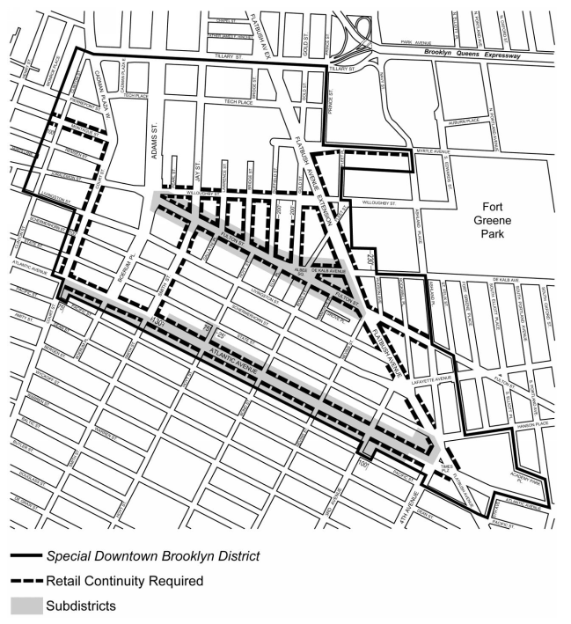

[PROPOSED MAP]

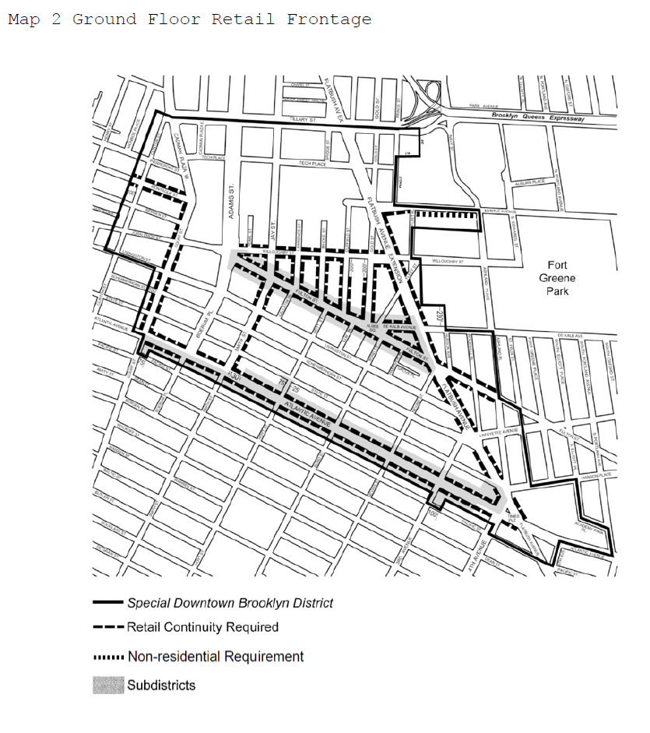
Adopted.

Office of the City Clerk, }
The City of New York, } ss.:

I hereby certify that the foregoing is a true copy of a Resolution passed by The Council of The City of New York on October 17, 2018, on file in this office.

.....……......................................... City Clerk, Clerk of The Council

