THE COUNCIL OF THE CITY OF NEW YORK
RESOLUTION NO. 331

Resolution approving the decision of the City Planning Commission on Application No. N 140182 ZRM, for an amendment of the Zoning Resolution of the City of New York, relating to Article IX, Chapter 6 (Special Clinton District) and Appendix F concerning regulations in Western Subarea C2 and Inclusionary Housing designated areas within Community District 4, Borough of Manhattan (L.U. No. 63).

By Council Members Greenfield and Weprin

WHEREAS, the City Planning Commission filed with the Council on May 12, 2014 its decision dated May 7, 2014 (the "Decision"), pursuant to Section 201 of the New York City Charter, regarding an application submitted by the New York City Department of Housing Preservation and Development, for an amendment of the text of the Zoning Resolution of the City of New York, relating to Article IX, Chapter 6 (Special Clinton District) and Appendix F concerning regulations in Western Subarea C2 and Inclusionary Housing designated areas. This text amendment action, along with the other related actions, would facilitate the development of two new buildings and rehabilitation of one building to provide approximately 530 residential units (of which 206 would be affordable to low-, moderate- and middle-income residents), 58,709 square feet of commercial floor area and approximately 7,500 SF of community gardens on portions of two blocks bounded by West 51st Street and West 53rd Street between Tenth and Eleventh avenues in Manhattan Community District 4 (Application No. N 140182 ZRM), Borough of Manhattan (the "Application");

WHEREAS, the Application is related to applications C 140181 ZMM (L.U. No. 62), an amendment of the Zoning Map, Section No. 8c to change M1-5 (CL) and R8 (CL) districts to R9/C2-5 (CL), and R8 (CL) to R8A (CL) districts; C 140183 ZSM (L.U. No. 64), a special permit pursuant to Section 74-74, Large-Scale General Development, to permit the transfer of floor area and height and setback waivers in a new Large-Scale General Development; and C 140185 HAM (L.U. No. 65), an urban development area action project designation and disposition of property on portions of blocks bounded by West 51st and West 53rd streets; 10th and 11th avenues;

WHEREAS, the Decision is subject to review and action by the Council pursuant to Section 197-d(b)(1) of the New York City Charter;
WHEREAS, upon due notice, the Council held a public hearing on the Decision and Application on June 17, 2014;

WHEREAS, the Council has considered the land use implications and other policy issues relating to the Decision and Application; and

WHEREAS, the Council has considered the relevant environmental issues including the revised negative declaration (CEQR No. 13HPD106M) dated April 29, 2014 (the “Revised Negative Declaration”);

RESOLVED:

The Council finds that the action described herein will have no significant impact on the environment as set forth in the Revised Negative Declaration.

Pursuant to Sections 197-d and 200 of the City Charter and on the basis of the Decision and Application, and based on the environmental determination and consideration described in this report, N 140182 ZRM, incorporated by reference herein, the Council approves the Decision.

The Zoning Resolution of the City of New York, effective as of December 15, 1961, and as subsequently amended, is further amended as follows:

Matter in underline is new, to be added;
Matter in strikeout is old, to be deleted;
Matter within # # is defined in Section 12-10;
* * * indicates where unchanged text appears in the Zoning Resolution

Article IX – Special Purpose Districts
* * *
Chapter 6
Special Clinton District
* * *
96-30
OTHER AREAS
* * *

96-31
Special Regulations in R8 Districts
* * *
(b) In R8A districts in Western Subarea C2, including #Commercial Districts# mapped within such R8A districts, the following special regulations shall apply:
(1) Inclusionary Housing Program
(i) R8A Districts in Other Areas, west of Tenth Avenue, shall be #Inclusionary Housing designated areas#, pursuant to Section 12-10 (DEFINITIONS), for the purpose of making the Inclusionary Housing Program regulations of Section 23-90, inclusive, applicable as modified within the Special District.
(2) Maximum #floor area ratio#
Within such #Inclusionary Housing designated areas#, the maximum #floor area ratio# for any #zoning lot# containing a #residential use# shall not exceed a base #floor area ratio# of 5.4, except that such base #floor area ratio# may be increased to a maximum #floor area ratio# of 7.2 through the provision of #affordable housing#, pursuant to the provisions relating to #Inclusionary Housing designated areas# in Section 23-90. However, any units for which a #floor area# increase has been earned, pursuant to Section 23-90 shall be located within the #Special Clinton District#.
(ii) Optional provisions for #affordable housing#
For #developments# or #enlargements# located within the #blocks# bounded by West 51st Street, 11th Avenue, West 53rd Street and 10th Avenue, the special optional regulations as set forth in paragraph (b)(1)(ii) of this Section, may modify the provisions of Section 23-952 (Floor area compensation in Inclusionary Housing designated areas).
The #residential floor area# of a #development# or #enlargement# may be increased by 0.833 square feet for each one square foot of #moderate income floor area#, or by 0.625 square feet for each one square foot of #middle income floor area#, provided that for each square foot of such #floor area compensation#, there is one square foot of #floor area compensation#, pursuant to Section 23-952. However, the amount of #affordable housing# required to receive such #floor area compensation# need not exceed the amounts specified as follows. If #affordable housing# is provided for both #low income# and #moderate income households#, the amount of #moderate income floor area# need not exceed 15 percent of the total #floor area#, exclusive of ground floor non-#residential floor area#, on the #zoning lot#, provided that the amount of #low income floor area# is at least 10 percent of the total #floor area#, exclusive of ground floor non-#residential floor area#, on the #zoning lot#. If #affordable housing# is provided for both #low income# and #middle income households#, the amount of #middle income floor area# need not exceed 20 percent of the total #floor area#, exclusive of ground floor non-#residential floor area#, on the #zoning lot#, provided that the amount of #low income floor area# is at least 10 percent of the total #floor area#, exclusive of ground floor non-#residential floor area#, on the #zoning lot#.
For the purposes of this paragraph, (b)(1)(ii), #low income floor area# may be considered #moderate income floor area# or #middle income floor area#, and #moderate income floor area# may be considered #middle income floor area#.
(3)(2) Special #use# and #bulk# regulations for existing electrical utility substations
Electrical utility substations, operated for public utility purposes, existing on June 14, 2011, and located wholly or partially within the portion of Western Subarea C2 east of 11th Avenue, shall be considered conforming #uses# that are subject to the #bulk# regulations of the underlying district and the #use# regulations of an M1-5 District. Any change of #use# on a #zoning lot# occupied by any such electrical utility substation shall be permitted only pursuant to the regulations of the underlying district. In the event any such electrical utility substation is damaged or destroyed, in whole or in part, by any means, including demolition, the provisions of Section 54-40 (DAMAGE OR DESTRUCTION IN NON-COMPLYING BUILDINGS) shall not apply and such electrical utility substation may be reconstructed, provided that such reconstruction shall not create a new #non-compliance# nor increase the degree of #non-compliance# with the applicable #bulk# regulations. However, in the event there is a complete cessation of #use# of the #zoning lot# as an electrical utility substation for a continuous period of five years, such electrical utility substation shall no longer be considered a conforming #use# on such #zoning lot#.

96-32
Special Regulations in R9 Districts

In R9 Districts in Western Subarea C2, the provisions of Section 23-633 (Street wall location and height and setback regulations in certain districts) for R9A Districts shall apply to all #buildings or other structures#. In #Commercial Districts# mapped within R9 Districts in Western Subarea C2, the provisions of Section 35-24 (Special Street Wall Location and Height and Setback Regulations in Certain Districts) for C2-7A Districts shall apply to all #buildings or other structures#. Notwithstanding the provisions of paragraph (c) of Section 23-011 (Quality Housing Program), in all such R9 Districts and #Commercial Districts# mapped within such R9 Districts, the provisions of paragraph (b) of Section 23-011 shall apply.
(a) Inclusionary Housing Program
(1) R9 Districts in Other Areas, west of Tenth Avenue, shall be #Inclusionary Housing designated areas# pursuant to Section 12-10 (DEFINITIONS) for the purpose of making the Inclusionary Housing Program regulations of Section 23- 90, inclusive, applicable as modified within the Special District.
(b) Maximum #floor area ratio#
Within such #Inclusionary Housing designated area#, the maximum #floor area ratio# for any #zoning lot# containing a #residential use# shall not exceed a base #floor area ratio# of 6.0, except that such base #floor area ratio# may be increased to a maximum #floor area ratio# of 8.0 through the provision of #affordable housing#, pursuant to the provisions relating to #Inclusionary Housing designated areas# in Section 23-90. However, any units for which a #floor area# increase has been earned pursuant to Section 23-90 shall be located within the #Special Clinton District#.
(2) Optional provisions for #large-scale general developments# within Western Subarea C2
For #developments# or #enlargements# located within the #blocks# bounded by West 51st Street, 11th Avenue, West 53rd Street and 10th Avenue, the special optional regulations as set forth in paragraph (a)(2) of this Section, may modify the provisions of Section 23-952 (Floor area compensation in Inclusionary Housing designated areas).
The #residential floor area# of a #development# or #enlargement# may be increased by 0.833 square feet for each one square foot of #moderate income floor area#, or by 0.625 square feet for each one square foot of #middle income floor area#, provided that for each square foot of such #floor area compensation#, there is one square foot of #floor area compensation#, pursuant to Section 23-952. However, the amount of #affordable housing# required to receive such #floor area compensation# need not exceed the amounts specified as follows. If #affordable housing# is provided for both #low income# and #moderate income households#, the amount of #moderate income floor area# need not exceed 15 percent of the total #floor area#, exclusive of ground floor non-#residential floor area#, on the #zoning lot#, provided that the amount of #low income floor area# is at least 10 percent of the total #floor area#, exclusive of ground floor non-#residential floor area#, on the #zoning lot#. If #affordable housing# is provided for both #low income households# and #middle income households#, the amount of #middle income floor area# need not exceed 20 percent of the total #floor area#, exclusive of ground floor non-#residential floor area#, on the #zoning lot#, provided that the amount of #low income floor area# is at least 10 percent of the total #floor area#, exclusive of ground floor non-#residential floor area#, on the #zoning lot#.
For the purposes of this paragraph, (a)(2), #low income floor area# may be considered #moderate income floor area# or #middle income floor area#, and #moderate income floor area# may be considered #middle income floor area#.

(b) #Uses# in Western Subarea C2 located within a #large scale general development#
(1) Within a C2-5 District mapped within an R9 District within Western Subarea C2, the following #uses#, when located wholly within a #large-scale general development#, shall be considered permitted #uses#:
From Use Group 8:
Lumber stores, with no limitation on #floor area#
From Use Group 10:
Photographic or motion picture production studios
From Use Group 12:
Art galleries, commercial
From Use Group 13:
Theaters
From Use Group 16:
Automotive service establishments
From Use Group 17:
Scenery construction.

(2) #Uses# permitted pursuant to paragraph (b)(1) shall be subject to the #commercial bulk# regulations of Article III, that are applicable to a C2-5 District mapped within an R9 District.
(3) The supplemental #use# provisions of Section 32-421 shall not apply to #commercial uses# located in a #building# with frontage on West 52nd Street.

* * *

EXISTING
(TO BE DELETED)
APPENDIX A – SPECIAL CLINTON DISTRICT MAP

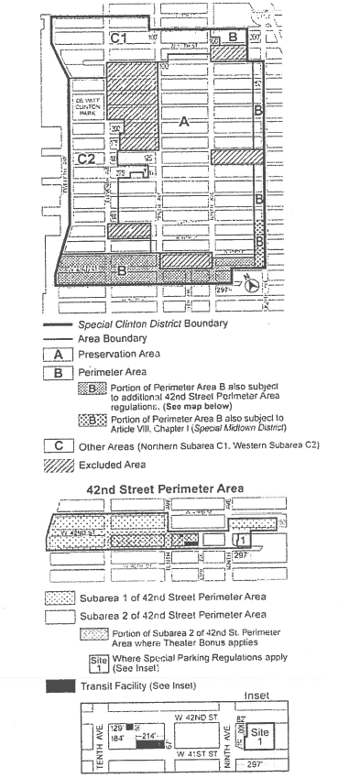

* * *
PROPOSED
(TO REPLACE EXISTING)
APPENDIX A – SPECIAL CLINTON DISTRICT MAP

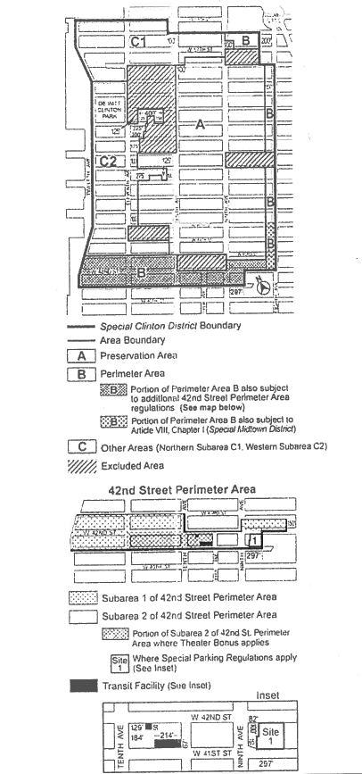

* * *

APPENDIX F
Inclusionary Housing Designated Areas
The boundaries of #Inclusionary Housing designated areas# are shown on the maps listed in this Appendix F. The #Residence Districts# listed for such areas shall include #Commercial Districts# where #residential buildings# or the #residential# portion of #mixed buildings# are governed by the #bulk# regulations of such #Residence Districts#. Where #Inclusionary Housing designated areas# are mapped in #Commercial Districts#, the residential district equivalent has instead been specified for each map.
* * *
Manhattan Community District 4
Map 2. (6/14/11)
Special Clinton District – see Sections 96-31, 96-32, 96-81 and 96-82
EXISTING
(TO BE DELETED)
APPENDIX F – MAP 2

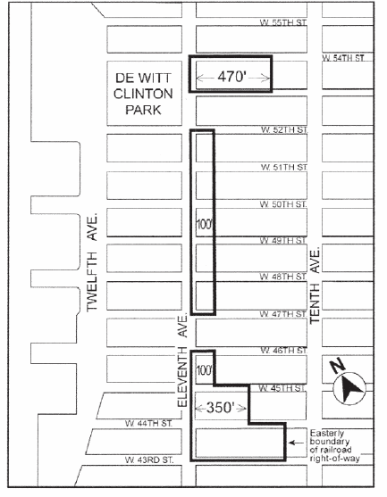
Portion of Community District 4, Manhattan
PROPOSED
(TO REPLACE EXISTING)
APPENDIX F – MAP 2

Portion of Community District 4, Manhattan

* * *

Adopted.
Office of the City Clerk, }
The City of New York, } ss.:

I hereby certify that the foregoing is a true copy of a Resolution passed by The Council of The City of New York on June 26, 2014, on file in this office.

.....…….........................................
City Clerk, Clerk of The Council

