THE COUNCIL OF THE CITY OF NEW YORK
RESOLUTION NO. 548

Resolution approving the decision of the City Planning Commission on Application No. N 180030 ZRK (Preconsidered L.U. No. 202), for an amendment of the Zoning Resolution of the City of New York, modifying Appendix F for the purpose of establishing a Mandatory Inclusionary Housing area, Community District 15, Borough of Brooklyn.

By Council Members Salamanca and Moya

WHEREAS, the City Planning Commission filed with the Council on August 17, 2018 its decision dated August 8, 2018 (the "Decision"), pursuant to Section 201 of the New York City Charter, regarding an application submitted by Quentin Plaza, LLC, for an amendment of the text of the Zoning Resolution of the City of New York, modifying Appendix F for the purpose of establishing a Mandatory Inclusionary Housing area, which in conjunction with the related action would facilitate a new, approximately 50,000-square-foot mixed-use development with ground floor retail use at 1881-1883 McDonald Avenue in the Homecrest neighborhood of Brooklyn, Community District 15, (Application No. N 180030 ZRK), Community District 15, Borough of Brooklyn (the "Application");

WHEREAS, the Application is related to application C 180029 ZMK (Pre. L.U. No. 201), a zoning map amendment to change an R5 zoning district to an R7A/C2-4 district;

WHEREAS, the Decision is subject to review and action by the Council pursuant to Section 197-d(b)(1) of the City Charter;
WHEREAS, upon due notice, the Council held a public hearing on the Decision and Application on September 5, 2018;

WHEREAS, the Council has considered the land use implications and other policy issues relating to the Decision and Application; and

WHEREAS, the Council has considered the relevant environmental issues, including the negative declaration issued April 9, 2018 (CEQR No. 18DCP105K), which includes an (E) designation to avoid the potential for significant adverse impacts related to hazardous materials, air quality and noise within the rezoning area (Block 6633, Lots 45 and 48; and Block 6658, Lots 1 and 86) (E-474) (the “Negative Declaration”).

RESOLVED:

The Council finds that the action described herein will have no significant impact on the environment as set forth in the Negative Declaration.

Pursuant to Section 200 of the City Charter and on the basis of the Decision and Application, and based on the environmental determination and consideration described in the report, N 180030 ZRK, incorporated by reference herein, the Council approves the Decision of the City Planning Commission.

* * *

Matter underlined is new, to be added;
Matter struck out is to be deleted;
Matter within # # is defined in Section 12-10;
* * * indicates where unchanged text appears in the Zoning Resolution.

APPENDIX F

Inclusionary Housing Designated Areas and Mandatory Inclusionary Housing Areas

* * *

BROOKLYN
* * *

Brooklyn Community District 15

* * *

Map 1. [date of adoption]

[PROPOSED MAP]

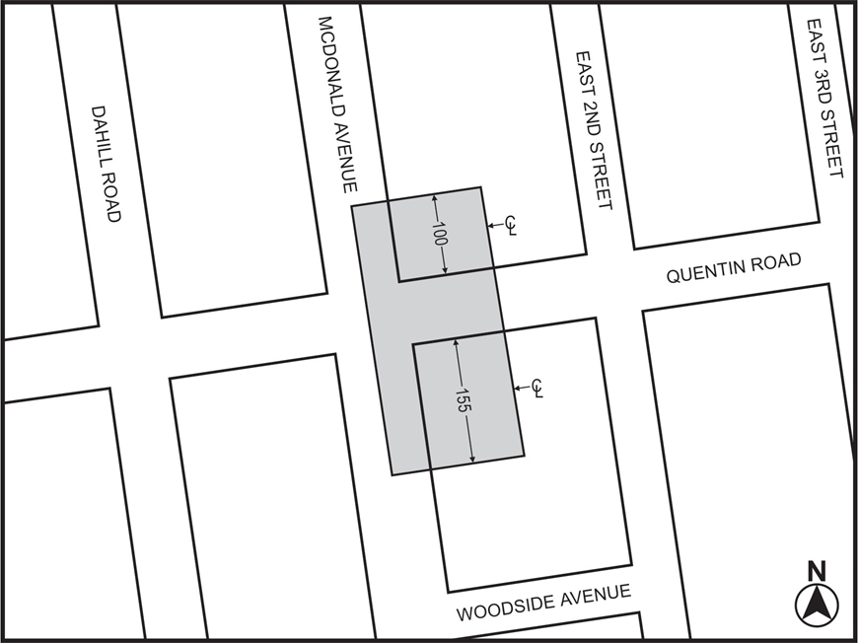
1

Mandatory Inclusionary Housing Program Area see Section 23-154(d)(3)
Area 1 [date of adoption] — MIH Program Option1 and Option 2

Portion of Community District 15, Brooklyn

* * *

Adopted.

Office of the City Clerk, }
The City of New York, } ss.:

I hereby certify that the foregoing is a true copy of a Resolution passed by The Council of The City of New York on September 26, 2018, on file in this office.

.....……......................................... City Clerk, Clerk of The Council

