Fire & Emergency Management Committee Staff
Josh Kingsley, Senior Counsel
William Hongach, Senior Policy Analyst
Tanveer Singh, Financial Analyst

Oversight & Investigations Committee Staff
Nicole Catá, Legislative Counsel
Alex Yablon, Policy Analyst
Erica Cohen, Policy Analyst
Owen Kotowski, Financial Analyst

Hospitals Committee Staff
Rie Ogasawara, Legislative Counsel
Mahnoor Butt, Policy Analyst
Amaan Mahadevan, Financial Analyst

Oversight & Investigations Division Staff
Brian Parcon, Investigative Counsel
Katie Sinise, Investigator
Uzair Qadir, Data Scientist
Amisa Ratliff, Investigative Policy Analyst



THE COUNCIL OF THE CITY OF NEW YORK

BRIEFING PAPER OF THE GOVERNMENTAL AFFAIRS,

AND HUMAN SERVICES, DIVISIONS

Andrea Vazquez, Director, Legislative Division

Rachel Cordero, Deputy Director, Governmental Affairs, Legislative Division

Smita Deshmukh, Deputy Director, Human Services, Legislative Division
Meagan Powers, Deputy Director, Oversight & Investigations Division

COMMITTEE ON FIRE & EMERGENCY MANAGEMENT
Hon. Joann Ariola, Chair
COMMITTEE ON OVERSIGHT & INVESTIGATIONS
Hon. Gale A. Brewer, Chair

COMMITTEE ON HOSPITALS
Hon. Mercedes Narcisse, Chair
November 1, 2024

Oversight – Ambulance Response Times

INTRODUCTION

On November 1, 2024, the Committee on Fire and Emergency Management, chaired by Council Member Joann Ariola, the Committee on Oversight and Investigations, chaired by Council Member Gale A. Brewer, and the Committee on Hospitals, chaired by Council Member Mercedes Narcisse, will conduct a joint oversight hearing on “Ambulance Response Times.” Those invited to testify include representatives from the New York City Fire Department (FDNY), the New York City Health and Hospitals Corporation (H+H), other interested stakeholders and members of the public.
- BACKGROUND
FDNY/EMS and 9-1-1 Ambulance Service
The core responsibility and expertise of the FDNY has evolved from an exclusive emphasis on fighting traditional structural fires to serving as a primary provider of Citywide pre-hospital care. Currently, FDNY’s Bureau of Emergency Medical Services (FDNY/EMS) is responsible for delivering ambulance and pre-hospital emergency medical services, and operates two types of ambulances: advanced life support (ALS) and basic life support (BLS). In New York City, ALS ambulances are staffed by two paramedics, and BLS ambulances are staffed by two emergency medical technicians (EMTs). Paramedics receive 1,500 hours of training, whereas EMTs are only required to complete 120 to 150 hours. The higher level of training received by paramedics allows them to perform advanced medical procedures, including patient intubation and the administration of drugs. ALS ambulances responds to life threatening medical emergencies, such as cardiac arrest, choking, difficulty breathing, unconsciousness and other critical medical emergencies. BLS ambulances respond to a wide variety of non-life-threatening conditions.
In addition to municipal ambulances operated by FDNY/EMS, the City’s 9-1-1 emergency system routinely dispatches voluntary hospital-based ambulances that are operated by a network of local hospitals pursuant to a voluntary-agreement with the City. These ambulances are owned by the operating hospital, and staffed by hospital employees, but dispatched by FDNY and supervised by FDNY/EMS officers. As of 2019, FDNY oversaw 1,266 daily ambulance tours, of which 844 were operated by the FDNY, while 422 were operated by voluntary hospital-based ambulances.
Additionally, FDNY relies on local fire companies to respond to certain serious medical emergencies—as firefighters receive training as Certified First Responders, and perform defibrillation to assist patients in cardiac arrest. The practice of dispatching fire companies to medical emergencies aims to improve response times to critical medical emergencies, and this practice has increased in recent years. When responding to medical emergencies, fire companies are able to evaluate and treat serious medical conditions but must rely on a later-arriving ambulance to provide hospital transport when necessary. .
During Fiscal Year 2024, FDNY responded to approximately 1.6 million medical emergencies, including 633,361 life-threatening incidents, and transported over 1 million patients to hospital emergency rooms. Of those incidents, fire companies responded to 363,617 medical emergencies.
NYC Health and Hospital
New York City has 53 emergency departments (EDs), with NYC Health + Hospitals (H+H) overseeing 40 EDs across its 11 hospitals and 29 Gotham Health Centers. These include six specialized trauma centers—NYC Health + Hospitals/Bellevue, Elmhurst, Jacobi, Kings County, Harlem, and Lincoln—which provide comprehensive care, from injury prevention to rehabilitation. Additionally, H+H operates seven adult and one child & adolescent Comprehensive Psychiatric Emergency Programs (CPEPs) that offer specialized psychiatric emergency care, extended observation, mobile crisis services, and access to crisis beds. Emergency and trauma services for children are available in all 11 H+H public hospitals, ensuring wide-reaching coverage for urgent healthcare needs across the five boroughs.
Emergency department overcrowding and extended wait times have become persistent issues in New York City and nationwide, driven by factors such as medical staff shortages, deferred care following the COVID-19 pandemic, limited access to primary and urgent care services, the complex needs of an aging population, and the ongoing opioid crisis. In NYC, emergency room visits surged by 6.5% in the first quarter of this year compared to the same period last year, according to data from the Greater New York Hospital Association. State data from POLITICO also indicates that average wait times for hospital beds increased to over 26 hours from just under 25 hours the previous year. In response to high demand, NYC Health + Hospitals/Jacobi in the Bronx experienced record patient volumes this summer, while Maimonides Health’s new emergency department in Brooklyn saw patient visits exceed projections by 15-20%. The closure and gradual downsizing of Mount Sinai Beth Israel have added strain on lower Manhattan facilities, leading Bellevue Hospital and NYU Langone to increase staffing and expand ER capacity to accommodate displaced patients.
To address high demand, hospitals are expanding emergency services and adding off-campus ERs, beds, and staff. H+H has adopted several strategies, including hiring full time nurses and physicians through better contracts and loan forgiveness programs to reduce reliance on temporary/travel medical staff; improving workflows through models like provider-in-triage; expanding ExpressCare clinics to redirect non-urgent cases; and expanding NYC Care to increases access to primary and specialty care for uninsured New Yorkers to reduce reliance on emergency rooms.
Relevant Budget Expenditures
The total Fiscal 2025 Adopted Budget for FDNY/EMS is $418 million, of which $299.7 million is specifically allocated for emergency medical services. This includes $247.6 million for a budgeted headcount of 3,684 positions. As of June 2024, the actual headcount was 3,320, resulting in 364 vacancies and a vacancy rate of approximately 9.9%. Additionally, while $22.5 million was designated for overtime expenses in the FY25 Adopted Budget, actual overtime spending in FY24 reached $40.2 million, which is approximately 79% higher than the budgeted amount.
The Fiscal 2025 Adopted Capital Commitment Plan for H+H includes $80.3 million in Fiscal 2025 for the procurement and outfitting of ambulances, which represents an increase of $9.4 million from the Executive Capital Commitment Plan. The Adopted Capital Plan also includes new funding of $55 million in Fiscal 2026 for ambulances. In addition, $2.2 million was added in the Adopted Capital Plan for the creation of an ambulance bay in Bellevue Hospital's Emergency Department.
- AMBULANCE RESPONSE TIMES
Generally, emergency response times serve as a key metric to monitor when working to evaluate, and improve, the delivery of pre-hospital emergency care. According to FDNY, the Department “regularly reviews response times to life-threatening medical emergencies across the City and develops strategies and reallocates resources to reduce response times in communities with higher response times.” However, in recent years FDNY’s response times to emergency medical incidents have consistently increased—a trend that is also seen in responses to life-threatening medical incident, the dire medical emergencies where prompt delivery of emergency medical care is most vital.
Analysis of Trends in Response Times
According to the Mayor’s Management Report, the overall average FDNY/EMS response time to life-threatening medical emergencies—dispatch and travel time—has increased more than one minute since Fiscal Year 2019—from 6m22s to 7m23s—with an increase in response times of 20 seconds occurring in the last fiscal year. For non-life-threatening emergencies, the average response time has risen nearly seven minutes during this period, reaching nearly 18 minutes in Fiscal Year 2024. Further, examination of publicly available data on medical response times indicates disparities in response times based on the location of the incident, with certain boroughs and neighborhoods experiencing significantly higher response times than Citywide averages. Additionally, recent increases in response times have largely aligned with increased call volume; however, data from Fiscal Year 2024 indicates that while call volume has stabilized, response times continue to increase. Finally, response time delays differ based on the severity of the medical emergency, as response times to non-life threatening medical incidents have increased at a greater rate than increases seen in response times to life-threatening medical emergencies.
Potential Causes for Increased Response Times
According to recent media reports, FDNY’s Chief of EMS Operations, Michael Fields, indicted that numerous factors have contributed to increased response times in recent years; however, he highlighted: (i) traffic; (ii) record call-volume; (iii) emergency room delays; and (iv) decreases in emergency room staffing. More specifically, Chief Fields mentioned lower speed limits, increased congestion, and the proliferation of bike lanes as factors that have made traversing the City more difficult, and slow, for emergency response vehicles. Additionally, Chief Fields cited decreases in the number of available emergency rooms and slower turnaround at emergency rooms, as contributing to increases in ambulance availability as EMTs/Paramedics must transfer care to a hospital before being dispatched to another incident. Finally, union representation for FDNY/EMS workers, have pointed to staffing shortages, and high worker turnover, as contributing to increased response times.

- ISSUES AND CONCERNS
The Committees seek to examine the increase in response times to medical emergencies, including disparities in borough specific response times. The Committees will seek information from FDNY regarding allocation of EMS resources, as it relates to both ambulance availability and EMT/Paramedic staffing. Further, the Committees will examine the intake of ambulances patients at hospital emergency rooms, and delays in transferring patient responsibility from ambulance personnel to hospital care.

Appendix

COUNCIL’S REVIEW OF DATA ON EMS RESPONSE TIMES

I. Introduction

To examine ongoing trends in EMS response times, the Council’s Oversight and Investigation Division (OID) analyzed publicly available data produced by the FDNY/EMS Computer Aided Dispatch System from 2018 to present (dispatch data), FDNY/EMS Fiscal Year 2024 MMR data (FY24 MMR), and data provided by FDNY regarding staffing and ambulance counts. OID analyzed call volume, response time, and staffing and ambulance count data.
OID’s analysis largely corresponds with data presented in the FY24 MMR: response times have consistently increased in recent years, with sharply rises seen in response times to non-life-threatening medical incidents, and a meaningful increase in response time to life-threatening incident. OID's analysis also aligned with the MMR's findings in showing that from 2020 to 2023, call volumes and response times were closely correlated. However, this pattern shifted in 2024, with call volumes leveling off while response times spiked, disrupting the previous trend (see Figure 1). This changing relationship between call volume and response time calls into question the current operational drivers of the spike in response times.
In addition, FDNY provided OID with ambulance staffing data from 2018 to the second quarter of 2024 (“Q2 2024”) and ambulance count data from 2018 to 2023. OID’s analysis showed these figures remained relatively flat during this time, even in the face of increasing call volume.

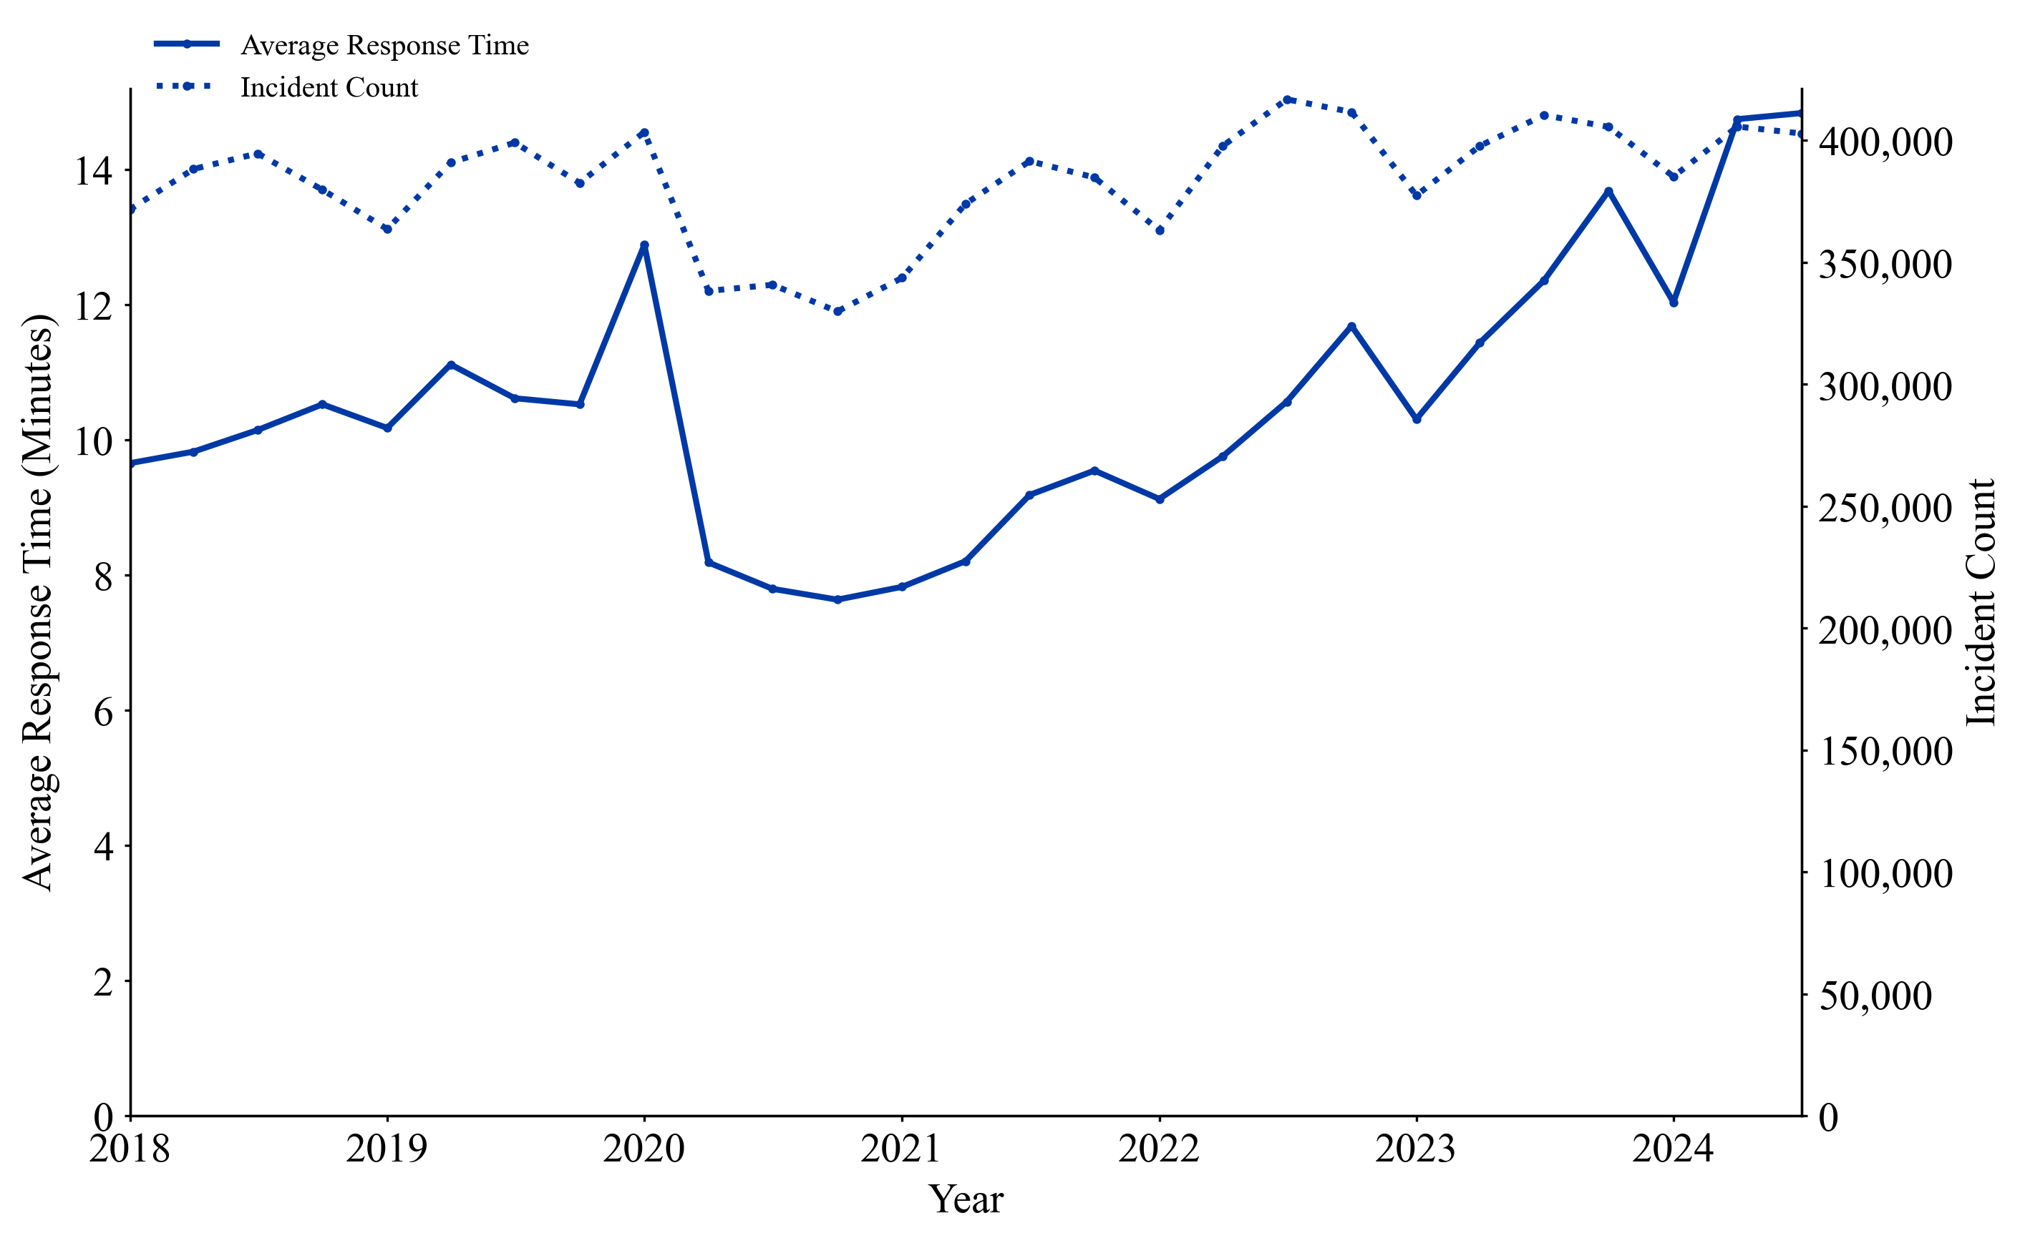
Figure 1 – EMS Incidents Count and Response Time Averages by Month, CY 2018-CY 2024Q3

II. Trends in Response Times

The COVID-19 pandemic appears to have heavily impacted average response times over the past five years. A significant decline in EMS incidents and a short-term increase in ambulances in-service from 2020 to 2021 during the height of the pandemic led to around a four-minute decrease in average response times for non-life-threatening incidents and an approximately one-minute decrease for life-threatening incidents.
However, since 2023, response times have returned to their pre-COVID upward trend and now exceed their former peaks. Comparing the third quarter of 2018 (Q3 2018) to the third quarter of 2024 (Q3 2024) data, average response times rose about seven minutes for non-life-threatening incidents and around one minute for life-threatening incidents. Moreover, comparing Q3 2018 to Q3 2024 call volume data, volume is also above 2018 levels.
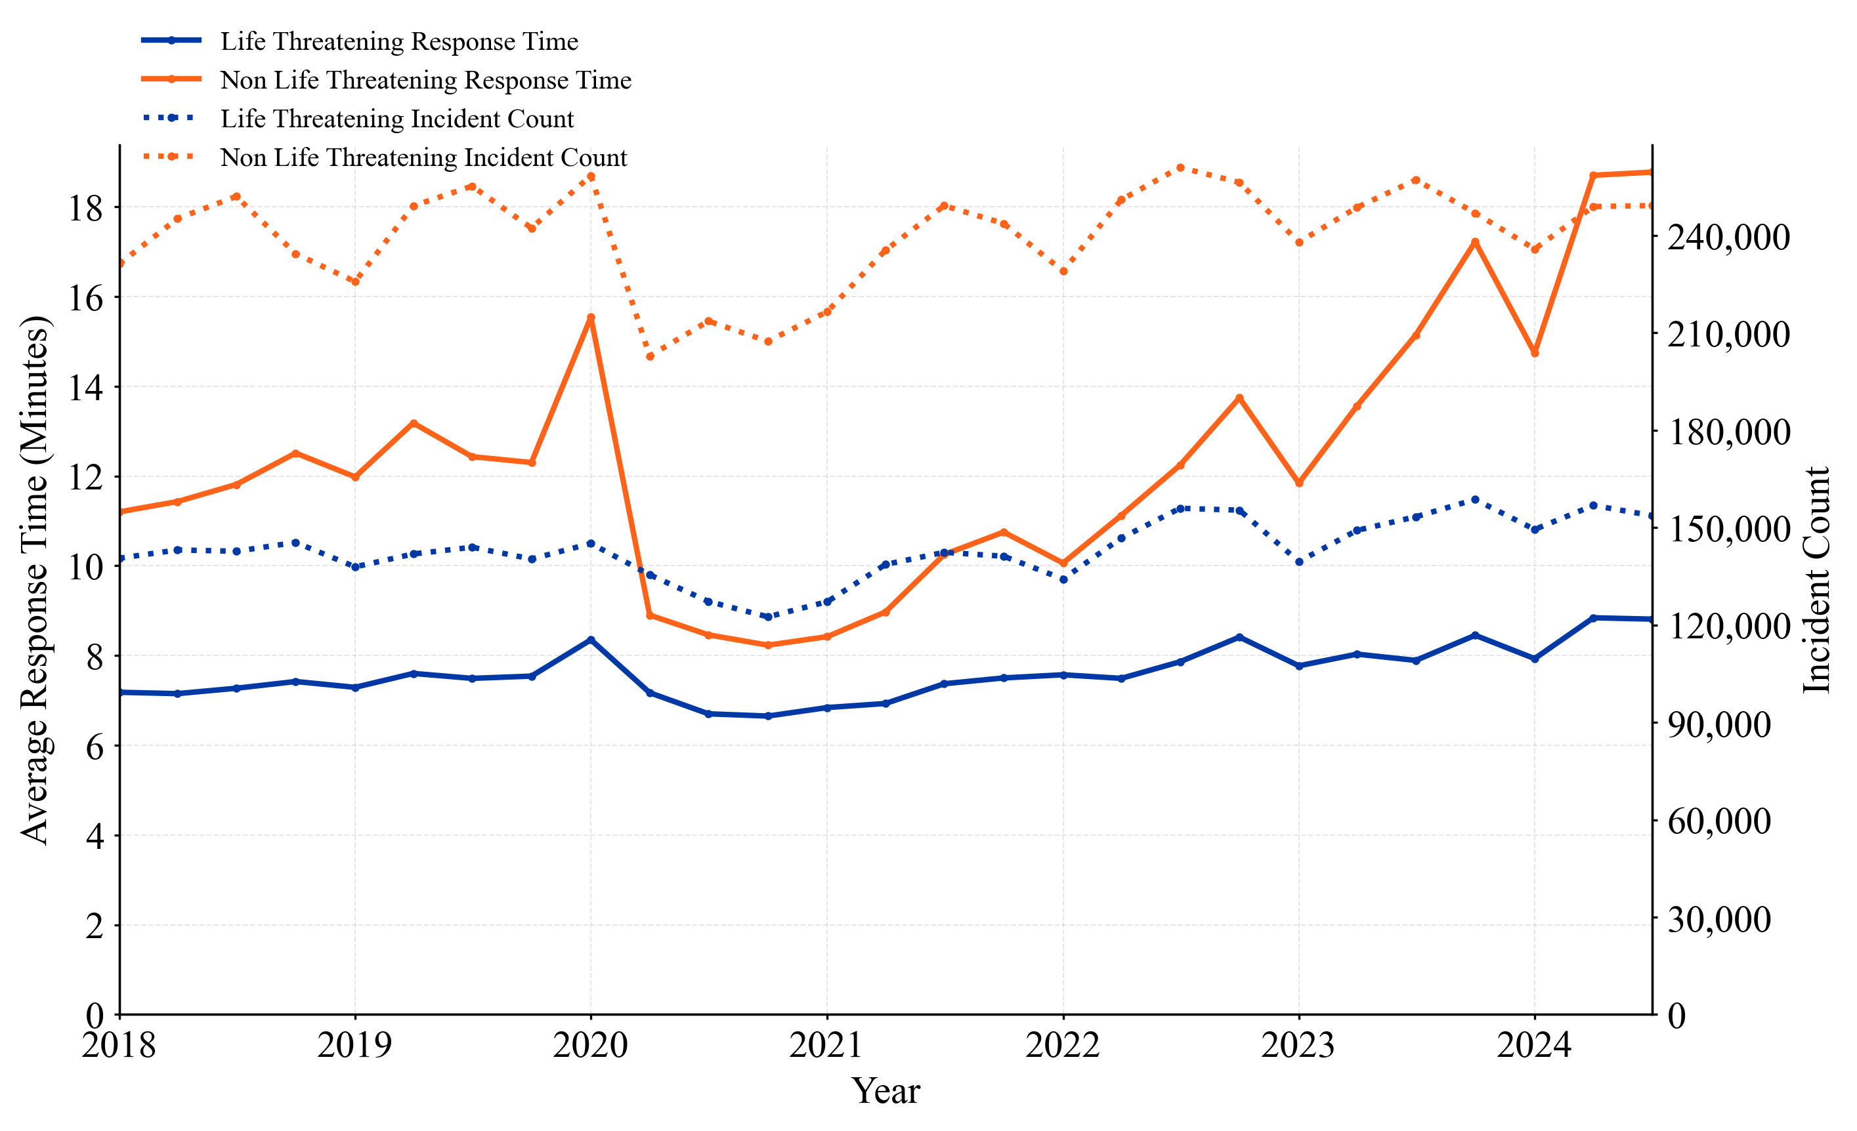Figure 2 – EMS Incidents Count and Response Time Averages by Month, CY 2018-CY 2024Q3

III. Geographic Trends in Response Times
Borough and zip code level analysis offer a more granular assessment of the situation. A key trend at the borough level is that as average response times increase overall, the differences in response times between boroughs are also growing. In the first quarter of 2018 (Q1 2018), average response times to life-threatening incidents for all boroughs besides Staten Island were clustered within 20 seconds of each other. By Q3 2024, significant gaps had appeared between the boroughs: response times in the Bronx were more than 2 minutes longer on average than response times in Brooklyn for life-threatening incidents (see Figure 3) and over 5 minutes longer for non-life-threatening incidents (see Figure 4).
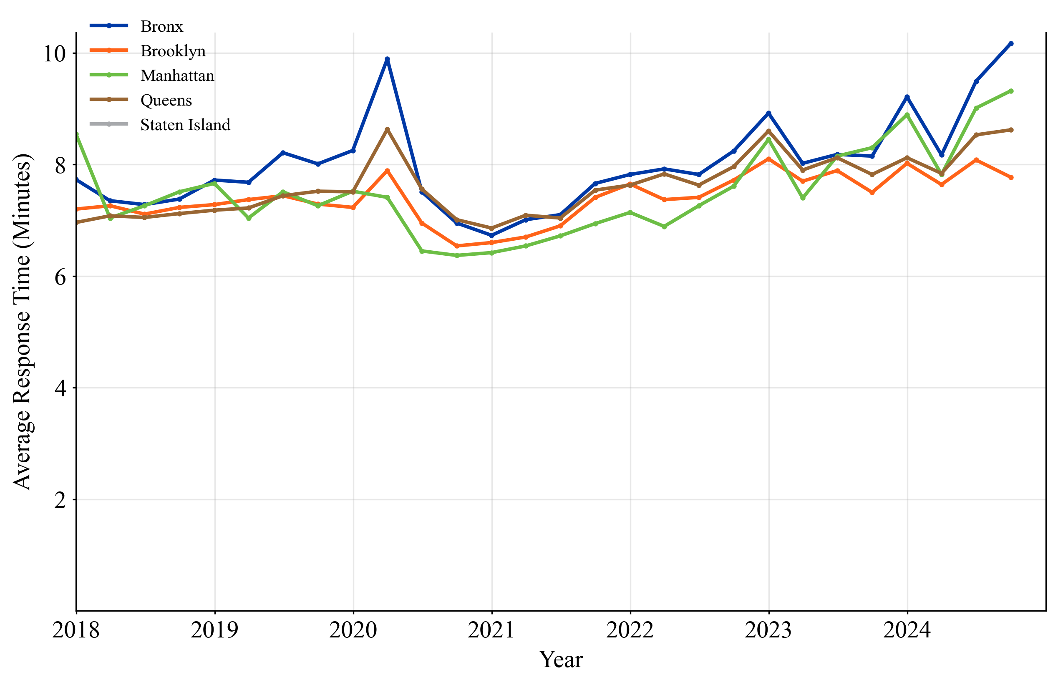
Figure 3 – Response Time Averages for Life Threatening Incidents by Month and Borough, CY 2018-CY 2024Q3

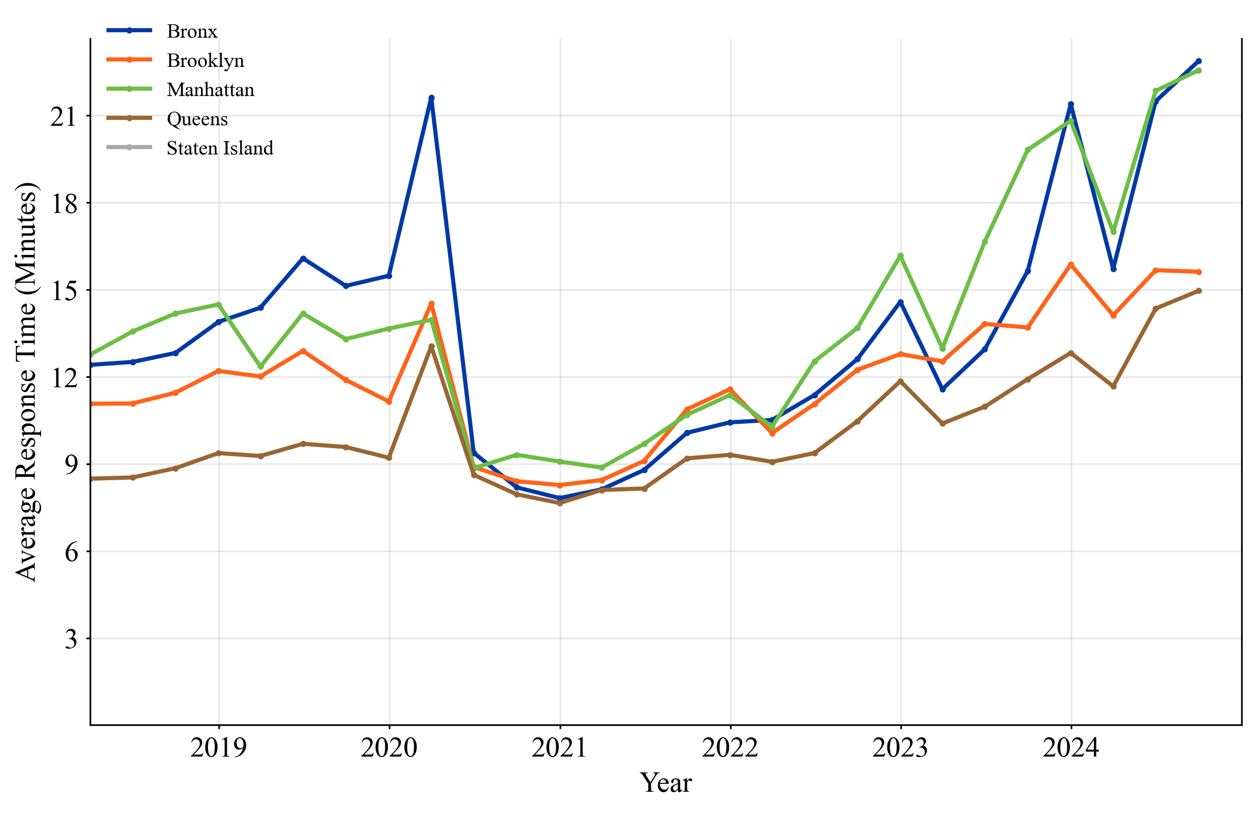
Figure 4 – Response Time Averages for Non-Life-Threatening Incidents by Month and Borough, CY 2018Q1-CY 2024Q3
Data aggregated at the zip code level shows some neighborhoods are driving this increase more than others for both non-life threatening and life-threatening calls for service. Parts of Upper Manhattan, the North Bronx, Astoria, and Greenpoint are hotspots where response times have increased over 30% for life-threatening incidents (see Figure 5) and have increased over 60% for non-life-threatening incidents. The disparities in average response times are even more pronounced by neighborhood for non-life-threatening incidents: some neighborhoods have seen increases of over 80% while response times in other areas have only increased around 10% (see Figure 6).

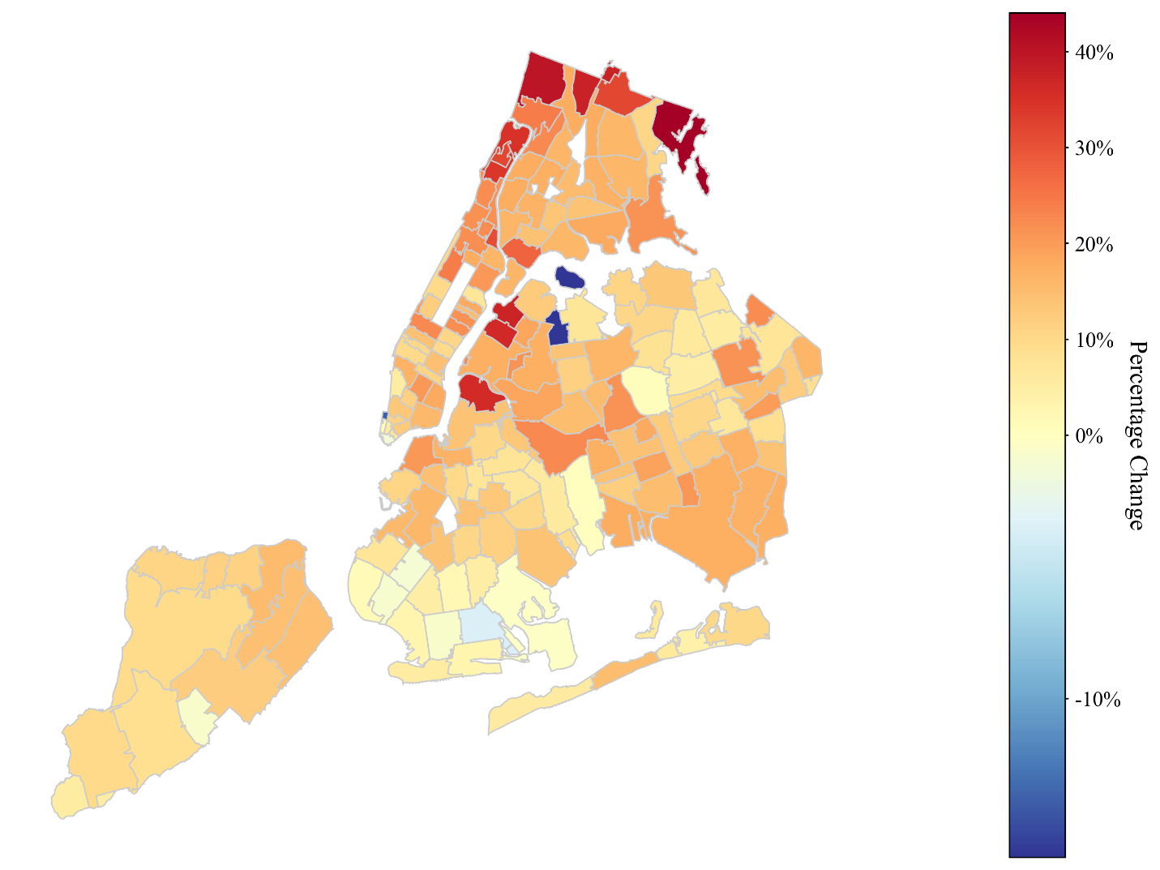
Figure 5 – Changes in Response Time Averages for Life-Threatening Incidents by Zip Code Between FY 2018 Q3-FY 2024Q3
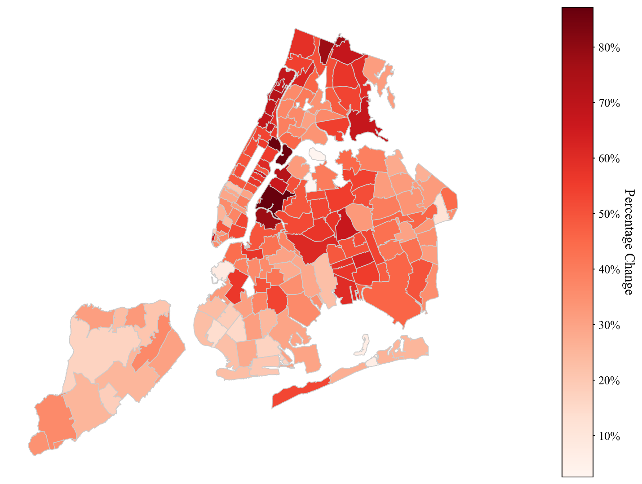
Figure 6 – Changes in Response Time Averages for Non Life-Threatening Incidents by Zip Code Between FY 2018 Q3-FY 2024 Q3

IV. Trends in Call Composition and Volume
FY24 MMR data showed a year-over-year five percent increase in response time to life-threatening incidents. To better understand the composition of these calls, OID analyzed incidents from the dispatch data based on the final call type recorded by the dispatcher. Similar call types, such as variants of cardiac incidents, trauma incidents, etc. were grouped to allow for a clearer visualization of trends. The full grouping procedure is outlined in appendix “A”.
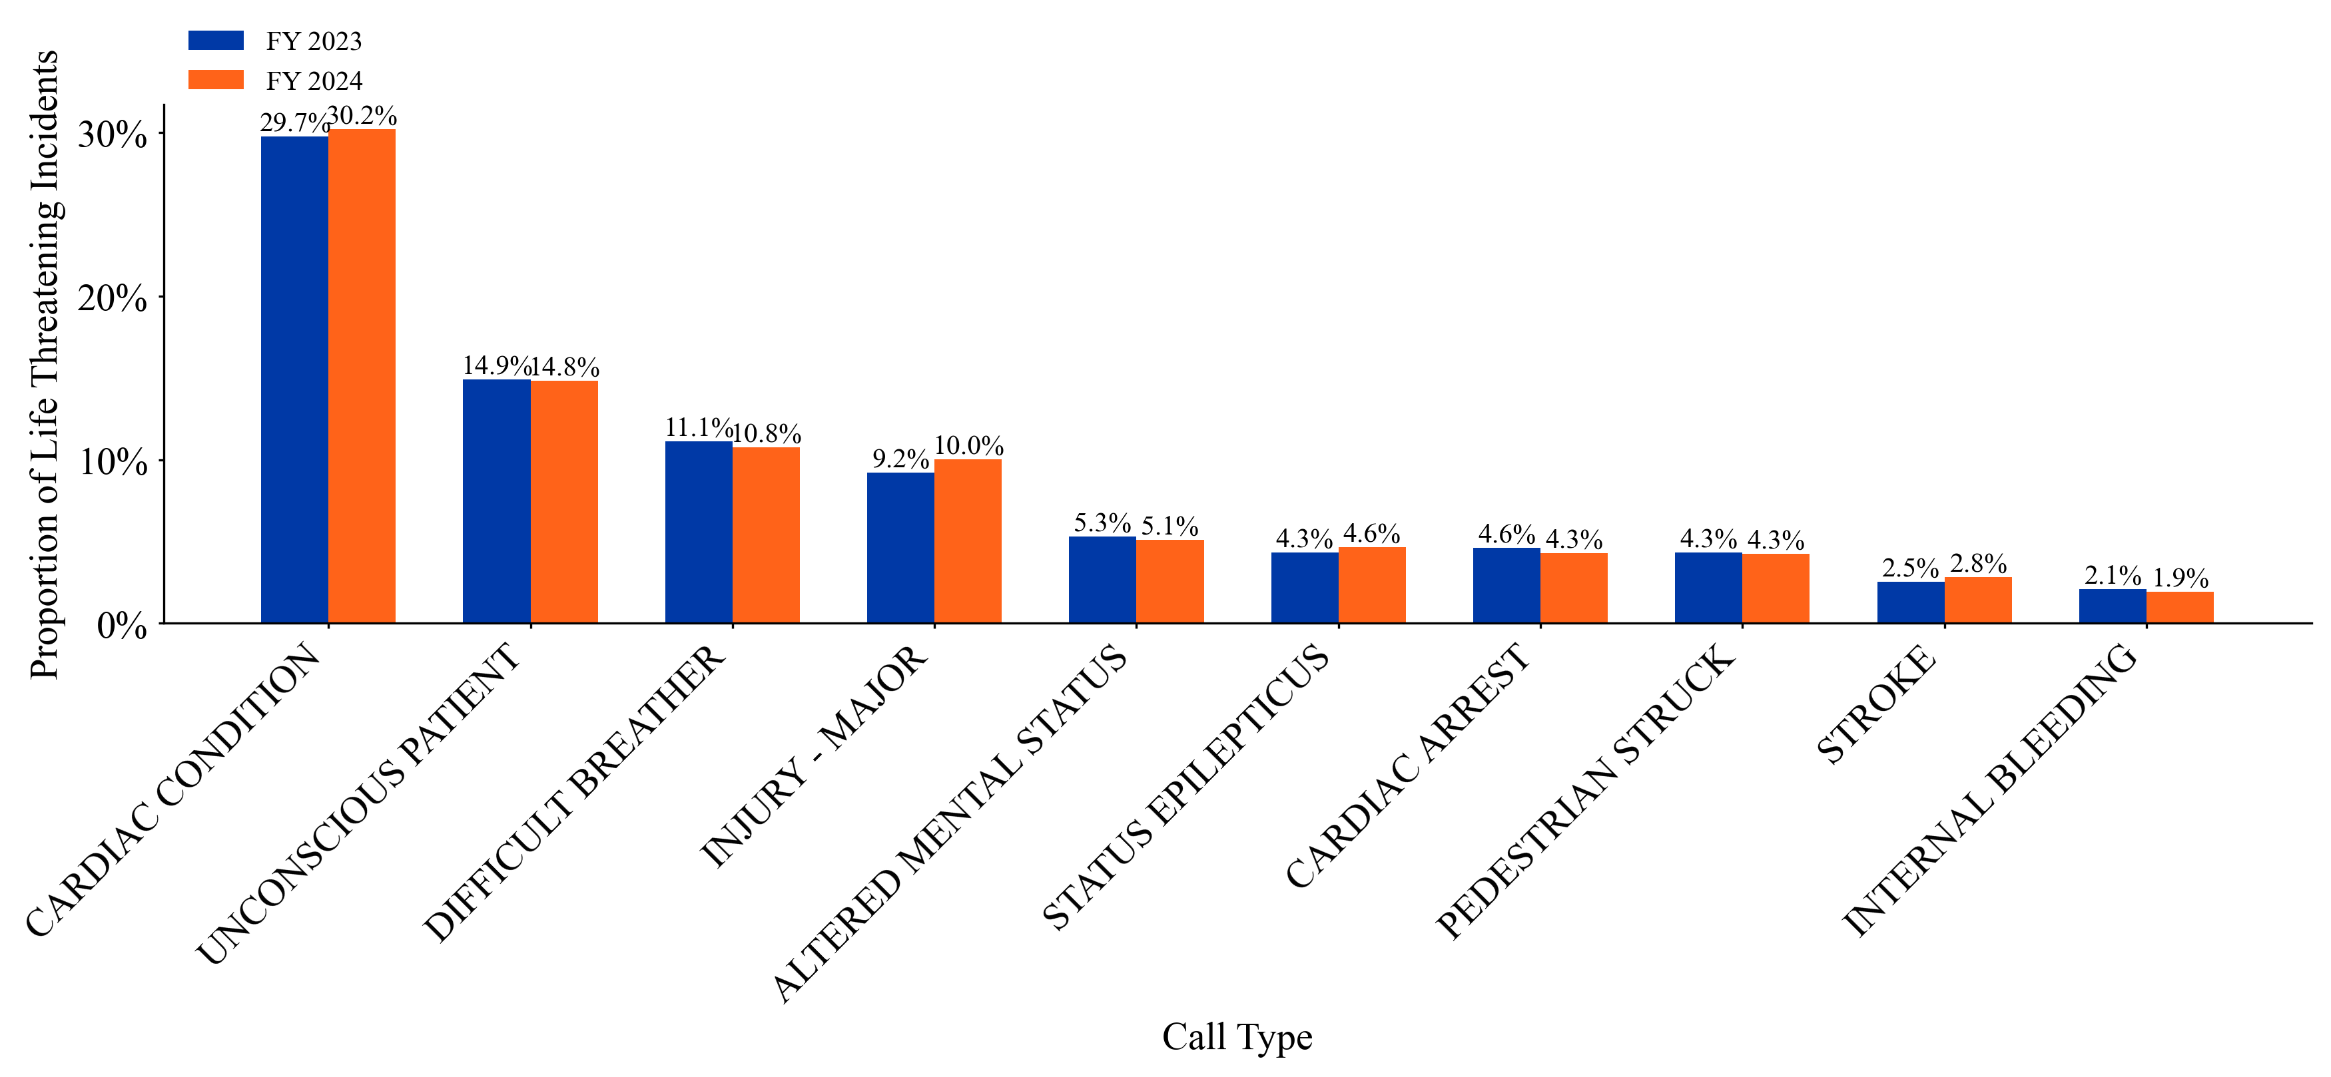
Figure 7 – Proportion of Life-Threatening Incidents Represented by Call Type, Top 10 Changes, FY23 vs FY24
While incident volumes were up for the majority of call types, OID’s analysis found only minor changes in the composition of life-threatening incidents between fiscal year 2023 (“FY23”) and fiscal year 2024(“FY24”). For example, while the number of stroke calls increased 15% between FY23 and FY24—the most significant increase for any call type—the proportion of life-threatening incidents this represents only increased by less than half a percentage point (see Figure 7). This suggests that call composition is not a significant driver in ambulance response times.
Response times by call type have largely remained consistent as well, albeit with some noteworthy changes. The most significant increases OID observed in response times to life-threatening incidents were for major injury, difficult breather, cardiac arrest, and stroke incidents which were all up by over five percent (see Figure 8).
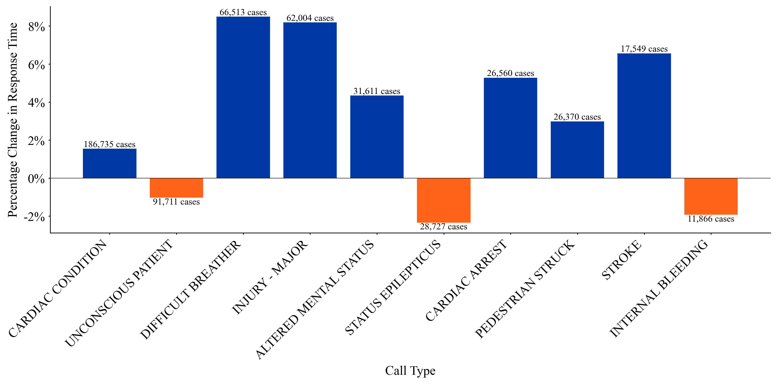Figure 8 – Percentage Change in Response Time, Life Threatening Incidents, Top 10 Changes, FY23 vs FY24

V. Trends in FDNY/EMS Resources

To evaluate how FDNY/EMS capacity has evolved given rising incident counts, OID requested staffing figures and vehicle counts for FDNY/EMS. While OID is awaiting 2024 vehicle figures, staffing data from 2018 to 2024 and FDNY ambulance counts from 2018 to 2023 suggest the department’s staffing and ambulance resources have not matched the call volume increase. The COVID-19 pandemic led to an increase in ambulances in service and available EMS personnel, with an increase of approximately 200 in-service ambulances between 2020 and 2021 However, this pandemic-spike was temporary—capacity has either stagnated or declined in recent years with fewer ambulances and EMS personnel available in Q4 2023 than in Q1 2018 (see Figure 9 and Figure 10). The decline in ambulances in service is primarily due to staffing constraints rather than maintenance issues: in response to a Council Inquiry, FDNY indicated that as of Dec. 2023, “19.2% of vehicles providing care in the 9-1-1 system were out-of-service due to both long-term and short-term staffing disruptions.” The department’s fixed staffing and ambulance capacity in the face of increased call volume burden might explain the significant increase in response times for non-life-threatening incidents as personnel are triaged to keep fast responses to critical incidents.
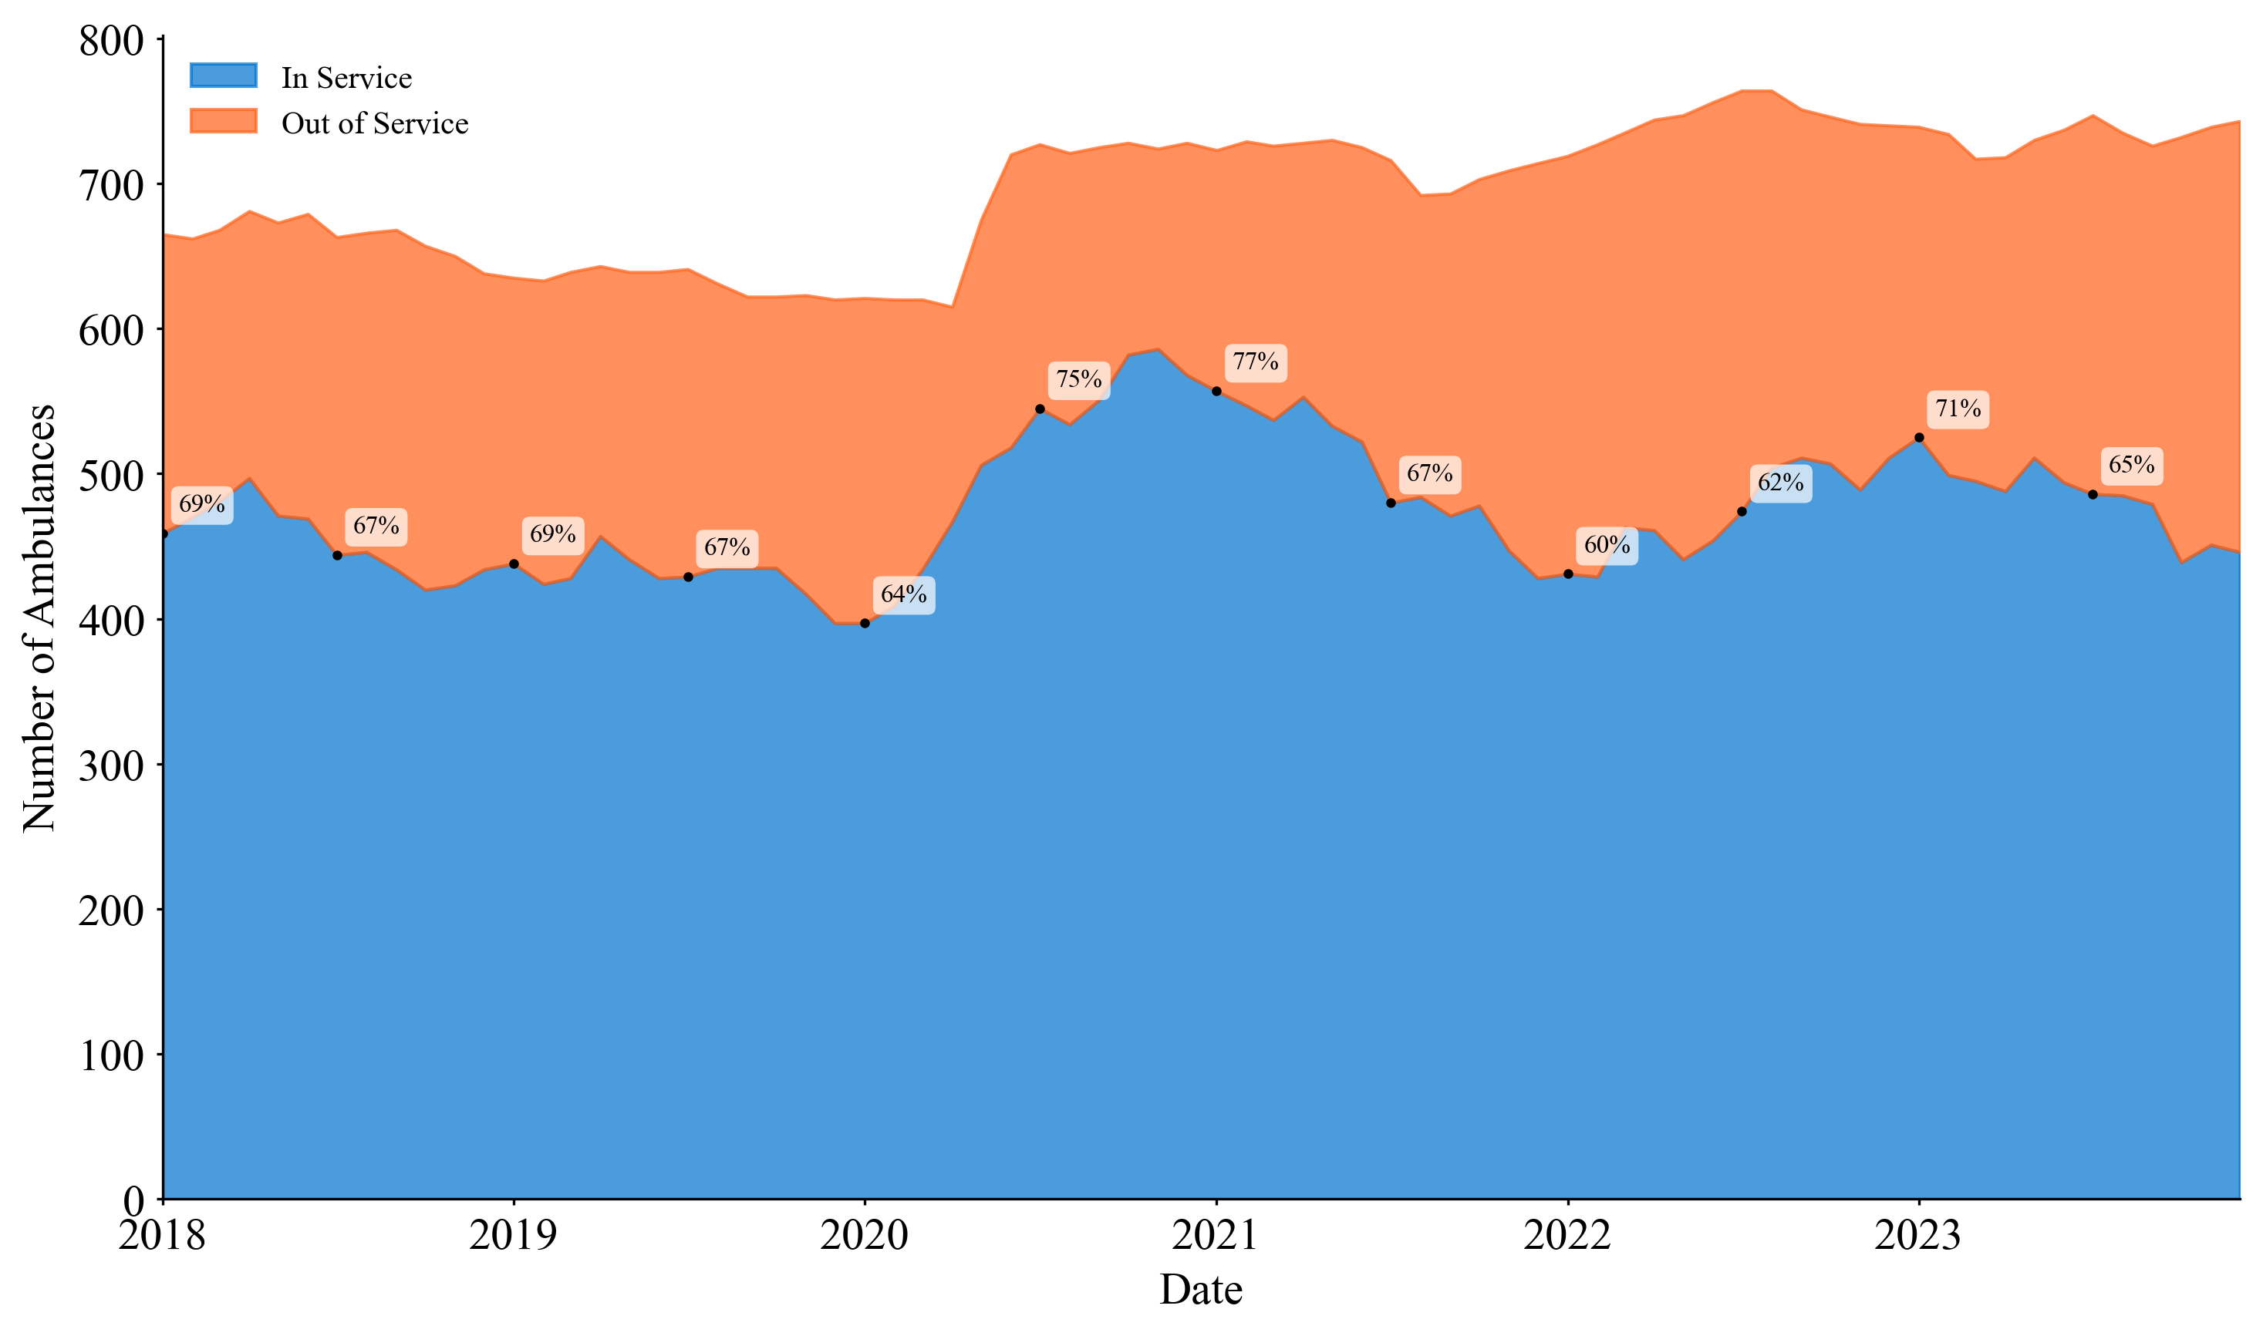
Figure 9 – Count of Ambulances in Service Between CY 2018 - CY 2024
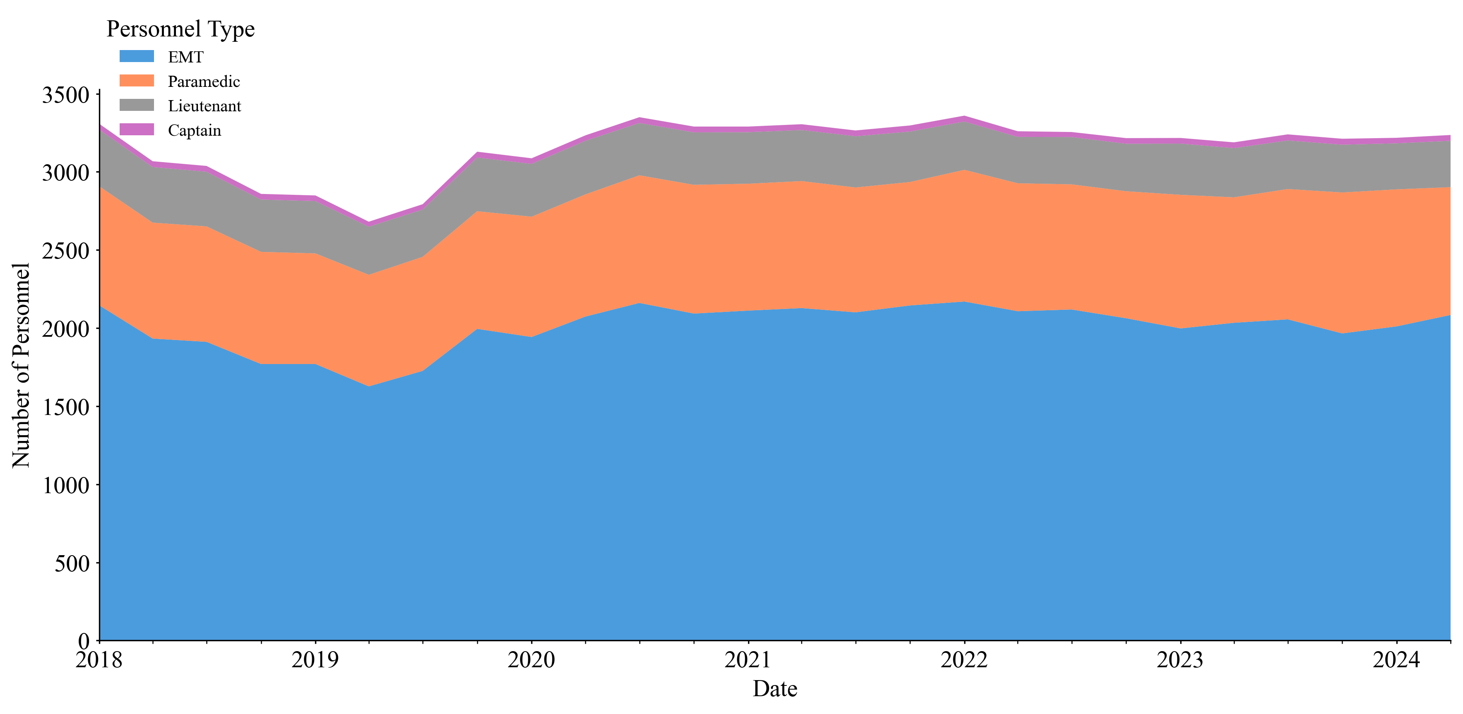Figure 10 – Count of EMS Personnel Between CY 2018 - CY 2024

VI. Conclusion
While overall response time increases have been driven by non-life-threatening incidents, it is critical to understand and address the challenges the agency is meeting and any added resources that may be needed to ensure that response times to life-threatening incidents are not negatively affected going forward. Additionally, discrepancies in response times between different boroughs and neighborhoods should be analyzed, and reallocation of resources or personnel potentially considered, to ensure that New Yorkers across the city can expect prompt responses to medical emergencies, particularly life-threatening incidents.
VII. Appendix A
Call types were grouped by mapping the call type to a call type description according to the data dictionary from the dispatch data. Then, call type descriptions were mapped to categories according to the following dictionary.

code_mapping = {
# Abdominal Pain Variants
'ABDOMINAL PAIN-FEVER & COUGH': 'ABDOMINAL PAIN',
'ABDOMINAL PAIN FEVER\\TRAVEL': 'ABDOMINAL PAIN',

# Active Shooter Variants
'ACTIVE SHOOTER': 'ACTIVE SHOOTER',

# Altered Mental Status Variants
'ALT MENTAL STATUS-FEVER&COUGH': 'ALTERED MENTAL STATUS',
'ALTERED MENTAL STATUS FEVER/TRAVEL': 'ALTERED MENTAL STATUS',

# Asthma Attack Variants
'ASTHMA ATTACK - FEVER&COUGH': 'ASTHMA ATTACK',
'ASTHMA PATIENT FEVER/TRAVEL': 'ASTHMA ATTACK',
'ASTHMA A': 'ASTHMA ATTACK',
'ASTHMA ATTACK-PEDS <15 YRS OLD': 'ASTHMA ATTACK',
'ASTHMA ATTACK': 'ASTHMA ATTACK',
'ASTHMA CRITICAL': 'ASTHMA ATTACK',

# Cardiac Arrest Variants
'CARD OR RESP ARREST-FEVERCOUGH': 'CARDIAC ARREST',
'CARDIAC ARREST PATIENT FEVER/TRAVEL': 'CARDIAC ARREST',

# Cardiac Condition Variants
'CARDIAC CONDITION-FEVER&COUGH': 'CARDIAC CONDITION',
'CARDIAC PATIENT FEVER/TRAVEL CONDITION': 'CARDIAC CONDITION',
'CDBRFC': 'CARDIAC CONDITION',

# Choking Variants
'CHOKING FEVER&COUGH': 'CHOKING',
'CHOKING PATIENT FEVER/TRAVEL': 'CHOKING',

# Difficult Breather Variants
'DIFF BREATHING - FEVER&COUGH': 'DIFFICULT BREATHER',
'DIFFICULT BREATHING FEVER/TRAVEL': 'DIFFICULT BREATHER',
'DIFFICULT BREATHER RF': 'DIFFICULT BREATHER',

# Drug/Alcohol Abuse Variants
'HX DRUG OR ALCHL ABUSE-FEV&COU': 'HX DRUG OR ALCOHOL ABUSE',

# Internal Bleeding Variants
'INTERNAL BLEEDING-FEVER&COUGH': 'INTERNAL BLEEDING',
'INTERNAL BLEEDING FEVER/TRAVEL': 'INTERNAL BLEEDING',

# Anaphylaxis Variants
'ANAPHYLACTIC SHOCK-FEVER&COUGH': 'ANAPHYLAXIS',
'ANAPHYLACTIC FEVER/TRAVEL': 'ANAPHYLAXIS',
'ANAPRF': 'ANAPHYLAXIS',

# Unconscious Patient Variants
'UNC PATIENT - FEVER & COUGH': 'UNCONSCIOUS PATIENT',
'UNCONSCIOUS FEVER/TRAVEL PATIENT': 'UNCONSCIOUS PATIENT',
'UNCONSCIOUS PATIENT-RASH&FEVER': 'UNCONSCIOUS PATIENT',

# Respiratory Distress Variants
'RESP DISTRESS - FEVER&COUGH': 'RESPIRATORY DISTRESS',
'RESPIRATORY DISTRESS FEVER/TRAVEL': 'RESPIRATORY DISTRESS',

# Seizures Variants
'SEIZURES - FEVER & COUGH': 'SEIZURES',
'SEIZURE PATIENT FEVER/TRAVEL': 'SEIZURES',
'MULT OR PROLONG SEIZUR-FEV&COU': 'SEIZURES',

# Status Epilepticus Variants
'STATUS EPILEPTICUS FEVER/TRAVEL': 'STATUS EPILEPTICUS',

# Sick Variants
'SICK - COUGH & FEVER': 'SICK',
'SICK - RASH AND FEVER': 'SICK',
'SICK PATIENT FEVER\\TRAVEL': 'SICK',

# Stroke Variants
'STROKE - FEVER & COUGH': 'STROKE',
'STROKE CRITICAL - FEVER&COUGH': 'STROKE',
'STROKE CRITICAL FEVER\\TRAVEL': 'STROKE',
'CVA (STROKE)': 'STROKE',

# Pediatric Sick Variants
'SICK PED<5 YRS-FEVER & COUGH': 'SICK PEDIATRIC, <5 YEAR OLD',
'PEDIATRIC FIVER\\TRAVEL': 'SICK PEDIATRIC, <5 YEAR OLD',

# Injury Variants
'MINOR INJURY': 'INJURY - MINOR',
'NON-CRITICAL INJURY': 'INJURY - MINOR',
'MAJOR INJURY': 'INJURY - MAJOR',
'INJURY LOWER EXT IN ELDERLY': 'INJURY - MAJOR',

# Auto Accident Variants
'AUTO ACC W/INJURIES': 'AUTO ACCIDENT',
'AUTO ACCIDENT, NO CONFIRMD INJ': 'AUTO ACCIDENT',

# Trauma Variants
'GUN SHOT WOUND': 'TRAUMA - MAJOR',
'STABBING': 'TRAUMA - MAJOR',
'AMPUTATION, ARM, HAND,LEG,FOOT': 'TRAUMA - MAJOR',
'AMPUTATION, FINGERS OR TOES': 'TRAUMA - MAJOR',

# Burn Variants
'MINOR BURNS <18% ADLT OR <10%': 'BURN',
'MAJOR BURNS 18% ADLT 10% CHILD': 'BURN',

# Obstetric Emergency Variants
'FEMALE IN LABOR': 'OBSTETRIC EMERGENCY',
'BABY OUT OR IMMINENT BIRTH': 'OBSTETRIC EMERGENCY',
'OBSTETRIC COMPLICATIONS': 'OBSTETRIC EMERGENCY',
'MAJOR OBSTETRICAL COMPLAINT': 'OBSTETRIC EMERGENCY',
'MISCARRIAGE': 'OBSTETRIC EMERGENCY',

# GYN Variants
'GYN BLEEDING/PT NOT PREGNANT': 'GYN/SEVERE PAIN/BLEEDING',

# Unknown Condition Variants
'UNKNOWN CONDITION': 'UNKNOWN CONDITION',
'CALLER HAS NO PT MEDICAL INFO': 'UNKNOWN CONDITION',
}

FDNY Strategic Plan at https://www.nyc.gov/site/fdny/about/resources/reports-and-publications/strategic-plans.page
Bernard O’Brien, Two Paramedics on an Ambulance—Only in New York, IBO Web Blog, Jul. 27, 2009, http://ibo.nyc.ny.us/cgi-park/?p=77.
Id.
Id.
Id.
Hearing testimony of Lillian Bonsignore, Chief of EMS, FDNY; provided to the Committee on Fire and Emergency Management on June 17, 2019; available at: https://legistar.council.nyc.gov/LegislationDetail.aspx?ID=3970952&GUID=8ECFBE57-45B1-400D-A1B9-A43147C6620D&Options=&Search.
Id.
Id.
Citizen Budget Commission of New York: Reviving EMS, Nov. 25, 2018; available at: https://cbcny.org/research/reviving-ems
Id.
Id.
2024 Mayor’s Management Report, FDNY; available at: https://www.nyc.gov/assets/operations/downloads/pdf/mmr2024/fdny.pdf.
Id.
NYC Health; available at: https://a816-health.nyc.gov/hdi/epiquery/visualizations?PageType=tsi&PopulationSource=Syndromic&Topic=1&Subtopic=39&Indicator=Influenza-like%20illness%20(ILI)&Year=2020#:~:text=Subtopic%3A%20Syndromic%20Surveillance,each%20of%20their%20patient%20encounters.
NYC Health + Hospitals, Emergency Services for Children & Adults; accessed on Oct. 28, 2024: https://www.nychealthandhospitals.org/services/emergency-services/; NYC Health + Hospital testimony, New York City Council Hearing: Safety of New York City Emergency Departments, Feb. 24, 2020; available at: https://nychealthandhospitals-appservice-test.azurewebsites.net/new-york-city-council-hearing-safety-of-new-york-city-emergency-departments/
Id.
Id.
Id.
Maya Kaufman, Emergency medical visits on the rise across New York City, POLITICO, Sep. 03, 2024; available at: https://www.politico.com/newsletters/weekly-new-york-health-care/2024/09/03/emergency-medical-visits-on-the-rise-across-new-york-city-00177007
Id.
Id.
Id.
Id.
Id.
NYC Health + Hospital testimony, New York City Council Hearing: Safety of New York City Emergency Departments, Feb. 24, 2020; available at: https://nychealthandhospitals-appservice-test.azurewebsites.net/new-york-city-council-hearing-safety-of-new-york-city-emergency-departments/
NYC Adopted Budget Fiscal Year 2025; available at: https://www.nyc.gov/assets/omb/downloads/pdf/adopt24/erc6-24.pdf.
Id.
Id.
Id.
Id.
Id.
Id.
2024 Mayor’s Management Report, FDNY; available at: https://www.nyc.gov/assets/operations/downloads/pdf/mmr2024/fdny.pdf.
Id.
2024 Mayor’s Management Report, FDNY; available at: https://www.nyc.gov/assets/operations/downloads/pdf/mmr2024/fdny.pdf; 2023 Mayor’s Management Report, FDNY; available at https://www.nyc.gov/assets/operations/downloads/pdf/mmr2023/2023_mmr.pdf.
NYC OPENDATA, EMS INCIDENT DISPATCH DATA, https://data.cityofnewyork.us/Public-Safety/EMS-Incident-Dispatch-Data/76xm-jjuj/about_data (database updated Oct. 21, 2024); see Appendix.
Id.
Id.
Id.
Katz, Matt, Wait Times for Ambulances in NYC is the longest since the start of COVID-19, Gothamist, July 1, 2024; available at:, https://gothamist.com/news/wait-time-for-ambulances-in-nyc-is-the-longest-since-the-start-of-covid-19
Id.
Id.
Id.
NYC OPENDATA, EMS INCIDENT DISPATCH DATA, https://data.cityofnewyork.us/Public-Safety/EMS-Incident-Dispatch-Data/76xm-jjuj/about_data (database updated Oct. 21, 2024)
NYC MAYOR’S MANAGEMENT REPORT, FISCAL 2024, at 79 (Sep. 2024) https://www.nyc.gov/assets/operations/downloads/pdf/mmr2024/MMR-2024-Cover.pdf.
Data Received Per Request from Council to FDNY (Oct. 28, 2024) (on file with N.Y. City Council)
One important caveat is that these figures do not represent the total capacity of the EMS system, as many ambulances which participate in the dispatch system are owned and operated by hospitals, volunteer ambulance companies, or commercial ambulance companies.
Data Received Per Request from Council to FDNY (Oct. 28, 2024) (on file with N.Y. City Council)

