THE COUNCIL OF THE CITY OF NEW YORK
RESOLUTION NO. 806

Resolution approving the decision of the City Planning Commission on Application No. N 240388 ZRM, for an amendment of the text of the Zoning Resolution (L.U. No. 228).

By Council Members Salamanca and Hanks

WHEREAS, the New York City Department of Housing Preservation and Development, filed an application pursuant to Section 201 of the New York City Charter, for an amendment of the text of the Zoning Resolution of the City of New York, modifying APPENDIX F for the purpose of establishing a Mandatory Inclusionary Housing area, which in conjunction with the related actions would facilitate the infill development of the New York City Human Resources Administration (HRA) Multi-Service Center (MSC) parking lot with a 21-story residential building containing approximately 277,000 square feet of floor area and 281 income-restricted housing units, and the project would also entail the gut renovation of the existing Multi-Service Center community facility improvement and its vertical enlargement with an additional floor (Block 1808, Lot 8), in the East Harlem neighborhood of Manhattan, Community District 11 (ULURP No. N 240388 ZRM), (the “Application”);

WHEREAS, the City Planning Commission filed with the Council on January 23, 2025, its decision dated January 22, 2025 (the "Decision") on the Application;

WHEREAS, the Application is related to applications C 240385 MMM (L.U. No. 225), a change to the City Map to clarify an existing encroachment into the mapped street line by demapping a roughly 30 foot north-south portion of East 120th Street fronting the development site and the adjacent Lot 7501; C 240386 ZMM (L.U. No. 226), a zoning map amendment to replace portions of existing R7-2 and R7X districts with an R8 zoning district; and C 240387 HAM (L.U. No. 227), a UDAAP designation, project approval, and disposition of City-owned property located at 413 East 120th Street and an approximately 7,260 square foot area of current East 120th Street running south of Lot 7501 (Condo Lots 1001-1003 (and Lot 8 for approximately 363 feet));

WHEREAS, the Decision is subject to review and action by the Council pursuant to Section 197-d of the City Charter;

WHEREAS, upon due notice, the Council held a public hearing on the Decision and Application on February 5, 2025;

WHEREAS, the Council has considered the land use implications and other policy issues relating to the Decision and Application; and

WHEREAS, the Council has considered the relevant environmental issues, including the Negative Declaration issued December 22nd, 2023 (CEQR No. 23HPD033M), which included measures that will be required through provisions for the Proposed Project contained in the Land Disposition Agreement and/or Regulatory Agreement(s) between HPD and the project sponsor to avoid the potential for significant adverse impacts related to hazardous materials and historic and cultural resources in which the requirements of the provisions are described in the Environmental Assessment Statement and Negative Declaration. With these measures in place, no significant adverse impacts related to hazardous materials or historic and cultural resources would occur as a result of the Proposed Actions and resultant development. On September 6, 2024, a Technical Memorandum was issued by HPD to analyze the potential effects of modifications to the Proposed Project and the Proposed Actions since the publication of the EAS dated December 22, 2023. The Technical Memorandum concludes that the modifications do not have the potential to result in environmental impacts not already considered in the EAS dated December 22, 2023, and would not meet any thresholds in the CEQR Technical Manual that would require any additional detailed analysis. The Technical Memorandum also acknowledges that while the City of Yes for Housing Opportunity text amendment would increase the maximum floor area permitted, the Project Sponsor does not intend to make use of the text amendment. The project has already completed HPD's Request for Proposals process and review. Any changes in project scope beyond what is currently contemplated would require additional HPD review, including further environmental review.

RESOLVED:

The Council finds that the action described herein will have no significant impact on the environment as set forth in the Negative Declaration.

Pursuant to Sections 197-d and 201 of the City Charter and on the basis of the Decision and Application, and based on the environmental determination and consideration described in the report, N 240388 ZRM, incorporated by reference herein, and the record before the Council, the Council approves the Decision of the City Planning Commission.

Matter underlined is new, to be added;
Matter struck out is to be deleted;
Matter within # # is defined in Section 12-10;
* * * indicates where unchanged text appears in the Zoning Resolution.

APPENDIX F
Mandatory Inclusionary Housing Areas and former Inclusionary Housing Designated Areas

MANHATTAN

* * *

Community District 11

Map 8 – [date of adoption]

[PROPOSED MAP]
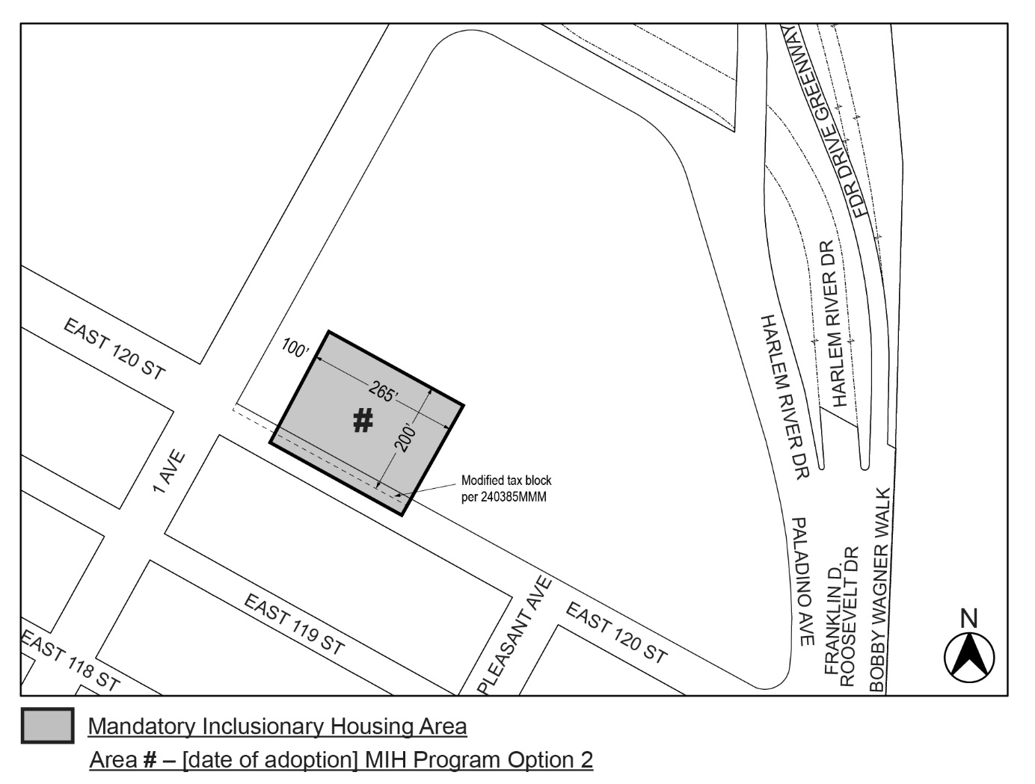

Portion of Community District 11, Manhattan

* * *

Adopted.

Office of the City Clerk,}
The City of New York,} ss.:

I hereby certify that the foregoing is a true copy of a Resolution passed by The Council of The City of New York on _________, 2025, on file in this office.

.....................................................
City Clerk, Clerk of The Council

