THE COUNCIL OF THE CITY OF NEW YORK
RESOLUTION NO. 1859

Resolution approving the decision of the City Planning Commission on Application No. N 210042 ZRQ, for an amendment of the text of the Zoning Resolution (Preconsidered L.U. No. 955).

By Council Members Salamanca and Moya

WHEREAS, Sunshine Elmhurst, LLC, filed an application pursuant to Section 201 of the New York City Charter, for an amendment of the text of the Zoning Resolution of the City of New York, modifying Appendix F for the purpose of establishing a Mandatory Inclusionary Housing area, which in conjunction with the related action would facilitate the development of a nine-story residential building at 45-20 83rd Street in the Elmhurst neighborhood of Queens, Community District 4 (ULURP No. N 210042 ZRQ), (the “Application”);

WHEREAS, the City Planning Commission filed with the Council on December 1, 2021, its decision dated December 1, 2021 (the "Decision") on the Application;

WHEREAS, the Application is related to application C 210041 ZMQ (Pre. L.U. No. ___), a zoning map amendment to change an M1-1 zoning district to an R7A district;

WHEREAS, the Decision is subject to review and action by the Council pursuant to Section 197-d of the City Charter;

WHEREAS, upon due notice, the Council held a public hearing on the Decision and Application on December 2, 2021;

WHEREAS, the Council has considered the land use implications and other policy issues relating to the Decision and Application; and

WHEREAS, the Council has considered the relevant environmental issues, including the Negative Declaration issued July 26th, 2021 (CEQR No. 21DCP113Q), which includes an (E) designation to avoid the potential for significant adverse impacts related to hazardous materials, air quality, and noise (E-630) (the “Negative Declaration”).

RESOLVED:

The Council finds that the action described herein will have no significant impact on the environment as set forth in the (E) Designation (E-630) and Negative Declaration.

Pursuant to Sections 197-d and 200 of the City Charter and on the basis of the Decision and Application, and based on the environmental determination and consideration described in the report, N 210042 ZRQ, incorporated by reference herein, and the record before the Council, the Council approves the Decision of the City Planning Commission.

Matter underlined is new, to be added;
Matter struck out is to be deleted;
Matter within # # is defined in Section 12-10;
* * * indicates where unchanged text appears in the Zoning Resolution.

* * *

APPENDIX F
Inclusionary Housing Designated Areas and Mandatory Inclusionary Housing Areas

* * *

QUEENS

* * *

Queens Community District 4

* * *

Map # – [date of adoption]

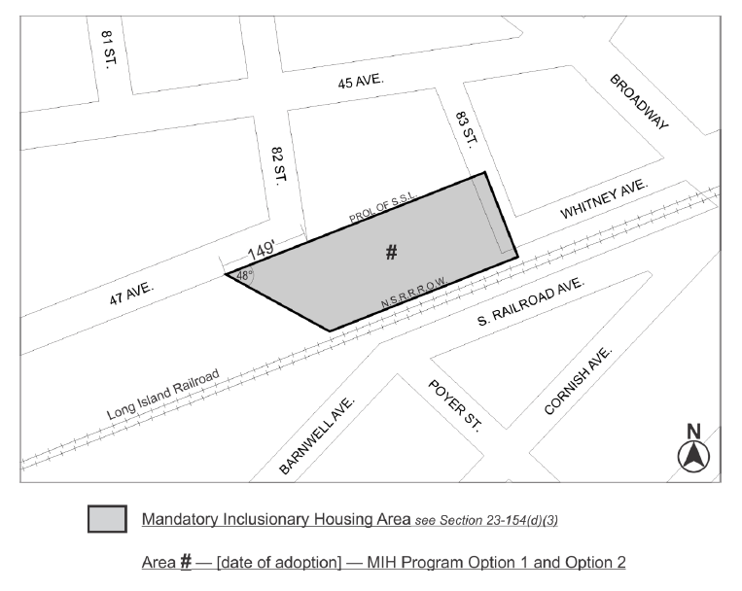

Portion of Community District 4, Queens

* * *

Adopted.

Office of the City Clerk,}
The City of New York,} ss.:

I hereby certify that the foregoing is a true copy of a Resolution passed by The Council of The City of New York on ___ ______, 2021, on file in this office.

.....................................................
City Clerk, Clerk of The Council

