Committee on Criminal Justice
Alana Sivin, Legislative Counsel
Kieshorne Dennie, Policy Analyst
Jin Lee, Financial Analyst



THE COUNCIL OF THE CITY OF NEW YORK
COMMITTEE REPORT AND BRIEFING PAPER OF THE
JUSTICE DIVISION
Jeffrey Baker, Legislative Director
Brian Crow, Deputy Director, Justice Division

COMMITTEE ON CRIMINAL JUSTICE
Hon. Keith Powers, Chair

February 26, 2019

OVERSIGHT
Correctional Programming

INT. NO. 261 By Council Member Richards

TITLE A Local Law to amend the New York City Charter, in relation to requiring DOC to conduct survey related to inmate quality of life.

ADMIN. CODE Add Section 9-153

INT. NO. 1184 By Council Member Dromm

TITLE A Local Law to amend the New York City charter, in relation to books in city correctional facilities

ADMIN. CODE Amends Section 9-155

- Introduction
On February 26, 2018, the Committee on Criminal Justice, chaired by Council Member Powers, will hold an oversight hearing on the programming offered to incarcerated individuals at the Department of Correction (DOC). The committee will also hear Introduction Number 261, a local law to amend the New York City Charter in relation to requiring DOC to conduct a survey related to inmate quality of life. It will also hear Introduction Number 1184, a local law to amend the New York City Charter in relation to books in city correctional facilities. The committee is expecting representatives from DOC, program providers, advocates, and other key stakeholders to testify.
- Background

Correctional programming for incarcerated persons encompasses a wide range of services and interventions, including educational, employment, and social support programming, as well as cognitive behavioral therapy and other mental health interventions. Such programs address the criminogenic and behavioral health needs of incarcerated individuals as they are associated with criminal behavior and misconduct in correctional facilities. Research shows that addressing these needs can improve the behavior of incarcerated individuals before and after their release from custody, which in turn can reduce misconduct in correctional facilities, improve post-release employment and reduce recidivism.

While the objective of correctional programming is to reduce misconduct in correctional settings and recidivism, the results have been mixed, though still generally positive. Studies show that correctional education and employment programs produced positive outcomes for post-release employment but have modest impact on misconduct in correctional settings and recidivism. But where correctional education programming is centered on post-secondary education, the outcome has been positive with respect to misconduct and recidivism. Studies also show that correctional social support programming and cognitive behavioral theory successfully decrease misconduct and reduce recidivism with the latter being the most effective in reducing misconduct in correctional facilities. Yet, despite the relatively positive impact of these programs, research suggests that many incarcerated individuals do not participate in programming while in custody.
- Programming in DOC Facilities
Under New York City law, DOC is required to offer individuals in its custody at least five hours programming or education per day except where the person is housed in punitive segregation or ineligible or unavailable for programming or education, or where providing programming or education creates a safety risk. In addition, local law requires the DOC to provide every incarcerated individual upon admission to DOC custody with written and oral information about “available services relating to education, vocational development, drug and alcohol treatment and counseling, and mental health treatment and counseling services” using “plain and simple language.” Under New York City law, the department is also required to report on the programs provided to incarcerated individuals, including (i) the amount of funding received; (ii) estimated number of incarcerated individuals served; (iii) a brief description of the program including the estimated number of hours of programming offered and utilized, program length, goals, target populations, effectiveness, and outcome measurements, where applicable; and (iv) successful completion and compliance rates.
While the department’s most recent report under this mandate lists certain metrics, the data are in many ways unclear. For example, out of 18 programs listed, the department only for three programs noted a number of “successful completions/milestones/certificates” in its CY 2017 report. For the remaining 15 programs, the report describes completions/milestones/certificates as “N/A.” Similarly, the department’s report fails to account for participation numbers for eleven of the eighteen programs listed. While the DOC report does provide a brief description of each of its 18 funded programs – and a summary of those programs is described below - it provides little to no information about the various additional programs that are provided to adults in DOC facilities through volunteer organizations.
In-House Programming
DOC facilities host their own counseling services, which include corrections-led individual counseling, group counseling, and social services. Adults and young adults housed in co-mingled general population housing areas and in the co-mingled Enhanced Supervision Housing areas have the option to receive DOC counseling services 2.5 hours between 2 and 3 days per week. Similarly, DOC offers “counselor-led programs” which focus on four areas: life skills, individual counseling, group services, and group counseling for adolescents and young adults. Counseling for this population is available for a minimum of 3 hours for 5 days per week. While the DOC has not published general information indicating how many incarcerated individuals have utilized DOC counseling services, it provides monthly progress reports on young adults who utilize internal programming in co-mingled areas.
Contracted Discharge, Reentry, and Vocational Programs
DOC contracts with various external discharge, reentry, and vocational providers. It houses two Individualized Correctional Assessment Network (I-CAN) programs – one at Osborne Association and the other at Fortune Society – to improve reentry efforts. The Osborne Association received about $7.6 million from the DOC in CY 2017 to provide job readiness and vocational training, in addition to other services such as anger management, financial literacy, and housing assistance. The Fortune Society received about $6.8 million to also provide job readiness and vocational training, in addition to housing assistance, cognitive behavioral therapy, and other services. In CY 2017, the average daily participation number for Fortune Society’s program was 469, and 458 for Osborne Association’s program.
DOC also contracts with five Specialized Model for Adult Reentry and Treatment (SMART) programs, which offer pre and post-release services in work readiness, behavioral interventions, housing, and job placement. SMART programs have different providers and receive different amounts in funding from DOC. Samaritan Daytop received about $614,000 in CY 2017 and had an average daily participation number of 128; STRIVE International received about $246,000 and had an average daily participation number of 43; Fedcap received about $1.07 million and had an average daily participation number of 130; Greenhope (which only serves women) received about $99,000 and had an average daily participation number of 25; and Housing Works received $515,012.32 in CY 2017, and had an average participation number of 99.
Programming for Adolescents and Young Adults
The department also contracts with several youth vocational services providers, including the Workforce Development Industry Recognized Training and Workforce Development Trading Futures, which both received about $1.7 million. The Youth Reentry Network is the largest provider for incarcerated youth in New York City and received about $4.1 million. In 2016, Friends of Island Academy launched the network, which is composed of 40 subcontracted youth organizations that “provide programming support to help minimize idle time and mitigation tensions/trauma, using time in custody to enrich and build skills among young people.” It is unclear how many young adults and adolescents participate in each program, and the DOC’s report does not provide a number for total or disaggregated participation. However, because DOC is required to provide monthly progress reports on programming for young adults in comingled units to the Board of Correction (BOC), DOC provides more detailed reports on the components of programming received by young adults in DOC facilities and on the total number of participants. According to the DOC’s last progress report, young adults participated in various internal and external programs, including anger-management, community meeting, civic education, and “education tablet."
- Issues and Concerns
Tracking and Evaluation
The committee is interested in learning more about DOC programming, including the number of programs available to incarcerated individuals, the number of people eligible for programming and the number enrolled, and the overall program participation rate and completion rate over the last two years following the adoption of Local Law 122 of 2016. To that end, the committee would like to learn about DOC’s systems and procedures for tracking the number of available programs and the number of people enrolled in those programs and evaluating the efficacy and quality of these programs to ensure that these programs are meeting the needs of incarcerated individuals.
Young Adults in ESH
The BOC conducts regular audits in Enhanced Supervision Housing (ESH) Units to track the degree to which young adults are offered and receive up to seven hours of programming. In its most recent December 2018 report, the Board could not determine young adult program participation in at least two incidents due to conflicting programming and housing area records. Accordingly, the BOC recommended designating supervisory staff to review programming attendance and to resolve inconsistencies. Furthermore, the BOC found that in many instances, incarcerated young adults were offered “self-guided programming” through tablets; the committee is interested in learning more about such self-guided programs and in ensuring that they do not replace interactive programming.
Access and Training
Program providers have brought several concerns to the Council surrounding access to programming, provider clearance, and volunteer training. Despite the law mandating that DOC provides information regarding programming to incarcerated individuals, program providers have expressed to the Council that many incarcerated individuals are not made aware of available programs or how to sign up for such programs. Similarly, volunteer providers have complained about the difficulty they face gaining entry into facilities. Temporary clearances are maintained on paper and communicated by fax, and volunteers have voiced that such clearances are often lost once they arrive at DOC facilities to conduct programming; as a result, incarcerated individuals lose the opportunity to participate in sessions.
Volunteers have also voiced concerns with the content of trainings, finding that such trainings are not only onerous, but also depict incarcerated individuals as manipulative and dangerous. In one example, a volunteer noted that the leaders of a PREA training compared incarcerated individuals to “garbage.” Other volunteers have mentioned that volunteer trainings feature a video of a violent assault conducted outside of DOC facilities. Program providers have expressed concern that the content of these trainings dissuade individuals from continuing to volunteer at DOC facilities. Moreover, while information regarding certain programs is made available on the DOC’s website, several program providers who regularly provide services at Rikers Island are not listed there or in the inmate handbook. The inmate handbook does discuss a reentry services program called “RIDE,” but there is no publicly available information on that program, or whether it still exists at all.
V. Bill Analysis
Introduction 261 (Richards): This bill would require the department of correction to administer an annual survey of inmates in city jails regarding living conditions and treatment by correction officers. The bill also require the department to post the findings from the survey on its website and submit a copy to the Speaker’s Office. The bill takes effect immediately once it becomes law.
Introduction 1184 (Dromm): This bill would require the department of correction to maintain a library offering general interest books to inmates in New York City jails. The library would be open during normal waking hours and incarcerated individuals would be permitted to access the library and borrow books, except during lockdown times. These books must be maintained in good condition and may be censored only if they may compromise the safety of the facility or provide instructions for escape. The department of corrections would also be required to report on the number of books it receives, the source of those books, and if those books are censored, the reason for censorship. The bill takes effect 120 days after it becomes law.

Appendix A: Internal Programming Participation for young adults in comingled units
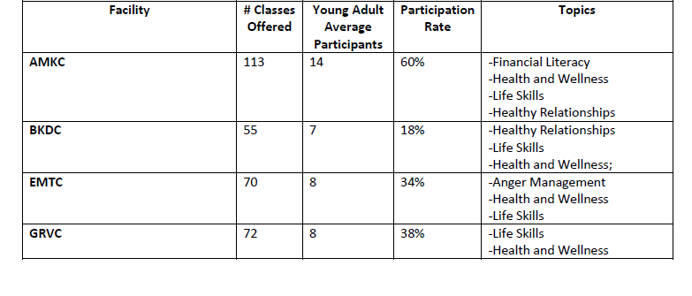
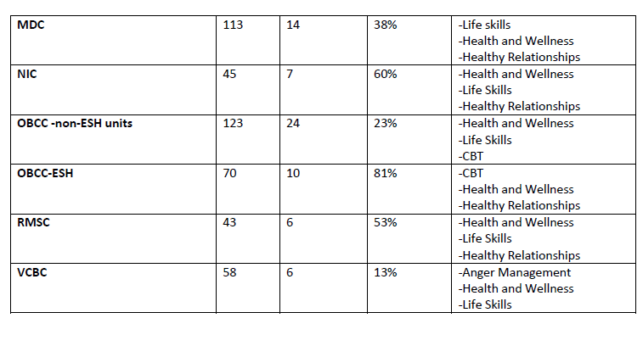
Source: Board of Correction, Young Adult Housing Monthly Progress Report, February 2019, available at https://www1.nyc.gov/assets/boc/downloads/pdf/Reports/BOC-Reports/February_2019_YA_Progress_Report.pdf

Appendix B: Number of Classes or Meetings Offered and the Average Number of Participants for Each Program Offered to Young Adults at All Facilities

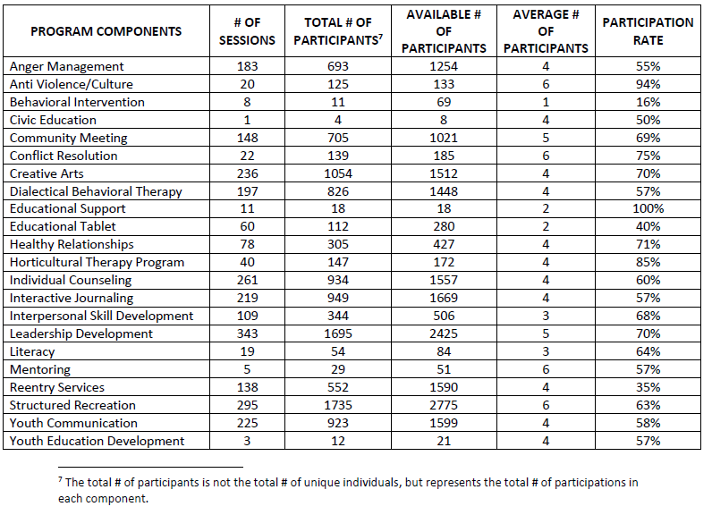
Source: Board of Correction, Young Adult Housing Monthly Progress Report, February 2019, available at https://www1.nyc.gov/assets/boc/downloads/pdf/Reports/BOC-Reports/February_2019_YA_Progress_Report.pdf

Int. No. 261

By Council Members Richards and Brannan

A Local Law to amend the administrative code of the city of New York, in relation to requiring the department of correction to conduct a survey related to inmate quality of life

Be it enacted by the Council as follows:
Section 1. Title 9 of the administrative code of the city of New York is amended by adding a new section 9-153 to read as follows:
§ 9-153 Inmate surveys.
a. Commencing one year after the effective date of the local law that added this section, an agent of the department shall provide all inmates with an annual survey regarding such inmate’s experiences in city jails. Such survey shall not attribute responses to any individual without their consent. In addition to questions, such survey shall include space for inmates to provide any additional information they wish to share.
b. Such survey shall be designed by the department in coordination with the agent designated in subdivision a of this section and relevant inmate advocates and health professionals.
c. Such survey shall include but not be limited to questions addressing the topics of living conditions and treatment by departmental employees.
d. No later than six months following the first administration of the survey, and annually thereafter, the department shall submit to the speaker of the council and post on its website aggregated data from the surveys required pursuant to this section and any steps the department has taken in response to the information provided in such surveys.
e. No information that is otherwise required to be reported pursuant to this section shall be reported in a manner that would violate any applicable provision of federal, state or local law relating to the privacy of information or that would interfere with law enforcement investigations or otherwise conflict with the interests of law enforcement.
§ 2. This local law takes effect immediately.

BC
LS 12009/Int. 1832-2017
LS 650
1/2/18

Int. No. 1184

By Council Member Dromm

A Local Law to amend the administrative code of the city of New York, in relation to books in city correctional facilities

Be it enacted by the Council as follows:

Section 1. Chapter 1 of title 9 of the administrative code of the city of New York is amended by adding a new section 9-155 to read as follows:
§ 9-155 Access to publications. a. The commissioner shall provide inmates with access to a library containing new or used publications from publishers, organizations, and outside donors. Such access shall be offered within 48 hours of the inmate’s admission whether or not affirmatively requested by the inmate.
b. Such library shall offer a variety of fiction and non-fiction publications, which shall not be censored unless they contain instructions on the manufacture or use of dangerous weapons or explosives, plans for escape, or other materials that may compromise the safety and security of the facility.
c. Publications offered to inmates shall be maintained in good condition.
d. Inmates shall be permitted to borrow such publications to read outside the library.
e. Such library shall be open during from at least 8:00 a.m to 9:00 p.m., and access by inmates shall not be restricted except during lockdown times.
f. No later than December 1, 2019, and on or before December 1 annually thereafter, the department shall report to the mayor and the council, and post on its website, the number of publications provided in each facility under the jurisdiction of the department, the source of such publications and, if such publications were censored, the reason for their censorship.
§ 2. This local law takes effect 120 days after it becomes law, provided that the commissioner of correction shall take all necessary action, including the promulgation of rules, before such effective date.

JG
LS # 7659
10/11/18 4:18 PM

Grant Duwe, The Use and Impact of Correction Programming for Inmates on Pre- and Post-Release Outcomes (June 2017), National Institute of Justice, available at https://www.ncjrs.gov/pdffiles1/nij/250476.pdf
Id.
Id.
Id.
Id at 22.
Id.
Id at 21.
Id at 8.
NYC Admin Code § 9-110
NYC Admin Code § 9-139
NYC Admin Code § 9-144
Department of Correction, Local Law 122 Report, CY 2017, available at https://www1.nyc.gov/assets/doc/downloads/pdf/LL_122_2017.pdf
Id.
Id.
Id.
Department of Correction, Local Law 122 Report, CY 2017, available at https://www1.nyc.gov/assets/doc/downloads/pdf/LL_122_2017.pdf
Id.
See Appendix A.
Department of Correction, Local Law 122 Report, CY 2017, available at https://www1.nyc.gov/assets/doc/downloads/pdf/LL_122_2017.pdf
Id.
Id.
Department of Correction, Local Law 122 Report, CY 2017, available at https://www1.nyc.gov/assets/doc/downloads/pdf/LL_122_2017.pdf
Organizations provided through the Youth Reentry Network Include Adeyemi Artistry, Alive and Free Community Outreach, Artistic Noise, A Voice For the Unheard, Bar Code Fitness, Bronx Connect, CASES, Cello Without Walls, Center For Community Alternatives, Chess NYC, Community Mediation Services, DREAMS/YouthBuild, Educate 2 Empower, The F.A.R.M NY, Frontline, Getting Out Staying Out, Glass Walls, Giant Thinking, Girl Vow, Good Samaritan Men’s Outreach, Healthy Masculinity, The International Child Program, Journalism and Writing Program, Lead by Example, Living Story Lab, The Possibility Project, Professional Development, Rebirth of a Woman, Speak Up, Success is a Journey, Urban Art Beat, Yaffa Cultural Arts, Youth Educational Development, Youth Represent, and 5-Star Youth. Friends of Island Academy, Youth Reentry Network, available at http://www.friendsny.org/home-grey-revised/youth-reentry-network/our-partnerships/
Hearing Testimony of Friends of Island Academy, Juvenile Justice Oversight Hearing, January 16, 2019, available at https://legistar.council.nyc.gov/LegislationDetail.aspx?ID=3822995&GUID=E0860207-12F8-4618-9E54-AE7429930DCD&Options=Advanced&Search=
Department of Correction, Local Law 122 Report, CY 2017, available at https://www1.nyc.gov/assets/doc/downloads/pdf/LL_122_2017.pdf
See Appendix A
Board of Correction, Young Adult Housing Monthly Progress Report, February 2019, available at https://www1.nyc.gov/assets/boc/downloads/pdf/Reports/BOC-Reports/February_2019_YA_Progress_Report.pdf
New York City Department of Correction, Young Adult ESH Compliance Audit – December 2018, available at https://www1.nyc.gov/assets/boc/downloads/pdf/Reports/DOC-Reports/YA-ESH-Audit/Final%20Public%20ESH%20Audit%20Report%20-%20December%202018.pdf
Id.
New York City Department of Correction, Inmate Handbook, p 15, available at https://www1.nyc.gov/assets/doc/downloads/pdf/inmate_hand_book_english.pdf

