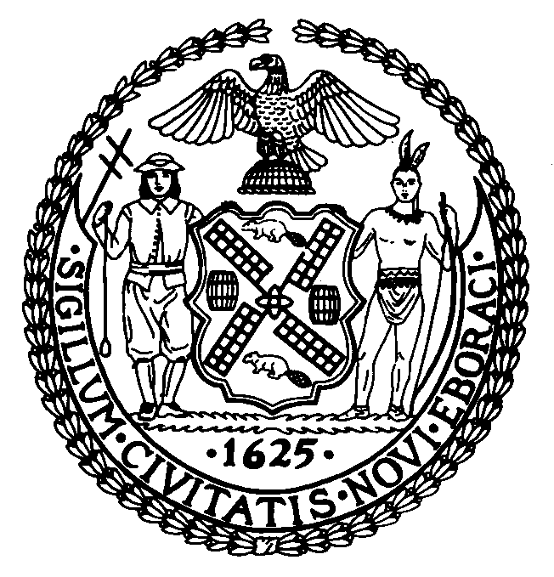 | The Council of the City of New York  Finance Division  Larian Angelo, Director  Fiscal Impact Statement  No: SLR 113 (S 7159 & A 11042)  Committee: State and Federal Legislation
Title: An act to amend the administrative code of the city of New York and the retirement and social security law, in relation to providing improved ordinary death benefits to emergency medical technicians employed in the city of New York | Sponsors: Council Member Rivera,
Summary of Legislation: Provides ordinary death benefits for FDNY EMTs and Paramedics (including their supervisors) equivalent to those available to other FDNY first responders (Firefighters, Fire Marshals) who joined the New York City Fire Department at the same time, city Sanitation Workers, Police Officers and Correction Officers.

Effective Date: This legislation shall take effect immediately.

Fiscal Year In Which Full Fiscal Impact Anticipated: Fiscal 2005

Fiscal Impact Statement:
 | Effective FY05 | FY Succeeding  Effective FY06 | Full Fiscal  Impact FY05
Revenues (+) | $0 | $0 | $0
Expenditures (-) | $75,000 | $75,000 | $75,000
Net | ($75,000) | ($75,000) | (75,000)

Impact on Revenues: There is no impact on revenue.

Impact on Expenditures: The cost of this legislation will be approximately $75,000 a year.

Source of Funds To Cover Estimated Costs: General Fund
Source of Information: Department of Finance

Estimate Prepared By: Frank Tramontano,First Deputy Director Daniel Turriago, Principal Financial Analyst, City Council Finance Division.

FIS History: This is a new bill
Date Submitted to Council: June 2, 2004

