THE COUNCIL OF THE CITY OF NEW YORK
RESOLUTION NO. 1777

Resolution approving the decision of the City Planning Commission on Application No. N 130065 ZRX, for an amendment of the Zoning Resolution of the City of New York, concerning Appendix F (Inclusionary Housing Designated Areas) in Community District 4, Borough of the Bronx (L.U. No. 804).

By Council Members Comrie and Weprin

WHEREAS, the City Planning Commission filed with the Council on April 12, 2013 its decision dated April 10, 2013 (the "Decision"), pursuant to Section 201 of the New York City Charter, regarding an application submitted by NR Property 2 LLC, for an amendment of the text of the Zoning Resolution of the City of New York, concerning Appendix F (Inclusionary Housing Designated Areas), in a proposed R7A zoning district to facilitate the development of a seven-story 147,821 square foot mixed use development with 100 residential units and 24 affordable units located at the corner of East 150th Street and Gerard Avenue (Block 2353, Lot 1) in Community District 4 (Application No. N 130065 ZRX), Borough of the Bronx (the "Application");

WHEREAS, the Application is related to application N 130064 ZMX (L.U. No. 803), a zoning map amendment changing from M1-2 to an R7A zoning district with a C2-4 overlay;

WHEREAS, the Decision is subject to review and action by the Council pursuant to Section 197-d(b)(1) of the City Charter;
WHEREAS, upon due notice, the Council held a public hearing on the Decision and Application on May 13, 2013;

WHEREAS, the Council has considered the land use implications and other policy issues relating to the Decision and Application; and

WHEREAS, the Council has considered the relevant environmental issues, the negative declaration (CEQR No. 11DCP143X) issued on November 13, 2012 (the “Negative Declaration”);

RESOLVED:

The Council finds that the action described herein will have no significant impact on the environment as set forth in the Negative Declaration and subject to CEQR Declaration E-292.

Pursuant to Sections 197-d and 200 of the City Charter and on the basis of the Decision and Application, and based on the environmental determination and consideration described in this report, N 130065 ZRX, incorporated by reference herein, the Council approves the Decision.

The Zoning Resolution of the City of New York, effective as of December 15, 1961, and as subsequently amended, is further amended as follows:

Matter Underlined is new, to be added;
Matter in Strikeout is old, to be deleted;
Matter within # # is defined in Section 12-10;
* * * indicate where unchanged text appears in the Zoning Resolution

APPENDIX F
Inclusionary Housing Designated Areas
The boundaries of #Inclusionary Housing designated areas# are shown on the maps listed in this Appendix F. The #Residence Districts# listed for such areas shall include #Commercial Districts# where #residential buildings# or the #residential# portion of #mixed buildings# are governed by the #bulk# regulations of such #Residence Districts#. Where #Inclusionary Housing designated areas# are mapped in #Commercial Districts#, the residential district equivalent has instead been specified for each map.
* * *

The Bronx, Community District 4

In the R7A, R8A and R9D Districts within the areas shown on the following Map 1:

* * *
EXISTING
(TO BE DELETED)
Map 1 (9/30/09)
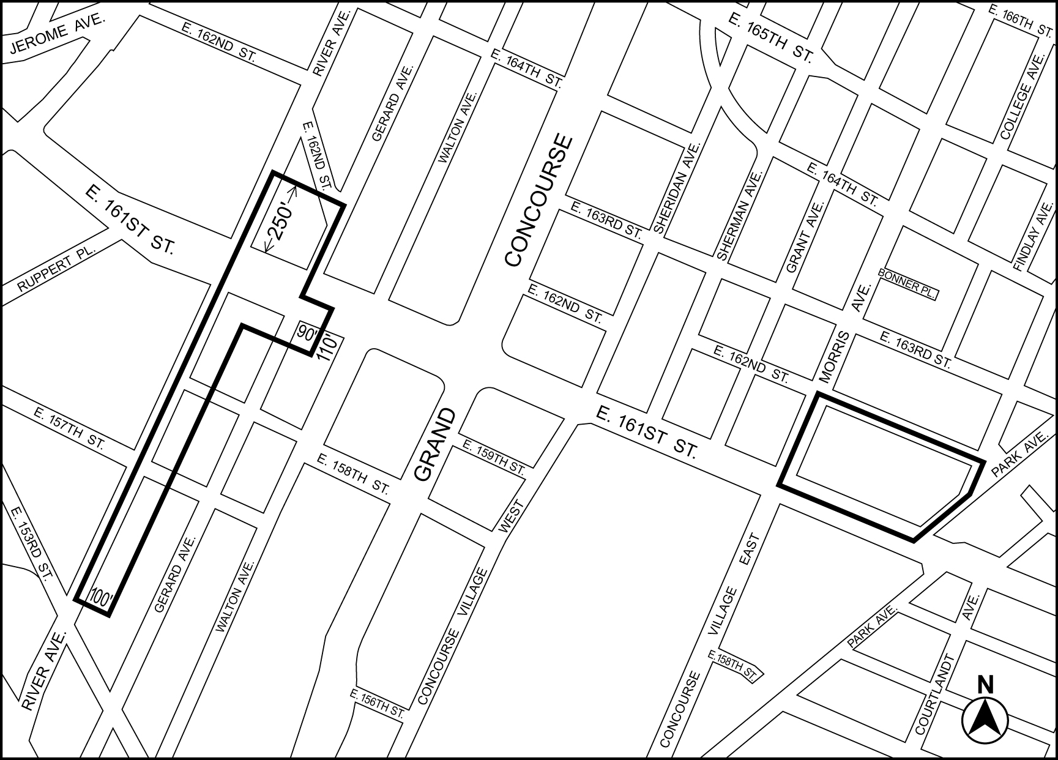

Portion of Community District 4, The Bronx

PROPOSED
(TO REPLACE EXISTING)
Map 1 (x/xx/xx)
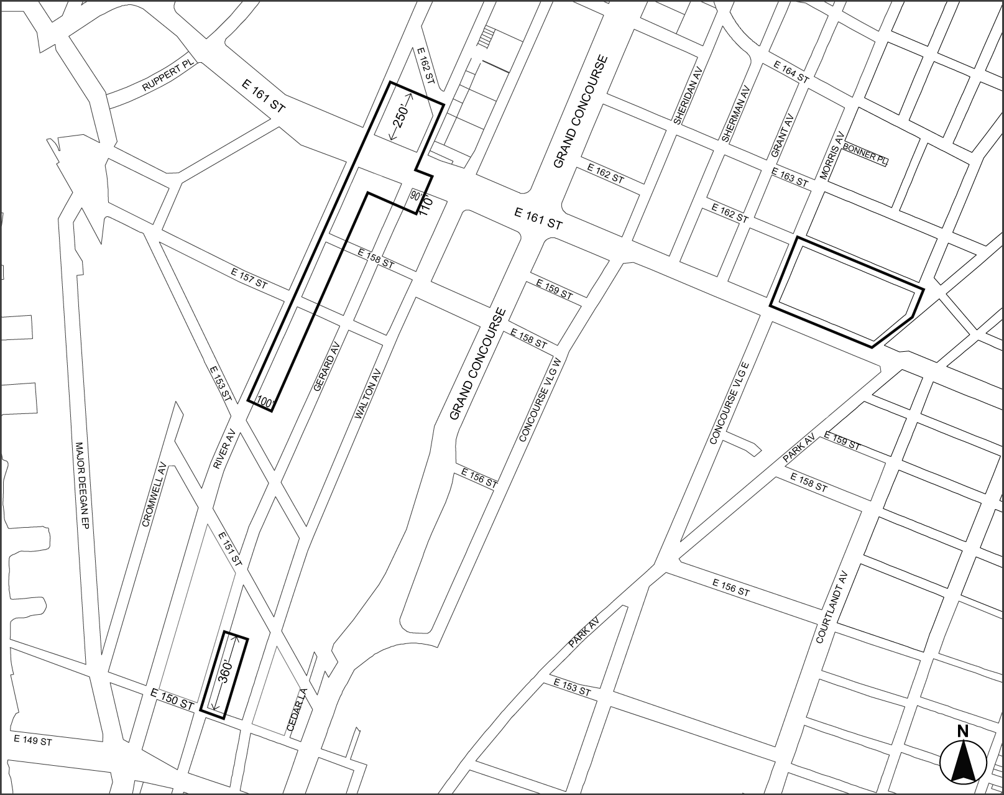

Portion of Community District 4, The Bronx
Adopted.
Office of the City Clerk, }
The City of New York, } ss.:

I hereby certify that the foregoing is a true copy of a Resolution passed by The Council of The City of New York on May 22, 2013, on file in this office.

.....…….........................................
City Clerk, Clerk of The Council

