Committee on Cultural Affairs, Libraries and
International Intergroup Relations
Christina Yellamaty, Legislative Counsel
Regina Paul, Legislative Policy Analyst
Sandra Gray, Financial Analyst

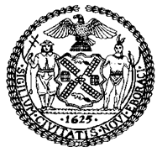

THE COUNCIL OF THE CITY OF NEW YORK

Briefing Paper of the Legislative Division
Andrea Vazquez, Director
Smita Deshmukh, Deputy Director, Human Services

Committee on Cultural Affairs, Libraries and
International Intergroup Relations
Hon. Chi Ossé, Chair

November 6, 2023

Oversight: An Update on the Percent for Art Program

INTRODUCTION
On October 31, 2023, the Committee on Cultural Affairs, Libraries and International Intergroup Relations, chaired by Council Member Chi Ossé, will hold an oversight hearing on Oversight: An Update on the Percent for Art Program. Witnesses invited to testify include the Department of Cultural Affairs (DCLA), various arts and cultural groups and organizations, community members, and other interested stakeholders.

BACKGROUND
In New York City (NYC), the Percent for Art law requires that one percent of the budget for eligible City-funded construction projects be spent on artwork for City facilities. It was initiated by Mayor Edward Koch and passed by the City Council in 1982. DCLA, the City agency responsible for helping to fund hundreds of arts and cultural organizations across the five boroughs, administers the program. DCLA developed a process for determining eligible projects and for selecting artists on an equitable basis. As a result of the law, permanent, site-specific artworks for a wide range of public facilities are commissioned, making art broadly accessible throughout NYC. The artists use various media, including painting, sculpture, mosaic, glass, textile, and lighting as well as works that are integrated into the infrastructure and architecture of whatever is being built. According to the Percent for Art Program website, the purpose of the Program is “to bring artists into the design process and enrich the City’s civic and community buildings.” The graph below shows how Percent for Art projects are geographically distributed:
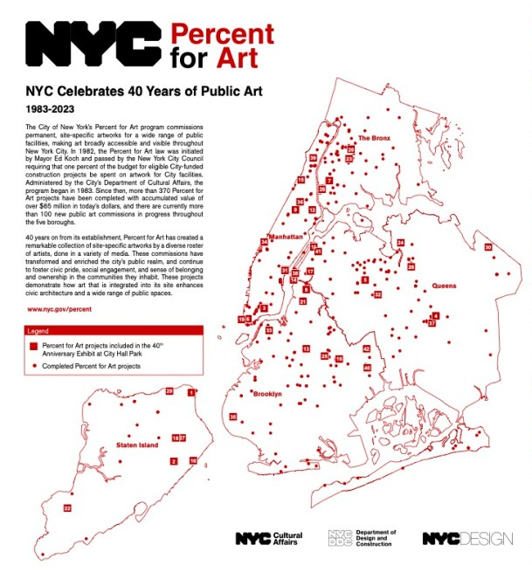

As of 2023, more than 370 Percent for Art projects have been completed, with an accumulated value of over $65 million, and there are currently more than 100 new public art commissions in progress throughout the five boroughs. DCLA, along with the Department of Design and Construction (DDC), recently unveiled an installation featured on a construction fence surrounding the steps at City Hall as it undergoes renovation. The installation, which celebrates the 40th anniversary of Percent for Art, includes images of more than 40 of the permanent public artworks commissioned through the Program since it was established. This text is featured on the fence installed at City Hall: “The Percent for Art program remains a crucial way for the creative vision of artists to be deeply embedded in our collective civic realm in a way that is collaborative with the agencies, designers, and residents these public projects are intended to serve.”

CreateNYC
CreateNYC, the comprehensive cultural plan for NYC, was developed in 2017 and recognized the importance of having art accessible in public spaces. CreateNYC proposed to “[i]ncrease opportunities for artists to work in public agencies and public space” (Objective 1) under the category of Arts and Culture in Public Space and, specifically, proposed this strategy: “Increase support for the Percent for Art program, which commissions artists to create public artworks that are integrated into infrastructure and architecture of eligible City-funded projects.” CreateNYC further noted that the City should “[s]upport the maintenance of completed Percent for Art projects” and “[c]reate opportunities to support socially engaged practices in combination with Percent for Art commissions.”
When translated into DCLA’s Action Plan in 2019, that strategy became Objective 1 Strategy B, “Increase funding for individual artists, especially those from underrepresented communities,” and Objective 1 Strategy G, “Support more opportunities for temporary and permanent art in public spaces.” In Fiscal Year 2019, actions taken to accomplish Strategy B included providing technical assistance to help underrepresented artists apply for Percent for Art public art commissions in low-income neighborhoods. Actions taken in Fiscal Year 2018 to accomplish Strategy G included passing legislation to increase the budget for Percent for Art projects for the first time since the law was established in 1982 in order to allow for larger commissions of permanent art and more artists per project. According to the Action Plan website, these specific commissions also were tagged as actions related to the Percent for Art Program: “Dedicated $10 million to commission new public monuments of historically underrepresented figures” (2018); “Announced seven new monuments to honor women-identified trailblazers who made extraordinary contributions to NYC” (2019); “Commissioned Artist Vinnie Bagwell to design a new monument to replace the statue of J. Marion Sims at 103rd Street and Fifth Avenue” (2020); “Installed ‘Unity,’ a new permanent, public artwork by Artist Hank Willis Thomas in downtown Brooklyn” (2020); “Collaborated with DOT Art and Marcus Garvey Park Alliance to install Boulevard of African Monarchs, a temporary monument at 116th Street and Adam Clayton Powell Blvd. in Harlem” (2020); and “Announced a new monument in Central Park to honor the Lyons Family who made extraordinary contributions” to NYC (2020).

CONCLUSION
At today’s hearing, the Committee expects to hear an overview of how the Percent for Art Program is operating today, including an explanation of the process of selecting artists and projects. The Committee is interested in what works are currently commissioned for what buildings and in the selection process for those particular buildings, including how those buildings are geographically distributed across the five boroughs. The Committee is also interested in the racial and ethnic backgrounds of artists chosen for commissioned works and the selection process for those artists. Finally, the Committee wants to understand the financial aspects of the Program, including total amounts commissioned and actually spent over the past 10 years.

About Percent for Art at https://www.nyc.gov/site/dclapercentforart/about/about.page#:~:text=In%201982%2C%20the%20Percent%20for,on%20artwork%20for%20City%20facilities.
Id.
Id.
The Department of Cultural Affairs Percent for Art at https://www.nyc.gov/site/dclapercentforart/index.page.
Supra, note 1.
Celebrating 40 Years of “Percent for Art” at https://thecitylife.org/2023/05/12/celebrating-40-years-of-percent-for-art/.
Id.
Id.
Id.
Id.
CreateNYC—A Cultural Plan for All New Yorkers at https://createnyc.cityofnewyork.us/the-cultural-plan/main/.
Id.
Id.
The Action Plan at https://createnyc.cityofnewyork.us/the-action-plan/.
Id.
Id.
Id.

