Consumer Affairs and Business Licensing Committee
Leah Skrzypiec, Policy Analyst
Noah Meixler, Policy Analyst
J. Florentine Kabore, Financial Analyst

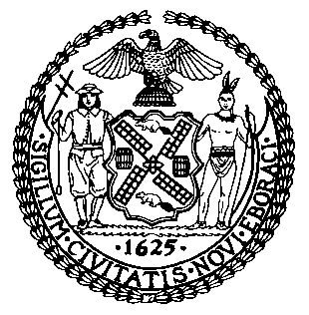

THE COUNCIL OF THE CITY OF NEW YORK

BRIEFING PAPER OF THE GOVERNMENTAL AFFAIRS DIVISION

Jeffrey Baker, Legislative Director

Rachel Cordero, Deputy Director for Governmental Affairs

COMMITTEE ON CONSUMER AFFAIRS AND BUSINESS LICENSING

Hon. Diana Ayala, Chair

February 8, 2021

Oversight: The Office of Financial Empowerment

- INTRODUCTION
On February 8, 2021, the Committee on Consumer Affairs and Business Licensing, chaired by Council Member Diana Ayala, will hold an oversight hearing on the Department of Consumer and Worker Protection’s (DCWP) Office of Financial Empowerment (OFE). The Committee has invited DCWP, OFE, advocates, legal and financial assistance groups, and other interested parties to testify.

- BACKGROUND
In December of 2006, then-Mayor Michael Bloomberg established the Center for Economic Opportunity (CEO), which sought to reduce the number of individuals living in poverty in New York City. CEO concentrated on high-poverty groups with the capacity to make demonstrable progress towards long-term financial stability. In an effort to provide financial counseling to low-income individuals, CEO developed the Office of Financial Empowerment (OFE). OFE was the first local government program in the nation directly aimed at “educating, empowering, and protecting those with low incomes, so they can build assets and make the most of their financial resources.” OFE was part of CEO’s multi-faceted anti-poverty initiative and was administered by DCWP. In 2014, the CEO was moved to the Mayor’s Office of Operations, eventually evolving to become NYC Opportunity in 2017. OFE, meanwhile, has remained part of DCWP.
To achieve its central goal of assisting New Yorkers with lower incomes, OFE has identified specific strategic priorities. These include: (i) increasing access to high-quality, low-cost financial education and counseling; (ii) increasing access to safe and affordable mainstream banking, and (iii) increasing access to income-boosting tax credits and savings.
- Financial Education and Counseling
OFE’s core mission is to ensure that consumers are outfitted with the best information to make educated decisions regarding their finances. To increase financial literacy, OFE established Financial Empowerment Centers (FEC), which offer New Yorkers direct one-on-one professional financial counseling on a variety of topics including, but not limited to, debt reduction, improving credit, and opening a bank account. In 2018, to celebrate the 10th anniversary of the FEC, the OFE launched "When it comes to money, we could all use a coach sometimes," a multi-lingual public awareness campaign. From 2008 through 2018, the FEC conducted 100,000 counseling sessions, helping 50,000 New Yorkers improve their financial health. Because of the financial challenges posed by the pandemic, the OFE has also recently produced public campaigns to raise awareness of their financial counseling services. FEC sessions are currently being conducted exclusively over the phone due to the pandemic.
In October of 2019, the OFE launched EmpoweredNYC, a campaign to raise awareness of financial counseling services tailored specifically to City residents with disabilities. EmpoweredNYC offers City residents with disabilities free and confidential counseling on topics including managing Supplemental Security Income or Social Security Disability Insurance benefits, transitioning to work, and tackling Social Security Administration overpayments.
The OFE’s FEC also collaborated with the Department of Housing Preservation and Development to administer “Ready to Rent,” which offers one-on-one counseling services to New Yorkers needing assistance in preparing to apply for affordable housing.
- Access to Banking
The OFE promotes the importance of maintaining a bank account as an avenue for individuals to monitor their spending and manage their money. In an effort to promote this form of financial stability, OFE created the NYC SafeStart Account, a starter account that provides a safe banking product with no fees to lower-income clients. There are six NYC SafeStart partner banks and credit union branches that offer this banking service. OFE also offers educational resources to City residents on how to open a checking account, understand prepaid cards, and how to create a 529 plan.
Additionally, in the Fall of 2011, OFE partnered with the New York City Office of Payroll Administration to expand a program called the “NYC Direct Deposit Initiative,” which offers free checking accounts to City employees who directly deposit their paychecks. The program was expanded in the spring of 2013 to include non-City employees as well.
- Tax Education and Credit Savings

OFE also helps eligible New Yorkers file their taxes. New Yorkers who made under $68,000 in 2020 are eligible for filing assistance through NYC Free Tax Prep. NYC Free Tax Prep offers virtual tax prep and an in-person service in which an IRS-certified Volunteer Income Tax Assistance (VITA)/Tax Counseling for the Elderly (TCE) volunteer preparer can assist in the preparation of 2020 tax returns. OFE also offers Assisted Self-Preparation, which allows New Yorkers to prepare their own tax returns online with an IRS-certified VITA/TCE volunteer preparer available by phone or email to answer questions.
As part OFE’s programs to help New Yorkers file their taxes, the City strives to increase the number of eligible New Yorkers claiming tax credits. OFE has produced tax credit fact sheets, which include information on the Earned Income Tax Credit (EITC) and NYC Child Care Tax Credit (CCTC). For City residents who were eligible for, but who did not receive, a first or second stimulus payment from the federal economic impact payments, NYC Free Tax Prep can also offer assistance in obtaining a stimulus payment by claiming the Recovery Rebate Credit.

- Pre-Pandemic Financial Conditions of City Residents

A September 2020 report by the OFE titled “Already At-Risk: The New Yorkers Struggling Economically Before COVID-19” offers background on the precarious financial situation many New Yorkers were experiencing prior to the pandemic. The report highlights how the economic fallout from the COVID-19 pandemic was heightened by the already insecure financial situation of many low-income City residents. Lacking substantial savings, unable to access credit, delinquent on debt, or shut out of the banking system, many New Yorkers did not have the financial foundation to manage a crisis without experiencing serious economic hardship.
- Lack of Access to Banking
According to data from the Urban Institute, the share of households in NYC without a bank account was 11 percent in 2017, nearly double that of the national rate of 6.5 percent. Unbanked households are also concentrated in certain neighborhoods. In the south and central Bronx, eastern Brooklyn, and northern Manhattan neighborhoods, the percent of unbanked households can be over 25 percent. By contrast, fewer than three percent of households are estimated to be unbanked on the Upper East Side.
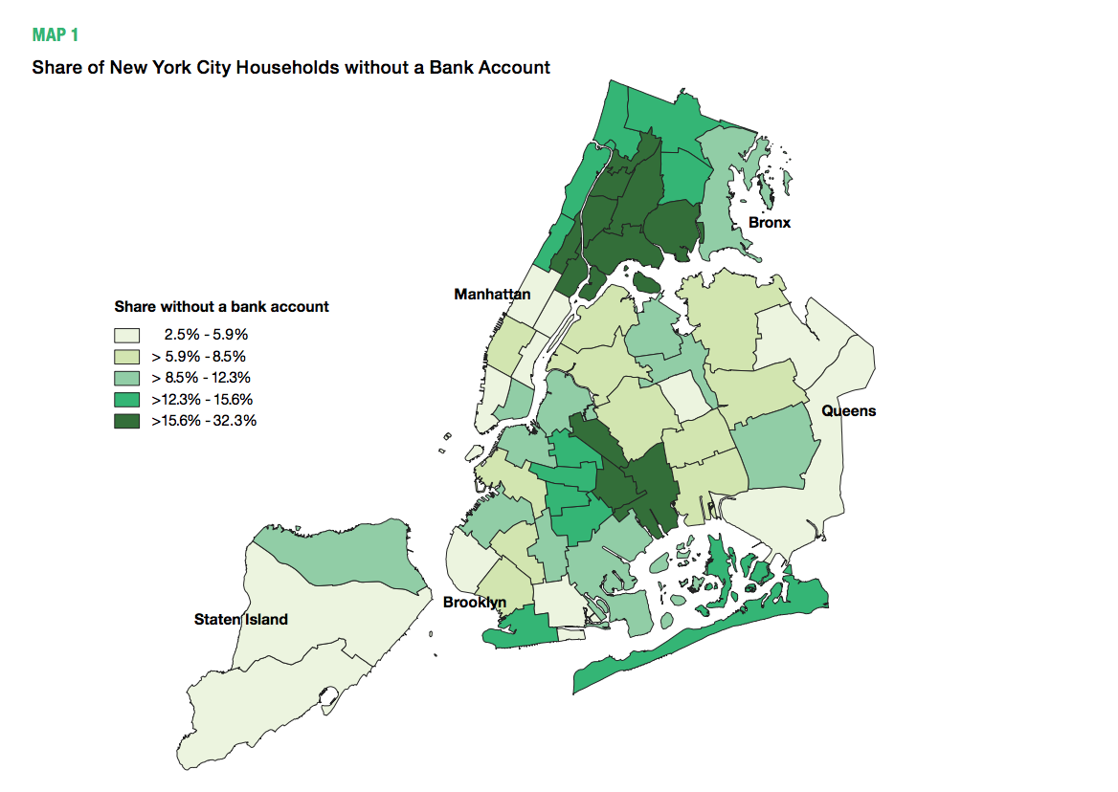
Share of NYC Households without a Bank Account

Certain demographic populations also have higher rates of being unbanked. For example, newly arrived or undocumented immigrants may not have adequate paperwork and identification, face language barriers, or be fearful of sharing personal information with official/quasi-government institutions. Immigrants also tend to be from lower socio-economic households and therefore maybe less likely to be banked due to minimum deposit requirements and financial barriers, such as fees. According to national data, compared to U.S. citizens, noncitizens are three times as likely to be unbanked.
- Lack of Access to Emergency Cash
Access to cash is one of the most secure ways for individuals to sustain themselves during periods of income loss. Even small amounts of savings can help households deal with financial emergencies. Other ways to deal with a financial emergency, such as borrowing money from family, selling possessions, or borrowing money from a 401(k) can damage an individual’s long-term financial health.
A 2019 report by the Columbia Population Research Center and Robin Hood found that 45 percent of New Yorkers could not pay for an emergency expense of $400. Disparities in access to emergency savings is also apparent across City neighborhoods. The report states, “The rate of inadequate savings is high across the city (49 percent), but particularly high in Brownsville, East Harlem, and south and central Bronx, where more than 60 percent of residents do not have adequate emergency savings.” The OFE report found that many of the neighborhoods with high numbers of unbanked households are communities with high shares of residents who lack adequate emergency savings.
- Lack of Access to Revolving Credit
In situations where City residents do not have cash accessible or savings to use during financial emergencies, they commonly turn to sources of credit. Having access to revolving credit such as credit cards, for example, can be essential to withstand emergencies, as they enable cardholders to borrow up to a predetermined limit. Access to these types of revolving credit are inaccessible, however, in certain neighborhoods, and communities without access to revolving credit have a greater difficulty obtaining credit during a crisis. While nearly 40 percent of City residents do not have access to revolving credit, the south and central Bronx, northern Manhattan, eastern Brooklyn, and the Rockaways in Queens have the highest concentrations of residents without access to revolving credit. City neighborhoods where a majority of families have low incomes also typically have low access to revolving credit.
For individuals that do have access to revolving credit, City residents with existing poor credit health and reduced credit scores can find it difficult or impossible to access additional debt to deal with decreases in income loss during an emergency. The chart below highlights how the percent of City residents with debt in collections is highest among Black and Hispanic New Yorkers, and in communities where a majority of families are low-income.

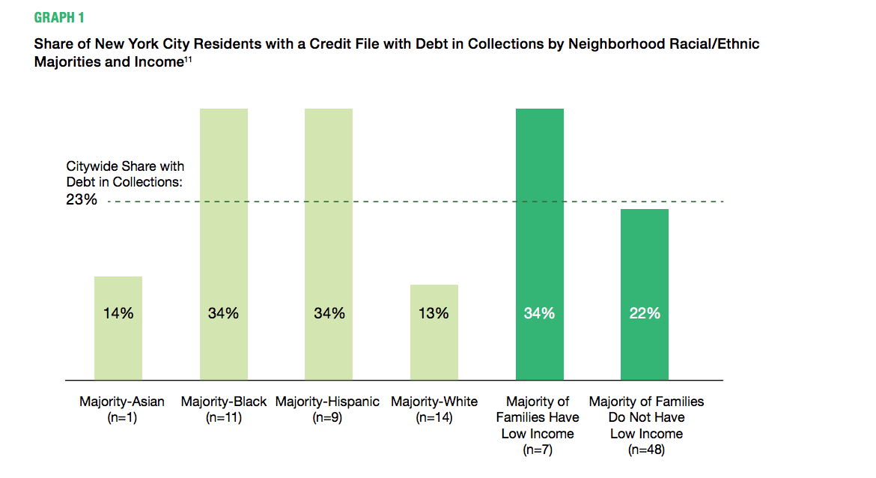
- PANDEMIC-INDUCED FINANCIAL CRISES FACING NEW YORKERS
The financial indicators discussed above reflect how income, race and ethnicity, and neighborhood are linked to the overall financial resiliency of City residents. Certain City residents’ lack of financial resiliency left them more exposed to the economic recession caused by the COVID-19 pandemic.
- Banking Access
Bank accounts, for example, are important for individuals, especially during the pandemic, as they can help facilitate savings and easy access to relief funds, including unemployment benefits and economic impact payments. Unbanked City residents experiencing a loss of income due to the financial fallout caused by the pandemic are forced to deal with delays of weeks or months in receiving critical relief. When relief efforts from the pandemic arrive to unbanked residents, typically in the form of a preloaded debit card or check, unbanked New Yorkers may need to use banks that charge nonmember fees to gain access to the funds.
Prior to the COVID-19 pandemic, bank branches across the country were already closing or reducing their footprint in many locations. Between 2012 and 2017, half of all counties in the United States lost bank branches. In New York City, bank branches are closing at the “fastest rate in 20 years.” In 2020, nearly 100 bank branches closed across the five boroughs. As people come to rely on unemployment and stimulus checks, and access to government loans and grants, bank branches are more important than ever. However, without access to traditional financial institutions, people are forced to rely on check-cashing outfits, which are typically more expensive.
- Unemployment
From March 2020 to April 2020, the unemployment rate increased by over 10 percentage points in the City. The City’s unemployment rate reached over 20 percent in June 2020, before falling each month from July 2020 through December 2020. Unemployment rates also varied by borough. In July of 2020, the unemployment rate in the Bronx was 25 percent, 20.5 percent in Brooklyn, 20.6 percent in Queens, 17.3 percent in Staten Island, and 16 percent in Manhattan. The impact of the pandemic on employment rates also disproportionately impacted Black City residents and other residents of color. In October 2020, the unemployment rate for Asian New Yorkers was 13.4 percent, 15.4 percent for Hispanic New Yorkers, 13.5 percent for Black New Yorkers, and under 13 percent for white New Yorkers. The unemployment rate in the City was around 11.5 percent in December 2020, which is over 7.5 percentage points higher than in December 2019. If consumer-spending habits that changed because of the pandemic, such as less money spent on restaurants and entertainment, continue to endure, job losses in major sectors such as hospitality, entertainment, and tourism may be permanent.
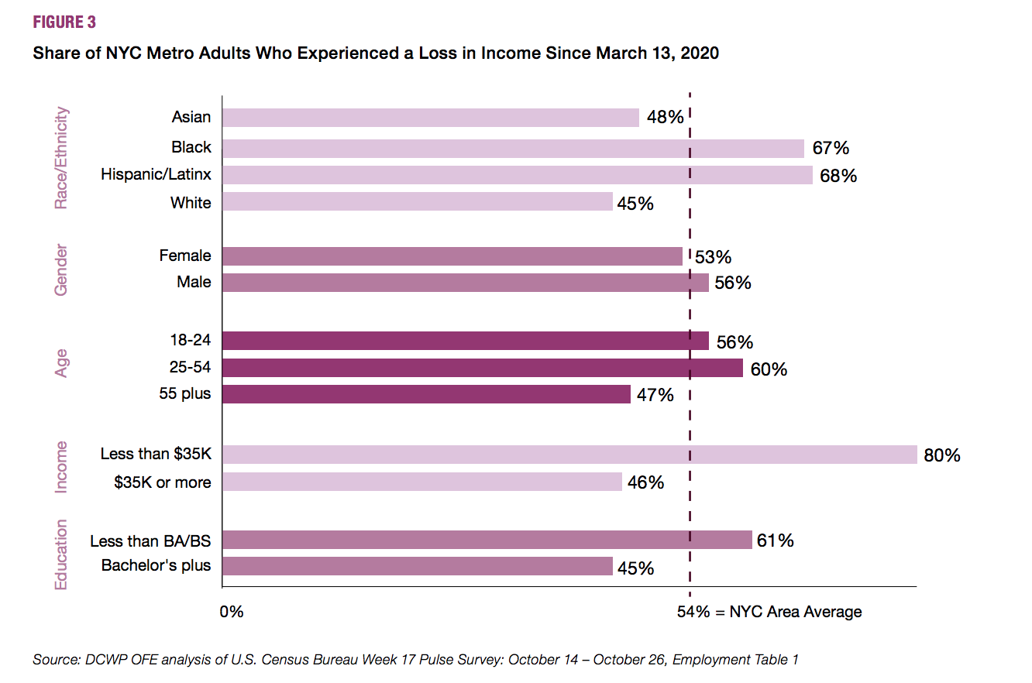
The immense increase in unemployment across the City has led New Yorkers to experience a loss in income, which can have a major impact on an individual’s financial, physical, and mental health. As of October 2020, 54 percent of adults in the City reported experiencing a loss of employment income. Rates of income loss for City adults also varied based on race and ethnicity, gender, age, income, and education level.
- Financial Insecurity
A major consequence of income loss is the inability of individuals to afford necessities. In a survey produced by OFE in October of 2020, 10 percent of adults reported being food insecure in the seven days prior to the survey. Fifteen percent of survey respondents who had experienced income loss were food insecure within the last week, in comparison to four percent of adults who had not experienced income loss. The severity of the unemployment rate in the Bronx brings into greater focus the cascading effects that income loss can cause. Regarding economic insecurity, 20 percent of Bronx residents applied for Supplemental Nutrition Assistance Program (SNAP) benefits in October, compared to 13 percent citywide. SNAP recipients in the Bronx increased by 69,000 from February 2020 to September 2020. Further, 10 percent of Bronx residents visited a food pantry or soup kitchen in October, with 15 percent indicating having enough food to eat was their main concern.
Without a source of income, many New Yorkers are also unable to afford housing. Approximately 23 percent of households in New York State reported that eviction or foreclosure in the next two months was “very likely” or “somewhat likely” during the summer of 2020. In addition, over 700,000 people in the state reported being behind on payments or had little to no confidence that they would be able to make the next one. Between 19 and 23 million Americans were expected to be at risk of eviction by September 30, 2020, with undocumented people, low-income and people of color being the most frequently at risk.
In New York, people are also falling behind on essential expenses such as utility bills. Reporting from the Public Utility Law Project of New York showed that, at August 20, 2020, over one million customers in the State were either in arrears or were at least two months behind on their bills. This was a 20 percent increase from the figures in February 2020. As a comparison in dollar amounts, in 2008 New Yorkers owed $587 million, while in August 2020 this amount had nearly doubled to $985 million.
As the economic fallout from the pandemic continues, predictions about financial recoveries are becoming more dire, although the impact will likely not be felt equally. A report conducted by the Federal Reserve Bank of New York predicts that Black-owned businesses are twice as likely as are other businesses during the pandemic. On top of being in COVID-19 hotspots, Black-owned businesses are more vulnerable because “weaker cash positions, weaker bank relationships, and preexisting funding gaps left Black firms with little cushion entering the crisis: even the healthiest Black firms were financially disadvantaged at the onset of COVID-19.”
To compensate for the immense financial loss so far experienced and predicated to be faced by City residents, various government programs have been created to try to provide immediate relief to those struggling. However, as discussed below, many of these efforts were marred with problems and again exacerbated the inequities along race and ethnicity, and along neighborhood lines.

- GOVERNMENT SUPPORT
Governments at all levels have been actively implementing programs in an effort to enable individuals, small businesses, and organizations, to weather the pandemic and its ongoing economic effects. At the federal level, assistance programs such as the Paycheck Protection Program (PPP), the Economic Injury Disaster Loan (EIDL), SBA Express Bridge Loans, and Debt Relief programs were created to assist businesses. Unemployment insurance stipends were increased, and eligibility was expanded, for laid-off or furloughed workers.
Meanwhile, at the local level, the City’s Department of Small Business Services rolled out the Employee Retention Grant Program and the Small Business Continuity Loan Fund, both of which have now ended. On November 25, 2020, Mayor de Blasio announced three new financial relief programs to benefit small businesses in low-to-moderate (LMI) income neighborhoods. The NYC LMI Storefront Loan, Interest Rate Reduction Grant, and Strategic Impact COVID-19 Commercial District Support Grant will disburse $37 million exclusively to small businesses located in LMI neighborhoods. More recently, the Mayor announced additional support measures for the City’s small businesses. This includes a Small Business Recovery Tax Credit, which gives qualifying businesses a tax credit of six percent of their rent (up to $10,000), and a new set of loans, up to $100,000 for 2,000 of the City’s small businesses.
All of these grants, loans, and assistance programs have mitigated some of the financial stress caused by the pandemic; however, all levels of government continue to be hampered by budgetary and political constraints, and have struggled to ensure that benefits are targeted to the neediest among us. For example, during the first round of the federal PPP rollout, only 12 percent of the City’s eligible businesses received assistance. Micro-businesses in New York City (those that employ ten or fewer workers), also complained about the complicated paperwork required, which often needed input from accountants and lawyers, and the fact that the program prioritized large loans over the smaller ones needed by micro-businesses. Meanwhile, businesses that were successful in gaining a PPP loan found that the application process for getting the loan forgiven has been complicated and extremely slow, threatening to negatively impact credit scores.
According to a report by the Federal Reserve Bank of New York, the reward of PPP loans was racially skewed. Their review of the federal program showed that PPP “loans reached only 20 percent of eligible firms in states with the highest densities of Black-owned firms, and in counties with the densest Black-owned business activity, coverage rates were typically lower than 20 percent.”
There have also been inequities with the awarding of funds through the two City programs. The majority (66 percent) of the money from the Small Business Continuity Loan Fund went to businesses in Manhattan; 18 percent went to businesses in Brooklyn; nine percent for those in Queens; five percent for those in Staten Island; and less than one percent for businesses in the Bronx. Similar inequities were seen with the money from the Employee Retention Grant Program, with 53 percent of Manhattan businesses receiving funds, while only 25 percent of businesses in Brooklyn, 16 percent of businesses in Queens and three percent of businesses in the Bronx and Staten Island receiving funds.

- CONCLUSION
The pandemic has clearly exacerbated the financial strain that many New Yorkers were already under prior to the COVID-19 emergency. In addition to worsening the economic stability of some City residents, the pandemic has intensified inequalities along race and ethnic, socioeconomic, and neighborhood lines. The OFE has a history of tackling these issues and the Committee is eager to hear how this work has been impacted by the pandemic. The Committee initiated this oversight hearing so that it could gain a better understanding of the biggest issues faced by OFE clients, whether New Yorkers are being served equally, and if there are any barriers to service that the Committee can help alleviate.

Testimony of Amelia Erwitt, Associate Commissioner, NYC Department of Consumer Affairs and Executive Director of the Office of Financial Empowerment, Before the NYC Council on Consumer Affairs, February 27, 2014, https://legistar.council.nyc.gov/LegislationDetail.aspx?ID=1662151&GUID=A48411C5-CA9B-48AA-84AA-7D59501D75F6&Options=&Search=
“History: The Mayor's Office for Economic Opportunity (NYC Opportunity) was formally announced in May 2017”, NYC Opportunity, available at: https://www1.nyc.gov/site/opportunity/about/history.page
NYC Consumer Affairs “Financial Empowerment”, available at: https://www1.nyc.gov/site/dca/partners/financial-empowerment.page
NYC Consumer Affairs “Get Free Financial Counseling”, available at: https://www1.nyc.gov/site/dca/consumers/get-free-financial-counseling.page
NYC Consumer Affairs “Department of Consumer Affairs Announces 50,000 New Yorkers Have Received Free Counseling at Financial Empowerment Centers”, June 14, 2018, https://www1.nyc.gov/site/dca/media/pr061418-50000-New-Yorkers-Have-Received-Free-Financial-Counseling.page
Id.
NYC Consumer Affairs “Public Awareness Campaign: Free Financial Counseling By Phone”, available at: https://www1.nyc.gov/site/dca/media/Free-Financial-Counseling-By-Phone.page
NYC Consumer Affairs “Get Free Financial Counseling”, available at: https://www1.nyc.gov/site/dca/consumers/get-free-financial-counseling.page
NYC Consumer Affairs “EmpoweredNYC Launches City's First Citywide Public Awareness Campaign for People with Disabilities”, October 7, 2019, https://www1.nyc.gov/site/dca/media/pr100719-EmpoweredNYC-Launches-Public-Awareness-Campaign.page
NYC Consumer Affairs “EmpoweredNYC”, available at: https://www1.nyc.gov/site/dca/partners/EmpoweredNYC.page
NYC Housing Preservation and Development “Ready to Rent”, available at: https://www1.nyc.gov/site/hpd/services-and-information/ready-to-rent.page
NYC Consumer Affairs “Open an Account”, available at: https://www1.nyc.gov/site/dca/consumers/open-savings-account.page
Id.
Id.
Financial Empowerment Center “Do More with Your Money: Open a Checking Account”, available at: https://www1.nyc.gov/assets/dca/downloads/pdf/consumers/OFE_CheckingAccount.pdf
Id.
Id.
“Department of Consumer Affairs Office of Financial Empowerment: Progress Report, 2010-2013”, December 2013, p. 26.
Id.
NYC Consumer Affairs “File Your Taxes with NYC Free Tax Prep”, available at: https://www1.nyc.gov/site/dca/consumers/file-your-taxes.page
NYC Consumer Affairs “Virtual Tax Prep”, available at: https://www1.nyc.gov/site/dca/consumers/file-your-taxes.page
NYC Consumer Affairs “Assisted Self-Preparation”, available at: https://www1.nyc.gov/site/dca/consumers/file-your-taxes.page
NYC Consumer Affairs “NYC Annual Tax Season Initiative”, available at: https://www1.nyc.gov/site/dca/media/tax-credit-campaign.page
NYC Free Tax Prep “Tax Credit: Fast Facts 2020”, available at: https://www1.nyc.gov/assets/dca/downloads/pdf/consumers/Tax-Credit-Fast-Facts.pdf
NYC Consumer Affairs “Economic Impact Payments”, available at: https://www1.nyc.gov/site/dca/consumers/economic-impact-payments.page
NYC Consumer Affairs and Worker Protection “Already at-Risk: The New Yorkers Struggling Economically Before COVID-19”, September 2020, available at: https://www1.nyc.gov/assets/dca/downloads/pdf/partners/COVID_Vulnerability_Brief.pdf
Id.
Id.
Id.
Id.
Erica Pearson “Many New York immigrants close bank accounts or avoid them, citing language barriers or high transaction fees, new study found”, New York Daily News, February 25, 2015, available at: https://www.nydailynews.com/new-york/immigrants-city-choose-non-bank-options-article-1.2127910.
Joe Valenti “Millions of Americans are outside the financial system”, Center for American Progress, October 30, 2014, available at: https://www.americanprogress.org/issues/economy/reports/2014/10/30/99967/millions-of-americans-are-outside-the-financial-system/.
NYC Consumer Affairs and Worker Protection “Already at-Risk: The New Yorkers Struggling Economically Before COVID-19”, September 2020, available at: https://www1.nyc.gov/assets/dca/downloads/pdf/partners/COVID_Vulnerability_Brief.pdf
Id.
Id; and Chloe Cargill, Matthew Maury, and Christopher Wimer “On the Precipice: An Analysis of the Vulnerability of New Yorkers to Financial Shocks”, June, 2019, Available at: https://robinhoodorg-production.s3.amazonaws.com/uploads/2019/06/EMERGENCY-EXPENSE-REPORT_6_19_FINAL.pdf
NYC Consumer Affairs and Worker Protection “Already at-Risk: The New Yorkers Struggling Economically Before COVID-19”, September 2020, available at: https://www1.nyc.gov/assets/dca/downloads/pdf/partners/COVID_Vulnerability_Brief.pdf
Id.
Id.
Id.
Id.
Id.
Id.
Id.
Id.
Natalie Wong and Nic Querolo “New York faces more empty storefronts as bank branches shrink”, Bloomberg, January 24, 2020, available at: https://www.bloomberg.com/news/articles/2020-01-24/shrinking-bank-branches-leave-nyc-with-more-retail-space-to-rent.
Aaron Elstein “As banks close branches, small businesses suffer”, Crain’s New York Business, October 27, 2020, available at: https://www.crainsnewyork.com/finance/banks-close-branches-small-businesses-suffer.
Id.
Ben Luthi “Check cashing: Are the fees worth it?”, Experian, January 17, 2019, available at: https://www.experian.com/blogs/ask-experian/check-cashing-are-the-fees-worth-it/.
Federal Reserve Bank of St. Louis “Counties: Economic Research: , available at: https://fred.stlouisfed.org/categories/29191
N.Y.C. Comptroller Scott Stringer, “New York By the Numbers: Weekly Economic and Fiscal Outlook,” November 23, 2020, available at https://comptroller.nyc.gov/newsroom/new-york-by-the-numbers-weekly-economic-and-fiscal-outlook-no-26-november-23-2020/
New York State Department of Labor “NYS Unemployment Rate Falls to 8.2% in December 2020”, available at: https://labor.ny.gov/stats/pressreleases/pruistat.shtm
NYC Consumer Affairs and Worker Protection “Uneven Impact: What Job Loss During COVID-19 Means for New Yorkers Now and into the Future”, December 2020, available at: https://www1.nyc.gov/assets/dca/downloads/pdf/partners/Uneven_Impact.pdf
Id.
Id.
Id.
Id.
Greg David, “Bronx Grapples with ‘Deepest Inequalities in America’ as COVID Surges Again,” The City, November 29, 2020, available at: https://www.thecity.nyc/bronx/2020/11/29/21725453/bronx-inequality-racism-covid-hunger-health-jobs-housing?mc_cid=d0ffff1966&mc_eid=37d5b46595
Id.
Id.
United States Census Bureau “Household Pulse Survey, Week 13: Likelihood of Eviction or Foreclosure: New York”, August 2020.
Id.
Mckay, Katherine Lucas and Zach Neumann and Sam Gilman “20 Million Renters Are at Risk of Eviction”, The Aspen Institute, June 19, 2020, available at: https://www.aspeninstitute.org/blog-posts/20-million-renters-are-at-risk-of-eviction/.
Rick Karlin “Advocates: Record number of New Yorkers are behind on utility bills”, Times Union, October 7, 2020, available at: https://www.timesunion.com/business/article/Record-number-of-people-are-behind-on-utility-15628550.php.
Id.
Id.
Federal Reserve Bank of New York “Double-jeopardy: COVID-19’s concentrated health and wealth effects in Black communities”, August 2020, available at: https://www.newyorkfed.org/medialibrary/media/smallbusiness/DoubleJeopardy_COVID19andBlackOwnedBusinesses, p. 1.
Id, p. 2.
Liberty SBF “SBA Paycheck Protection Program (PPP) Loans”, https://www.sbapaycheck.com/?gclid=CjwKCAiAsOmABhAwEiwAEBR0ZuzF2HsiEhbiQl4nxPALuc5PmgT0gnoCoa6bq4gX09-cgV8nDJZ-yBoC-N8QAvD_BwE, last accessed February 3, 2021.
United States Small Business Administration “Economic injury disaster loan emergency advance”, available at: https://www.sba.gov/funding-programs/loans/coronavirus-relief-options/economic-injury-disaster-loan-emergency-advance, last accessed February 3, 2021.
United States Small Business Administration “SBA Express Bridge Loans”, available at: https://www.sba.gov/funding-programs/loans/coronavirus-relief-options/sba-express-bridge-loans, last accessed February 3, 2021.
United States Small Business Administration “SBA debt relief”, available at: https://www.sba.gov/funding-programs/loans/coronavirus-relief-options/sba-debt-relief, last accessed February 3, 2021.
US Department of Labor “New COVID-19 unemployment benefits: Answering common questions”, January 11, 2021, available at: https://blog.dol.gov/2021/01/11/unemployment-benefits-answering-common-questions, last accessed February 3, 2021.
Paul Weiss “NY City: Employee Retention Grant Program”, April 6, 2020, available at: https://www.paulweiss.com/media/3979874/nyc2-employee-retention-grant-program-summary_4-6.pdf.
SKP “NYC Small Business Continuity Loan Fund”, available at: https://www.skpny.com/wp-content/uploads/2020/03/NYC-Small-Business-Continuity.pdf.
NYC Small Business “NYC Employee Retention Grant Program”, available at: https://www1.nyc.gov/nycbusiness/article/nyc-employee-retention-grant-program; and NYC Business “NYC Small Business Continuity Loan Program”, available at: https://www1.nyc.gov/nycbusiness/article/nyc-small-business-continuity-loan-program, both last accessed February 3, 2021.
City of New York “Recovery Agenda: City Launches Small Business Supports for Hard-Hit Low and Moderate Income (LMI) Communities”, November 25, 2020, https://www1.nyc.gov/office-of-the-mayor/news/812-20/recovery-agenda-city-launches-small-business-supports-hard-hit-low-moderate-income-lmi-
Office of the Mayor “State of the City 2021: Mayor de Blasio announces a recovery for all of us”, January 28, 2021, available at: https://www1.nyc.gov/office-of-the-mayor/news/062-21/state-the-city-2021-mayor-de-blasio-recovery-all-us.
Shant Shahrigian “NYC Comptroller Scott Stringer trashes de Blasio effort to help small businesses get PPP loans”, New York Daily News, January 13, 2021, available at: https://www.nydailynews.com/news/politics/new-york-elections-government/ny-paycheck-protection-program-loans-scott-stringer-20210113-tofkfbd4wvgnxbn37far624dse-story.html.
Ann Choi “How NYC small businesses got short shrift on PPP loans”, The City, December 13, 2020, available at: https://www.thecity.nyc/economy/2020/12/13/22173260/how-nyc-small-businesses-restaurants-ppp-loans?campaign_id=44&emc=edit_ur_20201214&instance_id=25014&nl=new-york-today&regi_id=85509400&segment_id=46833&te=1&user_id=50837394bf42f5dd0bd853677ab07392.
Bryce Covert “PPP loans were supposed to be forgiven. Business owners say they’re still waiting”, Vox, October 28, 2020, available at: https://www.vox.com/21529071/ppp-loan-forgiveness-lenders-sba-delay-paycheck-protection-program.
Federal Reserve Bank of New York “Double-jeopardy: COVID-19’s concentrated health and wealth effects in Black communities”, August 2020, available at: https://www.newyorkfed.org/medialibrary/media/smallbusiness/DoubleJeopardy_COVID19andBlackOwnedBusinesses, p. 2.
David Cruz “NYC's small business relief is mostly going to Manhattan shops”, Gothamist, April 30, 2020, available at: https://gothamist.com/news/nycs-small-business-relief-mostly-going-manhattan-shops.
Id.

