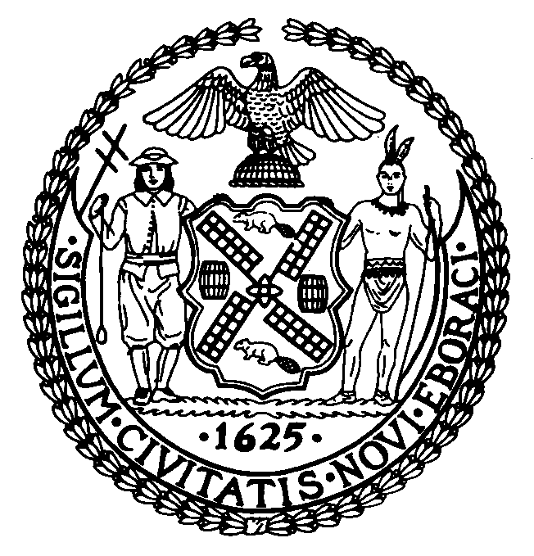 | The Council of the City of New York  Finance Division  Larian Angelo, Director  Fiscal Impact Statement  No: SLR114 (S 7017 & A 11041)  Committee: State and Federal Legislation
Title: An act to amend the retirement and social security  Law, in relation to providing a three- quarters pay accidental disability pension for persons employed by the city of New York as urban park rangers and associate urban park rangers | Sponsors: Council Member Rivera,
Summary of Legislation: Provides for a three-quarters pay accidental disability pension, for Urban Park Rangers and Associate Urban Park Rangers employed by the City of New York. These members have twenty-four hour peace officer status and are required to patrol parks and issue summonses and make arrests. This disability pension plan will enhance the protection offered to these members when they are seriously and permanently injured in the line of duty.
This legislation will also provide the presumption that if these employees contract HIV (upon evidence of exposure to bodily to fluids), hepatitis, or tuberculosis, it was as a result of their job and entitle them to three- quarter pay.
Effective Date: This legislation shall take effect immediately.

Fiscal Year In Which Full Fiscal Impact Anticipated: Fiscal 2005

Fiscal Impact Statement:
 | Effective FY05 | FY Succeeding  Effective FY06 | Full Fiscal  Impact FY05
Revenues (+) | $0 | $0 | $0
Expenditures (-) | $100,000 | $100,000 | $100,000
Net | ($100,000) | ($100,000) | (100,000)

Impact on Revenues: There is no impact on revenue.

Impact on Expenditures: The cost of this legislation is approximately $100,000 a year.

Source of Funds To Cover Estimated Costs: General Fund
Source of Information: Department of Finance

Estimate Prepared By: Frank Tramontano,First Deputy Director Daniel Turriago, Principal Financial Analyst, City Council Finance Division.

FIS History: This is a new bill
Date Submitted to Council: June 3, 2004

