Committee on Environmental Protection
Samara Swanston, Legislative Counsel
Bill Murray, Policy Analyst
Jon Seltzer, Finance Analyst

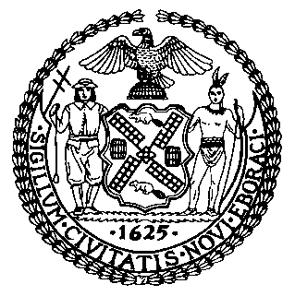

The New York City Council

Report of the Infrastructure Division
Matthew Gewolb, Legislative Director

Committee on Environmental Protection
Hon. Costa Constantinides, Chair

November 12, 2015

Int. No. 859: By Council Members Menchaca, Rosenthal, Chin, Mendez, Rose, Lander, Reynoso, Levin and the Public Advocate (Ms. James)

Title: A Local Law to amend the administrative code of the city of New York, in relation to reducing noise caused by sightseeing helicopters.

Administrative Code: Amends subchapter 6 of chapter 2 of title 24 of the administrative code of the city of New York

Int. No. 858: By Council Members Menchaca, Rosenthal, Chin, Mendez, Rose, Lander, Reynoso, Levin and the Public Advocate (Ms. James)

Title: A Local Law to amend the administrative code of the city of New York, in relation to reducing noise caused by sightseeing helicopters that meet federal noise reduction standards

Administrative Code: Amends subdivisions a and b of section 24-244.1 of the administrative code of the city of New York, as added by proposed introduction number 859-2015
Res. No. 892: By Council Members Vallone, Chin, Koo and Rose

Title: Resolution calling on the Federal Aviation Administration to amend the North Shore helicopter route to extend further west to cover Northeast Queens

Introduction
On November 12, 2015, the Committee on Environmental Protection, chaired by Council Member Costa Constantinides, will hold a hearing on Int. No. 859, in relation to reducing noise caused by sightseeing helicopters, Int. No. 858, in relation to reducing noise caused by sightseeing helicopters that meet federal noise reduction standards, and Res. No. 892, calling on the Federal Aviation Administration to amend the North Shore helicopter route to extend further west to cover Northeast Queens.
Background
There are currently three publicly-owned heliports in the City of New York that are available for public use: the East 34th Street Heliport, the West 30th Street Heliport and the Downtown Manhattan/Wall Street Heliport (“DMH”). There was a fourth public heliport at 60th Street which the City closed in 1997. The East 34th Street Heliport was closed to sightseeing flights in 1997 when the City evicted the former tenant of the Heliport, National Helicopter, and restricted operations to air taxi, general aviation, commuters and military flights.
In 1999 Mayor Rudolph Giuliani’s administration conducted the City’s first Heliport and Helicopter Master Plan Study (“HHMPS”) to take a comprehensive look at the City’s heliport system. The study analyzed the operations of the three Manhattan-based heliports to guide “policy and development decisions pertaining to the City's heliport system.” The HHMPS recommended that sightseeing flights should be prohibited from City-owned heliports, but concluded that there was little the Giuliani administration could do at the time to achieve such a ban. The State-owned West 30th Street Heliport was managed via contract with Air Pegasus of New York (“Air Pegasus”), a private tour operator, in effect until 2001; and the DMH was managed by the Port Authority of NY & NJ (“PANY/NJ”) under an agreement set to expire in 2005.
Locations of New York City Heliports
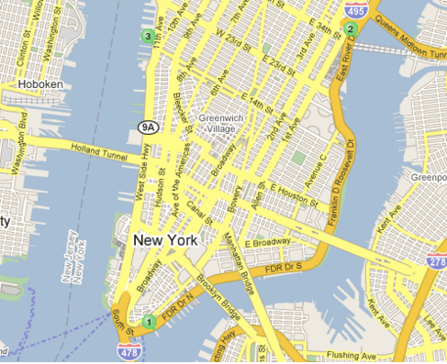
1) Downtown Manhattan/Wall Street Heliport 2) East 34th Street Heliport 3) West 30th Street Heliport

West 30th Street Heliport
In 1998 the State delegated the authority to manage the Hudson River Park to the Hudson River Park Trust (“the Trust”) for the “planning and development of the Hudson river park as a public park,” and “to operate exclusively for purposes relating to the promotion of the health and social welfare of the people of the state.” As part of the Trust’s formative statute, any heliport within the Hudson River Park could only be operated as a “non-tourist/non-recreation heliport for commercial and emergency transportation use.” An activist group known as the Friends of Hudson River Park (“FOHRP”) filed suit against the Trust, Air Pegasus, and another helicopter operator in 2007 to enforce the non-tourist/non-recreation terms of the Trust’s formative statute. The Trust and Air Pegasus ultimately settled with FOHRP, agreeing to, among other things, cease sightseeing flights at the West 30th Street Heliport by April 2010.
Downtown Manhattan Heliport
The remaining public heliport is the City-owned DMH, which has been managed by the New York City Economic Development Corporation (“EDC”) and operated by Saker Aviation since 2008. Despite the Giuliani-era HHMPS advisory that once the West 30th Street Heliport closes, “The City should work with the Port Authority to ensure that the sightseeing traffic at this heliport does not shift to the Downtown Manhattan Heliport,” it seems that all sightseeing traffic has in fact moved to the DMH. As of September 2012, the DMH operated on average 159 flights per day, from 9:00AM until 6:30PM, 27% of which are considered “transient general aviation” – the designation that covers sightseeing tours.
In April 2010 EDC released an updated New York City Helicopter Sightseeing Plan (“the Plan”) to “mitigate the impact of helicopter tours on surrounding neighborhoods while maintaining the important industry.” The Plan eliminated so-called “short tour” flights, which lasted between four and eight minutes and represented between 15-20% of sightseeing flights at the time. The Plan also eliminated sightseeing tours over Central Park, the Empire State Building and Brooklyn, and restricted all sightseeing tour operators to follow one of two routes designated by the Federal Aviation Administration (“FAA”) to “maximize[e] aircraft distances from the Brooklyn Bridge Park . . . [and] transit the Hudson at 1,500 feet or above thereby mitigating noise heard from lower altitude flights.”
Despite the restrictions placed by the 2010 Plan, complaints from residents have continued and a citizen’s group known as “Stop the Chop” has obtained support from a number of local, state and federal elected officials to regulate or outright ban helicopter sightseeing tours over New York Harbor and the Hudson River. The sightseeing helicopter companies operating out of the Downtown Manhattan reportedly employ around 200 people.

Maps Showing Authorized Sightseeing Helicopter Tour Routes
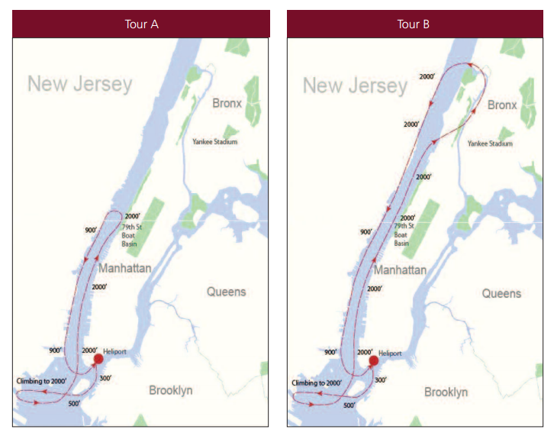
The maps above show each of the only two authorized sightseeing helicopter tour routes, as per a voluntary, yet binding agreement between the Economic Development Corporation and tour companies sanctioned by the Federal Aviation Administration. Note: the Tour B route has been modified to restrict sightseeing helicopters from crossing over Northern Manhattan, requiring them to remain above the Hudson River until returning southward.

Helicopter Noise Complaints
Noise complaints due to helicopter activities, or any other source of noise, may be submitted to 3-1-1, which is the City’s 24-hour phone number and website serving as a source of government information and non-emergency services. According to data accessible through the City’s Open Data portal, during the period January 2011 to June 25, 2015, a total of 207,642 noise-related complaints were submitted to 3-1-1. Of these, 4,710 complaints were due to helicopter noise. Of all complaints due to helicopter noise, 486 were determined by the New York City Economic Development Corporation to be due to sightseeing helicopters. The two maps that follow provide a sense of the geographic distribution of all helicopter complaints, and sightseeing helicopter complaints. The first map below illustrates that complaints due to all types of helicopters are highest around western and lower Manhattan and in sections of eastern Brooklyn that are roughly adjacent to the DMH heliport. The map also shows a relatively high number of helicopter complaints around Whitestone and northern Queens, in communities directly west of the North Shore Helicopter Route. The North Shore helicopter route is a route that the FAA requires pilots of civil helicopters to use when transiting along the north shore of Long Island. The second map below shows that the majority of complaints due to sightseeing helicopters occur in communities of Brooklyn adjacent to the downtown heliport and along the west side of Manhattan. Taken together, the maps and underlying data show that noise complaints submitted to 3-1-1 that are due to sightseeing helicopters comprise a relatively modest share of all helicopter noise complaints.

All Helicopter Noise Complaints (January 2011-June 2015)
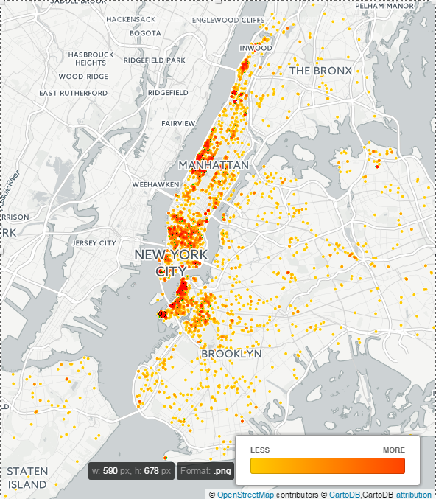
The map above is based on 3-1-1 data, accessible through the City’s Open Data portal. It shows the geographic distribution of complaints submitted to 3-1-1 that were due to noise caused by all types of helicopters. This includes government (such as NYPD), media, sightseeing and other helicopters. There were a total of 4,710 helicopter noise complaints.

Sightseeing Helicopter Noise Complaints (January 2011-June 2015)
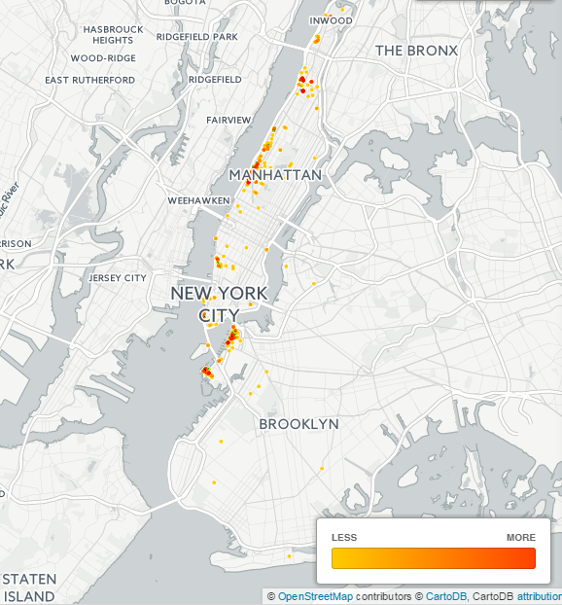
The map above is based on 3-1-1 data, which is accessible through the City’s Open Data portal. It shows the geographic distribution of complaints submitted to 3-1-1 that were likely due to noise caused by sightseeing helicopters. This includes sightseeing helicopters that were flying both in compliance (within the limits of) and in violation (outside the limits of) the New York City Helicopter Sightseeing Plan. There were 486 sightseeing helicopter noise complaints.

The New York City Noise Code

In 1972, Mayor John Lindsay enacted the New York City Noise Control Code (“Noise Code”) making New York one of the first cities in the nation to adopt a comprehensive local law aimed at reducing noise pollution. The pioneering law was intended to reduce ambient noise levels Citywide and set sound limits for a set of specific noise sources. In 2005, Mayor Michael Bloomberg enacted Local Law 113 of 2005 overhauling the City’s Noise Code for the first time in over 30 years in order to update the Noise Code and make it reflective of modern acoustic technologies and standards. The updated Noise Code, Local Law 113, took effect in 2007. It is enforced by the New York City Department of Environmental Protection (“DEP”) and the New York City Police Department (“NYPD”). The Code sets standards for what constitutes unreasonable and prohibited noise, and sets decibel limits (abbreviated dB, decibels are the universal unit of sound measurement) for various specific noise sources. The Code is enforced by DEP and NYPD agents who carry meter devices capable of detecting sound pressures and displaying readings on a A-weighted decibel, or dB(A), sound level scale. Some major noise sources covered by the Noise Code are motor vehicles and motorcycles, refuse collection vehicles, music from bars and restaurants, food vending vehicles, animal noises, residential noise and construction noise.

Table 1: The table below lists common noise sources and their sound levels. Note that sound levels vary depending on the distance between the noise source and the object receiving the sound, but the list below provides frequently heard sounds in the City and their approximate decibel levels based on common distances from the noise sources.
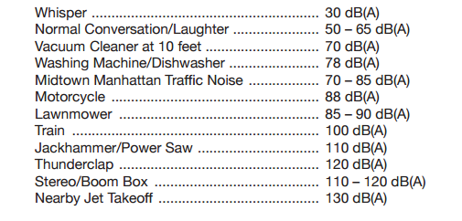
The sound level of helicopters frequently ranges from 80-102 dB.,

Summary of Int. No. 859
Section one of the proposed legislation would amend subchapter 6 of chapter 2 of title 24 of the administrative code of the city of New York by adding a new section 24-244.1. The new section would include definitions for the terms “chartered helicopter,” “sightseeing helicopter," “stage 1 noise level” and “stage 2 noise level.” The section would also prohibit any sightseeing helicopter that meets stage 1 or stage 2 noise levels from taking off or landing on any property that is owned or managed by the City. There is an exception for emergency situations.
Section two of the bill would add a new row to Table I following paragraph (5) of subdivision (b) of section 24-257 of the administrative code of the city of New York, specifying what the civil penalties shall be for violations of new section 24-244.1. Penalties shall be a maximum of $1,500 and minimum of $500 for a first violation, maximum of $3,000 and minimum of $1,000 for a second violation, and maximum of $4,500 and minimum of $1,500 for a third and subsequent violation. The legislation specifies that this local law would take effect 180 days after enactment.

Summary of Int. No. 858
Section one of the proposed legislation states the legislative findings and intent. Section two would amend subdivision a of section 24-244.1 of the administrative code of the city of New York, as added by introduction number 859-2015. The legislation would add to this subdivision a definition for the term “stage 3 noise level.” Section three of the bill would amend subdivision b of section 24-244.1 of the administrative code in such a way so as to prohibit any sightseeing helicopter that meets stage 3 noise levels from taking off or landing on any property that is owned or managed by the City. Section four of the bill specifies that this Local Law would take effect 270 days after enactment, provided that it is approved by the United States secretary of transportation pursuant to the federal airport noise and capacity act of 1990.

Conclusion
At this hearing the Committee hopes to receive testimony from the Mayor’s Administration, the sightseeing helicopter industry, companies and employees, organizations and advocates who are concerned with noise caused by sightseeing helicopters, and constituents and City residents who are impacted by helicopter noise. The Committee hopes to receive testimony and information regarding the merits of the proposed legislation.

Int. No. 859

By Council Members Menchaca, Rosenthal, Chin, Mendez, Rose, Lander, Reynoso, Levin and the Public Advocate (Ms. James)
A LOCAL LAW

To amend the administrative code of the city of New York, in relation to reducing noise caused by sightseeing helicopters.

Be it enacted by the Council as follows:

Section 1. Subchapter 6 of chapter 2 of title 24 of the administrative code of the city of New York is amended by adding a new section 24-244.1 to read as follows:
§ 24-244.1 Sightseeing helicopters. a. Definitions. For purposes of this section:
Chartered helicopter. The term “chartered helicopter” means a helicopter that is leased in its entirety for exclusive and temporary use, and not for the purpose of conducting sightseeing tours.
Sightseeing helicopter. The term “sightseeing helicopter” means a helicopter that is operated for the purpose of conducting regular aviation tours along flight routes approved by the federal aviation administration. The term “sightseeing helicopter” shall not include private helicopters, chartered helicopters, military helicopters, media helicopters or helicopters used by the fire department, police department, coast guard or emergency services.
Stage 1 noise level. The term “stage 1 noise level” means stage 1 noise level as such term is defined by subsection (h) of section 36.1 of title 14 of the code of federal regulations.
Stage 2 noise level. The term “stage 2 noise level” means stage 2 noise level as such term is defined by subsection (h) of section 36.1 of title 14 of the code of federal regulations.
b. No person shall use or permit the use of any sightseeing helicopter that meets stage 1 noise levels or stage 2 noise levels to take off or land from any property owned or managed by the city of New York, except in emergency situations or as otherwise directed by an aviation control tower or air traffic control center.
§ 2. Table I following paragraph (5) of subdivision (b) of section 24-257 of the administrative code of the city of New York as amended by local law number 153 for the year 2013 is amended by adding a new row immediately following row 24-244 to read as follows:
24-244.1 | 1,500 | 500 | 3,000 | 1,000 | 4,500 | 1,500

§ 3. This local law takes effect 180 days after it becomes law.

ARP
LS # 1976/3145.1
7/20/2015 12:15 PM

Int. No. 858

By Council Members Menchaca, Rosenthal, Chin, Mendez, Rose, Lander, Reynoso, Levin and the Public Advocate (Ms. James)
A LOCAL LAW

To amend the administrative code of the city of New York, in relation to reducing noise caused by sightseeing helicopters that meet federal noise reduction standards

Be it enacted by the Council as follows:

Section 1. Legislative findings and intent. The Council finds that there is significant noise pollution caused by the dozens of sightseeing helicopters operating daily from heliports owned by the city. The heliports used by sightseeing helicopters are near water which carries the sound of those helicopters and significantly disrupts the daily lives of city residents who live and work near the heliports or across the East River. A previous local law limited sightseeing tour operators to the stage 3 noise levels as determined by the federal aviation administration, however the Council finds that no current noise reduction measures will be acceptable to ensure the quiet repose of the affected communities. Therefore the Council finds that the prohibition on sightseeing helicopters needs to be extended to include helicopters that meet the stage 3 noise levels as well.
§ 2. Subdivision a of section 24-244.1 of the administrative code of the city of New York, as added by proposed introduction number 859-2015, is amended by adding a new definition of “stage 3 noise level” in alphabetical order to read as follows:
Stage 3 noise level. The term “stage 3 noise level” means stage 3 noise level as such term is defined by subsection (h) of section 36.1 of title 14 of the code of federal regulations.
§ 3. Subdivision b of section 24-244.1 of the administrative code of the city of New York, as added by proposed introduction number 859-2015, is amended to read as follows:
b. Sightseeing helicopters. No person shall use or permit the use of any sightseeing helicopter that meets stage 1 noise levels, [or] stage 2 noise levels or stage 3 noise levels to take off or land from any property owned or managed by the city of New York, except in emergency situations or as otherwise directed by an aviation control tower or air traffic control center.
§ 4. This local law takes effect 270 days after it becomes law, provided that it is approved by the United States secretary of transportation pursuant to the federal airport noise and capacity act of 1990.

ARP
LS # 1976/3145.2
7/23/2015 4:08 PM

Res. No. 892
Resolution calling on the Federal Aviation Administration to amend the North Shore helicopter route to extend further west to cover Northeast Queens
By Council Members Vallone, Chin, Koo and Rose
Whereas, In 2007, U.S. Senator Charles Schumer and Congressman Tim Bishop conducted a meeting with the Federal Aviation Administration (FAA), local helicopter operators and airport proprietors to address noise complaints stemming from helicopter operations along the north shore of Long Island, NY; and
Whereas, In 2008, as a result of this meeting, the FAA established a voluntary route that helicopter pilots could take over the north shore of Long Island, NY (the “North Shore helicopter route”); and
Whereas, In 2012, in response to concerns from a large number of residents disturbed by the level of noise from helicopters operating over Long Island, the FAA adopted a rule generally mandating use of the North Shore helicopter route; and
Whereas, Such rule was scheduled to lapse in 2 years unless the FAA determined that a permanent rule was merited; and
Whereas, In 2014, the FAA published a final rule that extends the requirement for the mandatory North Shore helicopter route for an additional two years; and
Whereas, According to the FAA’s North Shore helicopter route training, the mandatory route the helicopters have to fly only extends along the shore of Long Island; and
Whereas, There are four heliports in the city of New York that accept charter flights flying to and from Long Island that are required to fly along the North Shore helicopter route; and
Whereas, The North Shore helicopter route does not extend west of Long Island to cover areas of the city of New York that are also impacted by helicopters flying between the city of New York to Long Island, NY; and
Whereas, According to NYC Open Data Plan’s 311 Service Requests, the second largest number of noise complaints about helicopters in Queens, NY are from Whitestone, Queens, which is the northernmost community in Queens and the community directly west of the North Shore helicopter route; and
Whereas, In August 2015, Senator Charles Schumer sent a letter to urge the FAA Administrator to address the noise pollution caused by heavy helicopter traffic throughout Northeast Queens, including Whitestone and Malba Garden; and
Whereas, The letter specified that the FAA could apply its authority and create or make changes to helicopter flight patterns to redirect their flight paths, whenever possible, to all-water routes; now, therefore, be it
Resolved, That the Council of the city of New York calls on the Federal Aviation Administration to amend the North Shore helicopter route to extend further west to cover Northeast Queens.
RTH
LS# 5990
10/22/15 6:36PM

Levy, Cliford. Giuliani Plans To Reduce Copter Flights, N.Y. Times Apr. 30 1997 at B3.
See Nat'l Helicopter Corp. of Am. v. City of N.Y., 137 F.3d 81 (2d Cir. 1998).
See East 34th Street Heliport, AirNav.com, http://www.airnav.com/airport/6N5 (last visited Apr. 28, 2015).
See Press Release, Mayor’s Press Office, Mayor Giuliani Releases Heliport Master Plan Study, (Sep. 27, 1999) available at http://www.nyc.gov/portal/site/nycgov/index.jsp?epi-content=GENERIC&wcproxyurl=http%253A%252F%252Fwww.nyc.gov%252Fhtml%252Fom%252Fhtml%252F99b%252Fpr377-99.html&beanID=2027100071&viewID=proxy_view_secondary.
Id.
See id.
See id.
Map taken from NYCTourist.com, available at http://www.nyctourist.com/heliports_helicopter_airport_transportation.htm
NY Unconsol. Ch. 65, § 2(a)
NY Unconsol. Ch. 65, § 2(g).
NY Unconsol. Ch. 65, § 3(g)(v).
See Press Release, Friends of Hudson River Park, Friends of Hudson River Park Announces Agreement on Ending Tourist Flights at 30th Street Heliport by April 2010. (Jun. 20, 2008) available at http://www.hudsonriverpark.org/assets/content/general/6.20.08-Heliport_Final_Release_June_20_2008.pdf
See id.
Dee Downtown Manhattan Heliport, Helicopter Service, http://www.downtownmanhattanheliport.com/helicopterservice.html (last visited Apr. 28, 2015).
Mayor Giuliani Releases Heliport Master Plan Study, supra note 4.
See Downtown Manhattan/Wall St. Heliport, AirNav.com, http://www.airnav.com/airport/KJRB (last visited Apr. 28, 2015).
Press Release, New York City Economic Development Corporation, New York City Economic Development Corporation Releases New York City Sightseeing Plan (Apr. 30, 2010) http://www.nycedc.com/press-release/new-york-city-economic-development-corporation-releases-new-york-city-helicopter (last visited Apr. 28, 2015).
See id.
Id.
See Stop the Chop NY/NJ, Officials in Support of a Ban on Helicopter Sightseeing Tours Over New York Harbor and the Hudson River, http://www.stopthechopnynj.org/supportive-elected-officials.html (last visited Apr. 28, 2015).
John Spina and Jennifer Fermino, New York Daily News, “City Council bill would ban helicopter tours in NYC,” available at http://www.nydailynews.com/news/politics/exclusive-city-drafting-bill-ban-helicopter-tours-article-1.2284878
NYC Open Data Portal, 311 Service Requests dataset, filtered to show for the period January 1, 2011 through June 24, 2015 the 1) total number noise complaints, 2) total number of noise complaints related to helicopters and 3) total number of noise complaints related to sightseeing/tour helicopters.
The Federal Registry, Federal Aviation Administration rule on the New York North Shore Helicopter Route, available at https://www.federalregister.gov/articles/2015/02/17/2015-03066/new-york-north-shore-helicopter-route
NR Kleinfield, New York Times, “New York Quiet? Never. Quieter? Maybe. Listen up.,” available at http://www.tenant.net/Rights/Noise/noise4.html
“The New York City Noise Control Code: Not with a Bang, but a Whisper,” Fordham Urban Law Journal, 1972, Volume 1, Issue 3, Article 4, available at http://ir.lawnet.fordham.edu/cgi/viewcontent.cgi?article=1032&context=ulj
Id., “Guide to New York City’s Noise Code”
New York City Department of Environmental Protection, “A Guide to New York City’s Noise Code – Understanding the Most Common Souces of Noise in the City,” (hereafter cited as “Guide to New York City’s Noise Code” and available at http://www.nyc.gov/html/dep/pdf/noise_code_guide.pdf
Federal Aviation Administration, brochure on “Hearing and Noise in Aviation,” available at https://www.faa.gov/pilots/safety/pilotsafetybrochures/media/hearing_brochure.pdf and accessed 11/2/2015
Patrick Veillete, AviationWeek.com, “Managing Helicopter Noise,” article available at http://aviationweek.com/bca/managing-helicopter-noise

