THE COUNCIL OF THE CITY OF NEW YORK
RESOLUTION NO. 349

Resolution approving the decision of the City Planning Commission on Application No. N 100217 ZRM, for an amendment of the Zoning Resolution of the City of New York, relating to Article IX, Chapter 3 (Special Hudson Yards District) and Article XII, Chapter 1 (Special Garment Center District), Borough of Manhattan (L.U. No. 121).

By Council Members Comrie and Weprin

WHEREAS, the City Planning Commission filed with the Council on May 28, 2010 its decision dated May 26, 2010 (the "Decision"), pursuant to Section 201 of the New York City Charter, regarding an application submitted by the New York City Department of City Planning, for an amendment of the Zoning Resolution of the City of New York, concerning Article IX, Chapter 3 (Special Hudson Yards District) and Article XII, Chapter 1 (Special Garment Center District) in Community District 4 (Application No. N 100217 ZRM), Borough of Manhattan (the "Application");

WHEREAS, the Decision is subject to review and action by the Council pursuant to Section 197-d(b)(1) of the City Charter;
WHEREAS, upon due notice, the Council held a public hearing on the Decision and Application on June 15, 2010;

WHEREAS, the Council has considered the land use implications and other policy issues relating to the Decision and Application; and

WHEREAS, the Council has considered the relevant environmental issues and the Negative Declaration, issued on January 25, 2010 (CEQR No. 10DCP022M);

RESOLVED:

The Council finds that the action described herein will have no significant effect on the environment.

Pursuant to Sections 197-d and 200 of the City Charter and on the basis of the Decision and Application, and based on the environmental determination and consideration described in this report, N 100217 ZRM, incorporated by reference herein, the Council approves the Decision.

The Zoning Resolution of the City of New York, effective as of December 15, 1961, and as subsequently amended, is further amended as follows:

Matter in underline is new, to be added;
Matter in strikeout is old, to be deleted;
Matter within # # is defined in Section 12-10;
* * * indicates where unchanged text appears in the Zoning Resolution

Article IX - Special Purpose Districts

Chapter 3
Special Hudson Yards District

* * *
93-50
SPECIAL HEIGHT AND SETBACK REGULATIONS

In Subdistricts A, B and C, and Subareas D1, D2 and D3 of the Hell’s Kitchen Subdistrict D, and
Subdistrict E, the height and setback regulations set forth in paragraphs (a) through (d) of Section
93-42 (Height and Setback in Subdistricts A, B, C, D, E and F) shall apply, except that such regulations are modified in certain locations as set forth in this Section. Such modifications include the establishment of #street wall# location regulations, and minimum and maximum base heights, as shown on Map 3 (Mandatory Street Wall Requirements) of Appendix A. Such modifications also include depths of required setbacks, maximum length of building walls for towers, and tower #lot coverage#. Special provisions for recesses and sidewalk widenings are as follows:

(a) Recesses

Where #street walls# are required to be located on #street lines# or sidewalk widening lines, ground floor recesses up to three feet deep shall be permitted for access to building entrances, and deeper recesses shall be permitted only where necessary to comply with the pedestrian circulation space provisions of Section 93-63. Above a height of 60 feet for #buildings# fronting upon 34th Street in Subdistrict C or above a height of 50 feet for #buildings# fronting upon Tenth Avenue in Subdistrict C and Subdistrict D, and up to any specified minimum base height, recesses are permitted provided that the aggregate length of such recesses does not exceed 30 percent of the length of the required #street wall# at any level, and the depth of such recesses does not exceed five feet. No limitations on recesses shall apply above any specified minimum base height or to any portion of a #zoning lot# where #street walls# are not required.

Where #street walls# are required to extend along the entire #street# frontage of a #zoning lot#, no recesses shall be permitted within 20 feet of an adjacent #building#, or within 30 feet of the intersection of two #street lines#, except where corner articulation rules apply.

* * *

93-53
Special Height and Setback Regulations in the 34th Street Corridor Subdistrict C

(a) 34th Street

For #zoning lots# with frontage on 34th Street, the #street wall# of any #development# or #enlargement# shall be located on and extend along the entire West 34th Street #street line#, except that to allow for corner articulation, the #street wall# may be located anywhere within an area bounded by intersecting #street lines# and lines 15 feet from and parallel to such #street lines#. Such #street walls# shall rise without setback to a minimum base height of 120 feet and a maximum base height of 150 feet. For #corner lots#, these provisions shall also apply along any intersecting #street line# for a minimum distance of 50 feet and a maximum distance of 100 feet from its intersection with West 34th Street. Above a height of 150 feet, the setback provisions of paragraph (b) of Section 93-42 shall apply.

- Tenth Avenue

For #zoning lots# with frontage on Tenth Avenue, the provisions of paragraph (a) of Section 93-541 shall apply.

(c) Midblocks between Eighth Avenue and Ninth Avenue

For #zoning lots# with frontage on West 33rd Street or West 35th Street beyond 100 feet of Eighth Avenue and Ninth Avenue, the #street wall# of any #development# or #enlargement# shall be located on and extend along the entire West 33rd Street or West 35th Street frontage of the #zoning lot# not occupied by existing buildings to remain. Such #street wall# shall rise without setback to a minimum base height of 80 feet and a maximum base height of 90 feet. However, if the height of an adjacent #street wall# fronting on the same #street line# is higher than 90 feet before setback, the #street wall# of the new or #enlarged building# may rise without setback to the height of such adjacent #street wall#, up to a maximum height of 120 feet. Above a height of 90 feet or the height of the adjacent #street wall# if higher than 90 feet, the setback provisions of paragraph (b) of Section 93-42 shall apply. The #street wall# of any #development# or #enlargement# may rise to a height less than 80 feet provided that no #building# on the #zoning lot# exceeds such height.

93-55
Special Height and Setback Regulations in the South of Port Authority Subdistrict E

(a) Zoning lots with Eighth Avenue frontage

In the South of Port Authority Subdistrict E, for any #development# or #enlargement# on a #zoning lot# fronting on Eighth Avenue, the #street wall# of such #development# or # enlargement# shall be located on the Eighth Avenue sidewalk widening line and extend along the entire #street# frontage of the #zoning lot#. Such #street wall# shall rise without setback to a minimum height of 90 feet or the height of the #building#, whichever is less, and a maximum height of 120 feet. Above a height of 90 feet, no portion of the #development# or #enlargement# shall penetrate a #sky exposure plane# that begins at a height of 120 feet above the Eighth Avenue sidewalk widening line and #street lines# of West 39th Street and West 40th Street, as applicable, and rises over the #zoning lot# at a slope of four feet of vertical distance, for each foot of horizontal distance, except as provided below:

For #zoning lots# with frontage on Eighth Avenue, the #street wall# of a #development# or #enlargement# shall be located on the Eighth Avenue sidewalk widening line and, where applicable, on the West 39th Street and West 40th Street #street lines#, and extend along the entire #street# frontage of the #zoning lot#. Such #street walls# shall rise without setback to a minimum height of 90 feet and a maximum height of 120 feet. The #street wall# of any #development# or #enlargement# may rise to a height less than 90 feet provided that no #building# on the #zoning lot# exceeds such height.

Above a height of 120 feet, no portion of the #development# or #enlargement# shall penetrate a #sky exposure plane# that begins at a height of 120 feet above the Eighth Avenue sidewalk widening line and #street lines# of West 39th Street and West 40th Street, as applicable, and rises over the #zoning lot# at a slope of four feet of vertical distance, for each foot of horizontal distance, except as provided below:

(a)(1) any portion of the #building or other structure developed# or #enlarged# pursuant to the tower regulations of Sections 33-45 or 35-63, as applicable, may penetrate the #sky exposure plane#;

(b)(2) permitted obstructions, as listed in paragraph (a) of Section 93-41, may penetrate the #sky exposure plane#. In addition, a dormer, as listed in paragraph (c) of Section 23-62, may penetrate the #sky exposure plane#.

(b) Zoning lots without Eighth Avenue frontage

For #zoning lots# without frontage on Eighth Avenue, the #street wall# of a #development# or #enlargement# shall be located on the #street line# and extend along the entire #street# frontage of the #zoning lot# not occupied by existing #buildings# to remain. Such #street walls# shall rise without setback to a minimum base height of 80 feet and a maximum base height of 90 feet. However, if the height of an adjacent #street wall# fronting on the same #street line# is higher than 90 feet before setback, the #street wall# of the new or #enlarged building# may rise without setback to the height of such adjacent #street wall#, up to a maximum height of 120 feet. Above a height of 90 feet or the height of the adjacent #street wall# if higher than 90 feet, the setback provisions of paragraph (b) of Section 93-42 shall apply. The #street wall# of any #development# or #enlargement# may rise to a height less than 80 feet provided that no #building# on the #zoning lot# exceeds such height.

* * *

Appendix A

* * *

Map 3: Mandatory Street Wall Requirements
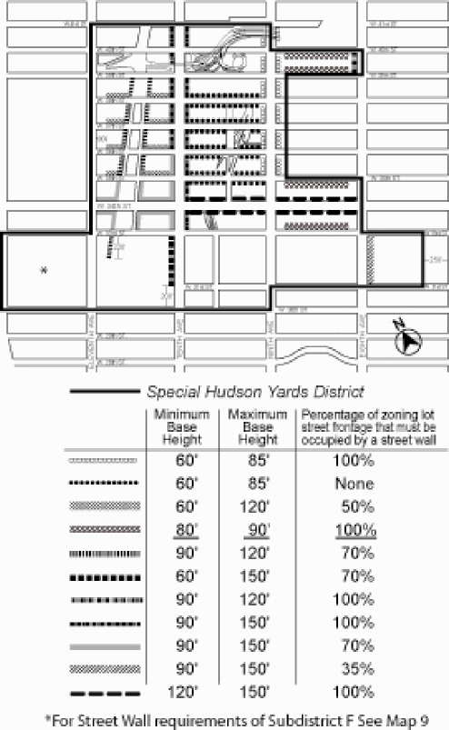

Article XII - Special Purpose Districts

Chapter 1
Special Garment Center District

* * *

121-30
SPECIAL BULK REGULATIONS WITHIN PRESERVATION AREA P-2

* * *

121-32
Height of Street Walls and Maximum Building Height

The #street wall# of any #development# or #enlargement# shall be located on the #street line# and extend along the entire #street# frontage of the #zoning lot# not occupied by existing #buildings# to remain. On a #zoning lot# with frontage of at least 200 feet, up to 20 percent of the #aggregate width of the street wall#, for a maximum width of 50 feet, may be recessed to a maximum depth of 15 feet from the #street line#, provided the recessed area is located a minimum of 2 0 feet from an adjacent #building# and that a minimum of 60 percent of such area be planted with any combination of grass, ground cover, shrubs, trees or other living plant material. Such #street wall# shall rise without setback to a maximum height of 90 feet or the height of the #building#, whichever is less. However, if the height of an adjacent #street wall# fronting on the same #street line# is higher than 90 feet before setback, the #street wall# of the new or #enlarged building# may rise without setback to the height of such adjacent #street wall#, up to a maximum height of 120 feet. Above a height of 90 feet or the height of the adjacent #street wall# if higher than 90 feet, no portion of the #development# or #enlargement# shall penetrate a #sky exposure plane# that begins at a height of 90 feet above the #street line# or the height of the adjacent #street wall# if higher than 90 feet and rises over the #zoning lot# at a slope of four feet of vertical distance for each foot of horizontal distance to a maximum height limit of 250 feet, except as provided below:

- any portion of the #building or other structure developed# or #enlarged# pursuant to the tower regulations of Sections 33 45 or 35 63, as applicable, may penetrate the #sky exposure plane#, provided no portion of such #building or other structure# exceeds the height limit of 250 feet; and

- permitted obstructions, as listed in paragraph (a) of Section 93 41, may penetrate the #sky exposure plane# and the height limit of 250 feet. In addition, a dormer, as listed in paragraph (c) of Section 23 62, may penetrate the #sky exposure plane#.

(a) Height of #street walls#

The #street wall# of any #development# or #enlargement# shall be located on the #street line# and extend along the entire #street# frontage of the #zoning lot# not occupied by existing #buildings# to remain. Such #street wall# shall rise without setback to a minimum base height of 80 feet and a maximum base height of 90 feet. However, if the height of an adjacent #street wall# fronting on the same #street line# is higher than 90 feet before setback, the #street wall# of the new or #enlarged building# may rise without setback to the height of such adjacent #street wall#, up to a maximum height of 120 feet.

For #zoning lots# or portions thereof, with #street# frontage of 25 feet or less existing on (the date of amendment), a minimum base height lower than 80 feet shall be permitted along such #street# frontage in accordance with the following provisions:

- where the height of an adjacent #street wall# fronting on the same #street line# is at least 60 feet and less than 80 feet, the #street wall# of the new or #enlarged building# may rise without setback to the height of such adjacent #street wall#; or

- where the height of an adjacent #street wall# fronting on the same #street line# is less than 60 feet, the #street wall# of the new or #enlarged building# may rise without setback to a minimum #street wall# height of 60 feet.

The #street wall# of any #development# or #enlargement# may rise to a height less than the minimum base height required pursuant to this paragraph, (a), provided that no #building# on the #zoning lot# exceeds such height.

(b) Maximum #building# height

Above a height of 90 feet or the height of the adjacent #street wall# if higher than 90 feet, no portion of the #development# or #enlargement# shall penetrate a #sky exposure plane# that begins at a height of 90 feet above the #street line#, or the height of the adjacent #street wall# if higher than 90 feet, and rises over the #zoning lot# at a slope of four feet of vertical distance for each foot of horizontal distance to a maximum height limit of 250 feet, except as provided below:

- any portion of the #building or other structure developed# or #enlarged# pursuant to the tower regulations of Sections 33-45 or 35-63, as applicable, may penetrate the #sky exposure plane#, provided no portion of such #building or other structure# exceeds the height limit of 250 feet; and

- permitted obstructions, as listed in paragraph (a) of Section 93-41, may penetrate the #sky exposure plane# and the height limit of 250 feet. In addition, a dormer, as listed in paragraph (c) of Section 23-62, may penetrate the #sky exposure plane#.

On a #zoning lot# with frontage of at least 200 feet along at least one #street#, up to 20
percent of the #aggregate width of the street wall# facing such #street#, for a maximum
width of 50 feet, may be recessed to a maximum depth of 15 feet from the #street line#, provided the recessed area is located a minimum of 20 feet from an adjacent #building# and that a minimum of 60 percent of such area be planted with any combination of grass, ground cover, shrubs, trees or other living plant material.
* * *

APPENDIX A
Special Garment Center District Plan

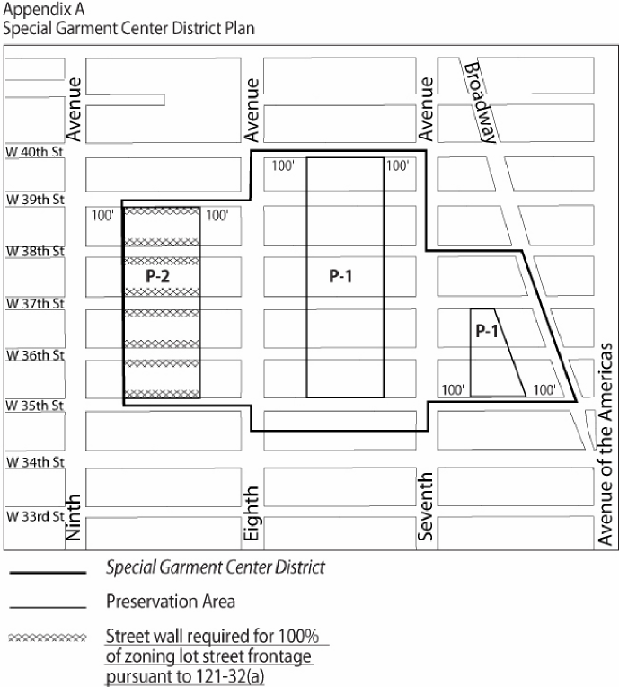

Adopted.

Office of the City Clerk, }
The City of New York, } ss.:

I hereby certify that the foregoing is a true copy of a Resolution passed by The Council of The City of New York on June 29, 2010, on file in this office.

...…….........................................
City Clerk, Clerk of The Council

