THE COUNCIL OF THE CITY OF NEW YORK
RESOLUTION NO. 384

Resolution approving the decision of the City Planning Commission on Application No. N 230338 ZRK, for an amendment of the text of the Zoning Resolution (L.U. No. 42).

By Council Members Salamanca and Riley

WHEREAS, Stellar 341, LLC, filed an application pursuant to Section 201 of the New York City Charter, for an amendment of the text of the Zoning Resolution of the City of New York, modifying provisions of Article II, Chapter 3 (Residential Bulk Regulations in Residence Districts) and related Sections, and modifying APPENDIX F (Inclusionary Housing Designated Areas and Mandatory Inclusionary Housing Areas) for the purpose of establishing a Mandatory Inclusionary Housing area, which in conjunction with the related actions would facilitate the development of two new 17- and 19-story mixed-use buildings totaling approximately 245,000 square feet with 305 residential units, 162 of which would be income restricted, and ground floor community facility and retail space at 341 10th Street (Block 1010, Lot 26) in the Park Slope neighborhood of Brooklyn, Community District 6, (ULURP No. N 230338 ZRK), (the “Application”);

WHEREAS, the City Planning Commission filed with the Council on March 11, 2024, its decision dated March 6, 2024 (the "Decision") on the Application;

WHEREAS, the Application is related to applications C 230337 ZMK (L.U. No. 41), a zoning map amendment to change R6A and R6B zoning districts to R7-3 and R7-3/C2-4 zoning districts; G 240045 XAK (L.U. No. 43), a real property tax exemption pursuant to Section 577 of Article XI of the Private Housing Finance Law; C 230339 ZSK (L.U. No. 46), a zoning special permit to establish a Large Scale General Development (LSGD) and modify bulk regulations; and C 230340 ZSK (L.U. No. 47), a zoning special permit to reduce parking requirements in the Large Scale General Development (LSGD);

WHEREAS, the Decision is subject to review and action by the Council pursuant to Section 197-d of the City Charter;

WHEREAS, upon due notice, the Council held a public hearing on the Decision and Application on March 12, 2024;

WHEREAS, the Council has considered the land use implications and other policy issues relating to the Decision and Application; and

WHEREAS, the Council has considered the relevant environmental issues, including the Negative Declaration issued on October 2, 2023 (CEQR No. 23DCP145K), which includes an (E) designation to avoid the potential for significant adverse impacts related to hazardous materials, air quality, and noise (E-730) (the “Negative Declaration”).

RESOLVED:

The Council finds that the action described herein will have no significant impact on the environment as set forth in the (E) Designation (E-730) and Negative Declaration.

Pursuant to Sections 197-d and 200 of the City Charter and on the basis of the Decision and Application, and based on the environmental determination and consideration described in the report, N 230338 ZRK, incorporated by reference herein, and the record before the Council, the Council approves the Decision of the City Planning Commission.

Matter underlined is new, to be added;
Matter struck out is to be deleted;
Matter within # # is defined in Section 12-10;
* * * indicates where unchanged text appears in the Zoning Resolution

* * *

ARTICLE II
RESIDENCE DISTRICT REGULATIONS

Chapter 1
Statement of Legislative Intent

* * *

21-10
PURPOSES OF SPECIFIC RESIDENCE DISTRICTS

* * *

21-15
R3-2, R4, R4B, R5, R6, R7, R8, R9 and R10 — General Residence Districts

These districts are designed to provide for all types of residential buildings, in order to permit a broad range of housing types, with appropriate standards for each district on density, open space, and spacing of buildings. However, R4B Districts are limited to single- or two-family dwellings, and zero lot line buildings are not permitted in R3-2, R4 (except R4-1 and R4B), and R5 (except R5B) Districts. The various districts are mapped in relation to a desirable future residential density pattern, with emphasis on accessibility to transportation facilities and to various community facilities, and upon the character of existing development. These districts also include community facilities and open uses which serve the residents of these districts or benefit from a residential environment.

R7-3 and R9-1 Districts may be mapped only as specified in this paragraph. Such districts may be mapped within the waterfront area and in the Special Mixed Use Districts and Mandatory Inclusionary Housing areas. In addition, R7-3 Districts may be mapped in the Special Long Island City Mixed Use District and Special St. George District, and R9-1 Districts may be mapped in Mandatory Inclusionary Housing areas.

Chapter 2
Use Regulations

* * *

Chapter 3
Residential Bulk Regulations in Residence Districts

23-00
APPLICABILITY AND GENERAL PURPOSES

23-01
Applicability of This Chapter

* * *

Special regulations applying only in Special Purpose Districts are set forth in Articles VIII, IX, X, XI, XII, XIII and XIV.

For the purposes of this Chapter, the regulations applicable to an R7-2 District shall apply to R7-3 Districts, unless otherwise specified.

In Manhattan Community Districts 1, 2, 3, 4, 5 and 6, Brooklyn Community Districts 1, 2, 6 and 8, and Queens Community Districts 1 and 2, the #conversion# of non-#residential# #floor area# to #residences# in #buildings# erected prior to December 15, 1961, or January 1, 1977, as applicable, shall be subject to the provisions of Article I, Chapter 5 (Residential Conversions Within Existing Buildings), unless such #conversions# meet the requirements for #residential developments# of Article II (Residence District Regulations).

* * *

23-10
OPEN SPACE AND FLOOR AREA REGULATIONS

* * *

23-15
Open Space and Floor Area Regulations in R6 Through R10 Districts

* * *

23-155
Affordable independent residences for seniors

R6 R7 R8 R9 R10

In the districts indicated, the maximum #floor area ratio# for #affordable independent residences for seniors# utilizing the Quality Housing #bulk# regulations shall be as set forth in the table in this Section.

In R6, R7, R8, R9 or R10 Districts without a letter suffix, the maximum #floor area ratio# and #open space ratio# for #affordable independent residences for seniors# utilizing the basic #bulk# regulations shall be as set forth for #residential uses# in Sections 23-151 (Basic regulations for R6 through R9 Districts) and 23-152 (Basic regulations for R10 Districts), as applicable.

MAXIMUM FLOOR AREA RATIO FOR AFFORDABLE INDEPENDENT RESIDENCES FOR SENIORS IN QUALITY HOUSING BUILDINGS

District | Maximum #Floor Area Ratio#
R6 R6A R7B | 3.90
R6B | 2.20
R7 R7-1 R7-2 R7A | 5.01
R7D | 5.60
R7X R7-3 | 6.00
R8 R8A R8X | 7.20

* * *

23-60
HEIGHT AND SETBACK REGULATIONS

* * *

23-66
Height and Setback Requirements for Quality Housing Buildings

* * *

23-664
Modified height and setback regulations for certain Inclusionary Housing buildings or affordable independent residences for seniors

R6 R7 R8 R9 R10

* * *

TABLE 2

ALTERNATIVE MAXIMUM BASE HEIGHT AND MAXIMUM BUILDING HEIGHT FOR CERTAIN QUALITY HOUSING BUILDINGS IN NON-CONTEXTUAL DISTRICTS

District | Maximum Base Height (in feet) | Maximum Height of #Buildings or other Structures# (in feet) | Maximum Number of #Stories#
R6 | 65 | 115 | 11
R7 R7-1 R7-2 | 75 | 135 | 13
R7-3 | 85 | 185 | 18
R8 | 105 | 215 | 21
R9-1 | 125 | 285 | 28

23-665
Additional regulations

* * *

Chapter 4
Bulk Regulations for Community Facilities in Residence Districts

24-00
APPLICABILITY, GENERAL PURPOSES AND DEFINITIONS

24-01
Applicability of This Chapter

* * *

Special regulations applying to #large-scale community facility developments# or to #community facility uses# in #large-scale residential developments# are set forth in Article VII, Chapters 9 or 8, respectively.

Special regulations applying only in Special Purpose Districts are set forth in Articles VIII, IX, X, XI, XII, XIII and XIV.

For the purposes of this Chapter, the regulations applicable to an R7-2 District shall apply to R7-3 Districts, unless otherwise specified.

Special regulations applying in the #waterfront area# are set forth in Article VI, Chapter 2.

* * *

24-013
Special provisions for certain community facility uses

The provisions of this Section shall apply to #buildings# containing #long-term care facilities# or philanthropic or non-profit institutions with sleeping accommodations, as listed in Use Group 3.

(a) #Buildings# containing #long-term care facilities#

(1) In R1 and R2 Districts

* * *

(3) In R6 through R10 Districts

In R6 through R10 Districts, the #bulk regulations# of Article II, Chapter 3 applicable to #affordable independent residences for seniors#, inclusive, shall apply to #buildings#, or portions thereof, containing #long-term care facilities#, except as follows:

(i) in R6A Districts or R6 Districts without a letter suffix, the maximum #floor area ratio# for #long-term care facilities# shall be 3.6;

(ii) in R7A Districts or R7 Districts without a letter suffix, other than R7-3 Districts, the maximum #floor area ratio# for #long-term care facilities# shall be 4.6; and

(iii) the minimum size of #dwelling unit# provisions of Section 23-23 shall not apply.

In R6 through R10 Districts without letter suffixes, the Commission may permit the #bulk# regulations of this Chapter to apply to such #long-term care facilities# pursuant to the special permit in Section 74-903.

* * *

Chapter 5
Accessory Off-Street Parking and Loading Regulations

* * *

25-00
GENERAL PURPOSES AND DEFINITIONS

* * *

25-02
Applicability

* * *

25-026
Applicability of regulations in the waterfront area R7-3 Districts

Special regulations applying in the #waterfront area# are set forth in Article VI, Chapter 2.
R7-3 Districts shall be governed by the #accessory# off-street parking regulations of an R7-2 District.

* * *

ARTICLE III
COMMERCIAL DISTRICT REGULATIONS

* * *

Chapter 3
Bulk Regulations for Commercial or Community Facility Buildings in Commercial Districts

33-00
APPLICABILITY, DEFINITIONS AND GENERAL PROVISIONS

33-01
Applicability of This Chapter

* * *

Special regulations applying only in Special Purpose Districts are set forth in Articles VIII, IX, X, XI, XII, XIII and XIV.

For the purposes of this Chapter, the regulations applicable to C1 or C2 Districts mapped within an R7-2 District shall apply to C1 or C2 Districts mapped within R7-3 Districts, unless otherwise specified.

All C6-1A Districts shall comply with the regulations of C6-1 Districts except as set forth in Sections 33-12, paragraph (c), 33-13, paragraph (b) and 33-15, paragraph (a).

* * *

33-012
Special provisions for certain community facility uses

The provisions of this Section shall apply to #buildings# containing #long-term care facilities# or philanthropic or non-profit institutions with sleeping accommodations, as listed in Use Group 3.

(a) #Buildings# containing #long-term care facilities#

(1) #Commercial Districts# with a residential equivalent of an R1 or R2 District

* * *

(3) #Commercial Districts# with a residential equivalent of an R6 through R10 District
In C1 or C2 Districts mapped within R6 through R10 Districts, or in #Commercial Districts# with a residential equivalent of an R6 through R10 District, the #bulk# regulations of Article II, Chapter 3, applicable to #affordable independent residences for seniors#, inclusive, shall apply to #buildings#, or portions thereof, containing #long-term care facilities#, except as follows:

(i) in C1 or C2 Districts mapped within R6A Districts or R6 Districts without a letter suffix, or in #Commercial Districts# with a residential equivalent of an R6A District or an R6 District without a letter suffix, the maximum #floor area ratio# for #long-term care facilities# shall be 3.6;

(ii) in C1 or C2 Districts mapped within R7A Districts or R7 Districts without a letter suffix, other than R7-3 Districts, or in #Commercial Districts# with a residential equivalent of an R7A District or an R7 District without a letter suffix, the maximum #floor area ratio# for #long-term care facilities# shall be 4.6;

(iii) the minimum size of #dwelling unit# provisions of Section 23-23 shall not apply;

* * *

Chapter 5
Bulk Regulations for Mixed Buildings in Commercial Districts

35-00
APPLICABILITY AND DEFINITIONS

35-01
Applicability of this Chapter

* * *

35-012
Special provisions for certain community facility uses

The provisions of this Section shall apply to #zoning lots# with #mixed buildings# containing #long-term care facilities#, or philanthropic or non-profit institutions with sleeping accommodations, as listed in Use Group 3.

(a) #Buildings# containing #long-term care facilities#

(1) #Commercial Districts# with a residential equivalent of an R1 or R2 District

* * *

(3) #Commercial Districts# with a residential equivalent of an R6 through R10 District

In C1 or C2 Districts mapped within R6 through R10 Districts, or in #Commercial Districts# with a residential equivalent of an R6 through R10 District, the #bulk# regulations of Article II, Chapter 3, applicable to #affordable independent residences for seniors#, inclusive, shall apply to #buildings#, or portions thereof, containing #long-term care facilities#, except as follows:

(i) in C1 or C2 Districts mapped within R6A Districts or R6 Districts without a letter suffix, or in #Commercial Districts# with a residential equivalent of an R6A District or an R6 District without a letter suffix, the maximum #floor area ratio# for #long-term care facilities# shall be 3.6;

(ii) in C1 or C2 Districts mapped within R7A Districts or R7 Districts without a letter suffix, other than R7-3 Districts, or in #Commercial Districts# with a residential equivalent of an R7A District or an R7 District without a letter suffix, the maximum #floor area ratio# for #long-term care facilities# shall be 4.6;

(iii) the minimum size of #dwelling unit# provisions of Section 23-23 shall not apply;

* * *

Chapter 6
Accessory Off-Street Parking and Loading Regulations

* * *

36-00
GENERAL PURPOSES AND DEFINITIONS

* * *

36-02
Applicability of District Regulations

* * *

36-027
Applicability of regulations in the waterfront area R7-3 Districts

Special regulations applying in the #waterfront area# are set forth in Article VI, Chapter 2.

In #Commercial Districts# where #residential uses# are governed by the #bulk# regulations of R7-3 Districts, the #accessory# off-street parking regulations of R7-2 Districts shall apply to #residential uses#.

36-028
Applicability of regulations in flood zones

* * *

APPENDIX F
Inclusionary Housing Designated Areas and Mandatory Inclusionary Housing Areas

* * *

BROOKLYN

Brooklyn Community District 6

Map 1 – [date of adoption]

[EXISTING MAP]

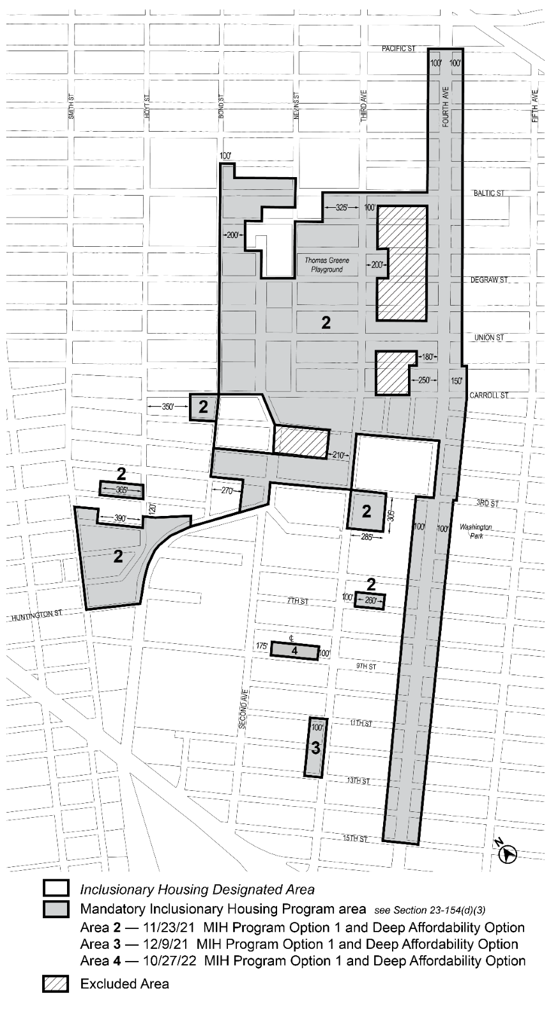

[PROPOSED MAP]

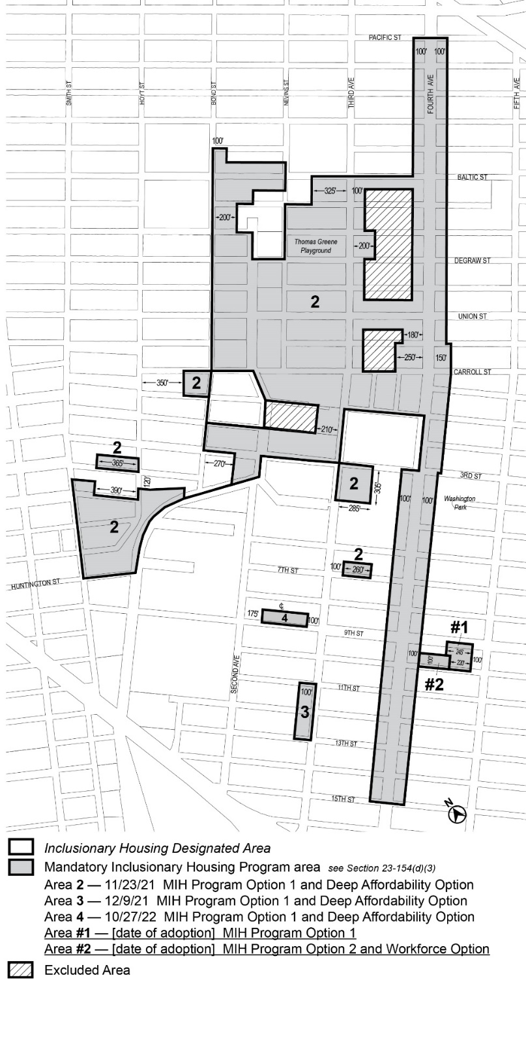
* * *

Adopted.

Office of the City Clerk,}
The City of New York,} ss.:

I hereby certify that the foregoing is a true copy of a Resolution passed by The Council of The City of New York on _________, 2024, on file in this office.

.....................................................
City Clerk, Clerk of The Council

