THE COUNCIL OF THE CITY OF NEW YORK
RESOLUTION NO. 358

Resolution approving with modifications the decision of the City Planning Commission on Application No. N 230308 ZRQ, for an amendment of the text of the Zoning Resolution (L.U. No. 40).

By Council Members Salamanca and Riley

WHEREAS, Efraim Realty, LLC, filed an application pursuant to Section 201 of the New York City Charter, for an amendment of the text of the Zoning Resolution of the City of New York, modifying APPENDIX F for the purpose of establishing a Mandatory Inclusionary Housing area, which in conjunction with the related action would facilitate the development of a six-story mixed-use building with 22 dwelling units, approximately six of which would be permanently income-restricted, and ground-floor commercial space at 23-01 Steinway Street in the Ditmars-Steinway neighborhood of Queens, Community District 1 (ULURP No. N 230308 ZRQ), (the “Application”);
WHEREAS, the City Planning Commission filed with the Council on March 8, 2024, its decision dated March 6, 2024 (the "Decision") on the Application;
WHEREAS, the Application is related to application C 230307 ZMQ (L.U. No. 39), a zoning map amendment to change an R5D and R5D/C2-3 zoning districts to an R6A/C2-4 zoning district;
WHEREAS, the Decision is subject to review and action by the Council pursuant to Section 197-d of the City Charter;
WHEREAS, upon due notice, the Council held a public hearing on the Decision and Application on March 12, 2024;
WHEREAS, the Council has considered the land use implications and other policy issues relating to the Decision and Application; and
WHEREAS, the Council has considered the relevant environmental issues, including the Negative Declaration issued on October 16, 2023 (CEQR No. 23DCP167Q), which includes an (E) designation (E-744) related to hazardous materials, air quality, and noise to avoid the potential for significant adverse impacts. The (E) designation (E-744) supersedes (E-245) on Block 793, Lot 73 and (E-524) on Block 805, Lot 61 (the “Negative Declaration”).
RESOLVED:
The Council finds that the action described herein will have no significant impact on the environment as set forth in the (E) Designation (E-744) and Negative Declaration.
Pursuant to Sections 197-d and 200 of the City Charter and on the basis of the Decision and Application, and based on the environmental determination and consideration described in the report, N 230308 ZRQ, incorporated by reference herein, and the record before the Council, the Council approves the Decision of the City Planning Commission, with the following modifications.
Matter underlined is new, to be added;
Matter struck out is to be deleted;
Matter double struck out is old, deleted by the City Council;
Matter double-underlined is new, added by the City Council;
Matter within # # is defined in Section 12-10;
* * * indicates where unchanged text appears in the Zoning Resolution.

* * *
APPENDIX F
Inclusionary Housing Designated Areas and Mandatory Inclusionary Housing Areas
* * *
QUEENS

Queens Community District 1
* * *
Map 8– [date of adoption]
[EXISTING MAP]
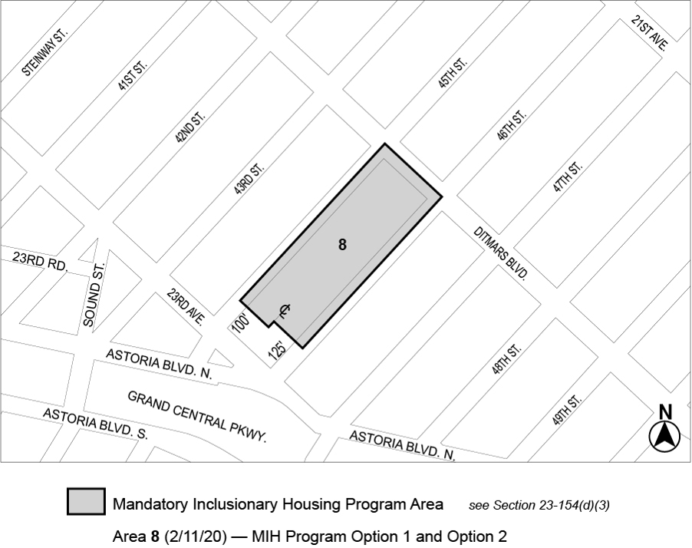
[PROPOSED MAP]
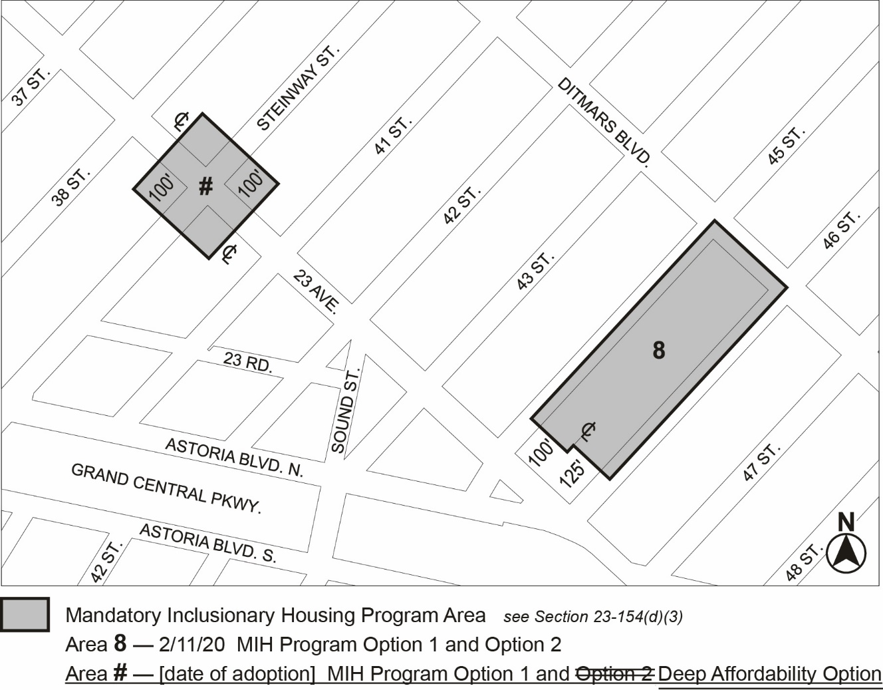

Portion of Community District 1, Queens

* * *

Adopted.

Office of the City Clerk,}
The City of New York,} ss.:

I hereby certify that the foregoing is a true copy of a Resolution passed by The Council of The City of New York on _________, 2024, on file in this office.

.....................................................
City Clerk, Clerk of The Council

