THE COUNCIL OF THE CITY OF NEW YORK
RESOLUTION NO. 297

Resolution approving the decision of the City Planning Commission on Application No. N 240031 ZRK, for an amendment of the text of the Zoning Resolution (L.U. No. 17).

By Council Members Salamanca and Hanks

WHEREAS, the New York City Department of Housing Preservation and Development, filed an application pursuant to Section 201 of the New York City Charter, for an amendment of the text of the Zoning Resolution of the City of New York, modifying Appendix F for the purpose of establishing a Mandatory Inclusionary Housing area, which in conjunction with the related actions would facilitate a nine-story mixed-use building with 290 income-restricted housing units, approximately 25,500 square feet of ground floor community facility uses for arts and cultural space, and approximately 17,150 square feet of outdoor open space, on property that is vacant and city-owned, in which the proposed development will have a total of approximately 257,700 square feet of floor area (including approximately 232,180 square feet of residential area) in the Borough of Brooklyn, Community District 16 (ULURP No. N 240031 ZRK), (the “Application”);
WHEREAS, the City Planning Commission filed with the Council on January 29, 2024, its decision dated January 24, 2024 (the “Decision”) on the Application;
WHEREAS, the Application is related to applications C 240029 HAK (L.U. No. 15), an urban development action area (UDAA) designation, project approval (UDAAP), and disposition of City-owned property; and C 240030 ZMK (L.U. No. 16), a zoning map amendment to change R6/C2-3 and C4-3 zoning districts to R7A and R7A/C2-4;
WHEREAS, the Decision is subject to review and action by the Council pursuant to Section 197-d of the City Charter;
WHEREAS, upon due notice, the Council held a public hearing on the Decision and Application on February 29, 2024;
WHEREAS, the Council has considered the land use implications and other policy issues relating to the Decision and Application; and
WHEREAS, the Council has considered the relevant environmental issues, including the Negative Declaration issued on August 18, 2023 (CEQR No. 20HPD019K) (the “Negative Declaration”).
RESOLVED:
The Council finds that the action described herein will have no significant impact on the environment as set forth in the Negative Declaration.
Pursuant to Sections 197-d and 200 of the City Charter and on the basis of the Decision and Application, and based on the environmental determination and consideration described in the report, N 240031 ZRK, incorporated by reference herein, and the record before the Council, the Council approves the Decision of the City Planning Commission.
Matter underlined is new, to be added;
Matter struck out is to be deleted;
Matter within # # is defined in Section 12-10;
* * * indicates where unchanged text appears in the Zoning Resolution

APPENDIX F
Inclusionary Housing Designated Areas and Mandatory Inclusionary Housing Areas

* * *

BROOKLYN

* * *

Brooklyn Community District 16

Map 6 – [date of adoption]

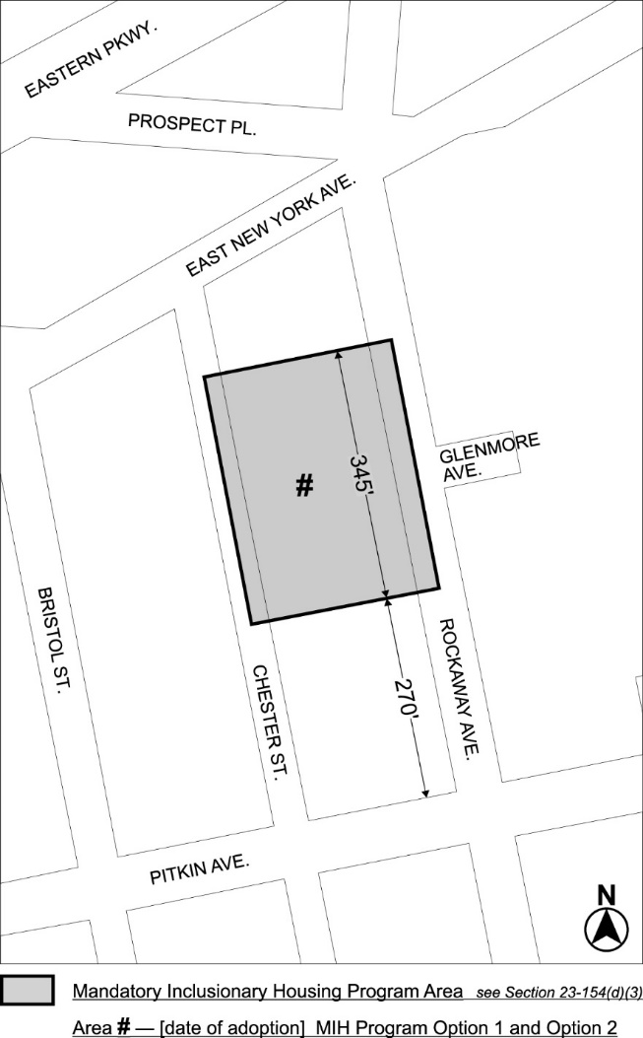

Portion of Community District 16, Brooklyn

* * *
Adopted.

Office of the City Clerk,}
The City of New York,} ss.:

I hereby certify that the foregoing is a true copy of a Resolution passed by The Council of The City of New York on March 19, 2024, on file in this office.

.....................................................
City Clerk, Clerk of The Council

