Oversight & Investigations Committee Staff
Nicole Catá, Legislative Counsel
Erica Cohen, Legislative Policy Analyst
Alex Yablon, Legislative Policy Analyst
Owen Kotowski, Financial Policy Analyst
Andrew Lane-Lawless, Legislative Financial Analyst

Oversight & Investigations Division Staff
Kevin Frick, Senior Investigative Counsel
Katie Sinise, Investigator
Uzair Qadir, Data Scientist
Amisa Ratliff, Legislative Fellow



THE COUNCIL OF THE CITY OF NEW YORK

BRIEFING PAPER OF THE GOVERNMENTAL AFFAIRS AND OVERSIGHT & INVESTIGATIONS DIVISIONS
Andrea Vazquez, Legislative Director

Aaron Mendelsohn, Director, Oversight & Investigations Division

Rachel Cordero, Deputy Director, Governmental Affairs Division

Meagan Powers, Deputy Director, Oversight & Investigations Division

Zachary Meher-Casallas, Assistant Deputy Director, Oversight & Investigations Division

COMMITTEE ON OVERSIGHT & INVESTIGATIONS
Hon. Gale A. Brewer, Chair

June 18, 2024

Oversight – Special Commissioner of Investigation for the New York City School District

INTRODUCTION

On June 18, 2024, the Committee on Oversight and Investigations, chaired by Council Member Gale A. Brewer, will conduct an oversight hearing on the Special Commissioner of Investigation for the New York City School District (SCI). Those invited to testify include representatives from SCI, school governance structures, unions, education advocates, legal services organizations, and other interested stakeholders and members of the public.
BACKGROUND
- Brief History of SCI
In December 1988, in response to several articles detailing corruption in the New York City School System as well as the highly public arrest of a Bronx principal for purchasing drugs, the Joint Commission on Integrity in Public Schools, more commonly referred to as the Gill Commission, was created to investigate corruption in the New York City School System. This Commission uncovered rampant corruption within the New York City Department of Education (DOE). In particular, it found that the school system’s own Office of Inspector General had turned a blind eye to corruption, patronage, and, in the case of the Bronx principal, criminal activity. The Gill Commission recommended the Office of Inspector General be replaced with a Special Commissioner, appointed by the Mayor, who would have the power to issue subpoenas and make arrests, which the school system’s own investigative arm lacked.
In accordance with the recommendations made by the Gill Commission, then-Mayor David Dinkins issued Executive Order 11, which created the Office of the Special Commissioner for the New York City School District. Since its inception in 1990, there have only been three Special Commissioners: Edward F. Stancik (1990-2002), Richard Condon (2002-2017) and the current Commissioner, Anastasia Coleman (2018-present).
While the Special Commissioner reports to the Commissioner of the Department of Investigation, the Executive Order creating the office allows it to operate as an independent agency. The head of the division was originally a Deputy Commissioner of Investigation for the City School District of the City of New York. Executive Order 34, issued in January 1992, changed the title to Special Commissioner of Investigation for the New York City School District.
In the past, SCI has come into conflict with both the DOI, to whom the Special Commissioner reports, as well as the DOE that it investigates. In 1997, then-New York City Schools Chancellor Rudy Crew called for the Special Commissioner to be replaced. Under the leadership of then-Special Commissioner Stancik, the office had produced numerous reports that were highly critical of the DOE. Dr. Crew alleged that these reports were exaggerated and damaging to the school system, and even ordered his own legal staff to launch an investigation. SCI Stancik was not removed, and in fact served an additional 15 years as Special Commissioner.
In 2018, the Department of Investigation, then led by Mark Peters, sought to bring the Office of the Special Commissioner under its direct control. Mr. Peters also sought to strip the Special Commissioner of the power to issue subpoenas, compel testimony and publish reports. Additionally, he sought to change the title of the Special Commissioner to “inspector general.” When the newly installed SCI, Anastasia Coleman, objected to these changes, the DOI fired her and demoted her deputy. A special whistleblower investigation stemming from Ms. Coleman’s firing found that Mr. Peters had overstepped his authority in seizing control of SCI’s Office. Ms. Coleman was reinstated as SCI, the office was given back its previous autonomy and all other unilateral changes made by Mr. Peters were rescinded. Mr. Peters was ultimately fired by the Mayor.

- SCI’s Work and Budget
SCI is the independent watchdog for the New York City School District, which includes the DOE and its retirement systems. As a law enforcement oversight agency independent from the DOE, SCI “investigates crime, corruption, and misconduct within the DOE or those conducting business with the DOE.” SCI investigates allegations including “misappropriation of funds, fraud, sexual misconduct or abuse of students by adults, conflicts of interest, and any other criminal or unethical conduct that hinders the public schools from functioning effectively.” The agency also “reviews, investigates, and makes determinations on all alleged violations of Whistleblower protection effecting DOE employees and vendors under both the NYC Charter and the corresponding BOE Whistleblower resolution, and serves as the Inspector General for both the Teachers Retirement System and the Board of Education Retirement System.” SCI’s investigations may result in arrests, criminal prosecutions, or other administrative proceedings. In 2022, SCI received 9,813 individual complaints, which represented a “high-water mark” for the agency and “surpassed the previous high of 9,638” in 2019. In 2023, “SCI received a record 10,265 complaints.”
Although SCI does not report to the DOE or the Chancellor, SCI’s budget is located within the DOE’s budget. The SCI funding is located in the 453 – Central Administration Unit of Appropriation (U/A). The Fiscal 2025 Executive Budget includes approximately $7 million in Fiscal 2024 and 2025, increasing to $7.2 million in the outyears for SCI. The SCI budget is mainly allocated towards Personal Services (PS) of approximately $6.7 million in Fiscal 2024. There are 69 positions supported with this funding in Fiscal 2024, 2025 and the outyears. As of April, there are 17 vacant positions in SCI.
- Local Law 43 of 2020
On February 27, 2020, the Council passed Local Law 43 of 2020, which requires DOI and SCI to create web applications to track agency cooperation and compliance with investigations and recommendations. After conducting an investigation into the DOE, SCI may issue reports on systemic deficiencies within the agency and make recommendations to address these vulnerabilities. If, in the course of an investigation, SCI uncovers the need for systematic changes at the DOE, it may publish Policy and Procedure Recommendations (PPRs). As such, SCI makes numerous PPRs “annually to the DOE related to corruption, mismanagement, and other ongoing or systemic deficiencies.”
Until the Council passed Local Law 43 of 2020, SCI did not publish many recommendations on how the District should address SCI’s findings. SCI also does not disclose in the Mayor’s Management Report the amount of recommendations they issued or the percentage of recommendations accepted by the District each year. The Council passed Local Law 43 of 2020 to improve public transparency of City agencies, including the DOE.
In relevant part, Local Law 43 of 2020 requires SCI to develop and maintain a web application providing information on the DOE’s compliance with SCI’s investigatory recommendations. The web application must contain information on each recommendation sent to a City agency resulting from an investigation; whether that recommendation was accepted or rejected by the City agency; and, if accepted, whether the City agency implemented the recommendation. SCI’s web application is required to contain information on recommendations issued on and after the effective date of the local law. The local law required SCI to make the web application available online by July 1, 2020, and to update and maintain it thereafter.
SCI currently lists PPRs from 2019 to present on its PPR Portal, which contains 256 entries.
OID’s DATA REVIEW OF SCI’s METRICS AND PERFORMANCE

- Introduction

The City Council’s Oversight and Investigations Division (OID) analyzed the annual metrics included in SCI’s Annual and Whistleblower Reports to assess SCI’s operational effectiveness from 2016 to present. OID also reviewed SCI’s PPRs, which are publicly available on the agency’s PPR Portal. OID’s analysis reveals issues with the agency’s ability to handle an increasing caseload at the same time as SCI’s staffing levels have remained stagnant. Furthermore, while SCI’s PPRs have historically been accepted by the DOE at high rates, fewer recommendations were made by SCI to the DOE in 2023 than in prior years, potentially reflecting limitations in the agency’s ability to guide policy.
- Budget and Funding

In addition to the challenges posed by low staffing levels and outstanding PPRs, SCI also faces significant budgetary constraints. Specifically, although SCI’s budget increased from $5.5 million in 2016 to $6.4 million in 2020, its budget has since plateaued. In that same period however, the agency saw an approximately 60% increase in the volume of misconduct complaints received, far outpacing the increase in SCI’s budget (as shown in Figure 1).
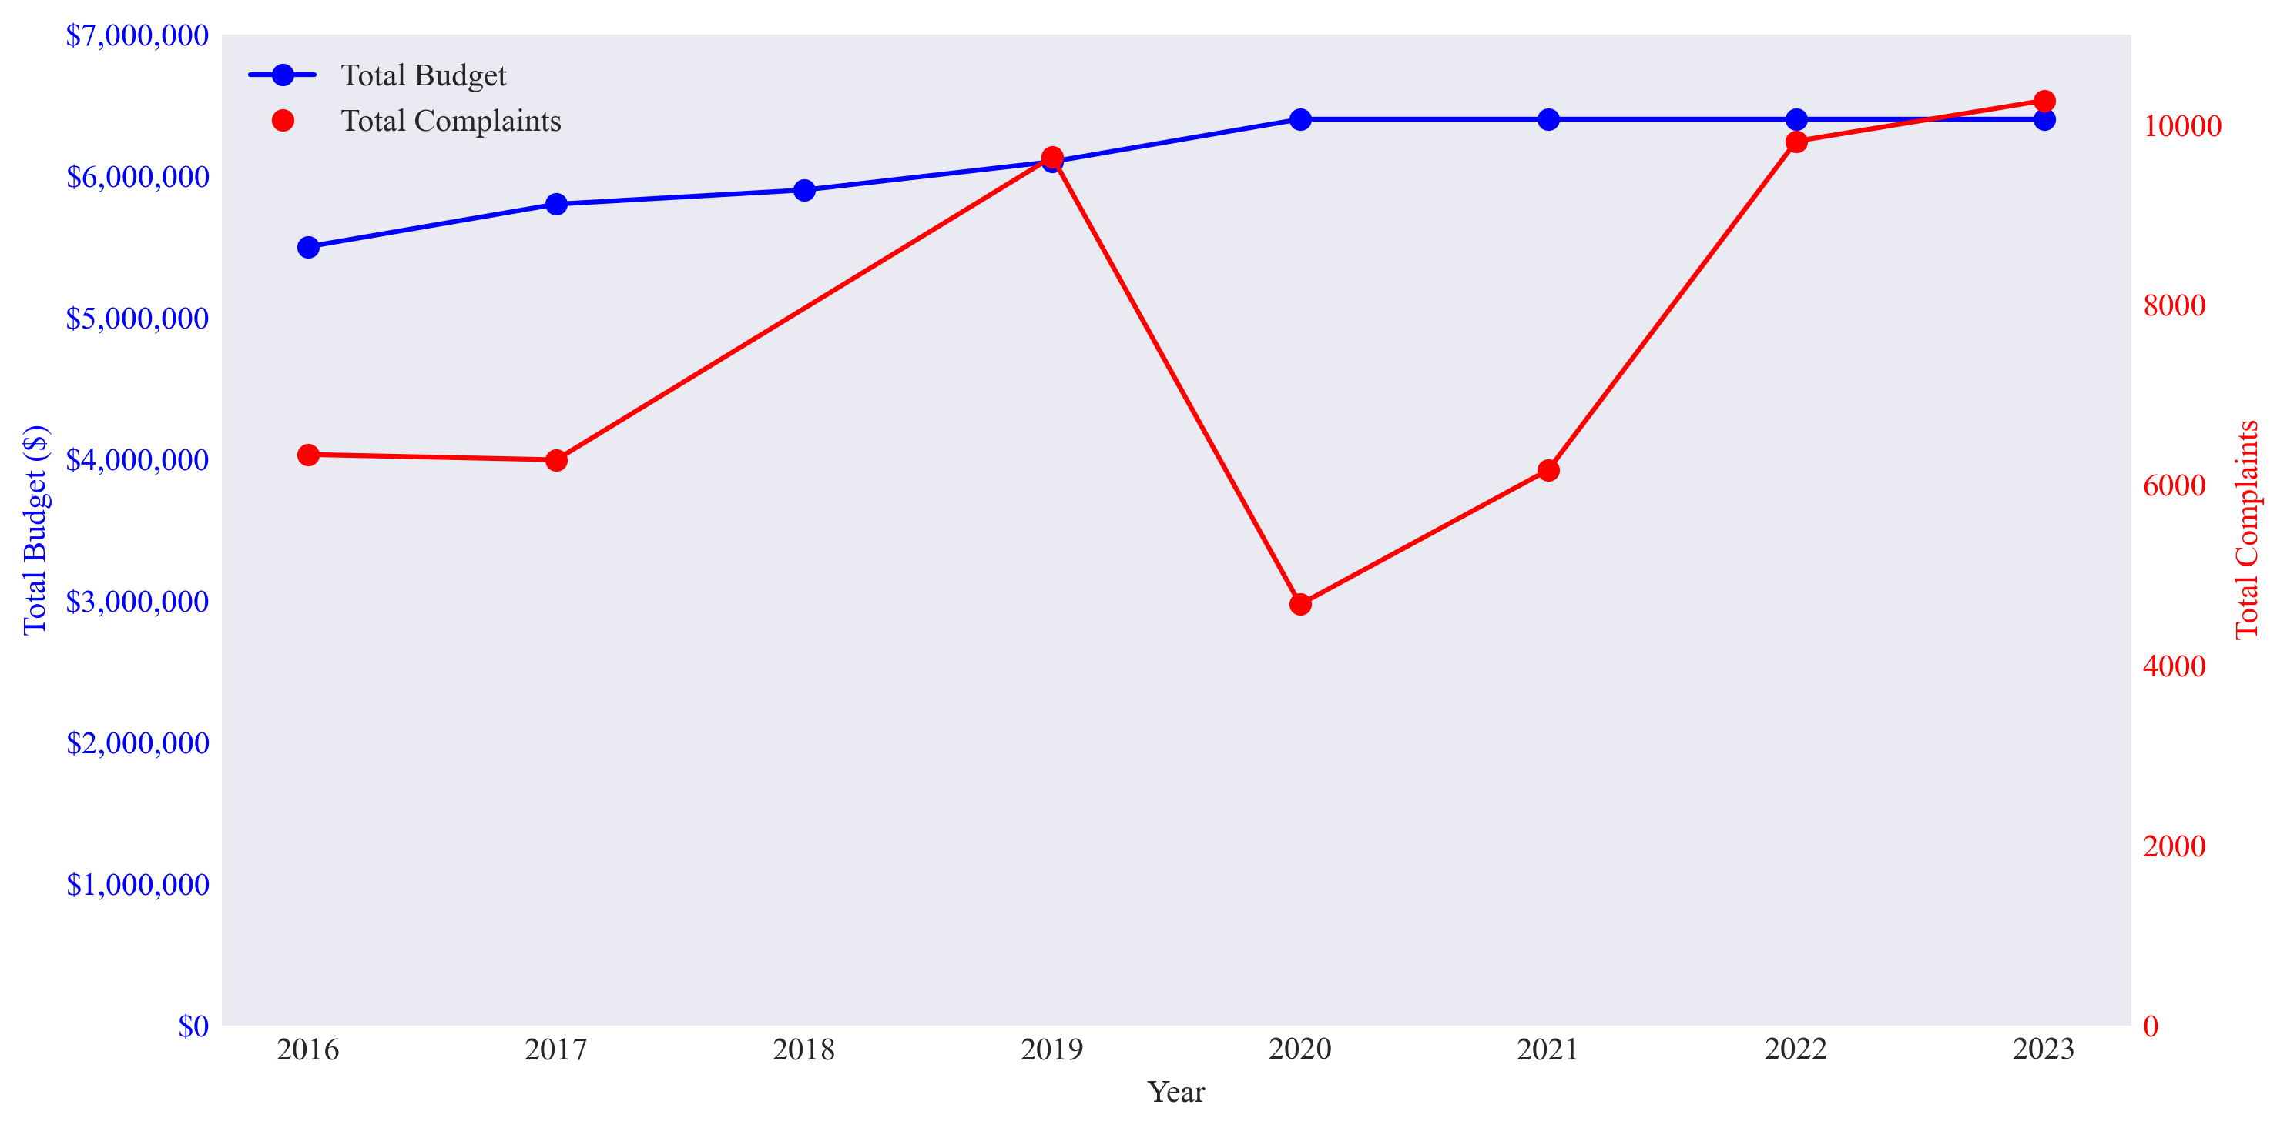
Figure 1 - SCI Historical Budget & Total Complaint Volume Changes
*Note: in the 2018 report, SCI presents two different figures for volume of complaints received. In the main body of the report, the figure is given as 8,930 while a data table of complaint volume from 2014-2018 lists the 2018 figure as 6,813. The 2018 figure is thus omitted from the chart.

- Staffing Issues
Beyond budgetary constraints, SCI also has staffing challenges. Despite SCI's budget remaining unchanged since 2020, attrition among staff and investigators has increased. Although the agency’s 2023 Annual Report does not provide overall staffing details, earlier reports reviewed by OID reveal a concerning trend: the number of SCI’s vacant positions has risen from approximately 13% in 2020 to 28% in 2022 (as shown in Figure 2).
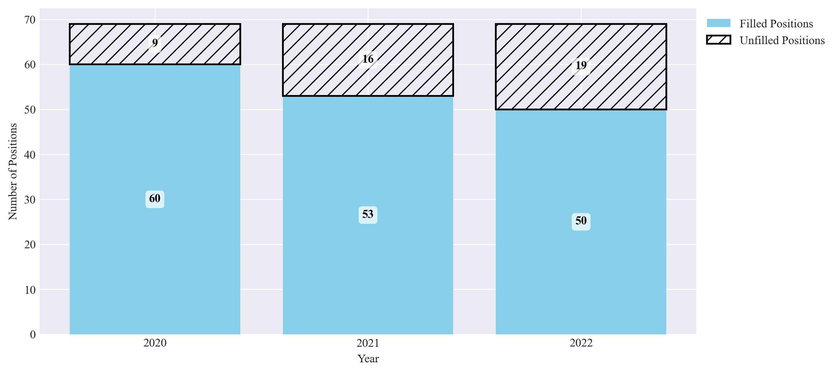
Figure 2 - SCI Staff Vacancies by Year

In addition to staffing challenges, SCI’s Whistleblower Reports provide information on the agency’s investigators, including data for 2023. Specifically, SCI went from 24 investigators in 2020 to 20 in 2023, an approximately 17% reduction. This includes the loss of two investigators assigned full-time to cases of Sexual/Inappropriate Conduct cases (all as shown in Figure 3).
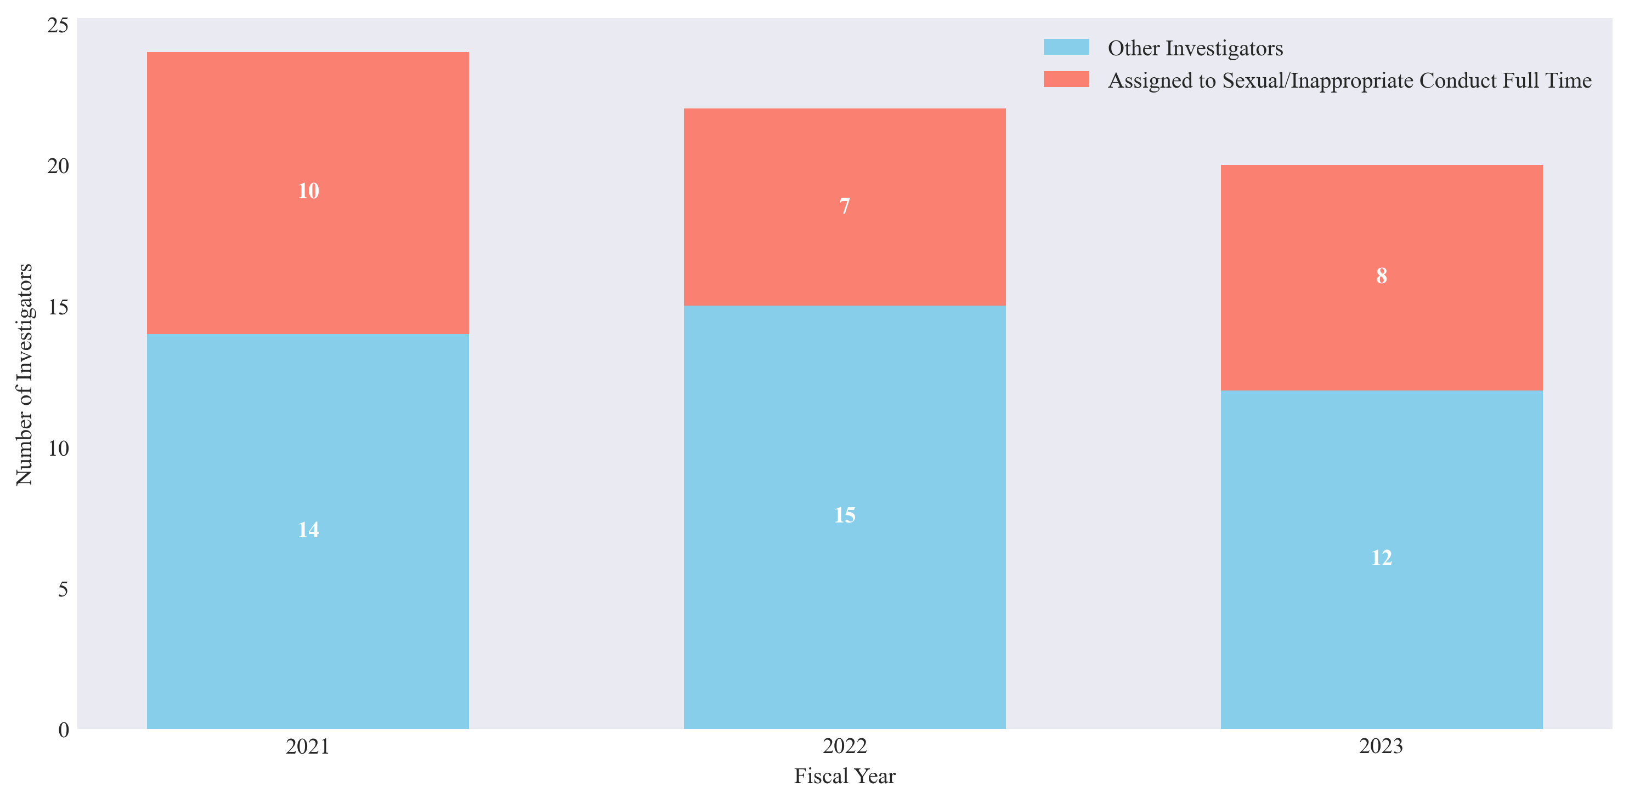
Figure 3 – Count of Investigators at SCI by Year
- Caseload and Investigations
Given SCI’s budgetary constraints and staffing challenges, the proportion of its complaints that lead to investigations serves as a possible metric for the agency’s capacity. Since 2014, there has been a marked decline in this metric. Specifically, the proportion of complaints resulting in investigations has plummeted from a peak of approximately 16% in 2015 to a historical low of around 4% in 2023. This decline underscores the growing strain on SCI’s ability to effectively manage its caseload (as shown in Figure 4). Note that prior to 2018, SCI does not report the proportion of complaints referred to other agencies, so any such cases would be included in the “Other Complaints” category.
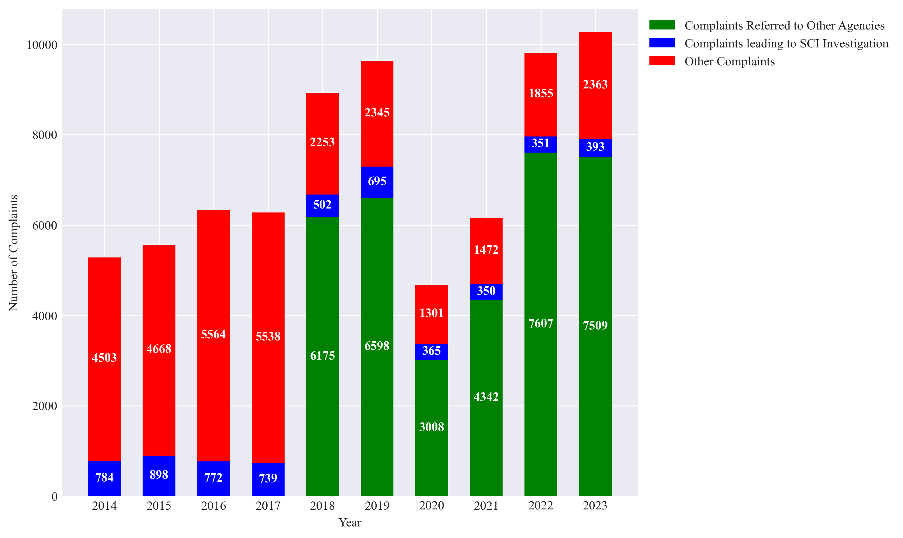
Figure 4- Complaints and Investigations
*Complaints referred to other agencies not listed in reports prior to 2018

- Investigation Outcomes
SCI’s investigation outcomes can be compared year over year, although data consistency varies across different categories of outcomes. The most common outcome of SCI investigations is a personnel-related recommendation, which may lead to disciplinary action, including termination. Notably, in 2023, a much smaller proportion of these personnel-related recommendations were disciplinary in nature, as compared to previous years.
In addition to disciplinary recommendations, administrative problem codes are frequently recommended in cases where subjects resign or are dismissed before investigations conclude. These codes prevent future employment or contracting of the individual by the DOE. The most serious outcomes, such as arrests, are quite rare: annual reports mention a single arrest in 2023, four arrests in 2022, and two arrests in 2021. While referrals to prosecutors are more common, they have steadily declined every year, from a peak of 30 referrals in 2020 to only 15 referrals to in 2023 (all as shown in Figure 5).
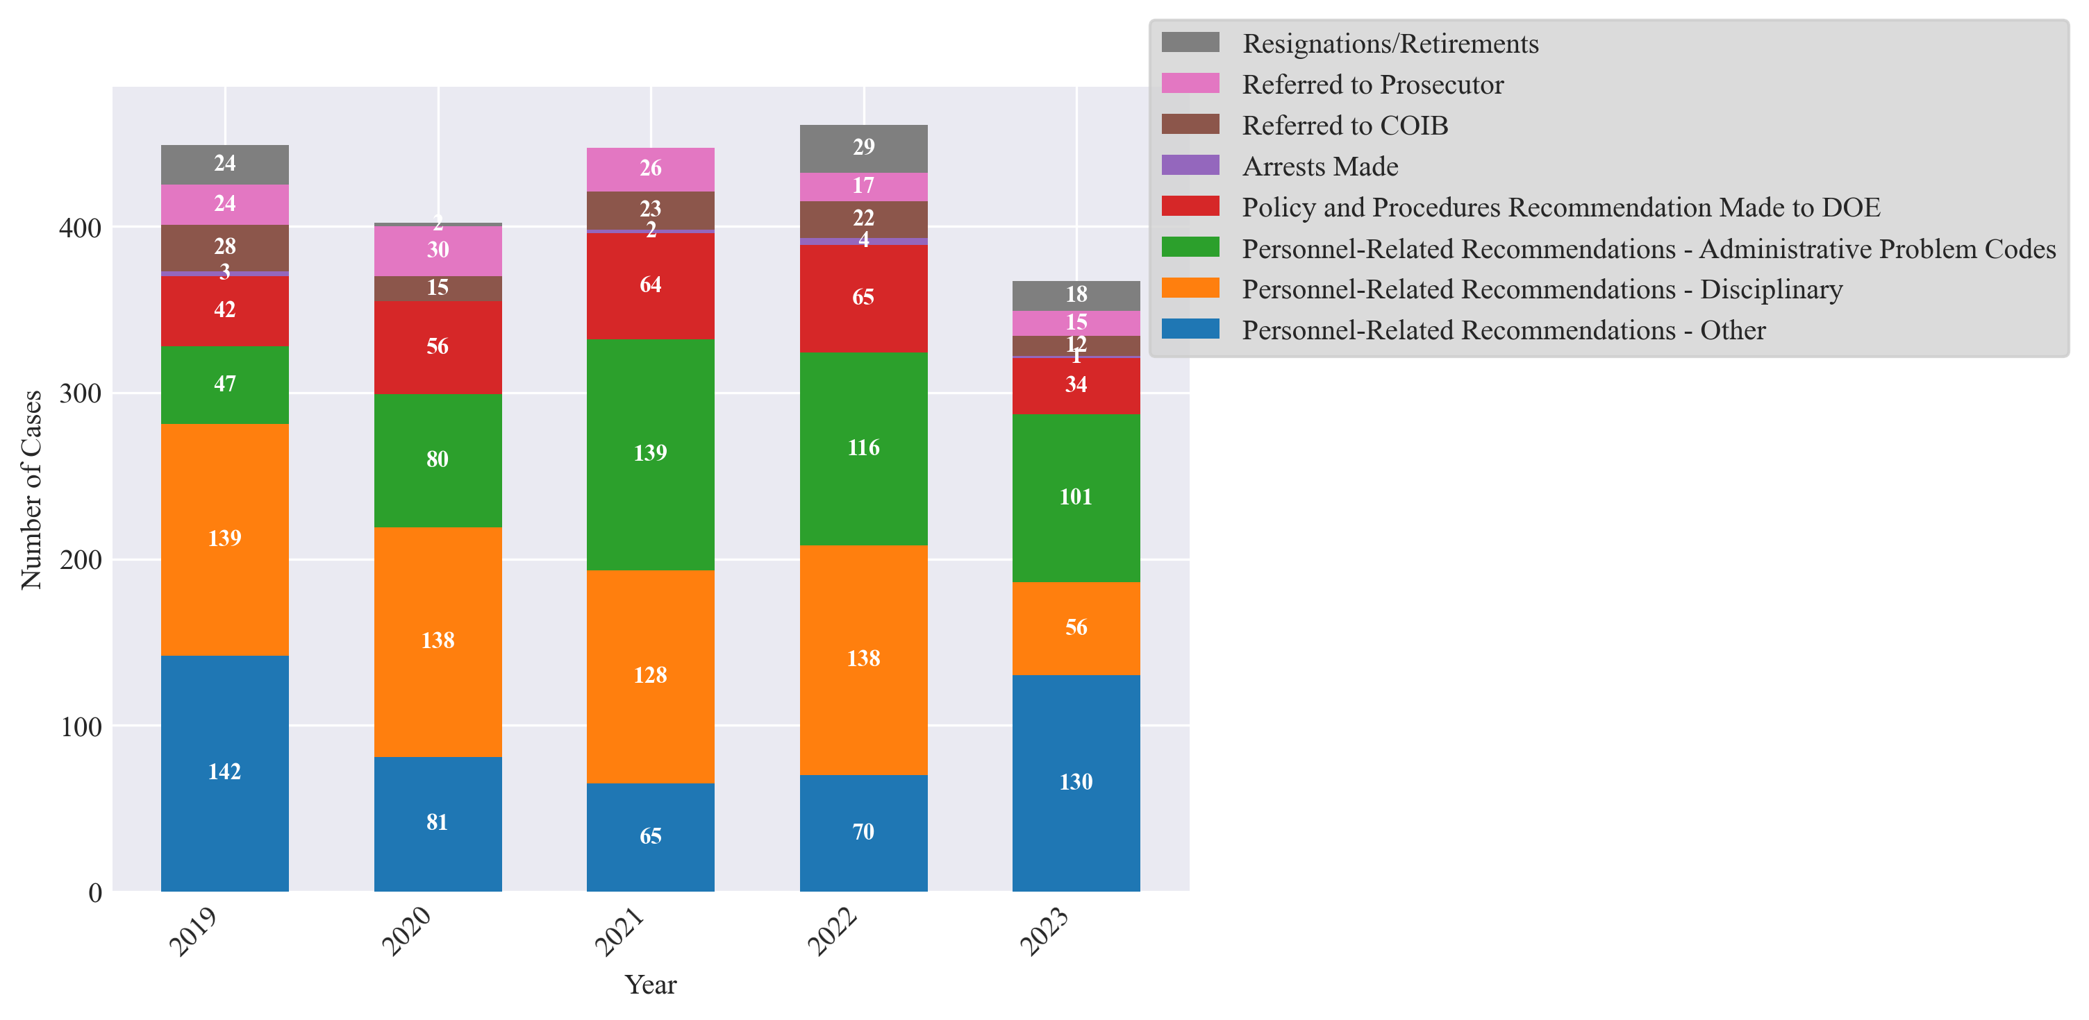
Figure 5 - Investigative Outcomes
- Policy and Procedures Recommendations
OID also analyzed SCI’s PPRs, which the agency makes to help the DOE identify and avoid fraud, corruption, mismanagement, and systemic deficiencies. Over the past four years, SCI has made fewer recommendations each year. For example, in 2020, the agency made 64 recommendations to the DOE, while in 2023, SCI made around half that number: just 34 recommendations. To date in 2024, SCI has made eight recommendations.
The DOE accepts most PPRs from SCI, but numerous recommendations from 2020-2024 are still listed either as “pending” or “under advisement.” Specifically, of the 65 PPRs made in 2022, 19 are still “pending.” Two PPRs from 2024 are listed as “accepted”, while the remaining six are still “pending” on SCI’s website (as seen in Figure 6).
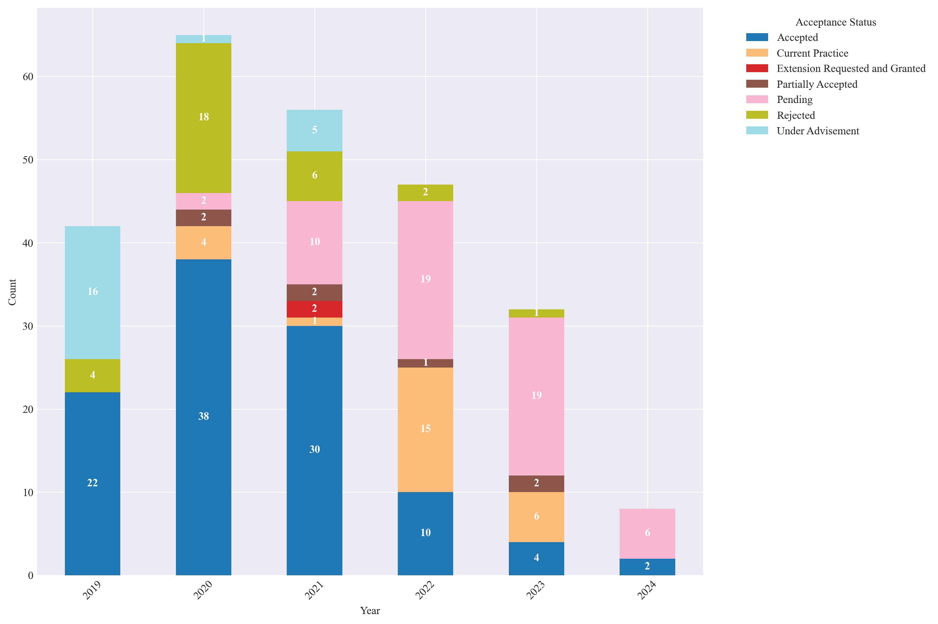 Figure 6 - PPR Outcomes
- Whistleblower Reporting
As part of its mandate to address misconduct, SCI investigates whistleblower complaints involving DOE employees and vendors. Most whistleblower complaints involve allegations of retaliation for reporting misconduct by a New York City officer or employee. Of note, there was a significant increase in such complaints from FY22, when there was only one, to FY23, when there were 15 (as shown in Figure 7).
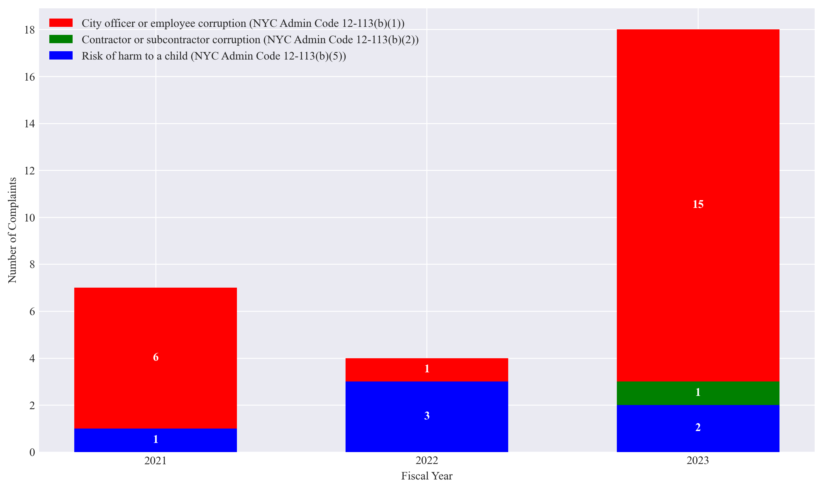
Figure 7 - Whistleblower Retaliation Complaints
- Conclusion
OID’s analysis reveals several critical challenges facing SCI. The agency’s funding has plateaued since 2020, while at the same time the volume of complaints has surged by approximately 60%. OID’s review indicates that this dichotomy has severely strained SCI’s resources, compounded by significant staff attrition that has further diminished the agency’s capability to effectively manage its caseload.
The data also indicates a troubling decline in the proportion of SCI complaints that lead to investigations, from a high of 16% in 2015 to a low of 4% in 2023. This underscores the agency’s growing inability to address its caseload. Moreover, while SCI continues to make personnel-related recommendations, fewer and fewer have been disciplinary in nature, and the most severe outcomes, such as arrests and referrals to prosecutors, have significantly decreased in recent years.
OID’s analysis also highlights the trend of a potential decrease in SCI’s impact on DOE policy due to a reduction in the number of PPRs issued. This trend seems on track to continue in 2024, as midway through the year only 8 PPRs have been issued.
Finally, the sharp increase in SCI whistleblower retaliation complaints in FY23, particularly those involving New York City officers or employees, underscores the urgent need for robust protections for SCI whistleblowers and swift, decisive action to address retaliation.
CONCLUSION
The Committee on Oversight and Investigations looks forward to hearing from SCI and interested stakeholders regarding the agency’s oversight of the DOE and its retirement systems. The Council seeks a better understanding of how the agency conducts its investigations, the financial and other resources SCI has at its disposal to conduct its oversight, and any recommendations SCI has regarding the policies and procedures of the City School District.

Anemone Hartocollis, “Crew attacks school investigator, calling his reports exaggerated,” The New York Times, Oct. 23, 1997, available at https://www.nytimes.com/1997/10/23/nyregion/crew-attacks-school-investigator-calling-his-reports-exaggerated.html.
The Special Commissioner of Investigation for the New York City School District, “History,” available at https://nycsci.org/history/.
Joseph Berger, “Investigators for schools are criticized,” The New York Times, Mar. 16, 1990, available at https://www.nytimes.com/1990/03/16/nyregion/investigators-for-schools-are-criticized.html.
Id.
The Special Commissioner of Investigation for the New York City School District, “History,” available at https://nycsci.org/history/.
Id.
William K. Rashbaum, “Fight to control office that roots out corruption in New York schools,” The New York Times, Mar. 16, 2018, available at https://www.nytimes.com/2018/03/16/nyregion/doi-schools-new-york-investigations.html.
Executive Order 11 of 1990, available at https://nycsci.org/wp-content/uploads/2018/History/Executive-Order113415.pdf.
Executive Order 34 of 1992, available at https://nycsci.org/wp-content/uploads/2018/History/Executive-Order113415.pdf
Anemone Hartocollis, “Crew attacks school investigator, calling his reports exaggerated,” The New York Times, Oct. 23, 1997, available at https://www.nytimes.com/1997/10/23/nyregion/crew-attacks-school-investigator-calling-his-reports-exaggerated.html.
Id.
William K. Rashbaum, “Fight to control office that roots out corruption in New York schools,” The New York Times, Mar. 16, 2018, available at https://www.nytimes.com/2018/03/16/nyregion/doi-schools-new-york-investigations.html.
Id.
Id.
William K. Rashbaum, “Chief watchdog misused power and punished whistle-blowers, inquiry finds,” The New York Times, Oct. 11, 2019, available at https://www.nytimes.com/2018/10/11/nyregion/doi-mark-peters-de-blasio-schools-nyc.html.
Gloria Pazmino and Sally Goldenberg “DeBlasio ousts city’s top watchdog; admits hiring Peters was a ‘mistake.’” Politico November 16, 2018. Available at https://www.politico.com/states/new-york/albany/story/2018/11/16/de-blasio-ousts-citys-top-watchdog-admits-hiring-peters-was-a-mistake-702704.
Id.
Id.
The DOE is currently also known as New York City Public Schools (NYCPS). See Mark Chiusano, “The Department of Education, Formerly the Board of Education, Is Actually ‘NYC Public Schools’—For Now,” Hell Gate, Mar. 18, 2024, available at https://hellgatenyc.com/doe-nyc-public-schools-brand-refresh. The SCI website refers to the agency as the DOE, its official name. Accordingly, this briefing paper refers to the agency as the DOE.
The Special Commissioner of Investigation for the New York City School District, available at https://nycsci.org/.
The Special Commissioner of Investigation for the New York City School District, “FAQs,” available at https://nycsci.org/faqs/.
Id.
The Special Commissioner of Investigation for the New York City School District, “About,” available at https://nycsci.org/about/.
The Special Commissioner of Investigation for the New York City School District, “FAQs,” available at https://nycsci.org/faqs/.
Commissioner Anastasia Coleman, “Annual Report of the Special Commissioner of Investigation for the New York City School District,” Special Commissioner of Investigation for the New York City School District, Mar. 29, 2023, available at https://a860-gpp.nyc.gov/concern/nyc_government_publications/f1881p84s?locale=en.
Commissioner Anastasia Coleman, “Annual Report of the Special Commissioner of Investigation for the New York City School District,” Special Commissioner of Investigation for the New York City School District, Mar. 14, 2024, available at https://nycsci.org/wp-content/uploads/2024/03/SCI-2023-ANNUAL-REPORT-1.pdf.
The Special Commissioner of Investigation for the New York City School District, “FAQs,” available at https://nycsci.org/faqs/.
NYC Council Finance Division, “Note on the Fiscal 2022 Executive Budget for the Special Commissioner of Investigation,” available at https://council.nyc.gov/budget/wp-content/uploads/sites/54/2021/05/SCI-Budget-Note.pdf.
The City of New York Executive Budget Fiscal Year 2025, “Supporting Schedules” at 513, 515, 532-33, available at https://www.nyc.gov/assets/omb/downloads/pdf/ss4-24.pdf.
Id.
Id. at 515.
Id.
Id.
New York City Council, “Meeting Minutes: Thursday, February 27, 2020, at 1:30 PM,” at 19, 31-32, available at https://legistar.council.nyc.gov/MeetingDetail.aspx?ID=764970&GUID=995FCFE2-F0ED-4BFC-B280-90F07284A4D2&Options=info|&Search=.
The Special Commissioner of Investigation for the New York City School District, Policy and Procedure Recommendations, available at https://nycsci.org/ppr/.
Id.
Id.
See The Special Commissioner for the New York City School District, Reports, https://nycsci.org/reports/ (last accessed on June 10, 2024).
See, e.g., City of New York, Fiscal Year 2023 Mayor’s Management Report, available at https://www.nyc.gov/assets/operations/downloads/pdf/mmr2023/2023_mmr.pdf (last accessed on June 10, 2024) (lacking information from SCI).
New York City Council, Committee Report of the Governmental Affairs Division – Stated Meeting, available at https://legistar.council.nyc.gov/LegislationDetail.aspx?ID=3852719&GUID=723B2E5F-78E9-4F26-85DF-590186F36655&Options=&Search= (last accessed on June 10, 2024).
Local Law 43 of 2020, available at https://intro.nyc/local-laws/2020-43 (last accessed on June 10, 2024).
Id.
Id.
Id.
See The Special Commissioner for the New York City School District, Policy and Procedure Recommendations from 2019 to Present, https://nycsci.org/ppr-portal/ (last accessed on June 10, 2024).
https://nycsci.org/reports/
https://nycsci.org/ppr-portal/
https://nycsci.org/wp-content/uploads/2024/03/SCI-2023-ANNUAL-REPORT-1.pdf.
For example, “Employees Terminated” and “Employees Receiving Written Admonishments” were reported only from 2019-2021, whereas the aggregate category of "Disciplinary Actions" was tracked in all reports from 2014-2023.
https://nycsci.org/wp-content/uploads/2024/03/SCI-2023-ANNUAL-REPORT-1.pdf.
Recommendations for which the “recommendation status” was blank (one in 2020 and two in 2023) were excluded from OID’s analysis.

