THE COUNCIL OF THE CITY OF NEW YORK
RESOLUTION NO. 360

Resolution approving with modifications the decision of the City Planning Commission on Application No. N 230382 ZRK, for an amendment of the text of the Zoning Resolution (L.U. No. 45).

By Council Members Salamanca and Riley

WHEREAS, PG Realty Investments, LLC, filed an application pursuant to Section 201 of the New York City Charter, for an amendment of the text of the Zoning Resolution of the City of New York, modifying APPENDIX F for the purpose of establishing a Mandatory Inclusionary Housing Area, which in conjunction with the related action would facilitate the development of a 46,000-square-foot mixed-use building containing a total of approximately 45 dwelling units, approximately 12 of which would be designated permanently income-restricted, as well as approximately 5,000 square feet of ground-floor commercial space at 396-400 Avenue X in the Gravesend neighborhood of Brooklyn, Community District 15 (ULURP No. N 230382 ZRK), (the “Application”);
WHEREAS, the City Planning Commission filed with the Council on March 8, 2024, its decision dated March 6, 2024 (the "Decision") on the Application;
WHEREAS, the Application is related to application C 230381 ZMK (L.U. No. 44), a zoning map amendment to change a R4/OP zoning district to a R7A/C2-4/OP zoning district;
WHEREAS, the Decision is subject to review and action by the Council pursuant to Section 197-d of the City Charter;
WHEREAS, upon due notice, the Council held a public hearing on the Decision and Application on March 12, 2024;
WHEREAS, the Council has considered the land use implications and other policy issues relating to the Decision and Application; and
WHEREAS, the Council has considered the relevant environmental issues, including the Negative Declaration issued on December 11, 2023 (CEQR No. 23DCP136K), which includes an (E) designation to avoid the potential for significant adverse impacts related to hazardous materials and air quality (E-743) (the “Negative Declaration”).
RESOLVED:
The Council finds that the action described herein will have no significant impact on the environment as set forth in the (E) Designation (E-743) and Negative Declaration.
Pursuant to Sections 197-d and 200 of the City Charter and on the basis of the Decision and Application, and based on the environmental determination and consideration described in the report, N 230382 ZRK, incorporated by reference herein, and the record before the Council, the Council approves the Decision of the City Planning Commission, with the following modifications.
Matter underlined is new, to be added;
Matter struck out is to be deleted;
Matter double struck out is old, deleted by the City Council;
Matter double-underlined is new, added by the City Council;
Matter within # # is defined in Section 12-10;
* * * indicates where unchanged text appears in the Zoning Resolution.

* * *
APPENDIX F
Inclusionary Housing Designated Areas and Mandatory Inclusionary Housing Areas
* * *
BROOKLYN
* * *
Brooklyn Community District 15
* * *
Map 6 – [date of adoption]
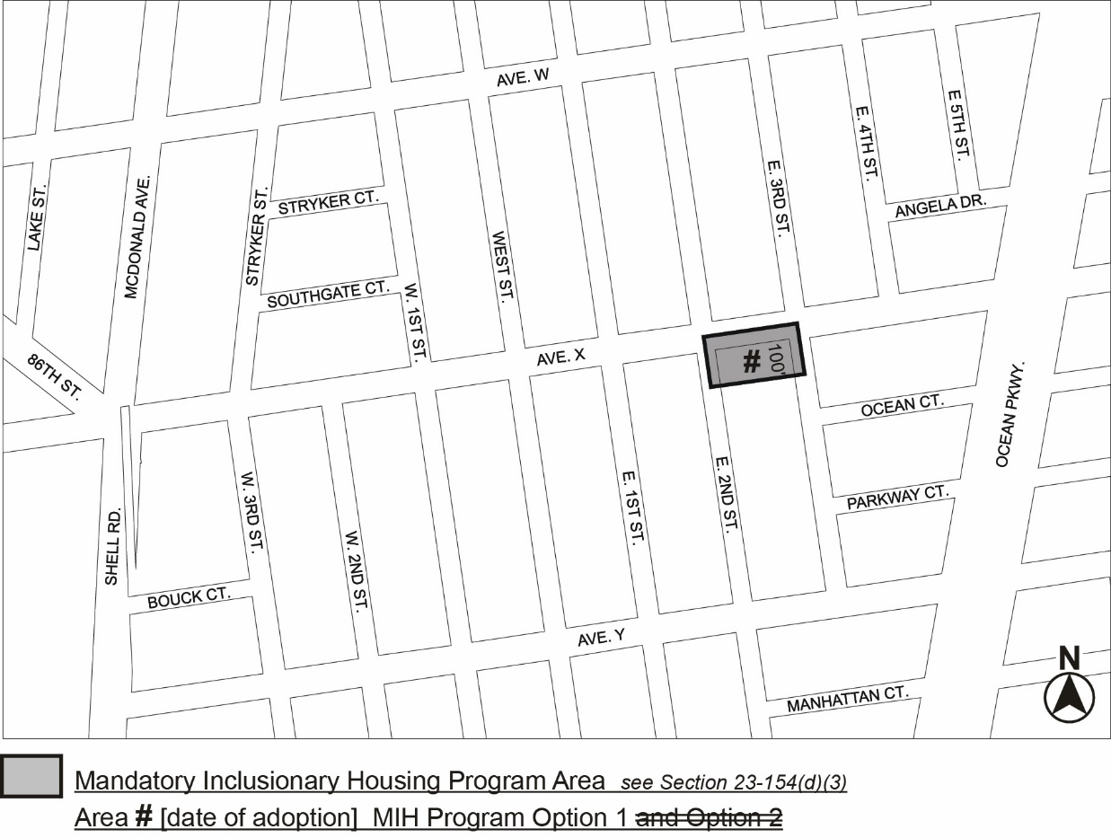
Portion of Community District 15, Brooklyn
* * *
Adopted.

Office of the City Clerk,}
The City of New York,} ss.:

I hereby certify that the foregoing is a true copy of a Resolution passed by The Council of The City of New York on _________, 2024, on file in this office.

.....................................................
City Clerk, Clerk of The Council

