THE COUNCIL OF THE CITY OF NEW YORK
RESOLUTION NO. 303

Resolution approving with modifications the decision of the City Planning Commission on Application No. N 230242 ZRM, for an amendment of the text of the Zoning Resolution (L.U. No. 28).

By Council Members Salamanca and Riley

WHEREAS, LM East 94, LLC, filed an application pursuant to Section 201 of the New York City Charter, for an amendment of the text of the Zoning Resolution of the City of New York, modifying APPENDIX F for the purpose of establishing a Mandatory Inclusionary Housing area, which in conjunction with the related action would facilitate the development of a mixed-use development with a Mandatory Inclusionary Housing (MIH) requirement, located at 205-239 East 94th Street (Block 1540, Lots 13, 14, and 18), in the Yorkville neighborhood of Manhattan Community District 8 (ULURP No. N 230242 ZRM), (the “Application”);
WHEREAS, the City Planning Commission filed with the Council on February 9, 2024, its decision dated February 7, 2024 (the "Decision") on the Application;
WHEREAS, the Application is related to application C 230241 ZMM (L.U. No. 27), a zoning map amendment to change an M1-4 zoning district to C4-6 and C2-8 zoning districts;
WHEREAS, the Decision is subject to review and action by the Council pursuant to Section 197-d of the City Charter;
WHEREAS, upon due notice, the Council held a public hearing on the Decision and Application on February 26, 2024;
WHEREAS, the Council has considered the land use implications and other policy issues relating to the Decision and Application; and
WHEREAS, the Council has considered the relevant environmental issues, including the Negative Declaration issued on October 13, 2023 (CEQR No. 22DCP186M), which includes an (E) designation to avoid the potential for significant adverse impacts related to hazardous materials and air quality (E-739). The application contained project components related to the environment (PCREs), and the applicant will enter into a Restrictive Declaration at the time of approval of land-use related actions and prior to issuance of any permits.
RESOLVED:
The Council finds that the action described herein will have no significant impact on the environment as set forth in the (E) Designation (E-739) and Negative Declaration.
Pursuant to Sections 197-d and 200 of the City Charter and on the basis of the Decision and Application, and based on the environmental determination and consideration described in the report, N 230242 ZRM, incorporated by reference herein, and the record before the Council, the Council approves the Decision of the City Planning Commission, with the following modifications.
Matter underlined is new, to be added;
Matter struck out is to be deleted;
Matter within # # is defined in Section 12-10;
* * * indicates where unchanged text appears in the Zoning Resolution.
Matter double struck out is old, deleted by the City Council;
Matter double-underlined is new, added by the City Council

* * *
APPENDIX F
Inclusionary Housing Designated Areas and Mandatory Inclusionary Housing Areas
* * *
MANHATTAN
* * *
Manhattan Community District 8
* * *
Map 2 [date of adoption]
[PROPOSED MAP]
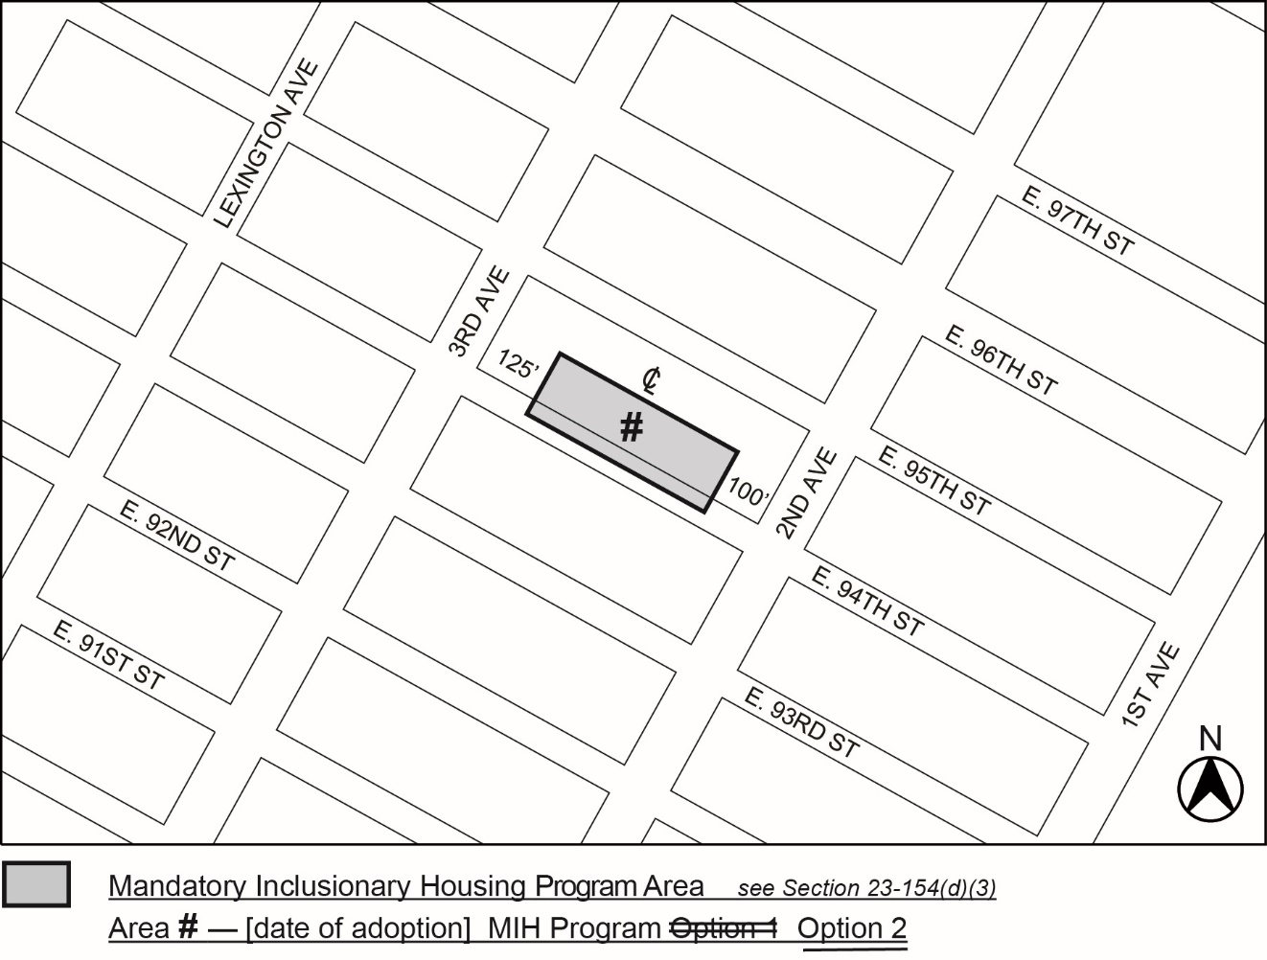
Portion of Community District 8, Manhattan

* * *

Adopted.

Office of the City Clerk,}
The City of New York,} ss.:

I hereby certify that the foregoing is a true copy of a Resolution passed by The Council of The City of New York on _________, 2024, on file in this office.

.....................................................
City Clerk, Clerk of The Council

