THE COUNCIL OF THE CITY OF NEW YORK
RESOLUTION NO. 301

Resolution approving with modifications the decision of the City Planning Commission on Application No. N 230256 ZRK, for an amendment of the text of the Zoning Resolution (L.U. No. 25).

By Council Members Salamanca and Riley

WHEREAS, St. Nicks Alliance filed an application pursuant to Section 201 of the New York City Charter, for an amendment of the text of the Zoning Resolution of the City of New York, modifying APPENDIX F for the purpose of establishing a Mandatory Inclusionary Housing area, which in conjunction with the related action would facilitate the development of a new 14-story mixed-use building with 218 Affordable Independent Residences for Seniors (“AIRS”) and ground-floor retail located at 819 Grand Street in the East Williamsburg neighborhood of Brooklyn, Community District 1 (ULURP No. N 230256 ZRK) (the “Application”);
WHEREAS, the City Planning Commission filed with the Council on February 9, 2024, its decision dated February 7, 2024 (the "Decision") on the Application;
WHEREAS, the Application is related to application C 230255 ZMK (L.U. No. 24), a zoning map amendment to change R6B, R7A, and R7A/C2-4 zoning districts to R7A, R7X, and R7X/C2-4 districts;
WHEREAS, the Decision is subject to review and action by the Council pursuant to Section 197-d of the City Charter;
WHEREAS, upon due notice, the Council held a public hearing on the Decision and Application on February 26, 2024;
WHEREAS, the Council has considered the land use implications and other policy issues relating to the Decision and Application; and
WHEREAS, the Council has considered the relevant environmental issues, including the Negative Declaration issued on September 11, 2023 (CEQR No. 23DCP133K), which includes an (E) designation to avoid the potential for significant adverse impacts related to hazardous materials and noise (E-729). In order to avoid the potential for significant adverse historic and cultural resources impact, the applicant has entered into a Restrictive Declaration, committing to the completion of a Phase 1B archaeological study (prior to any construction activity) as part of the proposed project, to be reviewed for approval by the New York City Landmarks Preservation Commission (LPC). Consequently, no significant adverse impacts related to historic and cultural resources are expected to result from the proposed actions.
RESOLVED:
The Council finds that the action described herein will have no significant impact on the environment as set forth in the (E) Designation (E-729) and Negative Declaration.
Pursuant to Sections 197-d and 200 of the City Charter and on the basis of the Decision and Application, and based on the environmental determination and consideration described in the report, N 230256 ZRK, incorporated by reference herein, and the record before the Council, the Council approves the Decision of the City Planning Commission, with the following modifications.
Matter underlined is new, to be added;
Matter struck out is to be deleted;
Matter within # # is defined in Section 12-10;
* * * indicates where unchanged text appears in the Zoning Resolution.
Matter double struck out is old, deleted by the City Council;
Matter double-underlined is new, added by the City Council

* * *

APPENDIX F
Inclusionary Housing Designated Areas and Mandatory Inclusionary Housing Areas

* * *

BROOKLYN
* * *

Brooklyn Community District 1
* * *

Map 2 – [date of adoption]

[EXISTING MAP]
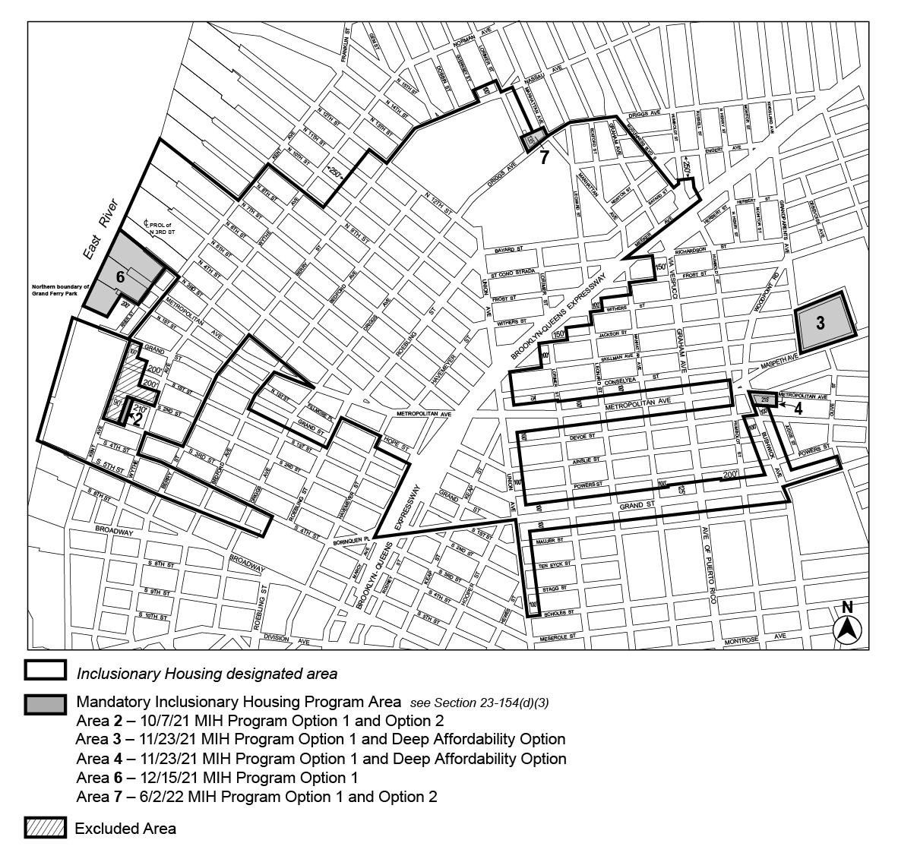

[PROPOSED MAP]
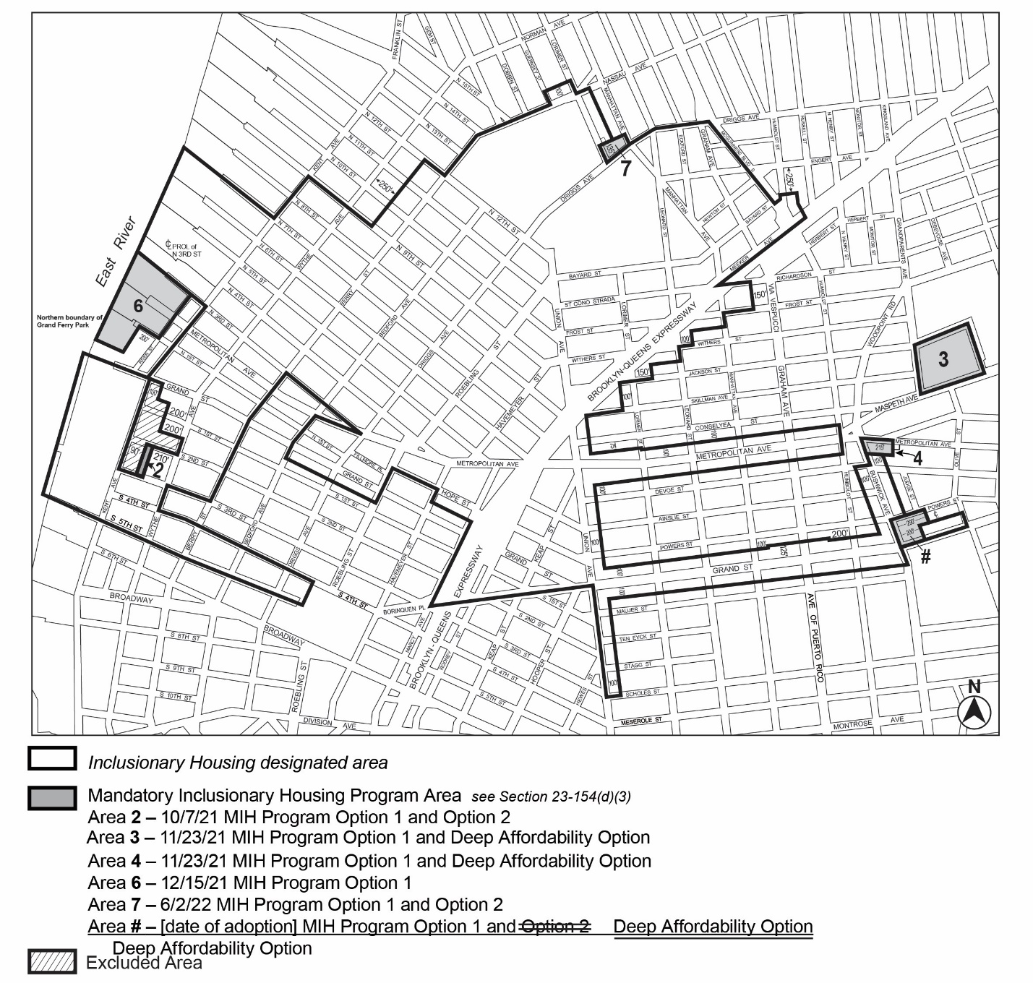

Portion of Community District 1, Brooklyn

* * *

Adopted.

Office of the City Clerk,}
The City of New York,} ss.:

I hereby certify that the foregoing is a true copy of a Resolution passed by The Council of The City of New York on _________, 2024, on file in this office.

.....................................................
City Clerk, Clerk of The Council

