THE COUNCIL OF THE CITY OF NEW YORK
RESOLUTION NO. 435

Resolution approving with modifications the decision of the City Planning Commission on Application No. N 200293 ZRK, for an amendment of the text of the Zoning Resolution (L.U. No. 69).

By Council Members Salamanca and Riley

WHEREAS, AA Atlantic, LLC, filed an application pursuant to Section 201 of the New York City Charter, for an amendment of the text of the Zoning Resolution of the City of New York, modifying APPENDIX F for the purpose of establishing a Mandatory Inclusionary Housing area, which in conjunction with the related action would facilitate the development of a new 14-story, 151,589 square-foot, mixed-use building with 112 dwelling units (approximately 34 of which would be income-restricted), 20,232 square-feet of ground-floor retail, and 16,324 square-feet of second-story community facility uses located at 1289 Atlantic Avenue in the Bedford-Stuyvesant neighborhood of Brooklyn, Community District 3 (ULURP No. N 200293 ZRK), (the “Application”);
WHEREAS, the City Planning Commission filed with the Council on April 8, 2024, its decision dated March 20, 2024 (the "Decision") on the Application;
WHEREAS, the Application is related to application C 200310 ZMK (L.U. No. 68), a zoning map amendment to change an M1-1 zoning district to a C4-5X and an R6B zoning district;
WHEREAS, the Decision is subject to review and action by the Council pursuant to Section 197-d of the City Charter;
WHEREAS, upon due notice, the Council held a public hearing on the Decision and Application on April 17, 2024;
WHEREAS, the Council has considered the land use implications and other policy issues relating to the Decision and Application; and
WHEREAS, the Council has considered the relevant environmental issues, including the Negative Declaration issued on October 30, 2024 (CEQR No. 21DCP054K), which includes an (E) designation to avoid the potential for significant adverse impacts related to hazardous materials, air quality, and noise (E-732). An analysis of historical and cultural resources in consultation with the New York City Landmarks Preservation Commission (LPC) determined that development on the applicant site could result in potential impacts. Therefore, a Restrictive Declaration will be recorded in conjunction with any approvals for the proposed actions. The applicant would commit to carry out archaeological work as prescribed by an LPC-approved Phase 1B work plan, prior to commencing construction. In the event that the archaeological field testing uncovers significant archaeological resources, additional archaeology may be needed as per the Guidelines for Archaeological Work in New York City. The Restrictive Declaration would preclude potential for significant adverse impacts related to historic and cultural resources.
RESOLVED:
The Council finds that the action described herein will have no significant impact on the environment as set forth in the (E) Designation (E-732) and Negative Declaration.
Pursuant to Sections 197-d and 200 of the City Charter and on the basis of the Decision and Application, and based on the environmental determination and consideration described in the report, N 200293 ZRK, incorporated by reference herein, and the record before the Council, the Council approves the Decision of the City Planning Commission, with the following modifications.
Matter underlined is new, to be added;
Matter struck out is to be deleted;
Matter double struck out is old, deleted by the City Council;
Matter double-underlined is new, added by the City Council;
Matter within # # is defined in Section 12-10;
* * * indicates where unchanged text appears in the Zoning Resolution.

* * *

APPENDIX F
Inclusionary Housing Designated Areas and Mandatory Inclusionary Housing Areas

* * *

BROOKLYN
* * *

Brooklyn Community District 3
* * *
Map 1 – [date of adoption]

[EXISTING MAP]
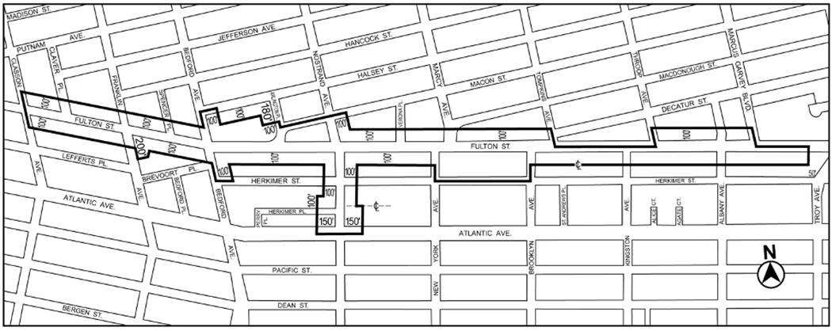

[PROPOSED MAP]
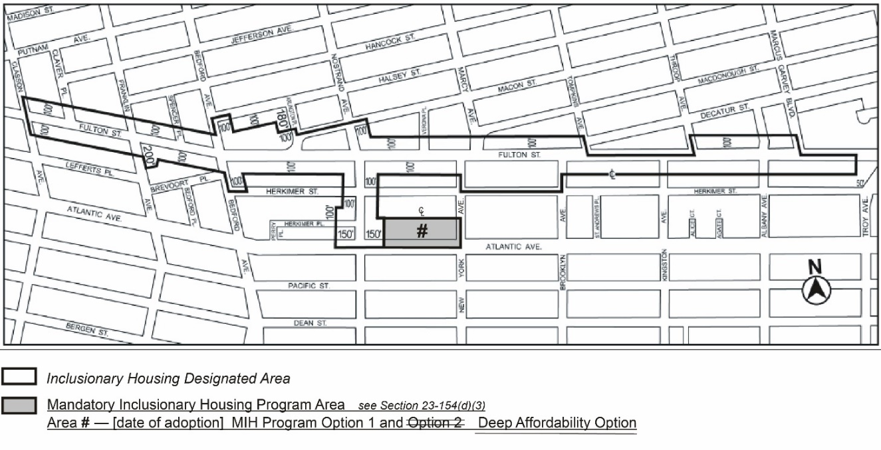
Portion of Community District 3, Brooklyn

* * *

Adopted.

Office of the City Clerk,}
The City of New York,} ss.:

I hereby certify that the foregoing is a true copy of a Resolution passed by The Council of The City of New York on _________, 2024, on file in this office.

.....................................................
City Clerk, Clerk of The Council

