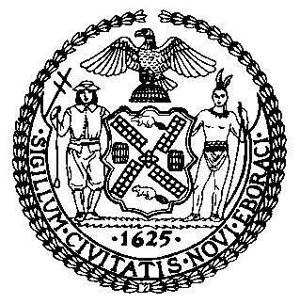 | The Council of the City of New York  Finance Division  Latonia Mckinney, Director  Fiscal Impact Statement  Proposed Intro. No.: 1638-A  Committee: Education
Title: A local law to amend the administrative code of the city of New York, in relation to requiring the department of education to report on gay-straight or gender-sexuality alliance organizations | Sponsors: Council Members Kallos, Dromm, Cohen, Rosenthal, Gentile, Rodriguez, Menchaca and Reynoso

Summary of Legislation: Proposed Intro. 1638-A would require the Department of Education to report annually to the Council (with the first report due June 1, 2019), and post online, information regarding student-led gay-straight alliances or gender-sexuality alliances (GSA) at each middle and high school. The report would include whether a school has a GSA, the number of teachers and administrators at each school (including the principal) who have received lesbian, gay, bisexual, transgender, queer or questioning and gender non-conforming (LGBTQGNC) training, and a description of the training offered to teachers and administrators, including whether any such training includes training related to GSAs.

Effective Date: This local law would take effect immediately.

Fiscal Year in Which Full Fiscal Impact Anticipated: Fiscal 2018
Fiscal Impact Statement:

 | Effective FY17 | FY Succeeding Effective FY18 | Full Fiscal Impact FY18
Revenues | $0 | $0 | $0
Expenditures | $0 | $0 | $0
Net | $0 | $0 | $0

Impact on Revenues: It is estimated that there would be no impact on revenues resulting from the enactment of this legislation.
Impact on Expenditures: It is anticipated that this legislation would have no impact on expenditures.
Source of Funds to Cover Estimated Costs: None
Source of Information: New York City Council Finance Division and New York City Department of Education.
Estimate Prepared by: Elizabeth Hoffman, Principal Financial Analyst

Estimate Reviewed by: Dohini Sompura, Unit Head
Eric Bernstein, Counsel

Legislative History: This legislation was introduced to the Council on June 6, 2017 as Intro. 1638 and was referred to the Committee on Education (Committee). The legislation was considered by the Committee at a hearing on September 14, 2017, and was laid over. The legislation was subsequently amended and the amended legislation, Proposed Intro. No. 1638-A, will be voted on by the Committee on October 30, 2017. Upon successful vote by the Committee, Proposed Intro. No. 1638-A will be submitted to the full Council for a vote on October 31, 2017.
Date Prepared: October 25, 2017

