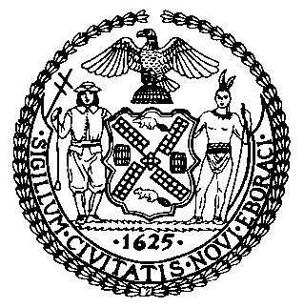 | The Council of the City of New York  Finance Division  Latonia Mckinney, Director  Fiscal Impact Statement  Proposed Intro. No: 1511-A  Committee: Small Business
Title: A local law in relation to a state of small business survey | Sponsor(S): Council Members Cornegy, Levin, Rosenthal, Menchaca, Cohen, Espinal, and Vallone
Summary of Legislation: This legislation would require the Commissioner of the Department of Small Business Services (SBS) to prepare and disseminate a state of small business survey by September 1, 2018, which would collect information from small businesses, including but not limited to, hiring needs, workforce development needs, barriers to growth, and the need for additional tools and resources.

Effective Date: This local law would take effect immediately.

Fiscal Year in Which Full Fiscal Impact Anticipated: Fiscal 2019
Fiscal Impact Statement:

 | Effective FY18 | FY Succeeding Effective FY19 | Full Fiscal Impact FY19
Revenues | $0 | $0 | $0
Expenditures | $150,000 | $0 | $0
Net | ($150,000) | $0 | $0

Impact on Revenues: It is anticipated that there would be no impact on revenues resulting from the enactment of this legislation.
Impact on Expenditures: It is anticipated that there would be a one-time $150,000 impact on expenditures as a result of this legislation for the development of the survey; outreach to community; data analysis; and the author and design phase of the survey.
Source of Funds To Cover Estimated Costs: General Fund
Source of Information: New York City Council Finance Division
New York City Office of Management and Budget
Estimate Prepared By: Crilhien Francisco, Unit Head, Finance Division
Estimate Reviewed By: Nathan Toth, Deputy Director, Finance Division
Rebecca Chasan, Counsel, Finance Division
Legislative History: This legislation was introduced by the Council on March 16, 2017 as Intro. No. 1511 and referred to the Committee on Small Business. A hearing was held jointly by the Committee on Small Business and the Committee on Veterans on June 20, 2017 and the bill was laid over. The legislation was subsequently amended and the amended version, Proposed Intro. No. 1511-A, will be voted on by the Committee on Small Business at a hearing on October 11, 2017. Upon successful vote by the Committee, Proposed Intro. No. 1511-A will be submitted to the full Council for a vote on October 17, 2017.
Date Prepared: October 10, 2017

