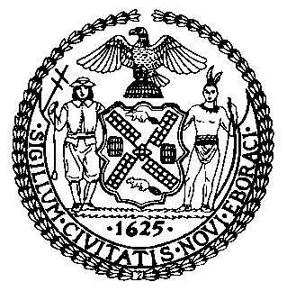 | The Council of the City of New York  Finance Division  Preston niblack, Director  jeffrey rodus, first deputy director  Fiscal Impact Statement  Proposed Intro. No: 1140-A  Committee: Committee on Sanitation and Solid Waste Management
Title: A Local Law to amend the administrative code of the city of New York, in relation to signs posted upon city-owned grassy areas adjacent to a street. | Sponsor(S): Council Members Oddo, Fidler, Gentile, James, Koo, Koppell and Rose
SUMMARY OF LEGISLATION: Proposed Int. No. 894-A would amend New York City’s Administrative Code in relation to signs posted upon city-owned grassy areas adjacent to a street.

This legislation would make it unlawful for anyone to paste, post, paint, print, nail or attach or affix by any means any handbill, poster, notice, sign, advertisement, sticker or other printed material upon any city-owned grassy area adjacent to a street that is not posted by order of a city agency.

EFFECTIVE DATE: This local law would take effect immediately.

Fiscal Year In Which Full Fiscal Impact Anticipated: Fiscal 2014
Fiscal Impact Statement:

 | Effective FY14 | FY Succeeding  Effective FY15 | Full Fiscal  Impact FY14
Revenues | $0 | $0 | $0
Expenditures | $0 | $0 | $0
Net | $0 | $0 | $0

Impact on Revenues: No impact on revenues is expected.
Impact on Expenditures: No impact on expenditures is expected.
Source of Funds To Cover Estimated Costs: N/A

Source of Information: Mayor’s Office of Legislative Affairs
Department of Sanitation (DSNY)

Estimate Prepared By: Kate Seely-Kirk, Senior Legislative Financial Analyst

Estimated Reviewed By: Nathan Toth, Deputy Director
Tanisha Edwards, Finance Counsel
Legislative History: On August 22, 2013, Intro. 1140 was introduced by the Council and referred to the Committee on Sanitation and Solid Waste Management. On November 22, 2013 the Committee held a hearing regarding this legislation, which was then laid over and subsequently amended. The Committee will consider an amended version of the legislation, Proposed Intro. 1140-A. on December 10, 2013. Following a successful Committee vote, the Full Council will vote on Proposed Int. 1140-A on December 10, 2013.

