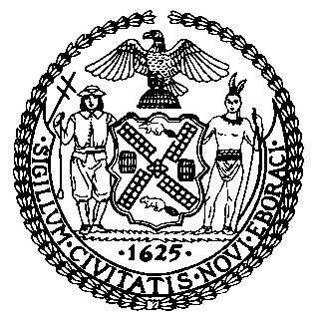 | The Council of the City of New York  Finance Division  Latonia Mckinney, Director  Fiscal Impact Statement  Proposed Intro. No: 653-A  Committee: Women
Title: A Local Law to amend the administrative code of the city of New York, in relation to mandating annual reporting on workplace sexual harassment within city agencies | Sponsors: Council Members Levine, Williams, Torres, Cabrera, Rose, Rosenthal, Chin, Gibson, Powers, Constantinides, and Reynoso
Summary of Legislation: Proposed Intro. No. 653-A would mandate annual reporting on workplace sexual harassment complaints within City agencies, as well as the offices of the borough presidents, the comptroller and the public advocate. Each agency would be required to report to the Department of Citywide Administrative Services (DCAS), which would compile the reports into a single report. The compiled report would be required to be submitted to the Mayor, Council, and Commission on Human Rights, and the Commission on Human Rights would be required to post it to its website.
Effective Date: This local law would take effect 180 days after it becomes law.
Fiscal Year In Which Full Fiscal Impact Anticipated: Fiscal 2020
Fiscal Impact Statement:
 | Effective FY19 | FY Succeeding Effective FY20 | Full Fiscal Impact FY20
Revenues | $0 | $0 | $0
Expenditures | $0 | $0 | $0
Net | $0 | $0 | $0

Impact on Revenues: There would be no impact on revenues resulting from this legislation.

Impact on Expenditures: It is anticipated that there would be no impact on expenditures resulting from the enactment of this legislation because existing workplace sexual harassment incident information and agency staff would be used to generate the reports, and existing online resources would be used to post the required reports.
Source of Funds To Cover Estimated Costs: Not applicable.
Source of Information: New York City Council Finance Division
Department of Citywide Administrative Services
Estimate Prepared by: Daniel Kroop, Financial Analyst

Estimate Reviewed by: Regina Poreda Ryan, Deputy Director
Dohini Sompura, Unit Head
Rebecca Chasan, Counsel
Legislative History: This legislation was considered at a joint hearing by the Committee on Women and the Committee on Civil and Human Rights as a Preconsidered Introduction at a hearing on February 28, 2018, and the legislation was laid over. The legislation was introduced to the Council as Intro. No. 653 on March 7, 2018 and referred to the Committee on Women. The legislation was subsequently amended and the amended version, Proposed Intro. No. 653-A, will be voted on by the Committee on Women at a hearing on April 9, 2018. Upon successful vote by the Committee, Proposed Intro. No. 653-A will be submitted to the full Council for a vote on April 11, 2018.
Date Prepared: April 8, 2018

