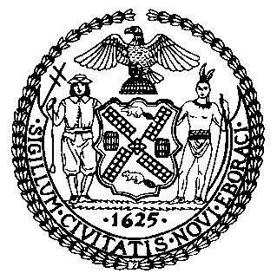 | The Council of the City of New York  Finance Division  Latonia Mckinney, Director  Fiscal Impact Statement  Proposed Intro. No. 663-A  Committee: Civil and Human Rights
Title: A Local Law to amend the administrative code of the city of New York, in relation to the statute of limitations for filing certain harassment claims arising under the city human rights law. | Sponsor: By Council Members Rosenthal, Rose, Adams Chin and Powers

Summary of Legislation: Proposed Intro. No. 663-A would amend the New York City Human Rights Law (HRL) for gender-based harassment claims by extending the statute of limitations for filing such claims under the HRL from one year to three years.

Effective Date: This local law takes effect immediately.

Fiscal Year In Which Full Fiscal Impact Anticipated: Fiscal 2019
Fiscal Impact Statement:
 | Effective FY18 | FY Succeeding  Effective FY19 | Full Fiscal Impact FY19
Revenues (+) | $0 | $0 | $0
Expenditures (-) | $0 | $0 | $0
Net | $0 | $0 | $0

Impact on Revenues: It is estimated that Proposed Intro. No. 663-A would have no impact on revenues.

Impact on Expenditures: It is estimated that Proposed Intro. No. 663-A would have no impact on expenditures.

Source of Funds to Cover Estimated Costs: N/A

Sources of Information: New York City Council Finance Division
New York City Commission on Human Rights

Estimate Prepared by: Sheila D. Johnson, Financial Analyst

Estimate Reviewed by: Regina Poreda Ryan, Deputy Director
Rebecca Chasan, Counsel
Eisha Wright, Unit Head

Legislative History: This legislation was introduced as Intro. No. 663 by the Council on March 7, 2018 and was referred to the Committee on Civil and Human Rights (Committee). The Committee considered the legislation at a hearing on February 28, 2018, and the legislation was laid over. The legislation was subsequently amended and the amended version of the legislation, Proposed Intro. No. 663-A, will be voted on by the Committee on April 9, 2018. Upon successful vote of the Committee, Proposed Intro. No. 663-A will be submitted to the full Council for a vote on April 11, 2018.

Date Prepared: April 6, 2018

