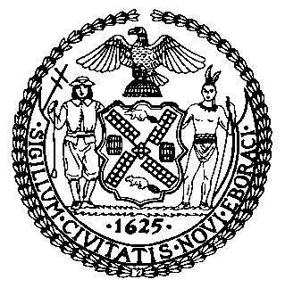 | The Council of the City of New York  Finance Division  Latonia McKinney, Director  Fiscal Impact Statement  Intro. No.: 897  Committee: Public Safety
title: A Local Law to amend the administrative code of the city of New York, in relation to declaring nuisances related to the sale of synthetic drugs and imitation synthetic drugs. | Sponsors: Council Members Garodnick, the Speaker (Council Member Mark-Viverito). Arroyo, Barron, Gibson, Johnson, Koo, Mealy, Mendez, Richards, Rose, Wills, Crowley, and Cohen.
Summary of Legislation: Intro. No. 897 would add violations of a proposed synthetic drug prohibition to the factors that allow the declaration of a public nuisance under the City’s Nuisance Abatement Law. It would allow a court, under the Nuisance Abatement Law, to issue restraining and closing orders against premises that repeatedly violate the proposed synthetic drug prohibition.

Effective Date: This local law would take effect 60 days after it becomes law.
Fiscal Year In Which Full Fiscal Impact Anticipated: Fiscal 2017
Fiscal Impact Statement:

 | Effective FY16 | FY Succeeding  Effective FY17 | Full Fiscal  Impact FY17
Revenues | $0 | $0 | $0
Expenditures | $0 | $0 | $0
Net | $0 | $0 | $0

Impact on Revenues: It is estimated that there would be no impact on revenues resulting from the enactment of this legislation.
Impact on Expenditures: It is anticipated that this legislation would have no impact on expenditures because existing resources at the Department of Health and Mental Health, New York Police Department, and Department of Finance, would be used to implement this legislation.
Source of Funds To Cover Estimated Costs: N/A

Source of Information: New York City Council Finance Division
Office of Management and Budget
Estimate Prepared By: Ellen Eng, Legislative Financial Analyst

Estimate Reviewed By: Regina Poreda Ryan, Deputy Director, New York City Council Finance Division
Rebecca Chasan, Assistant Counsel, New York City Council Finance Division
Tanisha Edwards, Chief Counsel, New York City Council Finance Division
Legislative History: Intro. No. 897 was introduced to the Council on September 17, 2015 and referred to the Committee on Public Safety. The Committee on Public Safety held a hearing jointly with the Committee on Consumer Affairs; the Committee on Health; and the Committee on Mental Health, Developmental Disability, Alcoholism, Substance Abuse, and Disability Services on Intro. No. 897 on September 21, 2015 and the legislation was laid over. The Committee on Public Safety will consider the legislation at a hearing on September 25, 2015, and upon successful vote by the Committee, Intro. No. 897 will be submitted to the full Council for a vote on September 30, 2015.
Date prepared: September 21, 2015

